<doc_instructions>

<analysis>

Task: Rejected Idea Dissection and Salvage

Level: Mid-level Abstraction

Scope: Recovery Reference

Instructions:

- For each rejected idea, identify the **specific point(s) of weakness** (e.g., brand mismatch, unclear messaging, off-tone humor, etc.).

- Separate and salvage any strong elements that can be repurposed into fresh, better-aligned ideas.

- Summarize findings under two headings for each idea:

1. Weakness Point(s)

2. Salvageable Elements

- Use this document as a **partial creative resource** — repurpose the good, avoid the bad.

</analysis>

</doc_instructions>

**Britannia Croissant | Valentines Day**

**Valentine's Day Idea:**

**Inspiration:**

<https://www.instagram.com/reel/DEKebhno1Kf/>

<https://www.instagram.com/reel/DDEtfZPy0Sv/?igsh=ZTRzdHh2NmxueDR0>

**The question:**

**“I am a treat to everyone but who is a treat to my eyes??”**

**The answer:**



The one thing we share with Kalki? She’s an absolute cutie- just like our croissants! And of course, she’s French-Indian, making this a match made in heaven. This Valentine’s week, we’re celebrating our love for Kalki the best way we know…

After all, even our croissant deserves a little treat ;)

**Post 1: Build-up**

**Format:** Reel

**Visual reference:** [**https://www.instagram.com/reel/DC8uHm9SEKC/?igsh=MXkzbWFreDd0anFq**](https://www.instagram.com/reel/DC8uHm9SEKC/?igsh=MXkzbWFreDd0anFq)

**Frame 1: Show the Eiffel Tower and India Gate**

** **

**Copy:**

Dil se desi ho lekin dikhne mai ho French 🤗

**Frame 2: Kalki’s picture appears followed by croissant’s**

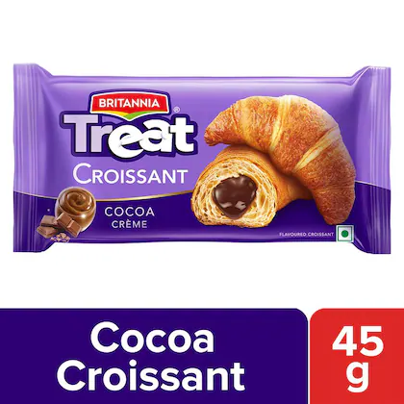

**Copy:**

Aap Kal-ki | Hum Aaj ke

**Frame 3: Kalki’s cutout appears with “Kwasangggg” appearing animatedly.**



**Copy:**

Aur sirf aap hi ho jo humara naam sahi se pukaar sakte ho

**Frame 4: Show a cutout of Kalki with a croissant and heart appearing between them.**

Will you be my Valentine? 🥺👉🏻👈🏻

**Post 2: Sustenance**

**Format:** Reel

**Visual reference:** <https://www.instagram.com/reel/DDMgdFdMnRN/?igsh=M2c4dDY5NWR3b3Y5>

**Visual:** We show a croissant getting a skincare routine(false-shaving, serum, etc) and a cool look, all prepped like a guy gearing up to propose. The copy is on the top center of the visual.

**Copy:**

Getting ready to propose and

become Kal-ki’s aaj ka💜

**Post 3: Valentine’s Day**

**Format:** Reel

**Ref:**

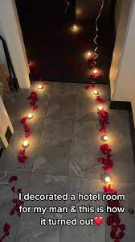

**Croissant ref:**

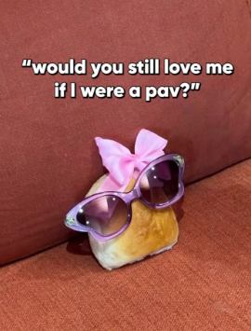

**Visual:**

The camera follows a trail of roses on the ground. The camera pans and we see Britannia Croissant sitting on the table with candles and a bouquet. The other chair is vacant.

**Copy:**

Waiting for Kal-ki to become my +1 😚🫶

**Post 4: Break up**

**Format: Reel**

**Visual reference:** <https://www.instagram.com/reel/DE1b7KvS1By/>

**Audio reference:** O bedardeya

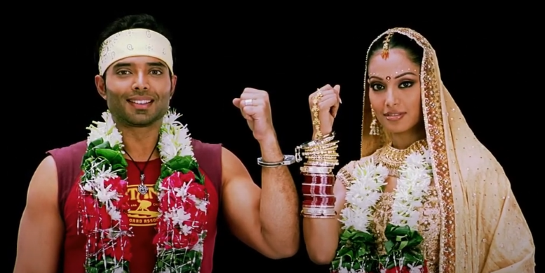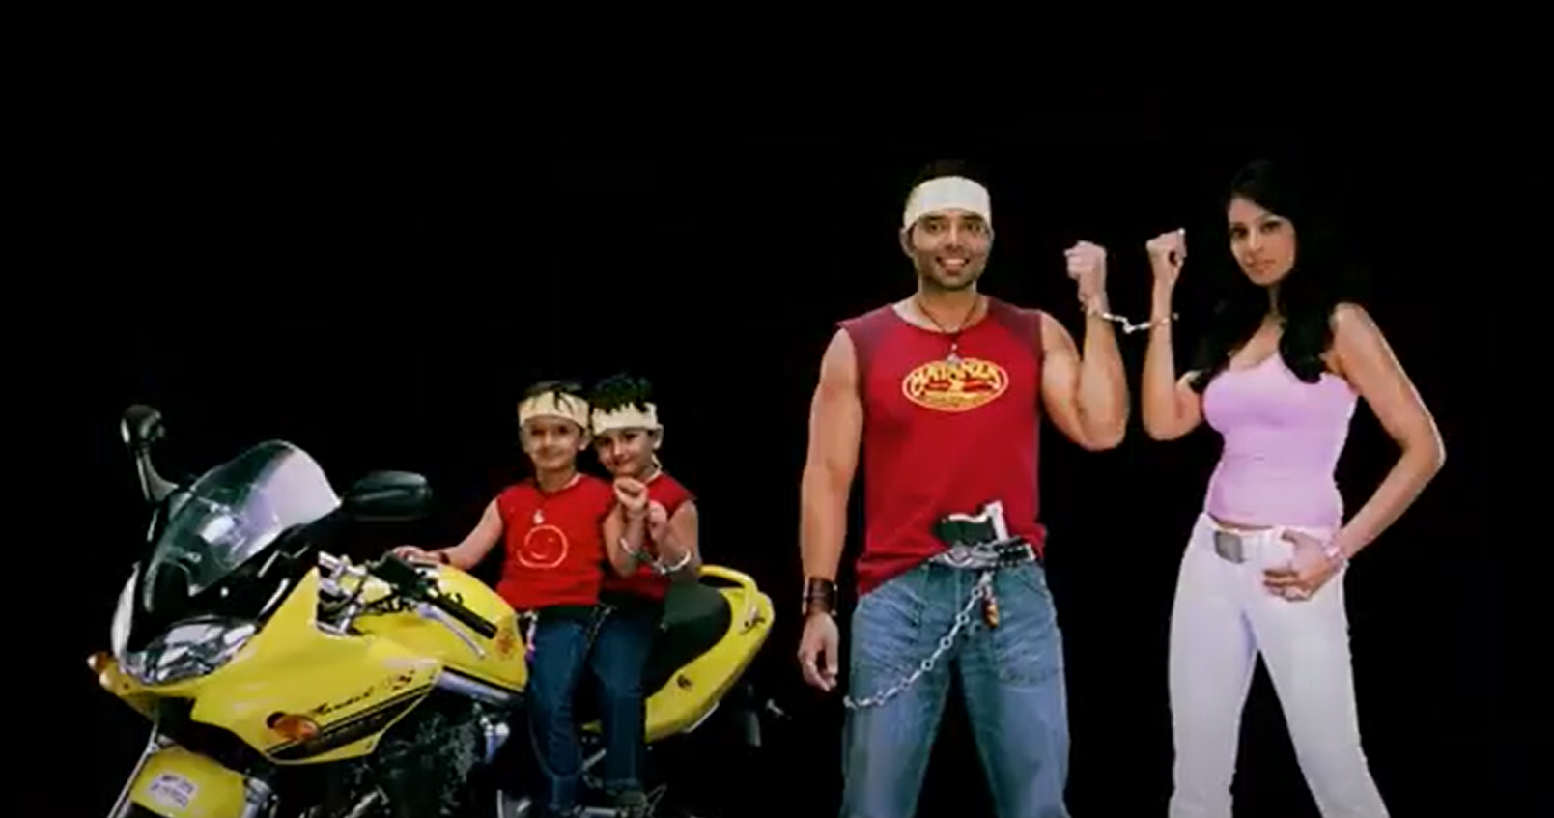

**Visual:** We see a Dulha and Dulhan but instead of their faces we place croissant and Kalki’s faces. Mini baby croissants with face of Kalki are sitting on the bike. The frame then shatters like broken glass. Then the end slate appears.

**End-slate Copy:**

We were meant to be…

in a parallel universe🥹

**Britannia Triple Choco Croissant | Influencer Idea**

**Influencer Idea | Rebel Kid:**

Kya mere paas patience milega? Nahi

Kya mere paas khushi milegi? Nahi

Kya mere paas kalesh milega? Bilkul milega.

Meri zindagi na Ekta kapoor X big boss ka collab ho rakhi hai.

Ek normal insaan subah kya chahta hai, shaanti se ek haath main coffee ho aur mobile scroll karna. Main bhi wahi kar rahi thi aur suddenly mujhe apne ex ki hathon main haath wali picture dikh jaati hai- ab waise toh mujhe stalker syndrome nahi hai, par pata nahi aisi situations mein, kese meri ungliyon ko mein nahi rok paati and I just zoomed in, aur bas- like hogayi. Huh, that isn’t the worst part- yeh dekhke meri aatma mere shareer se bahar aa gayi aur coffee meri fresh white bedsheet pe raite ki tarah fail gayi. And if this wasn’t it, my maid texted me ki “didi aaj main chutti pe hu”

Ab iss raita ko sametna mere scope main nahi tha.

Tabhi maine socha behen zindagi main twists and turns toh bohot aayenge aur

Jab situation 3x kharab ho, toh it's just better to twist the triple treat!

<her shot of eating croissant>

Zindagi ka toh pata nahi but mood sort karna ho toh triple choco kha lo!

Rebel kid- product first then rant “But I won’t rant”

Transition-mentos like

Overarching thought buildup

Instances-2,3

Rebel kid asset