Identify and Remove Suspicious Browser Extensions

# Objective:

To identify and remove any suspicious or unnecessary browser extensions to enhance browser security.

# Tools Used:

* Web Browser: Google Chrome
* OS: Windows 11

# Steps Followed:

* Accessed Extensions Page:  
  Visited chrome://extensions to view all installed extensions.
* Reviewed Installed Extensions:  
  Only two extensions were installed:
* Google Docs Offline (Version: 1.92.1)
* McAfee WebAdvisor (Version: 8.1.0.6519)

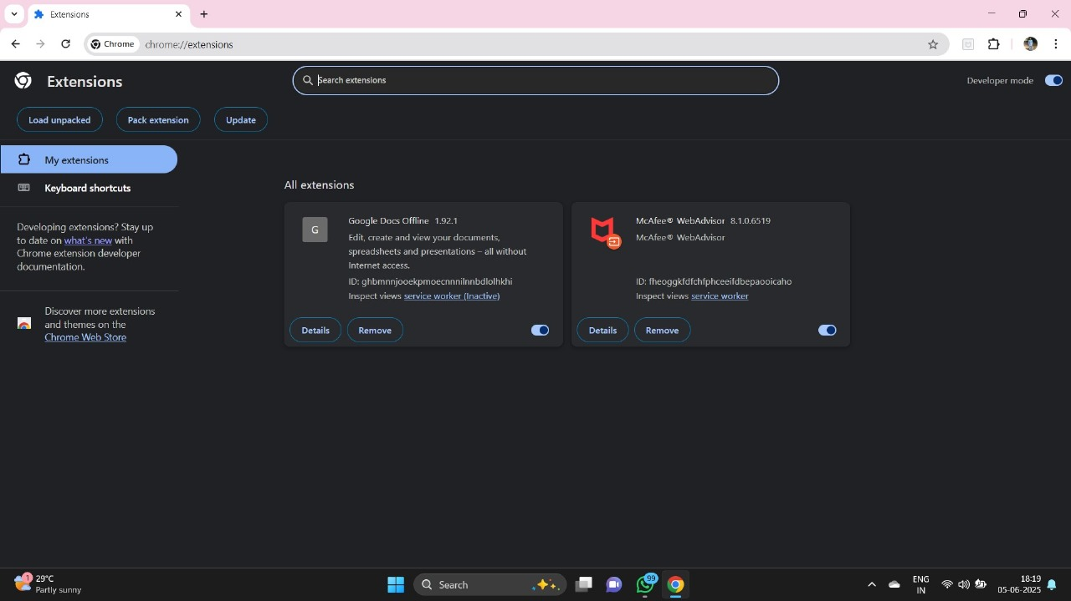

* Checked Permissions and Details:  
  • Google Docs Offline  
   - Source: Installed by default  
   - Permission: Access to Google Docs and Drive domains  
   - Status: Safe and useful for offline work

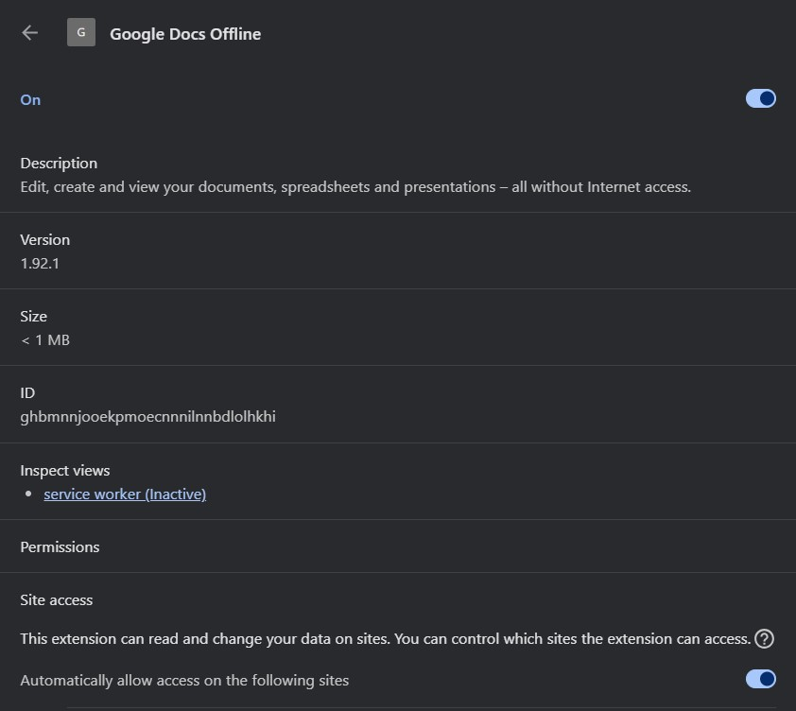

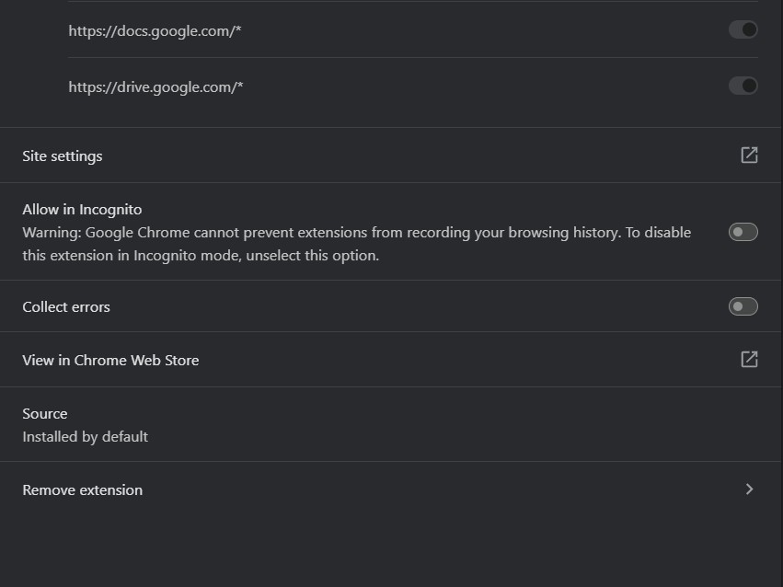

• McAfee WebAdvisor  
 - Purpose: Protects against malicious websites  
 - Status: No suspicious permissions, but considered optional depending on antivirus setup.

* Security Assessment:  
  Neither extension was found to be malicious.  
  - Google Docs Offline is safe and required.  
  - McAfee WebAdvisor is generally safe but can be removed if system antivirus already covers web protection.
* Actions Taken:  
  - No suspicious extensions were found.  
  - No extensions were removed, but usage was reassessed.
* Permissions Insight:  
  Verified that no extensions had overreaching permissions like:  
  - Read and change all your data on all websites  
  - Manage downloads  
  - Capture clipboard content