Working and Understanding VPN

# Objective

Gain hands-on experience using a VPN and understand how it enhances online privacy and security.

## Tools Used

* VPN Client: ProtonVPN (Free Tier)
* VPN Protocol: WireGuard (UDP)
* Browser: Google Chrome
* Testing Sites:  
   1) https://whatismyipaddress.com  
   2) https://wikipedia.org

# Steps Followed

1. Registered for a free ProtonVPN account.
2. Downloaded and installed the ProtonVPN client.
3. Connected to the fastest available free server:

* Server: Netherlands (NL-FREE#12)
* VPN IP: 138.199.7.160
* Protocol: WireGuard (UDP)
* Status: Connected and Protected

1. Verified IP Address change using whatismyipaddress.com:

* New location: Amsterdam, Netherlands

1. Tested encrypted connection by visiting Wikipedia:

* Verified secure connection (https with padlock icon)

# Screenshots

1. VPN Connection Active (ProtonVPN):

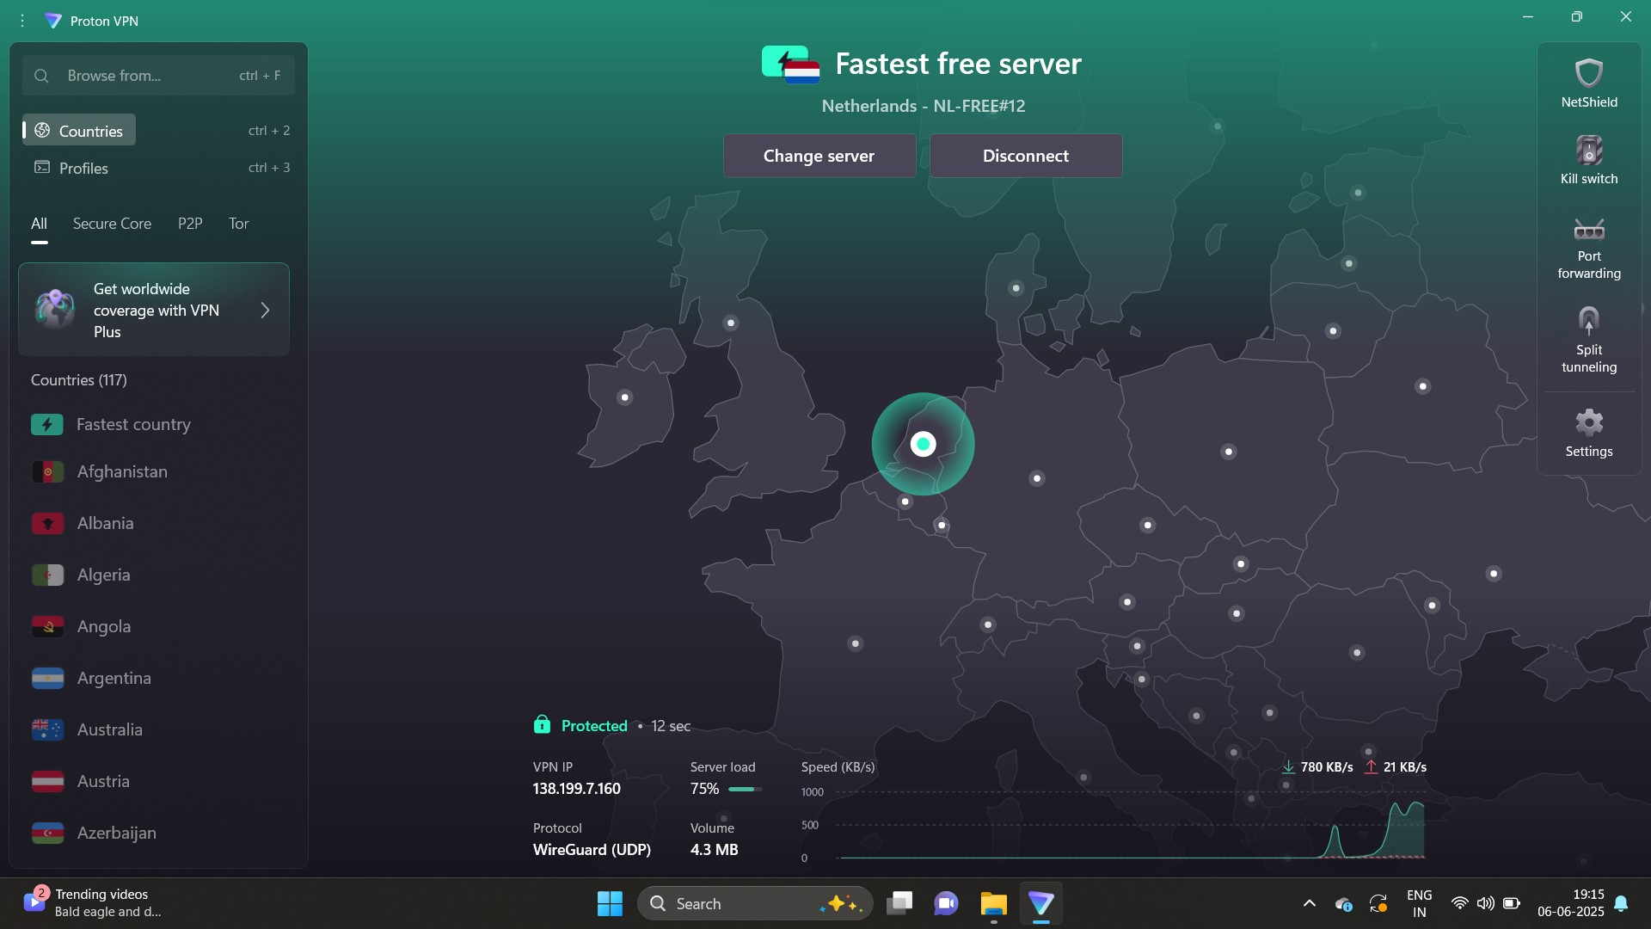

2. Secure Site (Wikipedia with VPN):

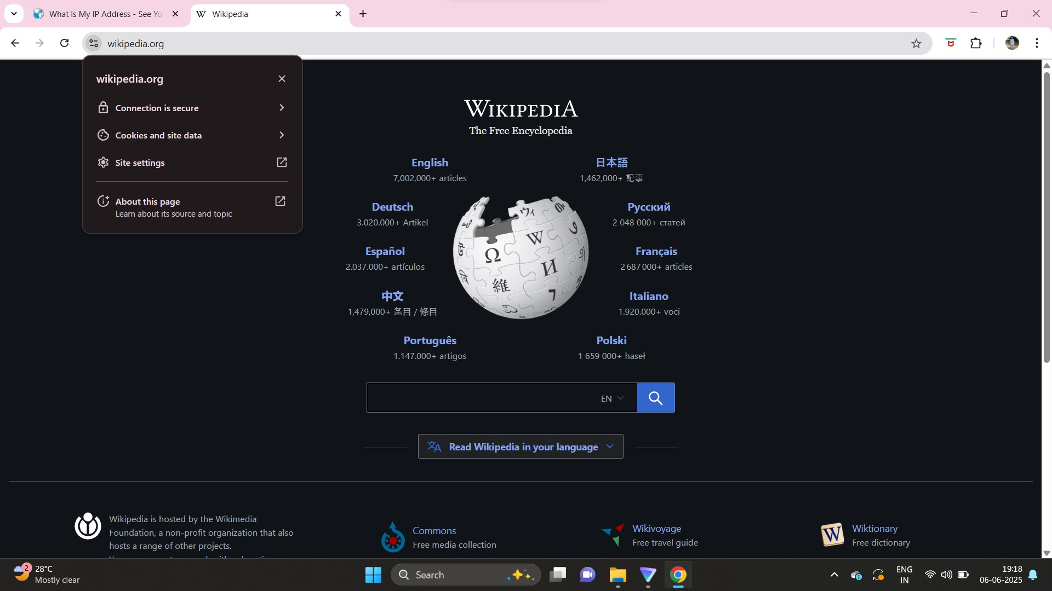

3. IP Verified as Netherlands Location:

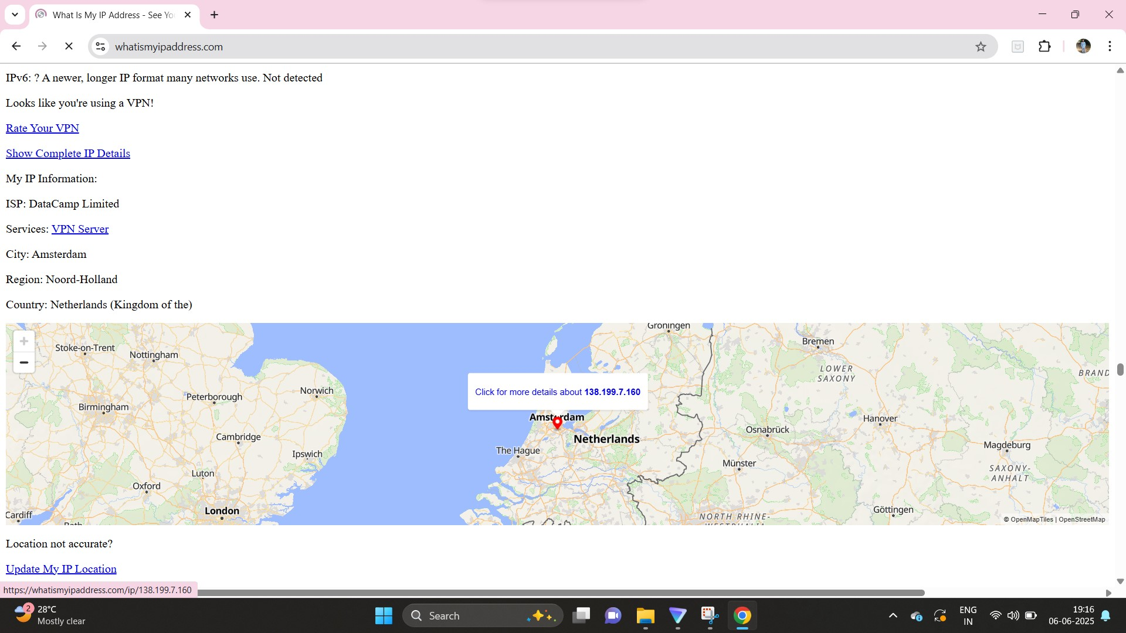

# Benefits of Using a VPN

* Encrypts internet traffic, ensuring privacy and security.
* Hides your real IP address, enhancing anonymity.
* Bypasses geo-restrictions and content filters.
* Protects against data tracking and surveillance on public Wi-Fi.

# Limitations of VPN

* Does not guarantee complete anonymity (VPN provider still knows your real IP).
* Can reduce internet speed depending on server load and distance.
* Some websites block VPN traffic.
* Free VPNs may have limitations on bandwidth, server choice, or privacy policies.