SOFTWARE REQUIREMENTS SPECIFICATION

Sahyog
Mutual Insurance Platform

Version 1.0 | March 2025
Capstone Project | The Hartford

Table of Contents
Table of Contents 2
1. Introduction 4
1.1 Purpose 4
1.2 Project Overview 4
1.3 Scope 4
1.4 Definitions and Abbreviations 4
1.5 Document Conventions 5
1.6 References 5
2. Overall Description 6
2.1 Product Perspective 6
2.2 Product Functions (Summary) 6
2.3 User Classes and Characteristics 6
2.4 Operating Environment 7
2.5 Design and Implementation Constraints 7
2.6 Assumptions and Dependencies 7
3. System Architecture 9
3.1 Architectural Overview 9
3.2 Interaction Flow: Claim Submission (Example) 9
3.3 Security Architecture 9
3.4 Component Architecture 10
4. Functional Requirements 11
4.1 Authentication & User Management 11
4.2 Region & Policy Management 11
4.3 Contribution Management 11
4.4 Disaster Event Management 12
4.5 Claim Submission & Eligibility 12
4.6 Claim Review & Officer Workflow 13
4.7 Payout Authorization & Fund Management 13
4.8 Government Audit & Reporting 13
5. Business Rules & Processing Logic 15
5.1 Contribution Calculation Engine 15
5.2 Claim Eligibility Validation 15
5.3 Claim Assignment Algorithm 15
5.4 Payout Calculation & Reserve Protection 15
5.5 Member Lifecycle States 16
6. Claim Processing Lifecycle 17
6.1 Claim Workflow Diagram 17
6.2 Claim Sequence Diagram 19
7. Non-Functional Requirements 20
7.1 Security 20
7.2 Performance 20
7.3 Reliability & Availability 20
7.4 Maintainability & Scalability 20
7.5 Usability 21
8. Database Design 22
8.1 Entity Overview 22
8.2 Key Entity Relationships 23
8.3 Entity-Relationship Diagram 23
8.4 Class Diagram 24
9. External Interface Requirements: API 26
9.1 Standard Response Envelope 26
9.2 Endpoint Summary 26
9.3 Error Codes 27
10. UML Diagrams 28
10.1 Use Case Diagram 28
11. Technical Challenges & Solutions 29
12. Future Enhancements 30
13. Conclusion 31

1. Introduction

1.1 Purpose
This Software Requirements Specification (SRS) document defines the complete functional and non-functional requirements for Sahyog, an automated mutual insurance pooling platform. It serves as the authoritative reference for developers, testers, architects, and academic evaluators throughout the project lifecycle. The document captures the system's intended behavior, constraints, user roles, business logic, data design, and interface specifications to ensure all parties share a single, unambiguous understanding of what the system must do and how it must perform.

1.2 Project Overview
Sahyog (meaning 'cooperation' in Hindi) is a full-stack, enterprise-grade digital platform designed to automate community-driven mutual insurance through regional pooling. Traditional community-level disaster relief relies on manual coordination, informal record-keeping, and delayed fund disbursement — resulting in mistrust and inefficiency.
Sahyog replaces this with a centralized, role-driven digital infrastructure covering member onboarding, regional enrollment, monthly contribution management, disaster event declaration, multi-stage claim processing, and pool fund payout authorization — all delivered through a secure RESTful API consumed by a modern Angular frontend.

1.3 Scope
The system covers the following functional domains:
- Member registration, authentication, and role-based access control
- Regional enrollment and pool management
- Monthly contribution processing with risk-adjusted multipliers
- Disaster event declaration and lifecycle management
- Multi-stage claim submission, officer review, and payout authorization
- Pool fund solvency and reserve protection enforcement
- Government view-only auditing of regional dashboards
Out of scope for version 1.0: real payment gateway integration, AI/ML-based risk assessment, push and email notification services, and mobile native applications.

1.4 Definitions and Abbreviations
Term / Abbreviation | Definition
SRS | Software Requirements Specification
JWT | JSON Web Token — stateless authentication mechanism
RBAC | Role-Based Access Control
ORM | Object-Relational Mapper (Spring Data JPA / Hibernate)
DTO | Data Transfer Object
SPA | Single Page Application
FR | Functional Requirement
NFR | Non-Functional Requirement
API | Application Programming Interface
BCrypt | Password hashing algorithm used for credential storage
H2 | In-memory database used during development
PoolFund | The shared financial pool for a region used to settle claims
riskLevel | Enum value (LOW / MEDIUM / HIGH) assigned to each region
waitingPeriodDays | Minimum days a member must be enrolled before filing a claim
reservePercentage | Minimum fraction of PoolFund balance that must remain after payout

1.5 Document Conventions
- Requirements are labeled FR-XX (functional) and NFR-XX (non-functional)
- All monetary values are expressed in Indian Rupees (INR) unless stated otherwise
- "User" refers to any authenticated entity; role-specific terms (Member, Claim Officer, Admin, Government) are used where precision is needed
- "System" refers to the complete Sahyog application including Angular frontend, Spring Boot backend, and MySQL/H2 database

1.6 References
- IEEE Std 830-1998: IEEE Recommended Practice for Software Requirements Specifications
- Spring Boot 3.4.3 Official Documentation
- Angular 21 Official Documentation by Google
- Spring Security 6.x with JWT Reference Documentation
- Springdoc OpenAPI Documentation

2. Overall Description

2.1 Product Perspective
Sahyog is a standalone, full-stack web application built on a decoupled client-server architecture. The Angular frontend communicates exclusively with the Spring Boot backend via REST APIs secured with JWT tokens. The system integrates no external services in version 1.0. All contribution processing, claim adjudication, and fund management logic is self-contained within the backend service layer.
The system is designed to be deployable on-premise or in cloud environments with minimal configuration changes. H2 is used during development for rapid iteration; MySQL is the target production database. Spring Data JPA abstracts all database interactions via the repository pattern.

2.2 Product Functions (Summary)
# | Function | Primary Actor(s)
1 | Member registration, login, and secure authentication | All roles
2 | Regional enrollment and policy configuration | Admin
3 | Monthly contribution payment with risk multipliers | Member
4 | Disaster event declaration and lifecycle tracking | Admin
5 | Claim submission with eligibility validation | Member
6 | Automatic claim assignment to least-busy officer | System
7 | Claim review, document verification, and decision | Claim Officer
8 | Final payout authorization with solvency check | Admin
9 | Regional dashboard and fund health monitoring | Admin, Government
10 | Pool fund balance and reserve management | System

2.3 User Classes and Characteristics
Role | Description | Technical Expertise
Member | Primary end-user. Registers via region enrollment, pays monthly contributions, views active disasters, and submits claims with proof documents. | Low — consumer-friendly UI required
Claim Officer | Reviews claims assigned to them by the system. Transitions status to UNDER_REVIEW, evaluates documents, and approves or rejects with verification notes. | Medium — domain knowledge required
Administrator | Super-user. Sets up regions, policies, and pool funds. Declares disaster events. Oversees the full claim queue and authorizes final payouts. | High — system and financial authority
Government | View-only stakeholder. Accesses regional dashboards and fund health reports for transparency and regulatory auditing. | Medium — read-only consumer

2.4 Operating Environment
Component | Technology / Environment
Backend Framework | Spring Boot 3.4.3 (Java 17)
Build Tool | Apache Maven
Frontend Framework | Angular 21 (TypeScript), Single Page Application
State Management | RxJS and Angular Signals
Database (Development) | H2 In-Memory Database
Database (Production) | MySQL (via mysql-connector-j)
ORM | Spring Data JPA / Hibernate
Authentication | Spring Security 6.x with JWT (Stateless)
Password Hashing | BCryptPasswordEncoder
API Documentation | Springdoc OpenAPI (Swagger UI at /swagger-ui/index.html)
Browsers Supported | Chrome 110+, Firefox 110+, Edge 110+, Safari 16+
Deployment | On-premise or cloud-ready (environment-variable configuration)

2.5 Design and Implementation Constraints
- All API endpoints except /api/auth/login and whitelisted registration endpoints must require a valid JWT Bearer token
- Passwords must be hashed using BCrypt before storage; plain-text credential storage is strictly prohibited
- Claim payout amounts must never cause the pool fund balance to fall below the configured reservePercentage threshold
- The system must enforce claim lifecycle state-machine transitions; invalid status changes are blocked at the service layer
- All monetary calculations must use BigDecimal types in Java to prevent floating-point precision errors
- CORS is configured to permit requests from http://localhost:4200 during development

2.6 Assumptions and Dependencies
- MySQL is available and accessible by the backend service in production environments
- H2 console access is available at /h2-console for development and testing purposes
- All users have access to a modern web browser with JavaScript enabled
- The system runs over HTTPS in production; JWT tokens must not be transmitted over plain HTTP
- A seeded administrator account (admin@sahyog.com / Admin@123) is available immediately after first boot via the DataLoader

3. System Architecture

3.1 Architectural Overview
Sahyog is built on a decoupled, multi-tiered RESTful architecture. Each layer has a single, well-defined responsibility, promoting separation of concerns, testability, and maintainability.
Layer | Technology | Responsibility
Presentation | Angular SPA (TypeScript) | Renders role-specific dashboards, handles input validation, consumes REST APIs asynchronously via RxJS
API / Routing | Spring Boot REST Controllers | Routes HTTP requests, validates JWT, enforces RBAC, parses and validates DTOs
Business Logic | Spring Service Layer (Java) | Enforces domain rules: contribution multipliers, eligibility checks, reserve protection, officer assignment
Data Access | Spring Data JPA Repositories | Abstracts SQL, manages CRUD operations, handles entity relationships and lazy/eager loading
Storage | H2 (Dev) / MySQL (Prod) | Persists all structured data including members, regions, contributions, claims, and pool funds

3.2 Interaction Flow: Claim Submission (Example)
- Member submits claim via Angular UI with disasterId and requestedAmount
- Angular → POST /api/claims + JWT in Authorization header
- Spring Security validates JWT signature and role (ROLE_MEMBER required)
- ClaimController passes DTO to ClaimService
- ClaimService: validateEligibility() — checks region match, waiting period, and current month's contribution
- ClaimService: findLeastWorkloadOfficer() — assigns claim to officer with fewest active claims in region
- ClaimRepository saves claim with status = SUBMITTED
- Controller returns ClaimResponse DTO with 201 Created

3.3 Security Architecture
- JWT tokens are signed using HMAC-SHA256 with a server-side secret key and contain subject (username/email) and role claims
- Token duration is fixed at 1 hour
- All backend controllers apply role-based access rules via Spring Security filter chain configuration
- The Angular frontend decodes the JWT payload to render role-appropriate navigation, but backend enforcement is the true security boundary
- BCryptPasswordEncoder is used for all user password hashing before storage

3.4 Component Architecture
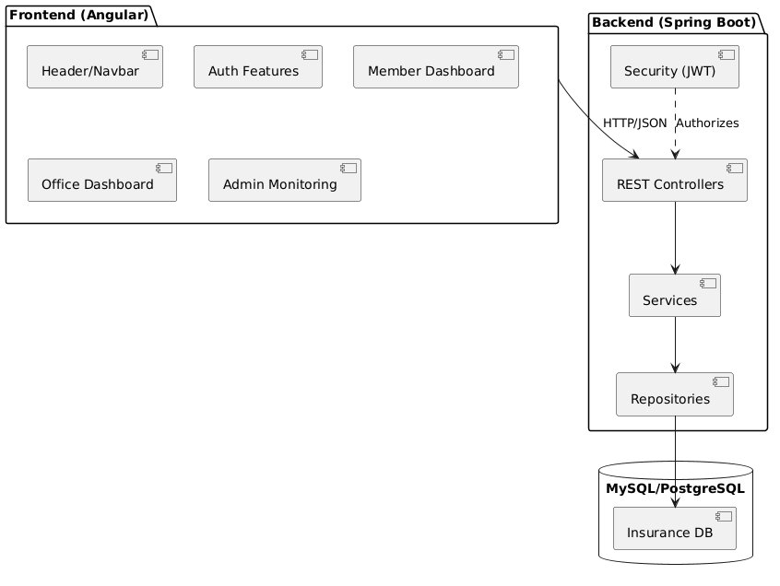
Figure 1: Component Diagram — Frontend and Backend Architecture

4. Functional Requirements

4.1 Authentication & User Management
ID | Requirement | Actor | Priority
FR-01 | The system shall allow new members to register via a region enrollment endpoint (/api/members/region/{regionId}) providing fullName, email, password, and acceptedTerms. | Member | High
FR-02 | The system shall validate that the email address is unique across all member accounts. | System | High
FR-03 | The system shall hash all passwords using BCryptPasswordEncoder before storing them in the database. | System | High
FR-04 | The system shall authenticate users via email and password and return a signed JWT containing subject (email) and role claim. | All roles | High
FR-05 | The Admin shall be able to register Claim Officers via the protected endpoint /api/auth/register/claim-officer (ROLE_ADMIN required). | Admin | High
FR-06 | The system shall allow authenticated users to retrieve their own profile information. | All roles | Medium

4.2 Region & Policy Management
ID | Requirement | Actor | Priority
FR-07 | The Admin shall be able to create and manage regions with fields: name, state, country, riskLevel (LOW/MEDIUM/HIGH), and status (ACTIVE). | Admin | High
FR-08 | The system shall expose an unauthenticated endpoint (/api/regions) returning all active regions for display on the landing page during member enrollment. | Public | High
FR-09 | The Admin shall be able to configure a Policy per region with: monthlyContribution (base), waitingPeriodDays, maxPayoutPerClaim, annualPayoutCap, and minContributionsRequired. | Admin | High
FR-10 | The Admin shall be able to configure a PoolFund per region with: totalBalance, reservePercentage, and adminFeePercentage. | Admin | High

4.3 Contribution Management
ID | Requirement | Actor | Priority
FR-11 | Authenticated members shall be able to pay their monthly contribution via POST /api/contributions (ROLE_MEMBER required). | Member | High
FR-12 | The system shall apply a risk multiplier to the base Policy monthlyContribution: 1.25x for MEDIUM risk regions and 1.50x for HIGH risk regions. | System | High
FR-13 | The system shall deduct the configured adminFeePercentage from each contribution before crediting the PoolFund totalBalance. | System | High
FR-14 | The system shall only accept contributions for the current calendar month; the contribution date is normalized to the 1st day of the month. | System | High
FR-15 | The system shall prevent duplicate contributions for the same member and the same calendar month. | System | High

4.4 Disaster Event Management
ID | Requirement | Actor | Priority
FR-16 | The Admin shall be able to declare a DisasterEvent with fields: name, disasterType, severityLevel, startDate, endDate, status (ACTIVE/CLOSED), and the associated region. | Admin | High
FR-17 | Members shall be able to view active disaster events declared in their enrolled region. | Member | High
FR-18 | The Admin shall be able to close a disaster event by setting its status to CLOSED. | Admin | Medium

4.5 Claim Submission & Eligibility
ID | Requirement | Actor | Priority
FR-19 | Authenticated members shall be able to submit a claim via POST /api/claims providing: disasterId, requestedAmount, description, and documentUrl (proof upload). | Member | High
FR-20 | The system shall reject claim submission if the disaster event's region does not match the member's enrolled region. | System | High
FR-21 | The system shall reject claim submission if the member has not paid the current month's contribution. | System | High
FR-22 | The system shall reject claim submission if the number of days between the member's joinDate and the current date does not exceed Policy.waitingPeriodDays (calculated via ChronoUnit.DAYS). | System | High
FR-23 | The system shall automatically assign the submitted claim to the Claim Officer with the lowest count of active claims within the same region (least-workload assignment). | System | High

4.6 Claim Review & Officer Workflow
ID | Requirement | Actor | Priority
FR-24 | The Claim Officer shall be able to view all claims assigned to them. | Claim Officer | High
FR-25 | The Claim Officer shall be able to transition a claim from SUBMITTED to UNDER_REVIEW status. | Claim Officer | High
FR-26 | The Claim Officer shall be able to approve a claim (transition to APPROVED) by providing verificationNotes. | Claim Officer | High
FR-27 | The Claim Officer shall be able to reject a claim (transition to REJECTED) with verificationNotes. | Claim Officer | High
FR-28 | The system shall record the ClaimOfficer's decision and notes in a ClaimVerification record. | System | High

4.7 Payout Authorization & Fund Management
ID | Requirement | Actor | Priority
FR-29 | The Admin shall be able to authorize and release payout for APPROVED claims via the claim payment endpoint. | Admin | High
FR-30 | The system shall enforce that the payout amount equals min(claim.requestedAmount, policy.maxPayoutPerClaim). | System | High
FR-31 | The system shall perform a solvency check before releasing payout: (poolFund.totalBalance - payoutAmount) >= (poolFund.totalBalance * poolFund.reservePercentage). The payout is blocked if this check fails. | System | High
FR-32 | Upon successful payout, the system shall deduct the approved amount from the PoolFund.totalBalance and transition the claim status to PAID. | System | High
FR-33 | The system shall prevent any payout that would cause the PoolFund balance to breach the configured reserve threshold. | System | High

4.8 Government Audit & Reporting
ID | Requirement | Actor | Priority
FR-34 | The Government role shall be able to view regional dashboard data including fund health metrics. | Government | Medium
FR-35 | The Admin shall be able to access an overview of all claims across all regions. | Admin | Medium

5. Business Rules & Processing Logic

5.1 Contribution Calculation Engine
The effective monthly contribution for a member is derived from the base Policy.monthlyContribution adjusted by the region's risk level:
Region Risk Level | Multiplier | Effective Contribution
LOW | 1.00x | Base contribution (no adjustment)
MEDIUM | 1.25x | 25% surcharge applied to base contribution
HIGH | 1.50x | 50% surcharge applied to base contribution
An adminFeePercentage is deducted from each contribution before the net amount is credited to the PoolFund totalBalance. Only the current calendar month is payable; all contribution dates are normalized to the 1st of the respective month.

5.2 Claim Eligibility Validation
Before a claim is persisted, ClaimService.validateEligibility() enforces the following rules sequentially:
Rule | Check | Rejection Reason if Failed
Region Match | member.region.id == disasterEvent.region.id | Member is not enrolled in the disaster's region
Contribution Compliance | Contribution exists for current month (YYYY-MM-01) | Member has not paid the current month's contribution
Waiting Period | ChronoUnit.DAYS.between(member.joinDate, LocalDate.now()) > policy.waitingPeriodDays | Member has not completed the mandatory waiting period

5.3 Claim Assignment Algorithm
Upon successful eligibility validation, the system automatically assigns the claim to the Claim Officer with the lowest count of currently active (non-terminal) claims within the same region. This is implemented via ClaimRepository.findLeastWorkloadOfficer(regionId), which counts open claims per officer and selects the minimum.

5.4 Payout Calculation & Reserve Protection
At payout authorization, the system executes the following logic:
- Approved Amount = min(claim.requestedAmount, policy.maxPayoutPerClaim)
- Solvency Check: (poolFund.totalBalance - approvedAmount) >= (poolFund.totalBalance * poolFund.reservePercentage)
- If the solvency check fails, the payout is BLOCKED and an error is returned to the Admin
- If the solvency check passes, the PoolFund.totalBalance is reduced by the approved amount and the claim status is updated to PAID

5.5 Member Lifecycle States
State | Trigger | Description
PENDING | Member registration completed | Account created, awaiting admin activation or automatic activation
ACTIVE | Waiting period passed and contributions current | Member can submit claims against active disaster events
SUSPENDED | Missed contributions or admin action | Member cannot submit claims; contribution required to reactivate

6. Claim Processing Lifecycle
Claims follow a strict state machine. No transition can be skipped or reversed. The system enforces valid transitions at the service layer; invalid status changes return an HTTP 422 Unprocessable Entity response.

Current Status | Trigger / Action | Next Status | Actor
— | Member submits claim after disaster declaration | SUBMITTED | Member
SUBMITTED | Claim Officer picks up claim for review | UNDER_REVIEW | Claim Officer
UNDER_REVIEW | Officer reviews and documents are valid | APPROVED | Claim Officer
UNDER_REVIEW | Officer finds insufficient or fraudulent proof | REJECTED | Claim Officer
APPROVED | Admin verifies solvency and releases payout | PAID | Admin
REJECTED / PAID | Terminal state — no further transitions permitted | — | —

6.1 Claim Workflow Diagram
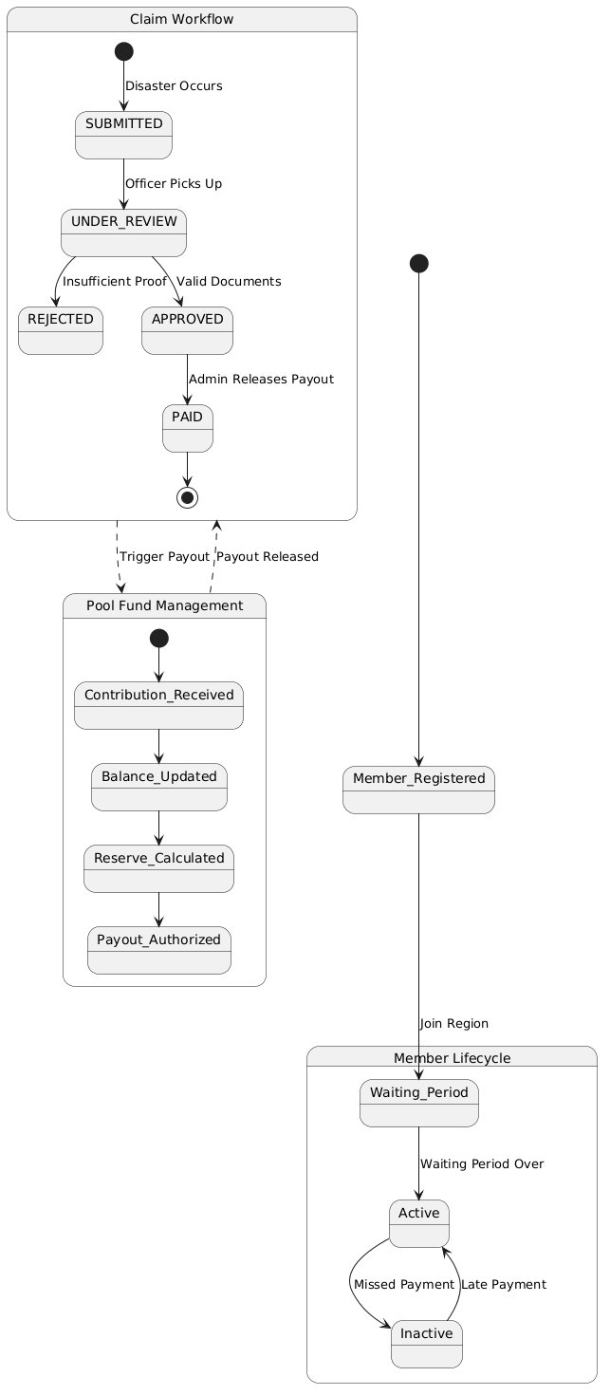
Figure 2: Claim Workflow and Activity Diagram

6.2 Claim Sequence Diagram
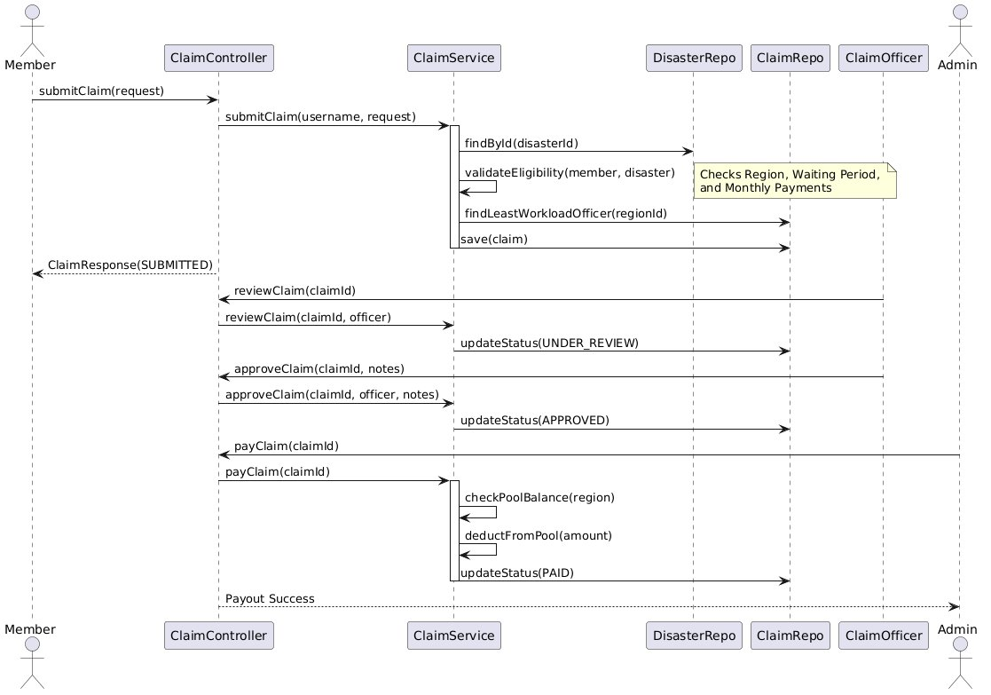
Figure 3: Claim Submission and Processing Sequence Diagram

7. Non-Functional Requirements

7.1 Security
ID | Requirement
NFR-01 | All API endpoints except /api/auth/login, /api/regions (GET), and /api/members/region/** must require a valid JWT Bearer token.
NFR-02 | JWT tokens must be signed with HMAC-SHA256 and must include an expiry claim (1-hour duration).
NFR-03 | Passwords must never be stored in plain text. BCryptPasswordEncoder is the mandatory hashing mechanism.
NFR-04 | Role-based access must be enforced at the Spring Security filter chain level, not solely on the Angular frontend.
NFR-05 | The CORS configuration must restrict API access to the permitted Angular origin (http://localhost:4200 in development).

7.2 Performance
ID | Requirement
NFR-06 | API response time for standard CRUD endpoints must be under 500ms under normal load.
NFR-07 | The contribution eligibility check and assignment algorithm must complete within 300ms.
NFR-08 | The system must support at least 100 concurrent users without degradation.

7.3 Reliability & Availability
ID | Requirement
NFR-09 | The system must target 99.5% uptime during operational hours.
NFR-10 | Database transactions must be ACID-compliant. Partial writes on failure must be rolled back via Spring's @Transactional.
NFR-11 | The system must handle malformed or expired JWT tokens gracefully, always returning HTTP 401, never HTTP 500.

7.4 Maintainability & Scalability
ID | Requirement
NFR-12 | The backend must follow layered clean architecture: Controllers, Services, and Repositories must be clearly separated into distinct packages.
NFR-13 | The database schema must be managed via Spring Boot / Hibernate DDL auto. Manual DDL scripts are not permitted.
NFR-14 | The architecture must support horizontal scaling via a fully stateless API design (JWT with no server-side sessions).
NFR-15 | No secrets (JWT secret key, database credentials) may be hardcoded in source-controlled files.

7.5 Usability
ID | Requirement
NFR-16 | The Angular frontend must render role-appropriate navigation and features based on the decoded JWT role claim.
NFR-17 | All forms must provide real-time validation feedback before submission.
NFR-18 | The UI must be responsive across desktop and tablet screen sizes.
NFR-19 | The Swagger UI must be available at /swagger-ui/index.html in the development environment for API testing.

8. Database Design
The relational database is designed to Third Normal Form (3NF) to ensure data integrity, eliminate redundancy, and support accurate historical tracking of contributions, claims, and fund balances.

8.1 Entity Overview
Entity | Primary Key | Key Foreign Keys | Description
AppUser | id (Long) | — | System authentication record. Stores email, hashed password, and role (MEMBER, ADMIN, CLAIM_OFFICER, GOVERNMENT).
Region | id (Long) | — | Geographical region with riskLevel, status, and linked Policy and PoolFund.
Policy | id (Long) | region_id → Region | Insurance rules per region: base contribution, waiting period, max payout, annual cap.
PoolFund | id (Long) | region_id → Region | Shared fund per region. Tracks totalBalance, reservePercentage, and adminFeePercentage.
Member | id (Long) | region_id → Region, user_id → AppUser | Regional member. Tracks joinDate, totalContribution, status (PENDING/ACTIVE/SUSPENDED), and acceptedTerms.
Contribution | id (Long) | member_id → Member | Monthly contribution record. Stores amount and contributionMonth (normalized to YYYY-MM-01).
DisasterEvent | id (Long) | region_id → Region | Declared disaster. Stores disasterType, severityLevel, start/end dates, and status (ACTIVE/CLOSED).
Claim | id (Long) | member_id → Member, disaster_id → DisasterEvent, officer_id → ClaimOfficer | Insurance claim. Tracks requestedAmount, approvedAmount, status, documentUrl, and description.
ClaimOfficer | id (Long) | region_id → Region | Officer entity with fullName, email, status, and workload tracking via claim count.
ClaimVerification | id (Long) | claim_id → Claim, officer_id → ClaimOfficer | Audit record of officer decision: decision (APPROVE/REJECT) and verificationNotes.

8.2 Key Entity Relationships
- One Region → One Policy, One PoolFund (1:1 per region)
- One Region → Many Members (1:N)
- One Region → Many DisasterEvents (1:N)
- One Member → Many Contributions (1:N)
- One DisasterEvent → Many Claims (1:N)
- One Claim → One ClaimVerification (1:1)
- One ClaimOfficer → Many Claims (1:N via assignment)

8.3 Entity-Relationship Diagram
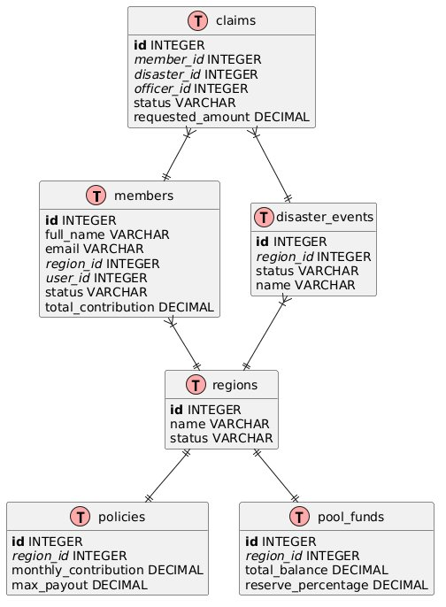
Figure 4: Entity-Relationship Diagram of the Database Schema

8.4 Class Diagram
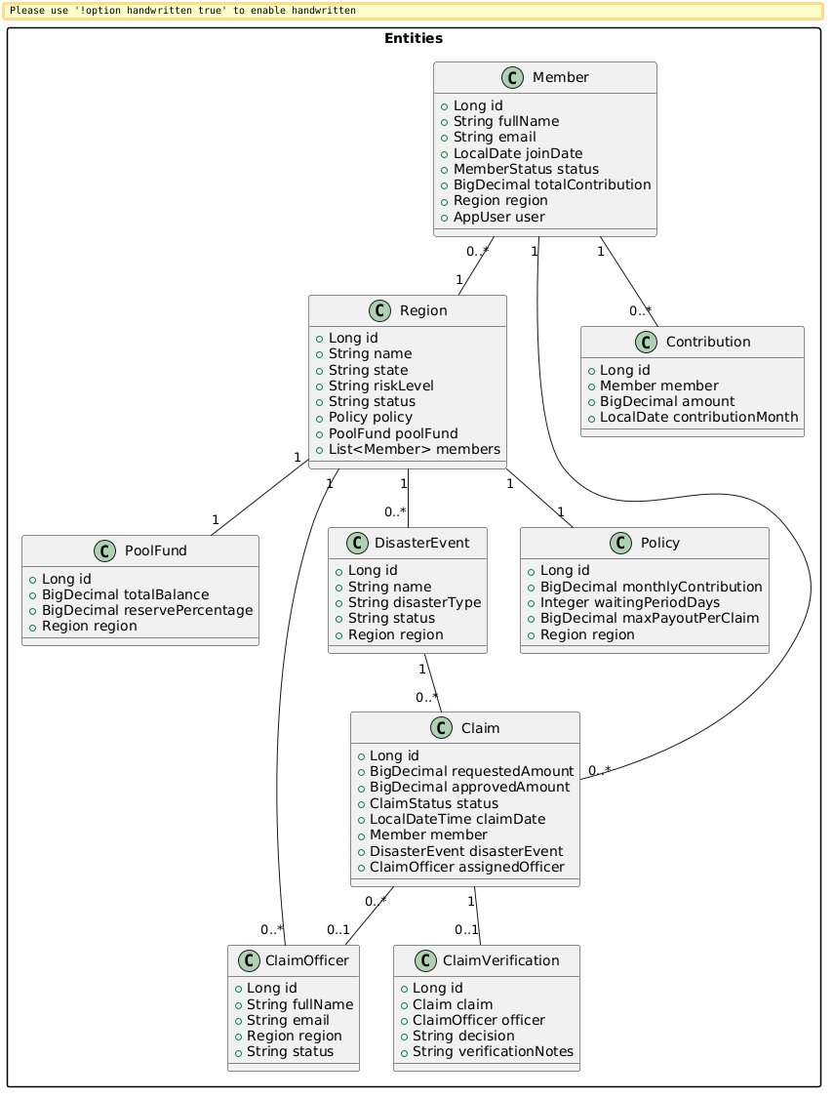
Figure 5: Domain Class Diagram

9. External Interface Requirements: API
All endpoints communicate over HTTPS using JSON (application/json). Every protected endpoint requires a valid Bearer token: Authorization: Bearer <jwt_token>

9.1 Standard Response Envelope
All API responses follow a consistent envelope structure:
{ "success": true, "message": "Optional description", "data": { ... } }

9.2 Endpoint Summary
Method | Endpoint | Access | Description
POST | /api/auth/login | Public | Authenticate user, receive signed JWT
POST | /api/members/region/{id} | Public | Register new member in a region
POST | /api/auth/register/claim-officer | ADMIN | Register a new Claim Officer account
GET | /api/regions | Public | List all active regions (landing page)
GET | /api/auth/profile | Authenticated | Retrieve own profile
POST | /api/contributions | MEMBER | Pay current month's contribution
GET | /api/contributions | MEMBER | View own contribution history
POST | /api/claims | MEMBER | Submit a new claim against a disaster
GET | /api/claims/my | MEMBER | View own claims
GET | /api/claims/assigned | CLAIM_OFFICER | View claims assigned to officer
PUT | /api/claims/{id}/review | CLAIM_OFFICER | Transition claim to UNDER_REVIEW
PUT | /api/claims/{id}/approve | CLAIM_OFFICER | Approve claim with verification notes
PUT | /api/claims/{id}/reject | CLAIM_OFFICER | Reject claim with verification notes
POST | /api/claims/{id}/pay | ADMIN | Authorize and release payout
GET | /api/admin/regions | ADMIN | Manage regions
POST | /api/admin/regions | ADMIN | Create new region
POST | /api/admin/disaster-events | ADMIN | Declare a new disaster event
GET | /api/admin/claims | ADMIN | View all claims across regions
GET | /api/government/dashboard | GOVERNMENT | View regional fund health dashboard

9.3 Error Codes
HTTP Code | Meaning | Common Cause
400 | Bad Request | Missing required fields, invalid input, or business rule violation
401 | Unauthorized | Missing or expired JWT token
403 | Forbidden | Valid token but insufficient role for the endpoint
404 | Not Found | Requested resource does not exist
409 | Conflict | Duplicate record — e.g., email already registered or contribution already paid for this month
422 | Unprocessable Entity | Data is syntactically valid but fails business logic — e.g., solvency check failure or invalid state transition
500 | Internal Server Error | Unexpected server-side failure

10. UML Diagrams
The following diagrams provide a comprehensive visual specification of the Sahyog system, covering actors, structure, data, workflows, and interaction sequences.

10.1 Use Case Diagram
Illustrates the interactions between the four primary actors (Member, Claim Officer, Administrator, and Government) and the functional use cases available to each within the Sahyog system.
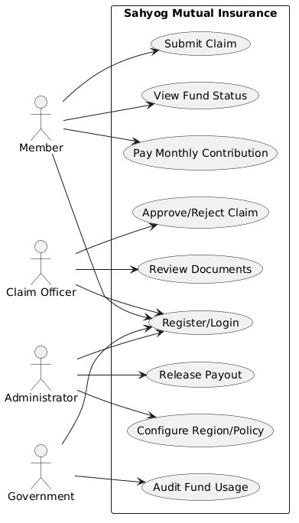
Figure 6: Use Case Diagram — Sahyog Mutual Insurance System

11. Technical Challenges & Solutions
Challenge | Problem | Solution Implemented
Multi-Role Claim State Collisions | Managing claim state transitions across roles without data collisions — e.g., an officer attempting to review a claim already transitioned to PAID. | Strict state machine logic enforced at the ClaimService layer using enum transition checks. Each change is explicitly validated; invalid transitions return HTTP 422.
Least-Workload Officer Assignment | Distributing claim assignments fairly across officers so no single officer is overloaded while others are idle. | ClaimRepository.findLeastWorkloadOfficer(regionId) queries active claim counts per officer in the region and assigns to the minimum. Assignment is atomic within the claim submission transaction.
Reserve Protection on Payout | Ensuring the pool fund never falls below the safety reserve threshold when admin authorizes high-value payouts. | Solvency check enforced at service layer before any deduction: (balance - payout) >= (balance * reservePercentage). Blocked payouts return a descriptive error to the admin.
Risk-Adjusted Contributions | Applying different contribution amounts to members in different risk-level regions without storing separate policies per member. | Risk multipliers (1.0x / 1.25x / 1.50x) are applied at contribution calculation time by reading the region's riskLevel from the linked Policy. No duplication of policy records.
Dual-Database Strategy | Supporting rapid local development (H2) and production readiness (MySQL) without code changes. | Spring Boot profiles with separate application.properties configurations. JPA schema auto-creation handles H2 DDL; MySQL uses the same entity model with dialect switching.

12. Future Enhancements
Enhancement | Description | Priority
Email & Push Notifications | Integrate SMTP / Firebase Cloud Messaging to notify members on contribution receipts, claim status transitions, and payout confirmations in real time. | High
AI Risk Assessment | Implement ML models for automated fraud detection on submitted claims and dynamic risk scoring for regions based on historical disaster frequency. | Medium
Real Payment Gateway | Replace simulated contribution processing with a live payment gateway (Razorpay or Stripe) for authenticated INR transactions. | High
Mobile Application | Extend the platform to native Android and iOS apps for member self-service, claim photo capture, and push notifications. | Medium
Government API Integration | Expose a formal read-only REST API for state and central government systems to programmatically pull regional fund health data. | Medium
Advanced Reporting | Build a dedicated ReportController with exportable PDF/CSV reports for admin fund analysis, claim trends, and contribution analytics. | Low

13. Conclusion
This Software Requirements Specification has defined the complete functional, non-functional, architectural, and data requirements for Sahyog — the Mutual Insurance Platform.
The system addresses real, measurable pain points in community-level disaster relief: manual coordination overhead, delayed fund disbursement, lack of transparency in pooled finances, and the absence of formal eligibility enforcement. By replacing these with secure, automated, role-driven digital workflows, Sahyog delivers concrete value to regional members, platform administrators, claim officers, and government auditors alike.
The architecture, built on a Spring Boot 3.4.3 backend, a decoupled Angular 21 frontend, JWT-based RBAC with BCrypt password security, Spring Data JPA ORM, and a dual H2/MySQL database strategy, provides a solid, maintainable, and extensible foundation for a production-ready mutual insurance system.
The Contribution Calculation Engine, three-tier Claim Eligibility Validator, Least-Workload Assignment Algorithm, and Reserve-Protected Payout Mechanism together form a sophisticated automated financial processing layer that removes human error from critical fund management decisions.
With the future enhancements outlined in Section 12 — including real payment gateways, AI fraud detection, and mobile applications — Sahyog is positioned to grow into a fully production-ready, AI-augmented mutual insurance platform capable of serving real regional communities across India.

