WEEK 3 TASK REPORT
Real-Time Performance Optimization of Computer Vision Algorithms
Computer Vision Internship Program — Prateek, RNS Institute of Technology

1. Objective
This task takes the CNN trained in Week 2 and applies optimization techniques to make it faster and lighter, while measuring the accuracy cost. All figures in this report are taken from an actual benchmark run (benchmark_results.json), not estimated.

2. Techniques Applied

2.1 Magnitude-based weight pruning
Weights with the smallest absolute values are set to zero, per layer, targeting 40% sparsity. The intent is that small-magnitude weights contribute least to the output and can be removed with limited accuracy loss.

2.2 Post-training int8 quantization
Each layer's weights are mapped from float32 to 8-bit integers using a per-layer symmetric scale (max absolute weight / 127), then dequantized for the forward pass. This is a simulated (fake-quant) evaluation: it reproduces the accuracy effect of int8 storage, and the storage size reported below is computed for int8 weights with fp32 biases.

3. Benchmark Setup
- Model: Week 2 CNN (67,252 parameters), loaded from model_checkpoint.npz
- Test set: 200 synthetic images (50 per class), resized to 32x32
- Latency: mean and standard deviation over 30 timed forward passes, batch size 32, after one warm-up pass
- Hardware/runtime: NumPy CPU implementation in the development sandbox; absolute times will differ on other machines, so compare the variants relative to each other

4. Results
Variant | Test Accuracy | Weight Size | Inference (ms, batch 32)
Baseline (fp32) | 0.920 | 262.7 KB | 12.46 ± 1.19
Pruned (40%) | 0.880 | 262.7 KB (dense storage) | 13.09 ± 0.93
Quantized (int8) | 0.910 | 65.9 KB | 13.57 ± 1.61
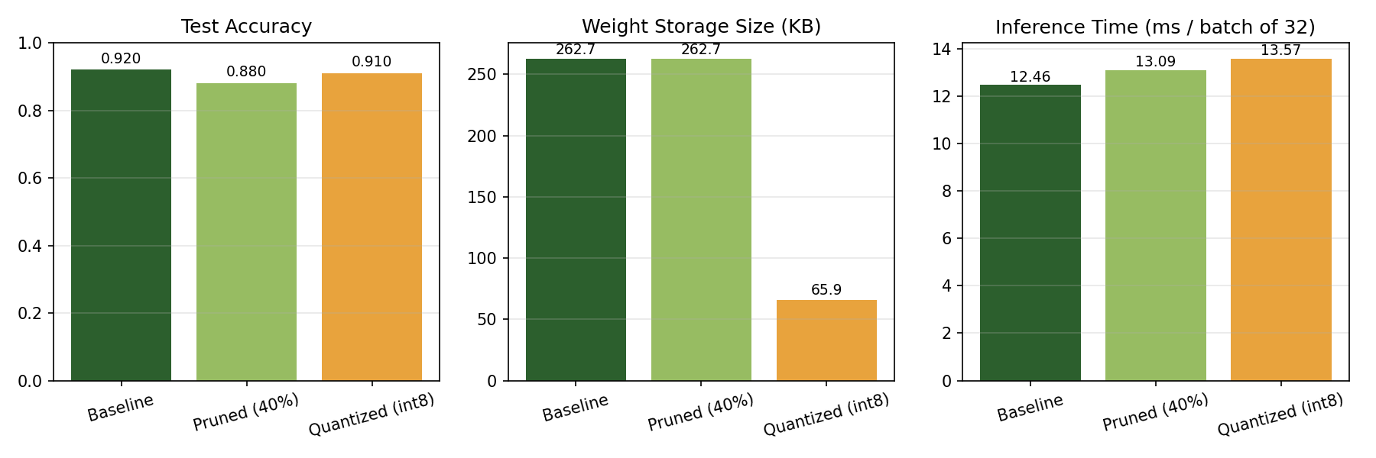
Figure 4. Accuracy, weight storage and inference time for each variant (actual benchmark run).

4.1 Pruning sparsity achieved per layer
Layer | Weights zeroed
conv1 | 39.8%
conv2 | 39.9%
fc1 | 40.0%
fc2 | 39.8%

5. Analysis and Trade-offs
- Quantization is the clear winner on size: weight storage fell by 74.9% (262.7 KB to 65.9 KB) for a 1.0-point accuracy drop.
- Pruning cost more accuracy (-4.0 points) and gave no storage saving in this implementation, because the zeroed weights are still stored densely. Realizing a size or speed gain from pruning requires a sparse storage format or sparse kernels.
- Inference time did not improve for either variant in this NumPy build. This is expected: pruning leaves the dense matrix multiply unchanged, and quantization's fake-quant evaluation dequantizes back to float32 before computing, so neither removes arithmetic. The observed differences (12.5 to 13.6 ms) are within run-to-run noise (standard deviations of roughly 1 to 1.6 ms), so no speed conclusion should be drawn from them.
- A real latency gain from int8 quantization requires an integer inference runtime (for example TensorFlow Lite, ONNX Runtime with int8 kernels, or a hardware NPU). This report therefore claims the storage reduction and the accuracy trade-off as measured, and treats speed as a deployment-time property to be measured on the target hardware.

6. Honest Limitations
- Accuracy figures are on a 200-image synthetic test set; differences of 1 to 4 points correspond to only 2 to 8 images and are not statistically strong.
- Timing was measured on a single CPU sandbox with NumPy; it is a relative comparison only.
- Quantization is simulated; it measures accuracy impact, not an integer-kernel speedup.

7. Recommendations for Future Work
- Deploy quantized weights through an integer runtime (TensorFlow Lite or ONNX Runtime) and benchmark FPS on the target device, such as the Jetson Orin Nano
- Use structured (channel-level) pruning instead of unstructured pruning, so the removed weights produce real speed and size gains on standard hardware
- Fine-tune after pruning to recover accuracy lost in the 40% sparsity step
- Repeat measurements over multiple test sets and random seeds to report confidence intervals

