WEEK 4 TASK REPORT
Integration of Computer Vision Solutions and Cross-functional Testing
Computer Vision Internship Program — Prateek, RNS Institute of Technology

1. Objective
This task integrates the optimized computer vision model into a small application service that other software components can call over a network, and tests that integration end to end. The results in this report come from an actual test run (integration_test_results.json).

2. Application Context
The simulated application is an image-classification service of the kind a real-time surveillance, quality-control or augmented-reality front end would call. A client uploads an image; the service returns the predicted shape class, its confidence and the full probability distribution. The model deployed is the Week 3 int8-quantized variant, which kept 91.0% accuracy at roughly one quarter of the original weight storage.

3. Integration Strategy

3.1 Architecture
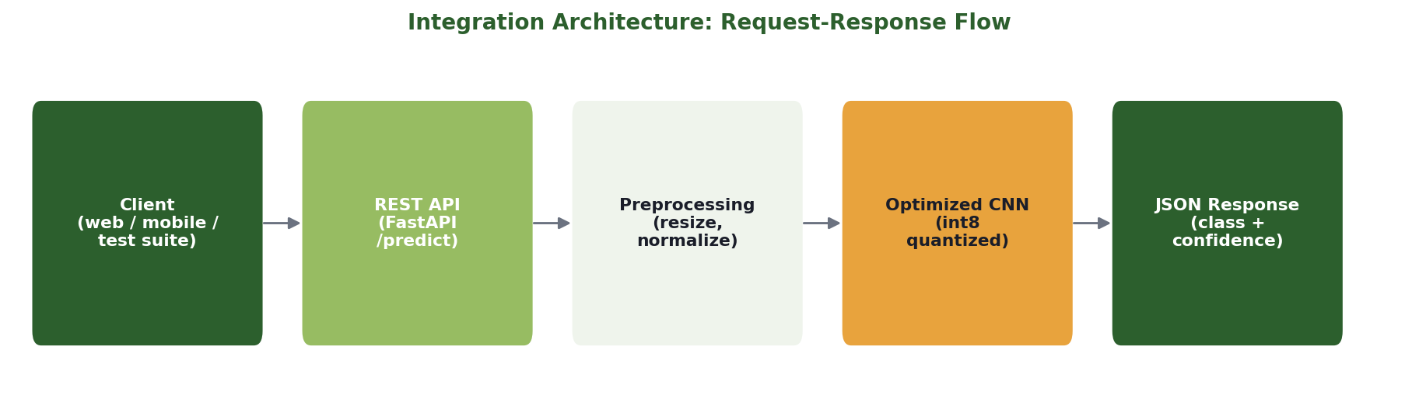
Figure 5. Request-response flow from client to classifier and back.

3.2 Interface
- GET /health: liveness check, returns service status
- POST /predict: multipart image upload; returns JSON with predicted_class, confidence and probabilities
- Input validation: non-image content types and undecodable image bytes are rejected with HTTP 400 and a descriptive message

3.3 Modularity
The web layer (api.py) depends only on the model's public forward pass and the class-label list. The model, quantization and training code live in separate modules, so the model can be retrained or re-optimized without changing the API contract.

4. Test Plan
Testing used FastAPI's in-process test client, which sends real HTTP-style requests through the full routing, validation and serialization path without opening a network socket. The plan covered three areas: service health, prediction behavior on fresh synthetic samples, and error handling for bad input.
Area | Cases | Purpose
Health | 1 | Service responds and reports status
Prediction | 60 | End-to-end classification correctness on unseen samples (15 per class)
Error handling | 2 | Non-image upload and corrupted image bytes are rejected cleanly

5. Results
Metric | Value
Total test cases | 63
Passed | 59
Failed | 4
Prediction accuracy via live API | 93.3% (56/60)

5.1 Per-class prediction results
Class | Correct | Samples | Accuracy
circle | 14 | 15 | 93.3%
square | 13 | 15 | 86.7%
triangle | 14 | 15 | 93.3%
star | 15 | 15 | 100.0%

5.2 Error-handling results
Case | HTTP status | Result
non image upload | 400 | PASS
corrupted image bytes | 400 | PASS

6. Analysis
- The service reproduces the model's behavior end to end: 56 of 60 fresh synthetic predictions were correct through the API. This is consistent with the 91.0% test accuracy measured in Week 3, within the variation expected for a 60-sample check.
- Every failure is a misclassification by the model, not a failure of the API layer. Each request returned HTTP 200 with a valid prediction body.
- Malformed input is handled at the boundary: the service never crashes on a bad upload and returns a clear client-error response instead.
- Misclassified samples (4): circle predicted as triangle; square predicted as triangle; square predicted as triangle; triangle predicted as star.

7. Challenges Encountered
- The model is loaded lazily on the first prediction request, so the health endpoint reports model_loaded = false until then. This is deliberate, to keep startup fast, but a production service would load the model at startup and fail fast if the checkpoint is missing.
- The test client emits a deprecation warning about its HTTP library dependency. This does not affect results, but the dependency should be updated before deployment.
- Test images are generated by the same synthetic generator used for training, so the prediction accuracy shows integration correctness on in-distribution data. It is not evidence of performance on real photographs.

8. Limitations
- Only one deployment target (a single local service) was exercised; no load, latency-under-concurrency or network-failure tests were run.
- No authentication, rate limiting or request logging is implemented.
- The service runs on the same synthetic 4-class task; a real application would need a model trained on its own domain data.

9. Recommendations
- Load the model at service startup and add a readiness check that reflects it
- Add load tests (concurrent requests) and record p95 latency on the target hardware
- Containerize the service and add authentication before any shared deployment
- Connect the service to a real client (a simple web page or a camera feed on the Jetson Orin Nano) for a live demonstration

