- Convert phi1, phi and phi2 to degrees
- Select the two pixels to be calculated
- Convert phi1, phi and phi2 to rotation matric for further calculations for both pixels. The conversion formula is given below. Its from Valrie Randle book on texture.
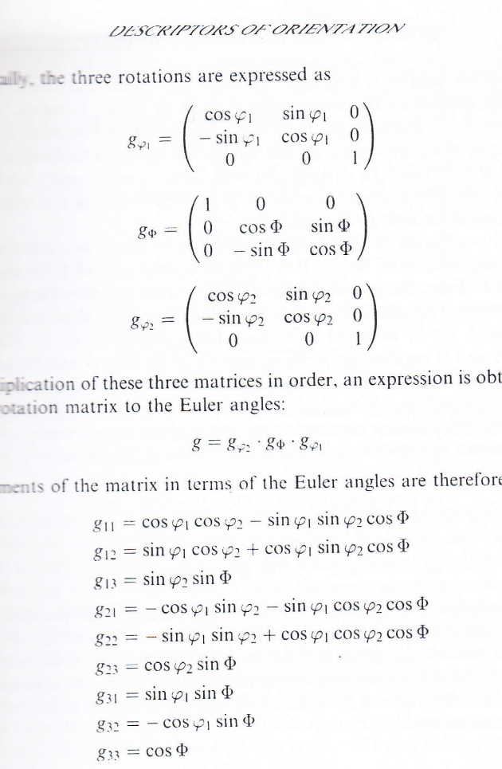

- Calculate the misorientation matrix for the two-orientation matrix using the 24 symmetry operators. The symmetry matrices for 24 equivalent combinations are as follows:
[1 0 0;0 1 0;0 0 1]
[0 0 1;1 0 0;0 1 0]
[0 1 0;0 0 1;1 0 0]
[0 -1 0;0 0 1;-1 0 0]
[0 -1 0;0 0 -1;1 0 0]
[0 1 0;0 0 -1;-1 0 0]
[0 0 -1;1 0 0;0 -1 0]
[0 0 -1;-1 0 0;0 1 0]
[0 0 1;-1 0 0;0 -1 0]
[-1 0 0;0 1 0;0 0 -1]
[-1 0 0;0 -1 0;0 0 1]
[1 0 0;0 -1 0;0 0 -1]
[0 0 -1;0 -1 0;-1 0 0]
[0 0 1;0 -1 0;1 0 0]
[0 0 1;0 1 0;-1 0 0]
[0 0 -1;0 1 0;1 0 0]
[-1 0 0;0 0 -1;0 -1 0]
[1 0 0;0 0 -1;0 1 0]
[1 0 0;0 0 1;0 -1 0]
[-1 0 0;0 0 1;0 1 0]
[0 -1 0;-1 0 0;0 0 -1]
[0 1 0;-1 0 0;0 0 1]
[0 1 0;1 0 0;0 0 -1]
[0 -1 0;1 0 0;0 0 1]

- Select the one with minimum angle
- Calculate the stored energy from Read Shockley equation. For time being you can use the arbitrary grain boundary energy say 10. It can be scaled later on to the required number.
- Divide by 2.
- Calculate stored energy for all the neighboring pixels.
- Store the average value for each pixel.

I am also attaching a presentation. It should be helpful.

Two datasets are also attached. One for hot rolled low carbon steel and other for 80% cold rolled low carbon steel.

I tried to make the files as small as possible. Belo this the data seemed to be meaningless.

