Report-3
Sanjana P Shetty
11/16/2017

Problem 1
A program was implemented for image analysis using feed forward neural networks and trained with backpropagation. A 1-hidden layer neural network with 100 hidden neurons and 10 output neurons, was trained for 700 epochs by taking random subsets of 100 data points from the 4000 data point training set in every epoch. The network was then tested over 1000 random points. The hit rate for both the training and testing was recorded and plotted. Classification was done based on max threshold approach. Additionally the confusion matrix for the training subsets and testing data was computed.

System Description:
- Number of hidden neurons = 100
- Learning rate for both outputs and hidden neurons= 0.05
- Output thresholds:
- Maximum threshold = 0.75
- Minimum threshold = 0.25
- Rule for choosing initial weights: weights are randomly generated with values ranging between -1 and 1
- Criteria to stop training: the training was tried over 10, 100, 500 and 1000 epochs. An optimum value of 700 was selected since it gave an efficient hit rate of upto 100%
- Alpha of momentum = 0.7

Results
- Confusion matrix

- Training Set
 | zero | one | two | three | four | five | six | seven | eight | nine
zero | 12 | 1 | 0 | 0 | 0 | 0 | 0 | 0 | 0 | 2
one | 0 | 7 | 0 | 0 | 0 | 0 | 0 | 0 | 0 | 0
two | 0 | 0 | 8 | 0 | 0 | 0 | 0 | 0 | 0 | 0
three | 0 | 0 | 0 | 10 | 0 | 0 | 0 | 0 | 0 | 0
four | 0 | 0 | 0 | 0 | 12 | 0 | 0 | 0 | 0 | 0
five | 0 | 0 | 0 | 0 | 0 | 6 | 0 | 0 | 0 | 0
six | 0 | 0 | 0 | 0 | 0 | 0 | 15 | 0 | 0 | 0
seven | 0 | 0 | 0 | 0 | 0 | 0 | 0 | 10 | 0 | 0
eight | 0 | 0 | 0 | 0 | 0 | 0 | 0 | 0 | 8 | 0
nine | 0 | 0 | 0 | 0 | 0 | 0 | 0 | 0 | 0 | 10
Table 1 Confusion matrix of last epoch of training subset

- Test Set
 | zero | one | two | three | four | five | six | seven | eight | nine
zero | 81 | 0 | 6 | 6 | 2 | 7 | 2 | 3 | 6 | 6
one | 0 | 106 | 0 | 0 | 0 | 1 | 1 | 1 | 0 | 1
two | 0 | 1 | 80 | 0 | 0 | 0 | 0 | 1 | 2 | 0
three | 0 | 0 | 1 | 101 | 0 | 1 | 1 | 0 | 1 | 1
four | 0 | 0 | 2 | 0 | 93 | 2 | 1 | 0 | 0 | 5
five | 0 | 0 | 0 | 2 | 0 | 73 | 5 | 0 | 2 | 2
six | 1 | 0 | 3 | 2 | 2 | 2 | 83 | 0 | 0 | 0
seven | 0 | 1 | 4 | 3 | 0 | 1 | 0 | 99 | 2 | 2
eight | 0 | 1 | 2 | 2 | 0 | 1 | 1 | 1 | 84 | 1
nine | 0 | 0 | 1 | 1 | 5 | 0 | 0 | 6 | 1 | 82
Table 2 Confusion matrix of test set

- Time Series of error during training (every 10th epoch)
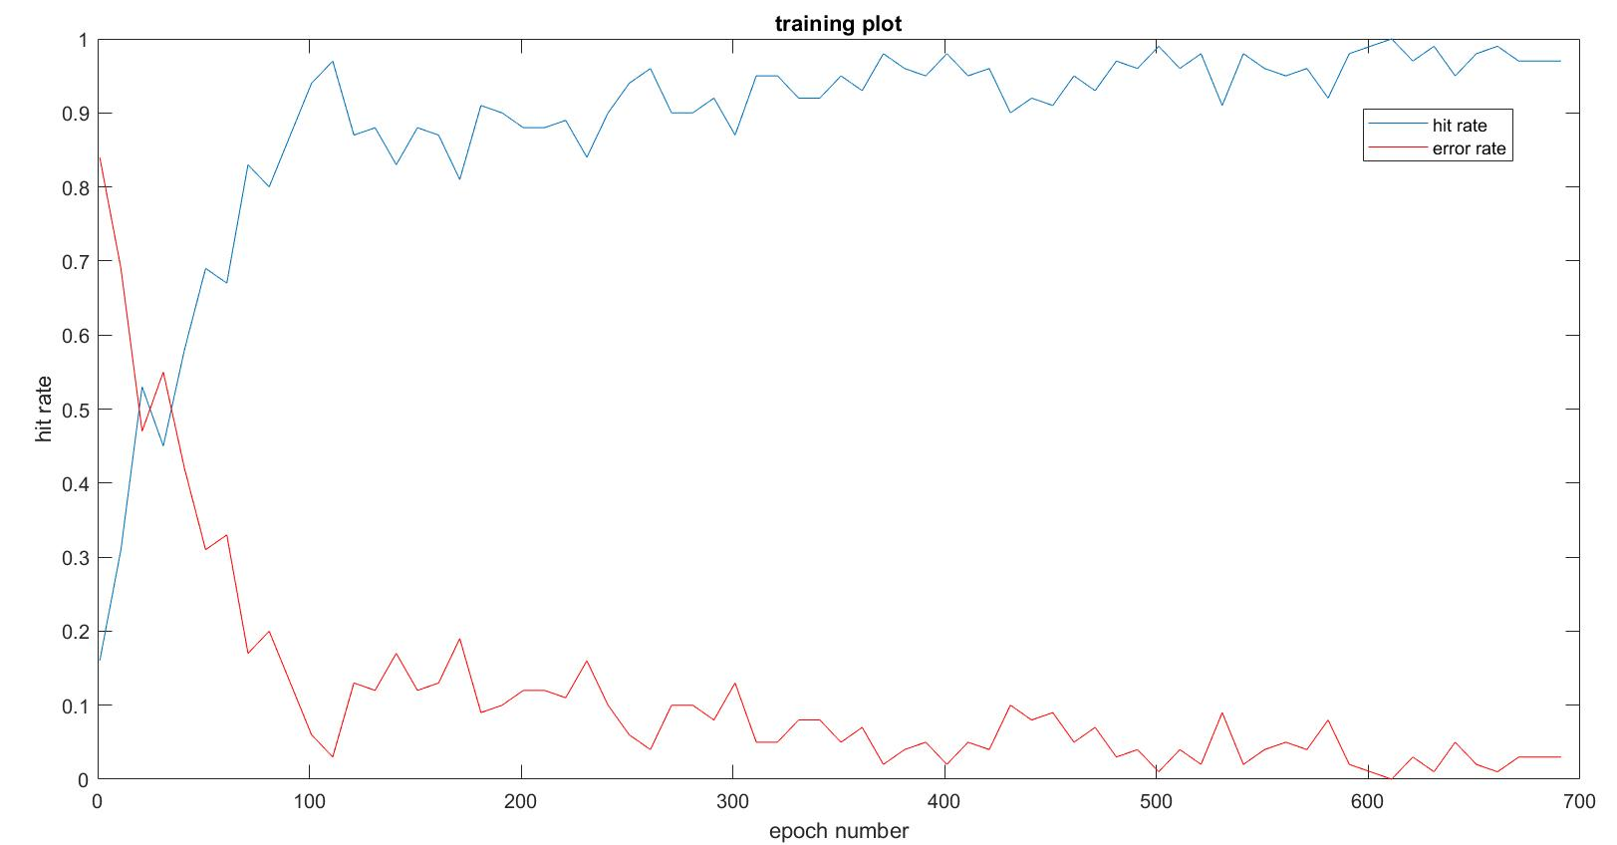
Figure 1 Hit rate of training set vs epoch number

- Hit Rate of testing data = 88.2%

Discussion
As observed in the hit rate graph, the hit rate steadily increases and saturates at a certain point. The goal of backpropagation is to optimize the weights so that the neural network can learn how to correctly map arbitrary inputs to outputs. With each forward pass, the output is computed and classified into the corresponding images by comparing the highest output generated by the neurons. This neuron’s weights are increased for the particular label, such that at the end of the training, each neuron corresponds to one of the 10 labels. The system was first observed without the addition of momentum and is observed to take a larger number of training cycles to reach the present efficiency. On increasing the learning rates and the momentum to a larger value than that allocated presently, the hit rate is observed to fluctuate more.
The hit rate is observed to steeply rise up until the 21st epoch after which it starts fluctuating. The error rate at these points is comparatively low and due to a moderately high learning rate, the hit rate is observed to fluctuate till it optimizes to an average of 90-100%.
The confusion matrix is used to denote the number of accurately classified data points. The rows denote the computed output and the columns denote the expected outputs. The diagonal therefore provides the correctly classified data. The summation of these was divided by the total and compared to the total to verify its accuracy. It is observed that images with similar features are increasingly incorrectly classified in one another, for example 8, 0 or 9.
Each of the hidden neurons gets trained on particular features. The number of hidden layer neurons were tested over a range 50-300. The less number of neurons resulted in a lower prediction rate and the higher number of neurons increased computation time with no increase in efficiency. An optimum number of 100 was selected. The number of epochs required and the time taken for each epoch was quite extensive. The high accuracy though, compensates for these shortcomings.
The Backpropagation algorithm is increasingly used in image classification. The principle of the backpropagation approach is to model a given function by modifying internal weightings of input signals to produce an expected output signal. The system is trained using a supervised learning method, where the error between the system’s output and a known expected output is presented to the system and used to modify its internal state.

Problem 2
An auto-encoder network was trained using the implementation of the backpropagation algorithm from Problem 1. The purpose was to obtain a good set of features representing the images. The training was regulated using the loss function and the grayscale image of the final output was plotted and compared to the original image.

System Description:
- Number of hidden neurons = 100
- Learning rates = 0.06
- Alpha of momentum = 0.6
- Output thresholds:
- Maximum threshold = 1
- Minimum threshold = 0
- Rule for choosing initial weights: weights are randomly generated with values ranging between -1 and 1
- Criteria to stop training: the training was tried over 150 epochs. Due to the excessive computation time necessary, the results were observed at this point and plotted

Results
- Loss function of training set and test set
The total loss function over 1000 data points from the training set and 1000 data points from the test set was plotted
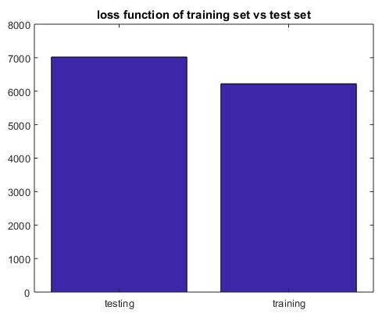
Figure 2 Bar graph of loss function of training set and loss function of test set

- Loss function of training set and test set for each digit
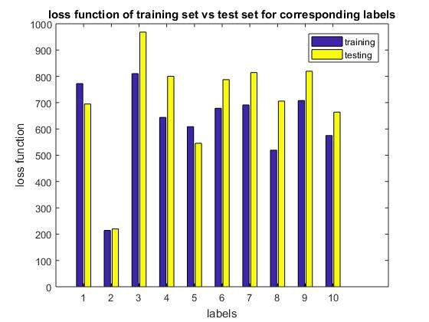
Figure 3 Bar graph of loss function of training set and loss function of test set for each digit in the label set
Figure 6 spike rate of neuron A vs. IA
- Grayscale image of 100 neuron weights
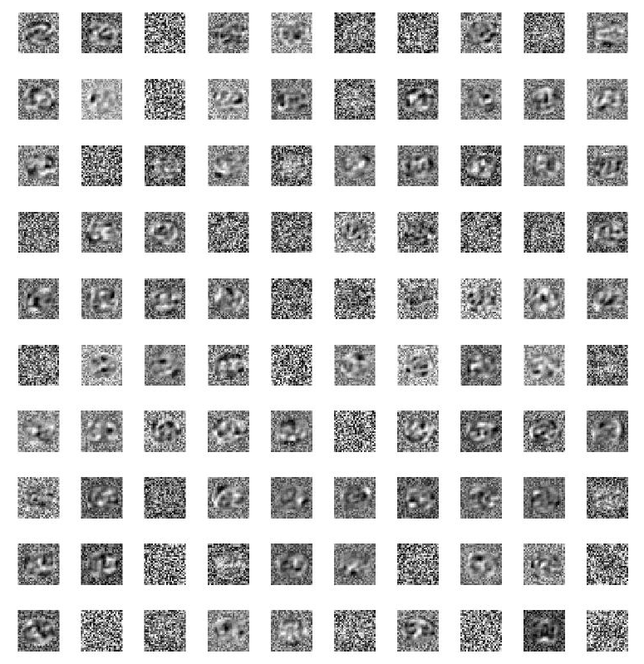
Figure 4 10×10 matrix of hidden neuron weights

- Grayscale image of 100 neuron outputs
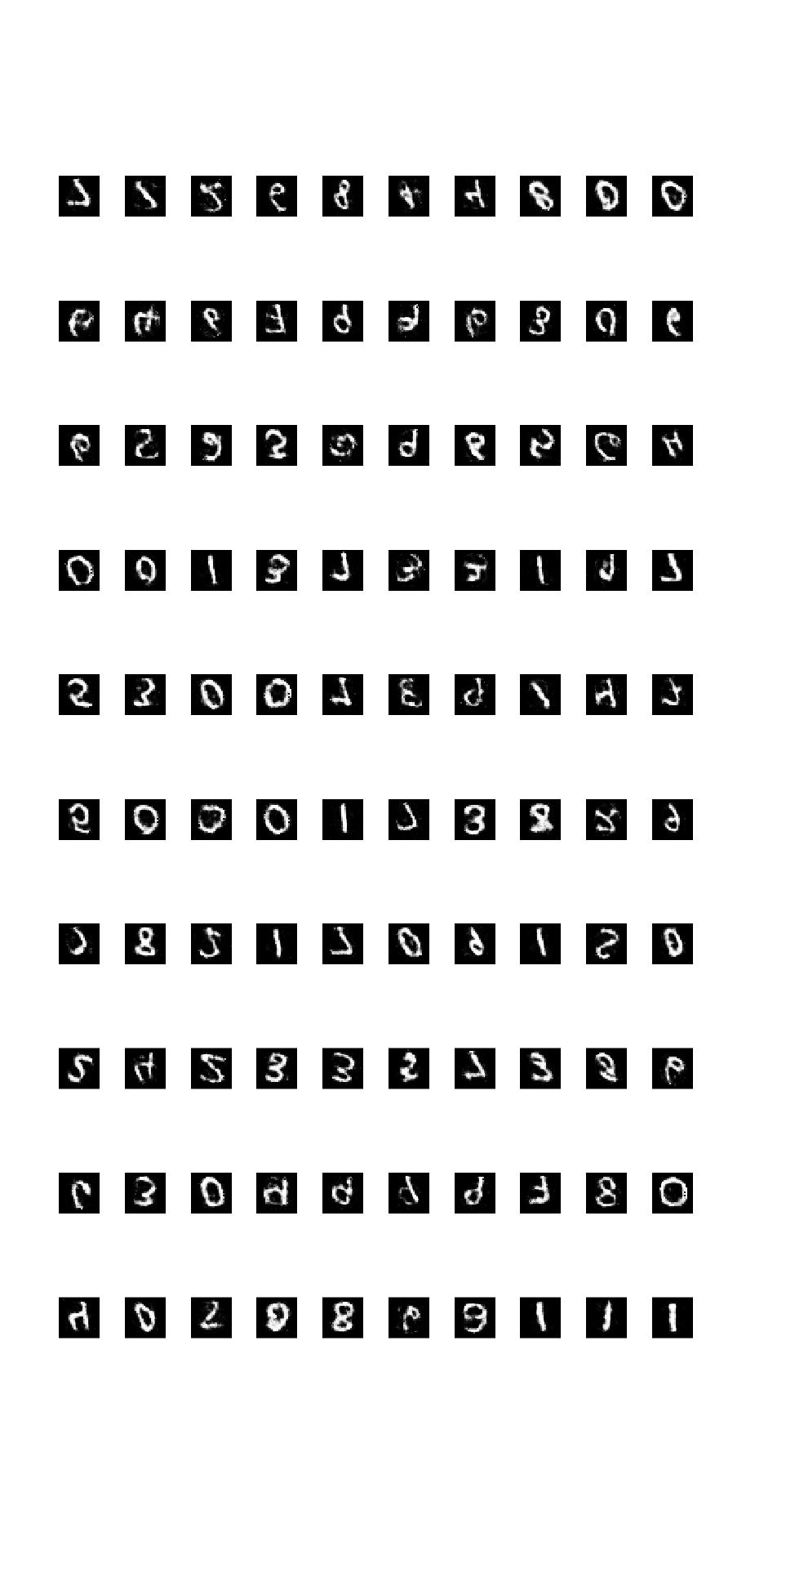
Figure 5 10×10 matrix of outputs

- Loss function vs epoch number of training over 1000 data points

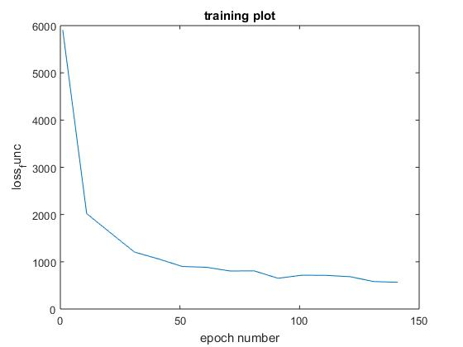

Figure 6 Loss function vs epoch number

Discussion
The auto-encoder is realized using the same program as the backpropagation algorithm, but instead of classifying the data, we are replicating the input to the output by increasing the number of output neurons to the same number as the input neurons. The performance of the auto encoder is evaluated using the value of loss function. The loss function reduced in the training over the 150 epochs, from an exorbitantly high value to a much smaller value; from around 5900 to around 500. The efficiency increases drastically and mildly saturates at this value with increase in the number of epochs.
Auto-encoder loss reduces drastically. As seen in figure 5 the digits are beginning to be reconstructed. The loss function of digit 3 is observed to be consistently higher and is thus concluded to be the toughest to reconstruct. This is due to the excessive features required to construct it which will require further training. The similarity to digits like 8 and 9, interrupt the learning.
The autoencoder is used extensively to denoise images. Once the network is trained, noisy or partial images can be reconstructed using auto encoders.
At the end of the training session we observe that each of the neurons are trained to a particular feature. Due to the randomization of the input data, the output is not identical to the input.
The system can also be observed to be used in compression of data. 100 neurons of the hidden layer are able to successfully reproduce the 784 size input
The auto encoder requires excessive training and is time consuming but the reconstruction of the images after the limited training provided

Appendix

Backpropagation
clear all;
count=1;
input_num=784;
data_points=5000;
num_neurons_hidden=100;
num_neurons_output=10; %%%% same as number of images %%%%
trainSubsetSize=100; %%%%% number of data points to be used in each epoch%%%

testSetSize = 1000;
trainSet_num = data_points-testSetSize;

thresh_high=0.75;
thresh_low=0.25;

label_d2=input_num+1;

weight_min=-1;
weight_max=1;
weight_range=weight_max-weight_min;

learningRate_ouput=0.05;
learningRate_hidden=0.05;

alpha=0.7; %%%%%%%%%% momentum %%%%%%%%
delta_weight_ij=zeros();
delta_weight_ij_t_1=zeros();

sum_output_hidden=0;
sum_output=0;

epoch_num=700;
epoch_store=1;

conf_matrix_train=zeros(10,10);
conf_matrix_test=zeros(10,10);

%MNISTnumImages5000
%MNISTnumLabels5000
%%%%%%%%%%% read data from text file %%%%%%%%%%%%
%image intensity%%%%%%%%%%%%%%%%5
fid_image = fopen('MNISTnumImages5000.txt');
formatSpecI = '%f %f';
sizeI = [input_num data_points];
I= fscanf(fid_image,formatSpecI,sizeI);
Data_orig_image=I';
fclose(fid_image);

%image label%%%%%%%%%%%%%%%%%%%%
fid_label = fopen('MNISTnumLabels5000.txt');
formatSpecL = '%f %f';
sizeL = [1 data_points];
L= fscanf(fid_label,formatSpecL,sizeL);
Data_orig_label=L';
fclose(fid_label);

% % %%%%%%%%%% normalize the inputs %%%%%%%%%%%%%%
%
% Norm_min= min(Data_orig_image(:,:));
% Norm_max= max(Data_orig_image(:,:));
%
% Norm_range= Norm_max-Norm_min;
%
% for i=1:data_points
% for j=1:input_num
% Norm_data(i,j)= (Data_orig_image(i,j)-Norm_min)/Norm_range;%(Data_orig_image(i,j)*2)-1;
% end
% end

% %%%%%%%%%%%%%%%%%% select random samples for testing and training%%%%%%%%%
%
% % %%%%%%%%%%% generate array of random numbers%%%%%%%
for i=1:data_points
test_1(i)=i;
end
for i=1:data_points
test_2=test_1(randperm(length(test_1)));
end
%%%%%%%%%% assign values to training set and test set%%%%%%%
for i=1:data_points
TotalSet_image(i,1:input_num)= Data_orig_image(test_2(i),:);

TotalSet_image(i,(label_d2))= Data_orig_label(test_2(i),:); %%%% storing the corresponding labels in the totalset %%%%%

end

for i=1: trainSet_num
TrainingSet(i,:)= TotalSet_image(i,:);

end
for i=trainSet_num+1:data_points
TestSet(count,:)= TotalSet_image(i,:);
count=count+1;
end

%%%%%%%%%%% random weight generation %%%%%%%%%%%%%%%%%%

weight_input_hidden_jk= ((weight_range)*(rand(num_neurons_hidden,input_num)))+weight_min;
weight_hidden_output_ij= ((weight_range)*(rand(num_neurons_output,num_neurons_hidden)))+weight_min;

%%%%%%%%%%%%%%%% setting label vector %%%%%%%%%%
%%%%%%% it sets a 1 to the point which corresponds to the label %%%%%%%%
%%%%%%% example if label is 7, 1 will be set to the 7th element of the
%%%%%%% array
%%%%%%% this is then treated as expected output from the 10 neurons and
%%%%%%% used for error correction
for c=1: data_points
temp_label_store= TotalSet_image(c,label_d2);
for i=1:num_neurons_output
if i == (temp_label_store+1)
expected_label_array(c,i) = 1;
else
expected_label_array(c,i) = 0;
end
end
end

expected_label_train = expected_label_array(1:trainSet_num,:);
expected_label_test = expected_label_array((trainSet_num+1):data_points,:);

% %%%%%%% choose a random start and end value for subsets on which to train
% %%%%%%% each epoch %%%%%%%%%%%%%%
% start_trainSubset=randi((trainSet_num-trainSubsetSize));
% end_trainSubset= start_trainSubset+trainSubsetSize;

%%%%%%%%%%%%%% compute output %%%%%%%%%%%%%%%%%%%%%%
for e=1:epoch_num

%%%%%%% choose a random start and end value for subsets on which to train
%%%%%%% each epoch %%%%%%%%%%%%%%
start_trainSubset=randi((trainSet_num-trainSubsetSize));
end_trainSubset= start_trainSubset+trainSubsetSize;

d2=1; %%%%%%%%% used as d2 for output and hidden neuron%%%
Q11=0;
%%%%%%%% loop for data_points %%%%%%%%%
for d= start_trainSubset:end_trainSubset

%%%%%%%%%% Forward pass %%%%%%%%%%%%
%%%% output layer neuron i %%%%

for i=1: num_neurons_output

%%%% hidden layer neuron j %%%%
sum_output=0;
for j=1:num_neurons_hidden
sum_output_hidden=0;
for k= 1:input_num
sum_output_hidden= sum_output_hidden+(weight_input_hidden_jk(j,k) * TrainingSet(d,k));
end
hidden_output_fj(d2,j)=1/(1+exp(-sum_output_hidden));

sum_output= sum_output + (weight_hidden_output_ij(i,j) * hidden_output_fj(d2,j));
end
actual_output_fi(d2,i)=1/(1+exp(-sum_output));

%%%%%%%%%%%%%%%%%%% creating output labelling %%%%%%%%%%%%%%%%
if actual_output_fi(d2,i) >=thresh_high %%%%% set threshold; anything greater than 0.75 is considered as high
output_label(d2,i)=1;

elseif actual_output_fi(d2,i) <=thresh_low %%%%%%% anything lesser -0.75 is considered as low (0)
output_label(d2,i)=0;

else
output_label(d2,i)=actual_output_fi(d2,i);
end
end

%%%%%%%%%%%%%% start loops for backpropogation %%%%%%%%%%%

%%%%% below part for momentum %%%%%%%
delta_weight_ij_t_1= delta_weight_ij;
%%%%%% above part for momentum %%%%%

for j=1:num_neurons_hidden %%%%% loop for change in weights %%%%%%%%%%

sum_delta_i=0;

for i2 = 1:num_neurons_output
%%%%%%% find error by comparing expected output with acquired output %%
error_output(d2,i2) = expected_label_train(d,i2)-output_label(d2,i2);

%%%%%%%%%% find delta i %%%%%%%%%%%%%%%%%
delta_output_i (d2,i2) = (1-actual_output_fi(d2,i2))*actual_output_fi(d2,i2)*(error_output(d2,i2));

%%%%%%%%%%%%%%% find weight change required for weights between output
%%%%%%%%%%%%%%% layer and hidden layer %%%%%%%%%%%

%%% without momentum: delta_weight_ij(i2,j) = learningRate_ouput * delta_output_i (d2,i2) * hidden_output_fj(d2,j);
%%%%% with momentum: %%%%%%%%%%%%%%%%%%
if d2==1
delta_weight_ij(i2,j) = learningRate_ouput * delta_output_i (d2,i2) * hidden_output_fj(d2,j);
else
delta_weight_ij(i2,j) = (learningRate_ouput * delta_output_i (d2,i2) * hidden_output_fj(d2,j)) + (alpha * delta_weight_ij_t_1(i2,j));
end

%%%%%%%% summation old weights * delta i %%%%%%%%%%%%%%%%%%

sum_delta_i = sum_delta_i + (weight_hidden_output_ij(i2,j) * delta_output_i (d2,i2));

%%%%%%%%%%%% make weight changes to output to hidden layer weights %%%%%%%%%%%

weight_hidden_output_ij(i2,j)= weight_hidden_output_ij(i2,j)+ delta_weight_ij(i2,j);
end
delta_hidden_j (d2,j) = ((1- hidden_output_fj(d2,j)) * hidden_output_fj(d2,j)) * sum_delta_i;
%%%%%%%%%%%%% loop inputs for weight change corresponding to hidden
%%%%%%%%%%%%% neuron- input (jk)
for k = 1:input_num
delta_weight_jk (j,k) = learningRate_hidden * delta_hidden_j (d2,j) * TrainingSet(d,k);

%%%%%%%%%%%% make weight changes to hidden to input layer weights %%%%%%%%%%%
weight_input_hidden_jk(j,k)= weight_input_hidden_jk(j,k)+ delta_weight_jk (j,k);
end
end

%%%%%%%%%%%%% classification %%%%%%%%%%%%%
%%%%%%% check if highest value at the ouput label corresponds to the
%%%%%%% position of 1 at the expected label
[m1,idx_output]=max(output_label(d2,:));
[m2,idx_expected]=max(expected_label_train(d,:));
if idx_output == idx_expected
Q11=Q11+1;
end
%%%%%%%%%%%%%%% confusionn matrix for training %%%%%%%%%%%%%%%
if e == epoch_num
conf_matrix_train(idx_output,idx_expected)= conf_matrix_train(idx_output,idx_expected)+1;
end
d2=d2+1;
end
%%%%%%%%%%% hit rate %%%%%%%%%%%%%%
if e==1 || mod(e,10)==1
hit_rate(epoch_store)=Q11/trainSubsetSize;
epoch_store = epoch_store+1;
end
end

%%%%%%% testing %%%%%%%%%%%%%%%
Q11_test=0;
%%%%%%%% loop for data_points %%%%%%%%%
for d= 1:testSetSize

%%%%%%%%% Forward pass %%%%%%%%%%%%
%%%% output layer neuron i %%%%

for i=1: num_neurons_output

%%%% hidden layer neuron j %%%%
sum_output=0;
for j=1:num_neurons_hidden
sum_output_hidden=0;
for k= 1:input_num
sum_output_hidden= sum_output_hidden+(weight_input_hidden_jk(j,k) * TestSet(d,k));
end
hidden_output_fj_test(d,j)=1/(1+exp(-sum_output_hidden));

sum_output= sum_output + (weight_hidden_output_ij(i,j) * hidden_output_fj_test(d,j));
end
actual_output_fi_test(d,i)=1/(1+exp(-sum_output));

%%%%%%%%%%%% labelling %%%%%%%%%%%%%%%%%%
if actual_output_fi_test(d,i) >=thresh_high %%%%% set threshold; anything greater than 0.75 is considered as high
output_label_test(d,i)=1;

elseif actual_output_fi_test(d,i) <=thresh_low %%%%%%% anything lesser -0.75 is considered as low (0)
output_label_test(d,i)=0;

else
output_label_test(d,i)=actual_output_fi_test(d,i);
end
end

%%%%%%%%%%%%% classification %%%%%%%%%%%%%
%%%%%%% check if highest value at the ouput label corresponds to the
%%%%%%% position of 1 at the expected label
[m1,idx_output_test]=max(output_label_test(d,:));
[m2,idx_expected_test]=max(expected_label_test(d,:));
if idx_output_test == idx_expected_test
Q11_test = Q11_test + 1;
end
%%%%%%%%%%%%% confusion matrix %%%%%%%%%%%%%%%
conf_matrix_test(idx_output_test,idx_expected_test)= conf_matrix_test(idx_output_test,idx_expected_test)+1;
end
hit_rate_test = Q11_test/testSetSize;

figure();
plot(1:10:epoch_num,hit_rate);
xlabel('epoch number');
ylabel('hit rate');
title('training plot');
hold on
plot(1:10:epoch_num,1-hit_rate,'r');

Auto-encoder

clear all;

count=1;
input_num=784;
data_points=5000;
num_neurons_hidden=100;
num_neurons_output=784; %%%% same as number of images %%%%
trainSubsetSize=100; %%%%% number of data points to be used in each epoch%%%

testSetSize = 1000;
trainSet_num = data_points-testSetSize;

thresh_high=1;%0.75;
thresh_low=0;%0.25;

label_d2=input_num+1;

weight_min=-1;
weight_max=1;
weight_range=weight_max-weight_min;

learningRate_ouput=0.06;%06;
learningRate_hidden=0.06;%06;

alpha=0.6; %%%%%%%%%% momentum %%%%%%%%
delta_weight_ij=zeros();
delta_weight_ij_t_1=zeros();

sum_output_hidden=0;
sum_output=0;

epoch_num=150;
epoch_store=1;

sum_error_square=0;
sum_error_square_test=0;
loss_func_e=zeros();
loss_func_q=zeros();
counter=1;
sum_loss_func_train=0;
loss_func_label_train= zeros(1,10);
loss_func_label_test = zeros(1,10);

%MNISTnumImages5000
%MNISTnumLabels5000
%%%%%%%%%%% read data from text file %%%%%%%%%%%%
%image intensity%%%%%%%%%%%%%%%%5
fid_image = fopen('MNISTnumImages5000.txt');
formatSpecI = '%f %f';
sizeI = [input_num data_points];
I= fscanf(fid_image,formatSpecI,sizeI);
Data_orig_image=I';
fclose(fid_image);

%image label%%%%%%%%%%%%%%%%%%%%
fid_label = fopen('MNISTnumLabels5000.txt');
formatSpecL = '%f %f';
sizeL = [1 data_points];
L= fscanf(fid_label,formatSpecL,sizeL);
Data_orig_label=L';
fclose(fid_label);

% % %%%%%%%%%% normalize the inputs %%%%%%%%%%%%%%
%
% Norm_min= min(Data_orig_image(:,:));
% Norm_max= max(Data_orig_image(:,:));
%
% Norm_range= Norm_max-Norm_min;
%
% for i=1:data_points
% for j=1:input_num
% Norm_data(i,j)= (Data_orig_image(i,j)-Norm_min)/Norm_range;%(Data_orig_image(i,j)*2)-1;
% end
% end

% %%%%%%%%%%%%%%%%%% select random samples for testing and training%%%%%%%%%
%
% % %%%%%%%%%%% generate array of random numbers%%%%%%%
for i=1:data_points
test_1(i)=i;
end
for i=1:data_points
test_2=test_1(randperm(length(test_1)));
end
%%%%%%%%%% assign values to training set and test set%%%%%%%
for i=1:data_points
TotalSet_image(i,1:input_num)= Data_orig_image(test_2(i),:);

TotalSet_image(i,(label_d2))= Data_orig_label(test_2(i),:); %%%% storing the corresponding labels in the totalset %%%%%

end

for i=1: trainSet_num
TrainingSet(i,:)= TotalSet_image(i,:);

end
for i=trainSet_num+1:data_points
TestSet(count,:)= TotalSet_image(i,:);
count=count+1;
end

%%%%%%%%%%% random weight generation %%%%%%%%%%%%%%%%%%

weight_input_hidden_jk= ((weight_range)*(rand(num_neurons_hidden,input_num)))+weight_min;
weight_hidden_output_ij= ((weight_range)*(rand(num_neurons_output,num_neurons_hidden)))+weight_min;

%%%%%%%%%%%%%%%% setting label vector %%%%%%%%%%
%%%%%%% it sets a 1 to the point which corresponds to the label %%%%%%%%
%%%%%%% example if label is 7, 1 will be set to the 7th element of the
%%%%%%% array
%%%%%%% this is then treated as expected output from the 10 neurons and
%%%%%%% used for error correction
for c=1: data_points
temp_label_store= TotalSet_image(c,label_d2);
for i=1:num_neurons_output
if i == (temp_label_store+1)
expected_label_array(c,i) = 1;
else
expected_label_array(c,i) = 0;
end
end
end

expected_label_train = expected_label_array(1:trainSet_num,:);
expected_label_test = expected_label_array((trainSet_num+1):data_points,:);

% %%%%%%% choose a random start and end value for subsets on which to train
% %%%%%%% each epoch %%%%%%%%%%%%%%
% start_trainSubset=randi((trainSet_num-trainSubsetSize));
% end_trainSubset= start_trainSubset+trainSubsetSize;

%%%%%%%%%%%%%% compute output %%%%%%%%%%%%%%%%%%%%%%
for e=1:epoch_num

%%%%%%% choose a random start and end value for subsets on which to train
%%%%%%% each epoch %%%%%%%%%%%%%%
start_trainSubset=randi((trainSet_num-trainSubsetSize));
end_trainSubset= start_trainSubset+trainSubsetSize;

d2=1; %%%%%%%%% used as d2 for output and hidden neuron%%%
Q11=0;
sum_loss_func_e=0;

%%%%%%%% loop for data_points %%%%%%%%%
for d= start_trainSubset:end_trainSubset

%%%%%%%%%% Forward pass %%%%%%%%%%%%
%%%% output layer neuron i %%%%

for i=1: num_neurons_output

%%%% hidden layer neuron j %%%%
sum_output=0;
for j=1:num_neurons_hidden
sum_output_hidden=0;
for k= 1:input_num
sum_output_hidden= sum_output_hidden+(weight_input_hidden_jk(j,k) * TrainingSet(d,k));
end
hidden_output_fj(d2,j)=1/(1+exp(-sum_output_hidden));

sum_output= sum_output + (weight_hidden_output_ij(i,j) * hidden_output_fj(d2,j));
end
actual_output_fi(d2,i)=1/(1+exp(-sum_output));

end
%%%%%%%%%%%%%% start loops for backpropogation %%%%%%%%%%%

%%%%% below part for momentum %%%%%%%
delta_weight_ij_t_1= delta_weight_ij;
%%%%%% above part for momentum %%%%%

for j=1:num_neurons_hidden %%%%% loop for change in weights %%%%%%%%%%

sum_error_square=0;
sum_delta_i=0;

for i2 = 1:num_neurons_output

%%%%%%% find error by comparing expected output which is the input with acquired output %%
error_output(d2,i2) = TrainingSet(d,i2)-actual_output_fi(d2,i2);

%%%%%%%%%% find delta i %%%%%%%%%%%%%%%%%
delta_output_i (d2,i2) = (1-actual_output_fi(d2,i2))*actual_output_fi(d2,i2)*(error_output(d2,i2));

%%%%%%%%%%%%%%% find weight change required for weights between output
%%%%%%%%%%%%%%% layer and hidden layer %%%%%%%%%%%

%%% without momentum: delta_weight_ij(i2,j) = learningRate_ouput * delta_output_i (d2,i2) * hidden_output_fj(d2,j);
%%%%% with momentum: %%%%%%%%%%%%%%%%%%
if d2==1
delta_weight_ij(i2,j) = learningRate_ouput * delta_output_i (d2,i2) * hidden_output_fj(d2,j);
else
delta_weight_ij(i2,j) = (learningRate_ouput * delta_output_i (d2,i2) * hidden_output_fj(d2,j)) + (alpha * delta_weight_ij_t_1(i2,j));
end

%%%%%%%% summation old weights * delta i %%%%%%%%%%%%%%%%%%

sum_delta_i = sum_delta_i + (weight_hidden_output_ij(i2,j) * delta_output_i (d2,i2));

%%%%%%%%%%%% make weight changes to output to hidden layer weights %%%%%%%%%%%

weight_hidden_output_ij(i2,j)= weight_hidden_output_ij(i2,j)+ delta_weight_ij(i2,j);

end

delta_hidden_j (d2,j) = ((1- hidden_output_fj(d2,j)) * hidden_output_fj(d2,j)) * sum_delta_i;
%%%%%%%%%%%%% loop inputs for weight change corresponding to hidden
%%%%%%%%%%%%% neuron- input (jk)
for k = 1:input_num
delta_weight_jk (j,k) = learningRate_hidden * delta_hidden_j (d2,j) * TrainingSet(d,k);

%%%%%%%%%%%% make weight changes to hidden to input layer weights %%%%%%%%%%%
weight_input_hidden_jk(j,k)= weight_input_hidden_jk(j,k)+ delta_weight_jk (j,k);
end
end

%%%%%%%%%%%%% classification %%%%%%%%%%%%%
%%%%%%% check if the input va;ues correspond to the ouptut
for i2 = 1:num_neurons_output
%%%%%%%%%%% calculate sum of square of errors
sum_error_square = (sum_error_square + ((error_output(d2,i2))^2));

if actual_output_fi(d2,i2)== TrainingSet(d,i2)
Q11=Q11+1;
end
end

loss_func_q(e,d2)= 0.5 * sum_error_square; %%%%%% loss function of each data point %%%%%%

%%%%%% loss function of each epoch %%%%%%
sum_loss_func_e = sum_loss_func_e + loss_func_q(e,d2);

d2=d2+1;

end
loss_func_e(e)=sum_loss_func_e;
%%%%%%%%%%% hit rate %%%%%%%%%%%%%%
hit_rate_temp(e)=Q11/trainSubsetSize;
%if (epoch_store*11)<=e
if e==1 || mod(e,10)==1
loss_func_tenth(epoch_store)=loss_func_e(e);
hit_rate(epoch_store)=Q11/trainSubsetSize;
epoch_store = epoch_store+1;
% end
end
end

for d= 1:(trainSet_num-3000)

%%%%%%%%%% Forward pass %%%%%%%%%%%%
%%%% output layer neuron i %%%%

for i=1: num_neurons_output

%%%% hidden layer neuron j %%%%
sum_output=0;
for j=1:num_neurons_hidden
sum_output_hidden=0;
for k= 1:input_num
sum_output_hidden= sum_output_hidden+(weight_input_hidden_jk(j,k) * TrainingSet(d,k));
end
hidden_output_fj(d,j)=1/(1+exp(-sum_output_hidden));

sum_output= sum_output + (weight_hidden_output_ij(i,j) * hidden_output_fj(d,j));
end
actual_output_fi(d,i)=1/(1+exp(-sum_output));

end
%%%%%%%%%%%%%% start loops for backpropogation %%%%%%%%%%%

%%%%% below part for momentum %%%%%%%
delta_weight_ij_t_1= delta_weight_ij;
%%%%%% above part for momentum %%%%%

for j=1:num_neurons_hidden %%%%% loop for change in weights %%%%%%%%%%

sum_error_square=0;
sum_delta_i=0;

for i2 = 1:num_neurons_output

%%%%%%% find error by comparing expected output which is the input with acquired output %%
error_output(d,i2) = TrainingSet(d,i2)-actual_output_fi(d,i2);

%%%%%%%%%% find delta i %%%%%%%%%%%%%%%%%
delta_output_i (d,i2) = (1-actual_output_fi(d,i2))*actual_output_fi(d,i2)*(error_output(d,i2));

%%%%%%%%%%%%%%% find weight change required for weights between output
%%%%%%%%%%%%%%% layer and hidden layer %%%%%%%%%%%

%%% without momentum: delta_weight_ij(i2,j) = learningRate_ouput * delta_output_i (d2,i2) * hidden_output_fj(d2,j);
%%%%% with momentum: %%%%%%%%%%%%%%%%%%
if d==1
delta_weight_ij(i2,j) = learningRate_ouput * delta_output_i (d,i2) * hidden_output_fj(d,j);
else
delta_weight_ij(i2,j) = (learningRate_ouput * delta_output_i (d,i2) * hidden_output_fj(d,j)) + (alpha * delta_weight_ij_t_1(i2,j));
end

%%%%%%%% summation old weights * delta i %%%%%%%%%%%%%%%%%%

sum_delta_i = sum_delta_i + (weight_hidden_output_ij(i2,j) * delta_output_i (d,i2));

%%%%%%%%%%%% make weight changes to output to hidden layer weights %%%%%%%%%%%

weight_hidden_output_ij(i2,j)= weight_hidden_output_ij(i2,j)+ delta_weight_ij(i2,j);

end

delta_hidden_j (d,j) = ((1- hidden_output_fj(d,j)) * hidden_output_fj(d,j)) * sum_delta_i;
%%%%%%%%%%%%% loop inputs for weight change corresponding to hidden
%%%%%%%%%%%%% neuron- input (jk)
for k = 1:input_num
delta_weight_jk (j,k) = learningRate_hidden * delta_hidden_j (d,j) * TrainingSet(d,k);

%%%%%%%%%%%% make weight changes to hidden to input layer weights %%%%%%%%%%%
weight_input_hidden_jk(j,k)= weight_input_hidden_jk(j,k)+ delta_weight_jk (j,k);
end
end

%%%%%%%%%%%%% classification %%%%%%%%%%%%%
%%%%%%% check if the input va;ues correspond to the ouptut
for i2 = 1:num_neurons_output
%%%%%%%%%%% calculate sum of square of errors
sum_error_square = (sum_error_square + ((error_output(d,i2))^2));

if actual_output_fi(d,i2)== TrainingSet(d,i2)
Q11=Q11+1;
end
end

loss_func_q_train(d)= 0.5 * sum_error_square; %%%%%% loss function of each data point %%%%%%
label_loss_train = TrainingSet(d,785) + 1;
loss_func_label_train(label_loss_train)= loss_func_label_train(label_loss_train) + loss_func_q_train(d);

d2=d2+1;

end
loss_func_train=sum(loss_func_q_train);

%%%%%%% testing %%%%%%%%%%%%%%%
Q11_test=0;
%%%%%%%% loop for data_points %%%%%%%%%
for d= 1:testSetSize

sum_error_square_test=0;

%%%%%%%%% Forward pass %%%%%%%%%%%%
%%%% output layer neuron i %%%%

for i=1: num_neurons_output
%%%% hidden layer neuron j %%%%
sum_output=0;
for j=1:num_neurons_hidden
sum_output_hidden=0;
for k= 1:input_num
sum_output_hidden= sum_output_hidden+(weight_input_hidden_jk(j,k) * TestSet(d,k));
end
hidden_output_fj_test(d,j)=1/(1+exp(-sum_output_hidden));

sum_output= sum_output + (weight_hidden_output_ij(i,j) * hidden_output_fj_test(d,j));
end
actual_output_fi_test(d,i)=1/(1+exp(-sum_output));

%%%%%%% find error by comparing expected output which is the input with acquired output %%
error_output_test(d,i) = TestSet(d,i)-actual_output_fi_test(d,i);

%%%%%%%%%%% calculate sum of square of errors
sum_error_square_test = (sum_error_square_test + ((error_output_test(d,i))^2));
end

%%%%%%%%%%%%% hit rate %%%%%%%%%%%%%%%%%%

for i2 = 1:num_neurons_output
if actual_output_fi_test(d,i)== TestSet(d,i)
Q11_test = Q11_test + 1;
end
end
loss_func_q_test(d)= 0.5 * sum_error_square_test;
label_loss_test = TestSet(d,785) + 1;
loss_func_label_test(label_loss_test)= loss_func_label_test(label_loss_test) + loss_func_q_test(d);

end
hit_rate_test = Q11_test/testSetSize;
loss_func_e_test = sum(loss_func_q_test);

%%%%%%%%%%%%%%%%% gray scale image %%%%%%%%%%%%%%%%%%%%%
figure();
while(counter<=100)
total_pts=1;
for g_r=1:28
for g_c=1:28
grey_image(g_r,g_c)= weight_hidden_output_ij(total_pts,counter);
total_pts=total_pts+1;
end
end
ABCD= mat2gray(grey_image);
subplot(10,10,counter), imshow(ABCD);
counter=counter+1;
end

figure();
c = categorical({'training','testing'});
bar(c,[loss_func_train;loss_func_e_test]);
title('loss function of training set vs test set');

figure();
trans_label_train=transpose(loss_func_label_train);
trans_label_test=transpose(loss_func_label_test);

figure();
bar([trans_label_train(1:10,1), trans_label_test(1:10,1)]);
xlabel('labels')
ylabel('loss function')
title('loss function of training set vs test set for corresponding labels');
legend('training','testing');

figure();
plot(1:10:epoch_num,loss_func_tenth);
xlabel('epoch number');
ylabel('loss_func');
title('training plot');

