Amazon S3
Role in the system:
Primary data lake and model artifact store.

Why S3 was chosen
1. Durable, scalable object storage
S3 provides 11 9’s durability and virtually unlimited scale. This makes it ideal for:
- Raw transaction batches (raw/)
- Processed feature sets (processed/)
- Trained models (models/)
- Glue scripts and artifacts
2. Native integration with analytics services
AWS Glue and Spark integrate directly with S3 without additional connectors.
3. Event-driven architecture support
S3 can trigger Lambda on object creation, enabling:
- Automatic model retraining
- Pipeline orchestration
4. Cost-efficient data lake pattern
S3 supports a standard “raw → processed → curated” lake structure at low cost.
Architectural fit:
S3 acts as the backbone storage layer for the entire pipeline.

AWS Lambda
Role in the system:
Event-driven orchestration and automation layer.

Why Lambda was chosen
1. Serverless execution model
No infrastructure management required.
2. Native S3 trigger integration
When a new batch file is uploaded:
- Lambda automatically starts the Glue job.
3. Cost-efficient for burst workloads
Retraining is event-driven, not continuous. Lambda’s pay-per-invocation model is ideal.
4. Lightweight orchestration
Lambda acts as the glue between storage and analytics.
Architectural fit:
Lambda enables reactive ML retraining without persistent compute.

AWS Glue
Role in the system:
Distributed ETL and ML model training engine (Spark-based).

Why Glue was chosen
1. Managed Apache Spark environment
No EMR cluster management required.
2. Distributed processing
Handles large CSV datasets efficiently.
3. Native ML pipeline compatibility
Spark ML pipelines integrate cleanly in Glue jobs.
4. S3-native execution model
Reads and writes directly to S3.
5. Job orchestration + logging included
Glue provides:
- Managed execution
- Retry support
- Integrated CloudWatch logging
Architectural fit:
Glue provides scalable, managed ML training without cluster management overhead.

Amazon ECS (Fargate)
Role in the system:
Containerized fraud prediction API runtime.

Why ECS was chosen
1. Container-based deployment
The fraud API is packaged as a Docker container for portability.
2. Fargate eliminates server management
No EC2 instances to manage.
3. Scalable microservice deployment
ECS integrates with:
- Application Load Balancer
- Auto scaling policies
4. Production-grade runtime isolation
Containers isolate dependencies and runtime.
5. ALB health checks
Ensures:
- Only healthy containers receive traffic
- Automatic task replacement
Architectural fit:
ECS provides scalable, production-ready hosting for the inference API.

AWS CloudFormation
Role in the system:
Infrastructure-as-Code (IaC) provisioning.

Why CloudFormation was chosen
1. Declarative infrastructure management
All infrastructure is defined in YAML templates:
- S3 buckets
- IAM roles
- Lambda
- Glue jobs
- ECS cluster
- ALB
2. Repeatable deployments
Enables:
- Environment parity (dev/test/prod)
- Version-controlled infrastructure
3. Automated dependency resolution
CloudFormation ensures:
- Correct resource ordering
- Automatic rollback on failure
4. Change management visibility
Stack events provide detailed deployment diagnostics.
Architectural fit:
CloudFormation ensures the entire fraud pipeline is reproducible and automated.

Architectural Summary
Layer | Service | Purpose
Storage | S3 | Data lake + model store
Orchestration | Lambda | Event-driven job triggering
Data Processing | Glue | Distributed ETL + ML training
Serving | ECS (Fargate) | Scalable inference API
Infrastructure | CloudFormation | IaC deployment automatio

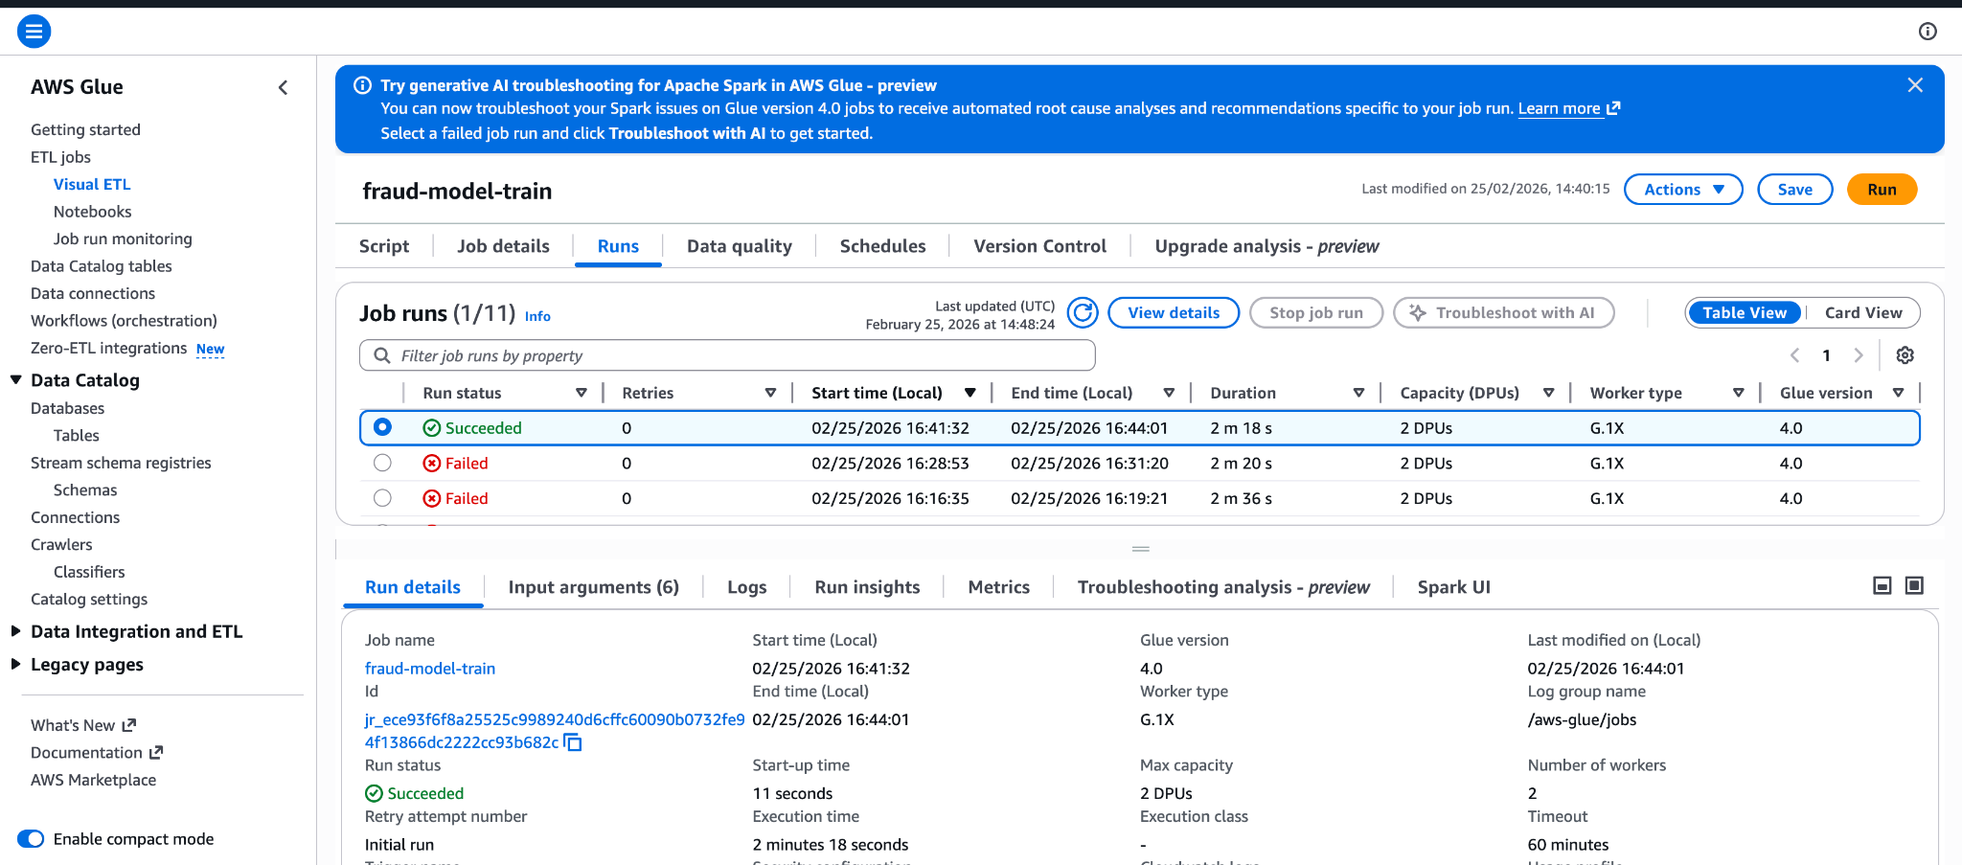

AWS Roles

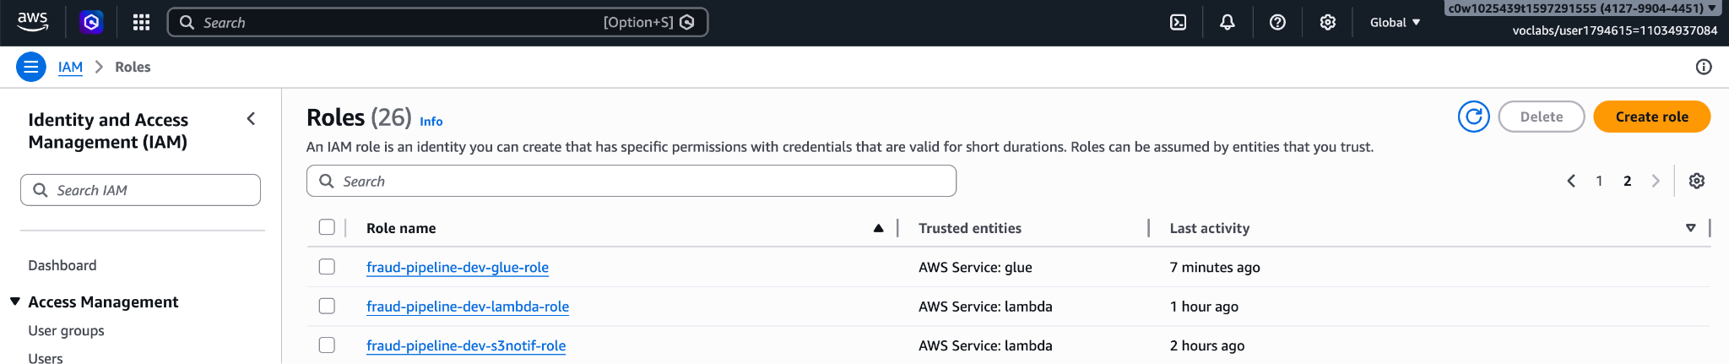

ECS Service

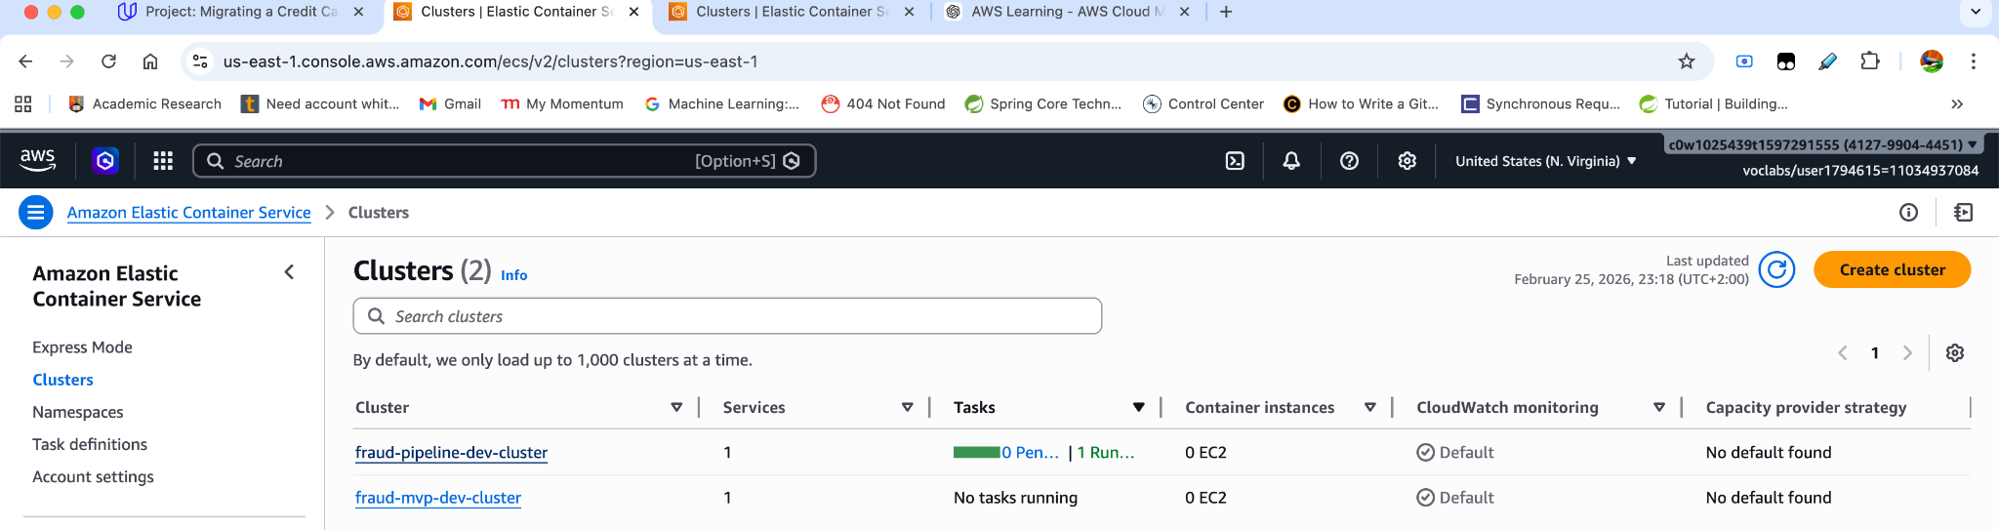
API Test
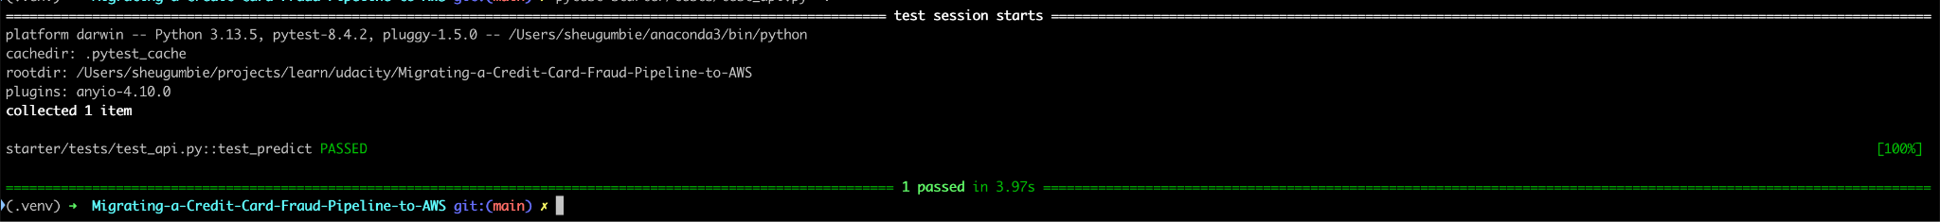
More ECS
