- ECS - I used AWS ECS for running docker images without the complexity of k8s.
- AWS Lambda - I used lambda trigger retraining
- AWS NLB - I used the network load balancer to expose my service externally
- AWS S3 - Used S3 for storage

I created a script to help with the creation of resources:

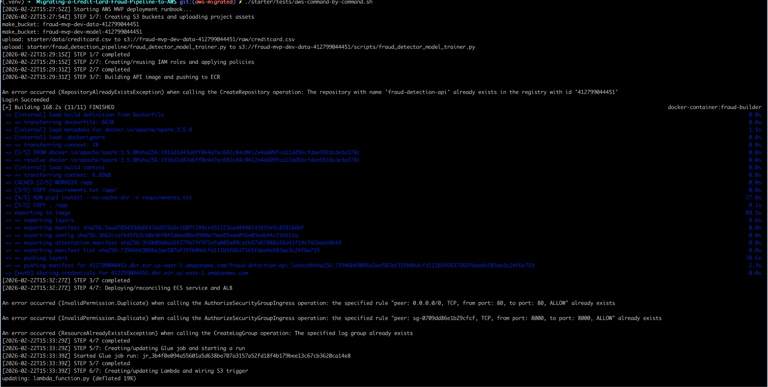

Some results that show that the application was running but I ran out of credits.

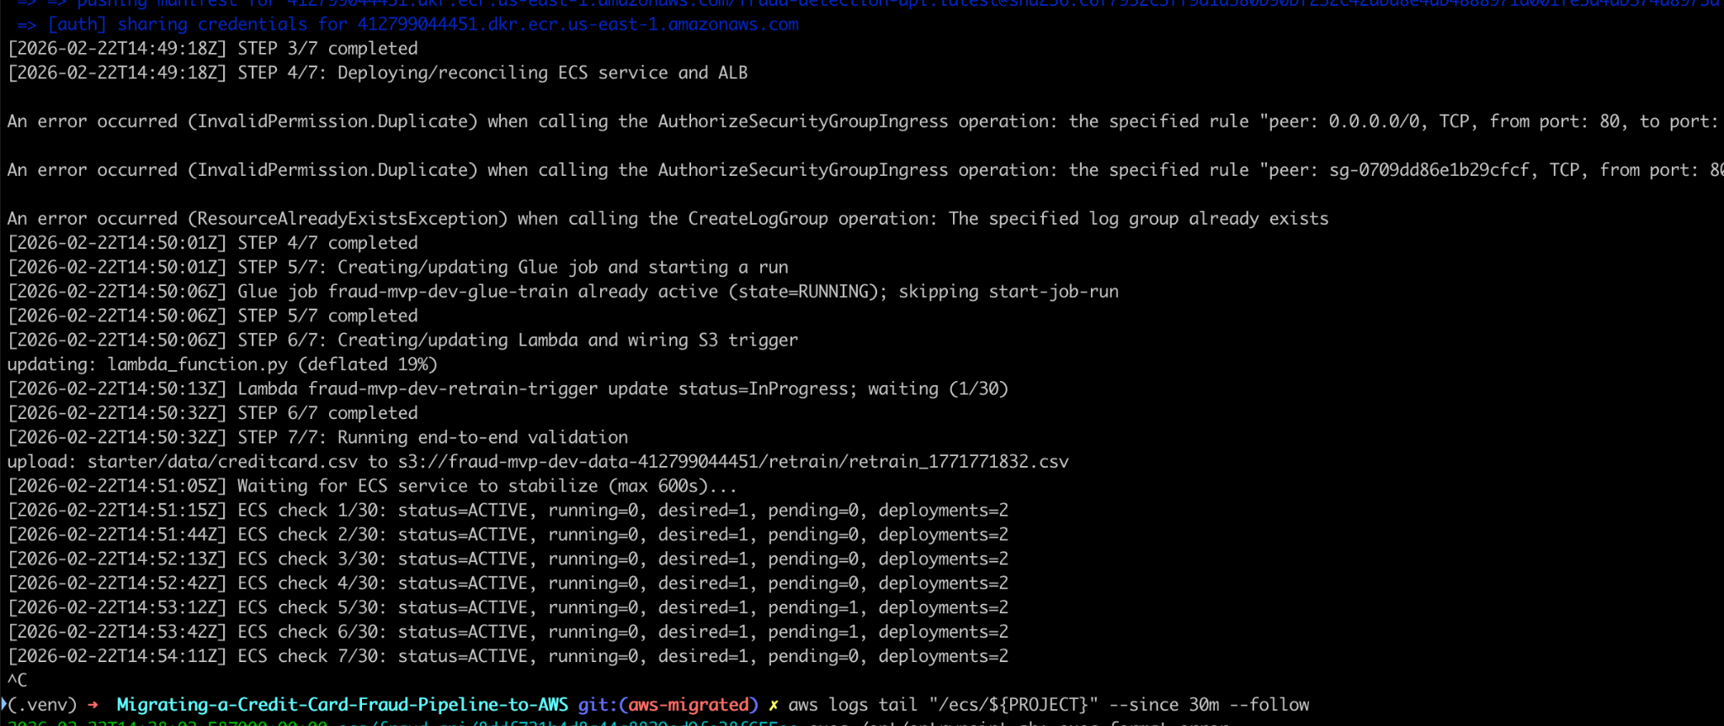

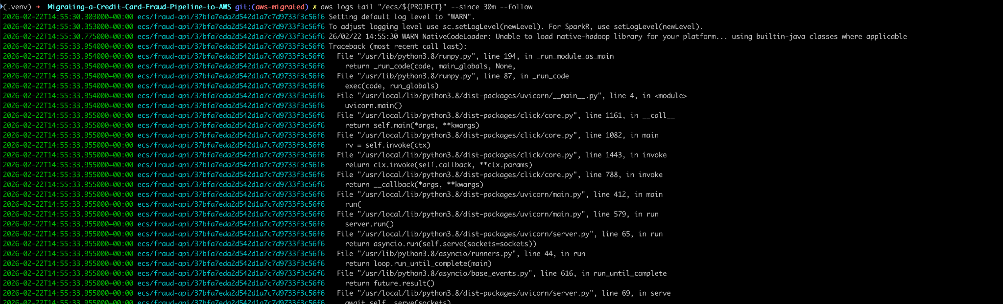

Running my supper script:

