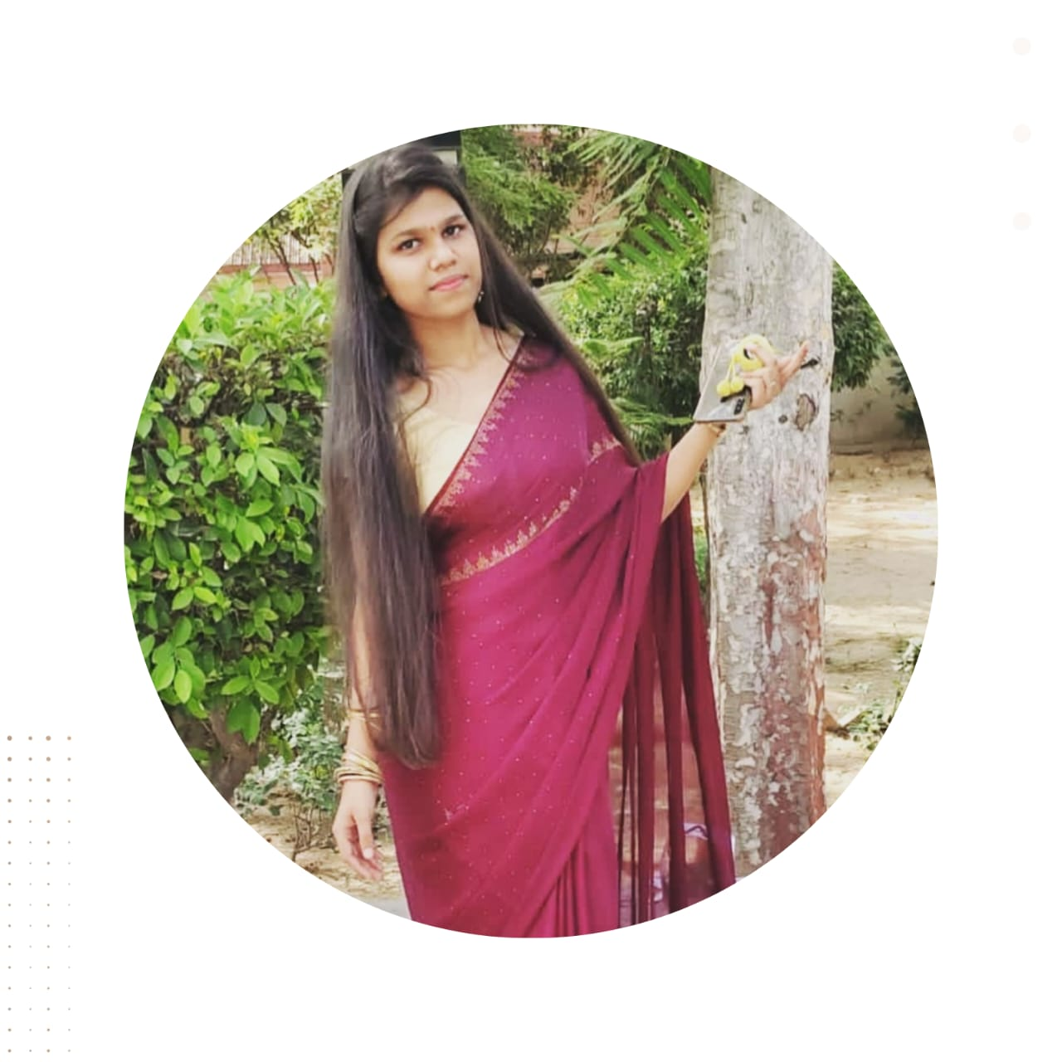

**Shivani**

**Giri**



**CONTACT**

**INTRODUCTION**



Shivanigiri36@gmail.com

**TECHNICAL SKILLS**

+91 7678419218

I am Shivani Giri, a dedicated and enthusiastic Frontend Developer currently pursuing my B.Tech degree at ABES Engineering College. Committed to continuous learning and skill development, my goal is to evolve into a proficient Software Developer. With a strong work ethic and a passion for staying up-to-date with industry trends, I am focused on contributing my expertise to innovative software projects.





Ghaziabad , Uttar Pradesh

linkedin/shivani-giri-6b1773257

* HTML
* CSS
* JS (Basics)
* C language

**EDUCATION**

**RAM KISHAN INSTITUTE sanjay nagar, gzb**

* Web designing
* Playing Hockey
* Dancing
* Problem-Solving
* Team Leadership

Creating a responsive website portfolio, where I apply my newfound skills in HTML, CSS, and JavaScript to showcase my dedication to web development.

In the future, I am committed to continuous learning and plan to craft aesthetic websites by harnessing advanced HTML, CSS, and JavaScript techniques to deliver an immersive user experience.

Completed 10th with a CGPA 8.02 in (19-20)

Completed 12th with a CGPA 9.0 in (21-22)

2022 - 2026

**ABES ENGG. COLLEGE , gzb**

BACHELOR OF TECHNOLOGY in COMPUTER SCIENCE

**HOBBIES**

**PROJECTS**

©AZURIUS - My-resume-templates.com

**INTERPERSONAL SKILLS**

**LANGUAGES**

* Hindi : Native
* English: communicative
* Communication
* Leadership
* Team Work
* Decision Making