Testing Scheme for Steam Store

1. Smoke Test

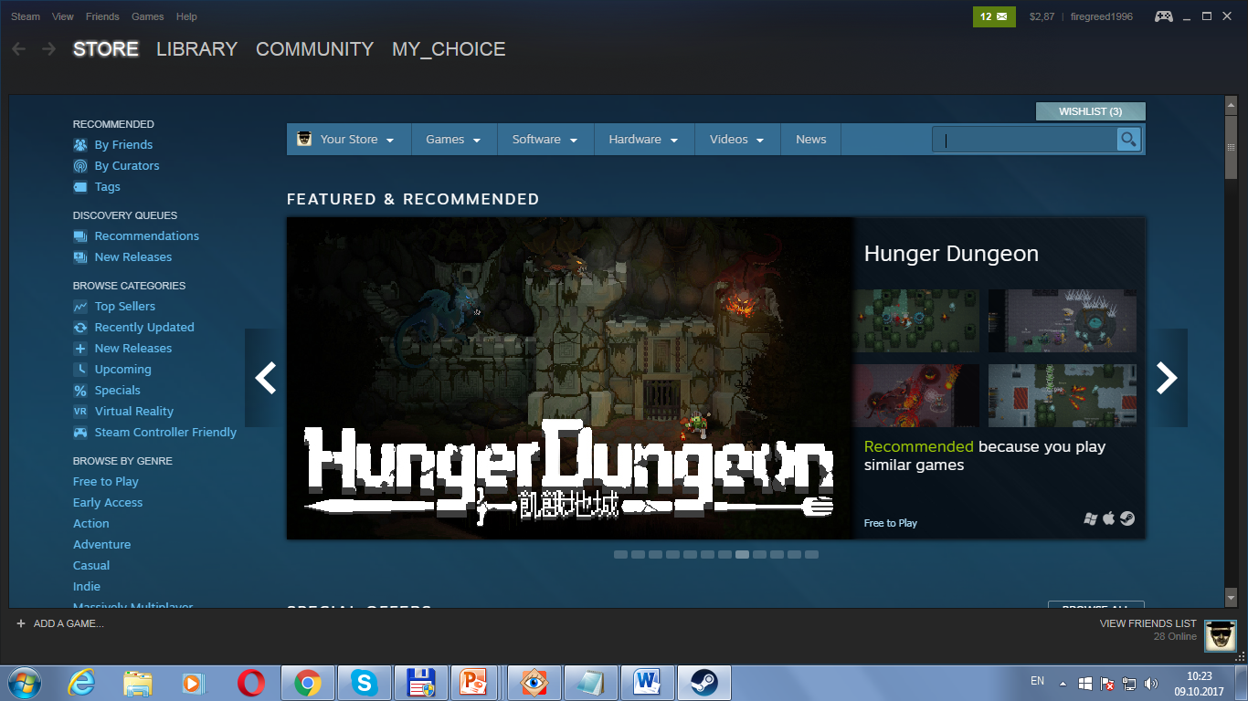

1. I want to test Search functionality
2. State Transition:

Info about NO games

False Name

List of games

True Name

Wait for request

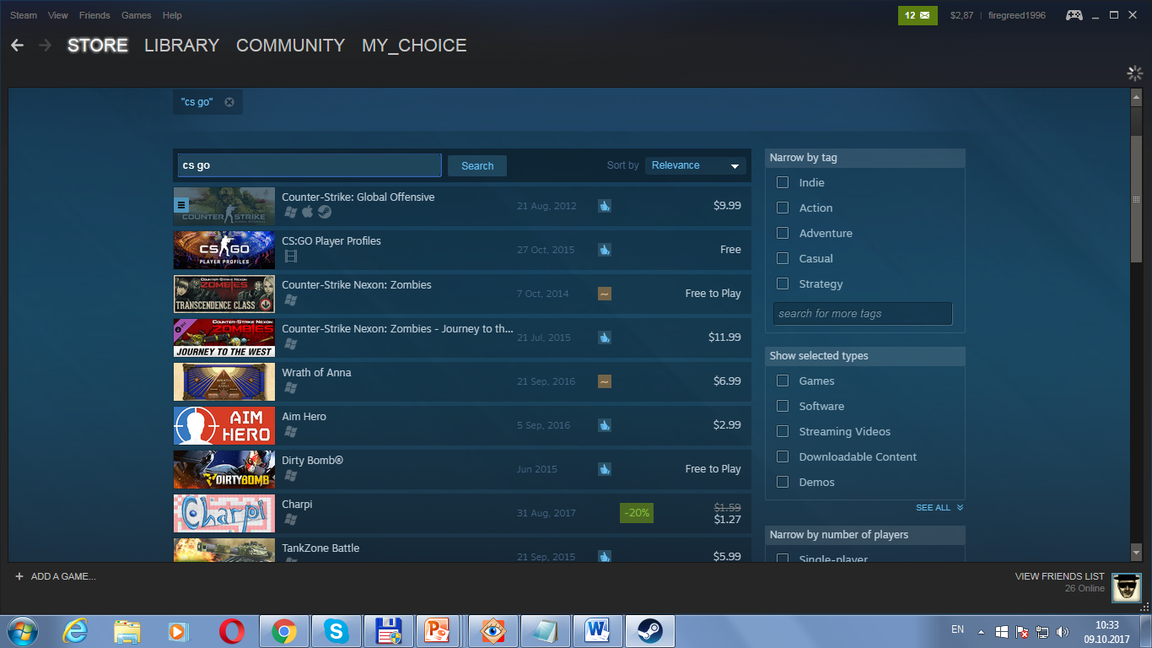

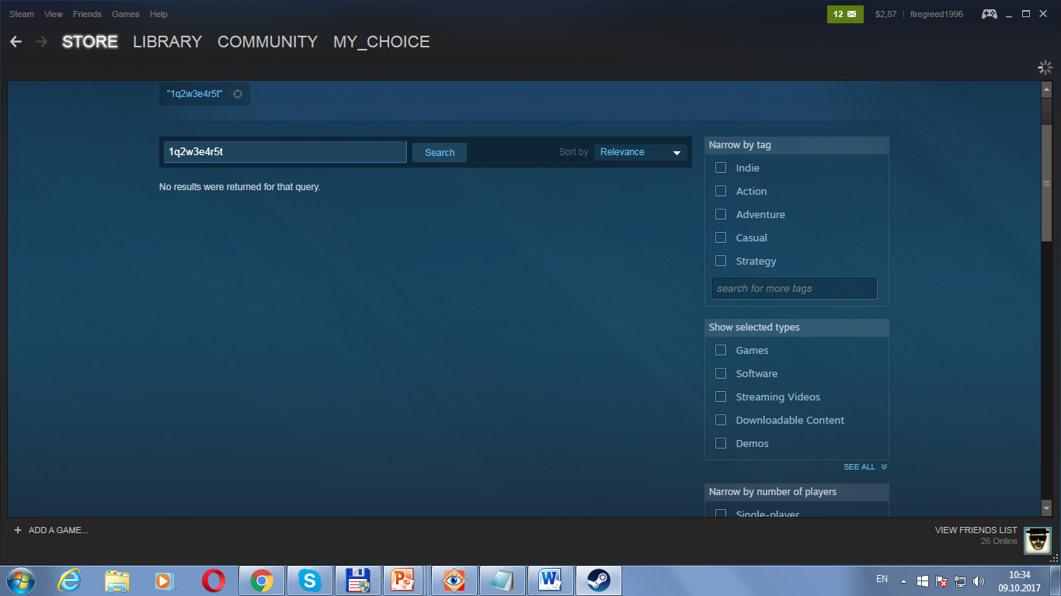

1. Decision Table

|  |  |  |  |  |  |
| --- | --- | --- | --- | --- | --- |
| Causes(inputs) | R1 | R2 | R3 | … | Rn |
| Indie | - | + | + | . | + |
| Action | - | - | + | . | + |
| Adventure | - | - | - | . | + |
| Casual | - | - | - | . | + |
| Strategy | - | - | - | . | + |

1. Pairwise

|  |  |  |  |
| --- | --- | --- | --- |
| Tag | Type | NoP | VR |
| Indie | Games | Single | + |
| Action | SoftWare | Multy | + |
| Adventure |  | Single | + |
|  |  |  |  |
| Indie | SoftWare | Multy | - |
| Action | Games | Single | - |
| Adventure | SoftWare | Online | + |
|  |  |  |  |
| Indie |  | Multy | + |
| Action | SoftWare | Single | - |
| Adventure | Games | Multy | - |

Testing Scheme for Rubik's Cube

1. Smoke Test

It’s Cube?) YES

1. Installation Testing: —
2. GUI-Testing: Cube have: red, blue, white, green, yellow and orange square’s. There are 19 square’s of each colour. Cube consist’s of 27 cube’s.
3. Regression Testing: —
4. Compatibility Testing: The cube works equally both on the street and at home. The environment does not affect its operation.
5. Performance Testing: Everything works after 80 actions.
6. Stress Testing: Everything works after more then 80 actions.
7. Functionality Testing:
8. Each verge moves vertically and horizontally;
9. A certain combination allows you to make a cube with monochrome sides;
10. Useability Testing: The cube is easy to use for new user’s.

10)Acceptance testing: Cube meets all requirements.