General Overview:
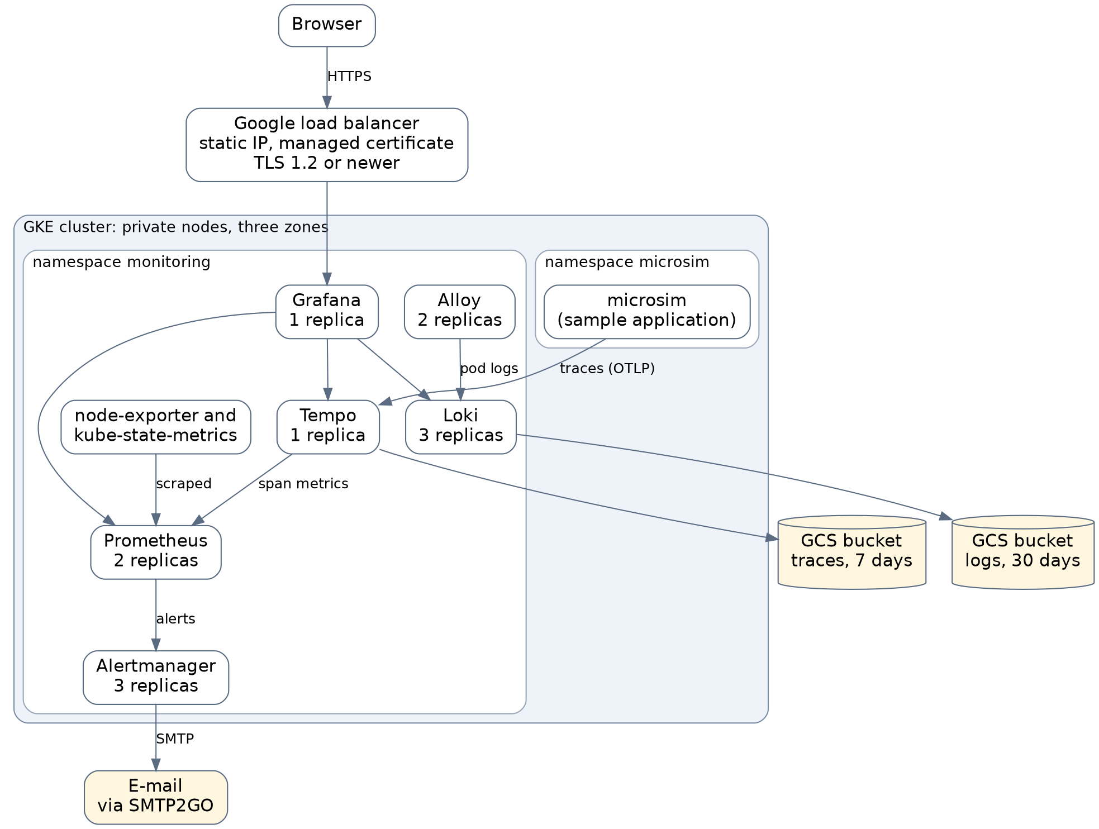
This setup runs a sample microservice application on a GKE cluster and collects its metrics, logs and traces. All three end up in one Grafana:
- Metrics. Prometheus pulls them from the cluster and keeps 7 days on a persistent disk. Alerts from Prometheus go to Alertmanager, which sends e-mail.
- Logs. Alloy reads the logs of every pod and sends them to Loki, which stores them in a GCS bucket for 30 days.
- Traces. The sample application(microsim) sends OpenTelemetry traces straight to Tempo, which stores them in a GCS bucket for 7 days.

1. Cluster
The cluster is a GKE cluster with three nodes, one in each zone. Each node is an 4 vCPU, 16 GB.
I sized them with one rule in mind: if a node fails, all the pods must still fit on the other two.
• The nodes are private: they have no public IP addresses. Outbound traffic (image pulls, SMTP) goes through Cloud NAT. The Kubernetes API endpoint is still public and protected by authentication, so kubectl works from anywhere.
• The nodes run as their own service account with only the role Google made for GKE nodes, instead of the default Compute Engine account, which has broad rights over the whole project.
• Workload Identity is on. Loki and Tempo use it to reach their buckets without any key files.
Terraform state is kept in a versioned GCS bucket.
The Terraform code is looks like this:
File | What is in it
main.tf | Google APIs, static IP, node service account, cluster, node pool
network.tf | Cloud Router and Cloud NAT for the private nodes
security.tf | TLS policy for the load balancer
storage.tf | Buckets for Loki and Tempo, their service accounts and Workload Identity bindings
variables.tf, outputs.tf | Settings (region, node size) and the values printed after apply
backend.tf, versions.tf | Remote state bucket and provider versions

2. What runs inside
Component | Version | Replicas | Storage
Prometheus | kube-prometheus-stack chart 92.10.1 | 2 | 15 Gi disk per replica, 7 days of data
Alertmanager | same chart | 3 | none
Grafana | same chart | 1 | 2 Gi disk
Loki | chart 18.17.1 | 3 | GCS bucket (30 days) and a 5 Gi buffer disk per replica
Tempo | chart 3.2.0 | 1 | GCS bucket (7 days) and a 5 Gi buffer disk
Alloy | chart 1.13.1 | 2 | none
microsim (sample app) | image v0.6.0 | 1 | none

3. Alerts and Dashboard
Alerts
Prometheus evaluates about 100 default Kubernetes rules and 7 of my own (in custom-alerts.yaml), and sends alerts to Alertmanager. Alertmanager sends an e-mail through SMTP2GO, plus a second one when the problem is gone.
My own rules cover the application and the stack itself:
- more than 5 percent of spans failing, and no traces arriving at all
- the sample application having no running pod
- Loki, Tempo or Alloy not running
- a StatefulSet running with fewer replicas than configured, which means the redundancy is reduced
- a monitoring target that Prometheus cannot scrape
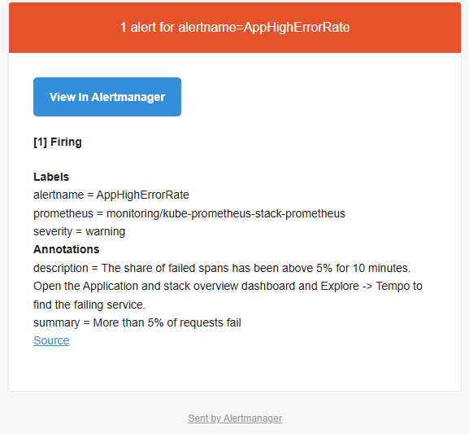
Dashboard
The dashboard called Application and stack overview is a ConfigMap in git. Grafana loads it automatically, so it comes back after a reinstall. It shows request rate, errors and latency per service, a log panel for the sample application, and CPU, memory and disk use of the stack.

4. Grafana
Only Grafana is reachable from outside. A GKE Ingress creates a Google Cloud load balancer on a reserved static IP address, so the DNS record for grafana.sheveria.com never has to change, even if the Ingress is recreated. The certificate is a Google-managed one: once the A record points at the load balancer, Google issues it and renews it on its own. Plain HTTP is redirected to HTTPS, and a TLS policy created in Terraform makes the load balancer refuse anything older than TLS 1.2.
5. Security
What is in place:
• One public entry point (Grafana), HTTPS with TLS 1.2 or newer, login required, no anonymous access and no self sign-up.
• Private nodes with outbound access only through Cloud NAT.
• Least privilege for the accounts. The nodes have their own account with one minimal role. Loki and Tempo each have an account that can touch only its own bucket, and the buckets cannot be made public.
• No keys anywhere: pods get access to the buckets through Workload Identity.
• The Grafana admin password and the SMTP password are created in the cluster at install time and never committed to git.
What is not covered:
• The API endpoint is public (authentication only).
• There are no NetworkPolicies, and traffic between pods is not encrypted.
• Grafana has one shared admin account, no SSO and no MFA.
• Kubernetes secrets are not encrypted with a KMS key, and images are not scanned.
6. High availability
Three nodes in three zones, and enough room to lose one of them. On top of that, these components run with more than one replica:
Component | Replicas | When one replica or node fails
Prometheus | 2 | The other one keeps scraping. Graphs can differ very slightly between the two, because Grafana reads through a Service.
Alertmanager | 3 | They form a cluster and share what has already been sent, so there are no duplicate e-mails.
Loki | 3 | Each line is written to three replicas and a write succeeds with two, so logs keep flowing and nothing is lost.
Alloy | 2 | The surviving replica takes over the pods of the failed one.
Tempo | 1 | Traces sent during a restart are lost. Stored traces are safe in the bucket.
Grafana | 1 | The UI is down for about a minute. Dashboards and data sources come from git.

Prometheus, Alertmanager and Loki have PodDisruptionBudgets, so a node drain or an automatic upgrade takes down only one replica at a time. Their replicas also use hard anti-affinity, which means two replicas never share a node. I did not put a budget on the single-replica components, because it would block draining a node.
7. Additional tasks that is covered
Item | Status | Notes
Long-term support | Written down | See section 8.
Longer-term data storage | Done for logs and traces | Logs 30 days and traces 7 days in GCS. Metrics stay at 7 days; Thanos or Managed Prometheus would extend that.
DNS and TLS | Partly done | Own domain, static IP, managed certificate, HTTPS redirect, TLS 1.2 or newer.
Security hardening | Partly done | Private nodes, least-privilege accounts, Workload Identity, private buckets. Not done: NetworkPolicy, service mesh with mTLS, authorized networks for the API, Secret Manager.
Extra tooling | Partly done | E-mail alerting, custom alert rules, dashboard as code,. Not done: GitOps, CI pipeline.
8. Long-term support and next steps
For long-term care, everything should be in a git. Kubernetes and node upgrades happen on their own through the release channel. A CI job should run terraform plan and helm lint on every change. Beyond routine upkeep, several parts need to be reworked: a service mesh should be added, because there is currently no control over traffic between services (mTLS, authorization policies, retries); the Prometheus approach should be redone, with Thanos or Managed Prometheus for long-term storage and one consistent view of the two replicas; Tempo should get an OpenTelemetry Collector in front of it and move to distributed mode; and Grafana should be made highly available by moving its database to external database and running two or more replicas.

