**ENSE 475 Lab 6 Test Cases**

**Apr. 7, 2017**

**Daniel Shevtsov**

**SID: 200351253**

**Overview:**

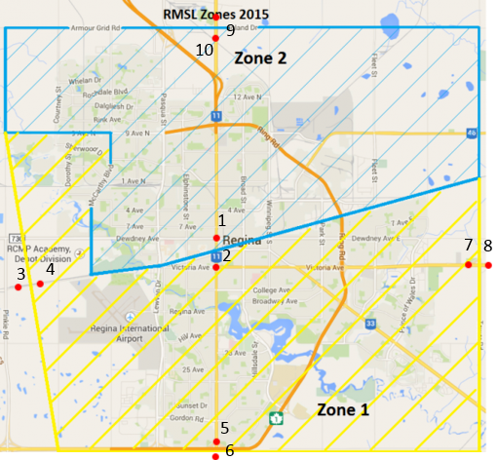

Test Points w/ Expected Outputs:

1. 2572 Dewdney Ave, Regina, SK – Zone 2
2. 2502 Victoria Ave, Regina, SK – Zone 1
3. General Rd, Regina, SK – Out of town
4. 2140 Campbell St, Regina, SK – Zone 1
5. 4969 Albert St, Regina, SK – Zone 1
6. Sherwood No. 159, SK – Out of town
7. 2610 Victoria Ave E, Regina, SK – Zone 1
8. Edenwold No. 158, SK – Out of town
9. 1850 Inland Dr, Zehner, SK – Out of town
10. 1891n 12 Ave N, Regina, SK – Zone 2

**Details:**

|  |  |  |  |  |  |
| --- | --- | --- | --- | --- | --- |
| **Test Case** | **Test Name** | **Test Data** | **Expected Result** | **Actual Result** | **Status (Pass/Fail)** |
| 1 | testPoint1 | Address = “2572 Dewdney Ave”  City = “Regina”  Province = “SK” | Zone 2 | Zone 2 | Pass |
| 2 | testPoint2 | Address = “2502 Victoria Ave”  City = “Regina”  Province = “SK” | Zone 1 | Zone 1 | Pass |
| 3 | testPoint3 | Address = “General Rd”  City = “Regina”  Province = “SK” | Out of town | Out of town | Pass |
| 4 | testPoint4 | Address = “2140 Campbell St”  City = “Regina”  Province = “SK” | Zone 1 | Zone 1 | Pass |
| 5 | testPoint5 | Address = “4969 Albert St”  City = “Regina”  Province = “SK” | Zone 1 | Zone 1 | Pass |
| 6 | testPoint6 | Address = “Sherwood No. 159”  City = “”  Province = “SK” | Out of town | Out of town | Pass |
| 7 | testPoint7 | Address = “2610 Victoria Ave E”  City = “Regina”  Province = “SK” | Zone 1 | Zone 1 | Pass |
| 8 | testPoint8 | Address = “Edenwold No. 158”  City = “”  Province = “SK” | Out of town | Out of town | Pass |
| 9 | testPoint9 | Address = “1850 Inland Dr”  City = “Zehner”  Province = “SK” | Out of town | Out of town | Pass |
| 10 | testPoint10 | Address = “1891n 12 Ave N”  City = “Regina”  Province = “SK” | Zone 2 | Zone 2 | Pass |