Sevika Singh

13th September, 2012

CSC 210 Homework 2

1. Using PHASER, determine if the origin is an unstable or asymptotically stable fixed point of the following maps. Make sure to include one screen image of stair-step diagram for each map. Show that derivative of each equation at the origin is either 1 or -1 so that the Linearization theorem is not useful in determining the stability type of the origin (e.g. when the derivative is 1 or -1, the stability type of the fixed point, whether is unstable or asymptotically stable, depends on the nonlinear terms of the equation).
2. x1 -> x1 - 1.3\*x1\*x1\*x1

Origin is asymptotically stable because the iterations approach zero.

Origin stability cannot be determined with Linearization theorem, because the derivative at the origin is one.

F’(x) = 1 – 3.9 $x^{2}$

F’(0) = 1- 3.9 🡪 F’(0) = 1

Original graph 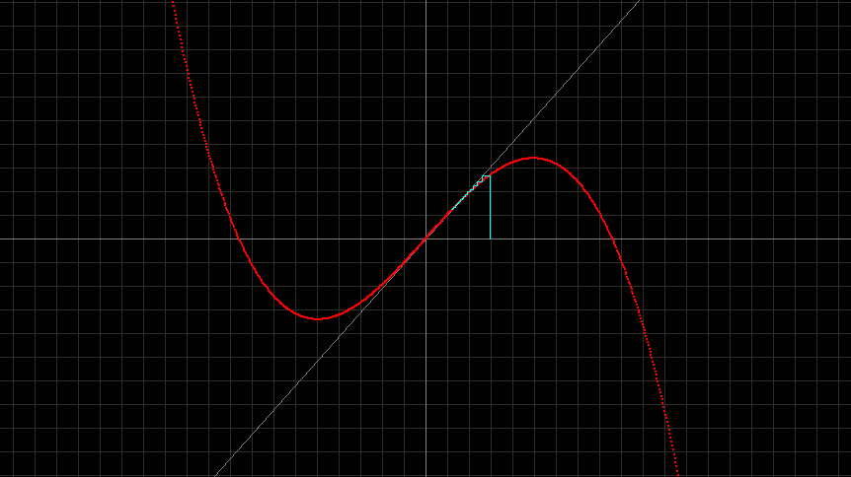

1. x1 -> x1 + 1.2\*x1\*x1\*x1

Origin is unstable because the iterations run away from zero.

Origin stability cannot be determined with Linearization theorem, because the derivative at the origin is 1.

F’(x) = 1 + 3.6 $x^{2}$

F’(0) = 1 + 3.6 🡪 F’(0) = 1

Original Graph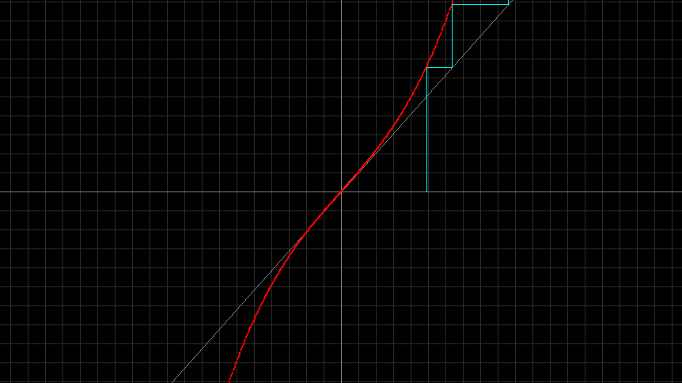

1. x1 -> -x1 - 1.1\*x1\*x1\*x1

Origin is unstable because iterations run away from zero.

Origin stability cannot be determined with Linearization theorem, because the derivative at the origin is -1.

F’(x) = -1 - 3.3 $x^{2}$

F’(0) = -1 - 3.3 🡪 F’(0) = -1

Original Graph

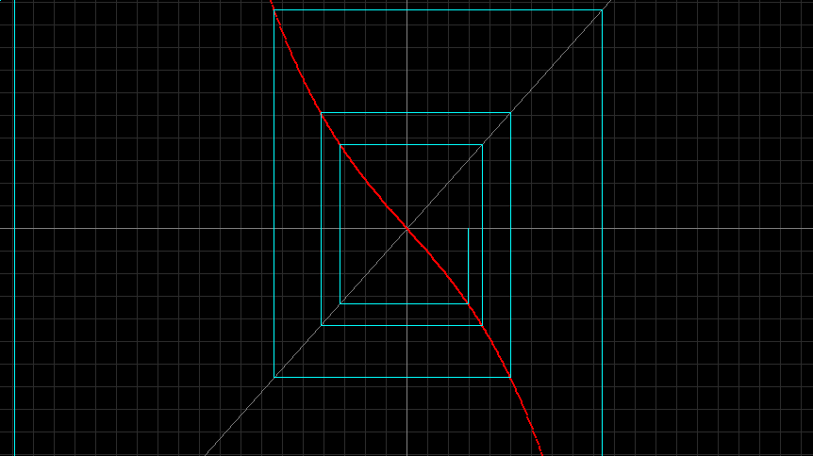

1. x1 -> -x1 + 1.12\*x1\*x1\*x1

Origin is unstable because iterations cannot meet zero.

Origin stability cannot be determined with Linearization theorem, because the derivative at the origin is -1.

F’(x) = -1 + 1.12 $x^{2}$

F’(0) = -1 + 1.12 🡪 F’(0) = -1

Original Graph

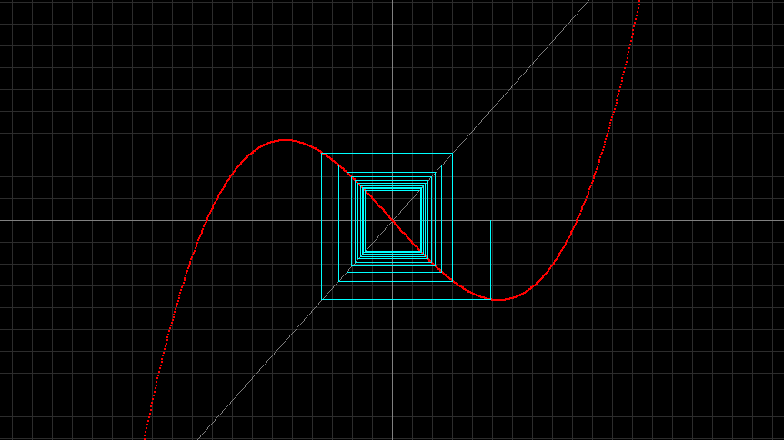

1. Consider the map x1 -> a + x1 + x1\*x1 where a is a parameter. Draw at least three stair step diagrams, say, for a = -0.13, a = 0, and a = 0.13. Describe the changes in the number and stability types of fixed points as the parameter a is changed pass 0.

a = -0.13

The first fixed point (at about (-0.36, -0.36)) is asymptotically stable because the iterations continuously approach the fixed point. After the parameter is changed past zero, the graph is still asymptotically stable towards the first fixed point, until it reaches the second fixed point (at about (0.36, 0.36)) where it becomes unstable because the iterations run away from it.

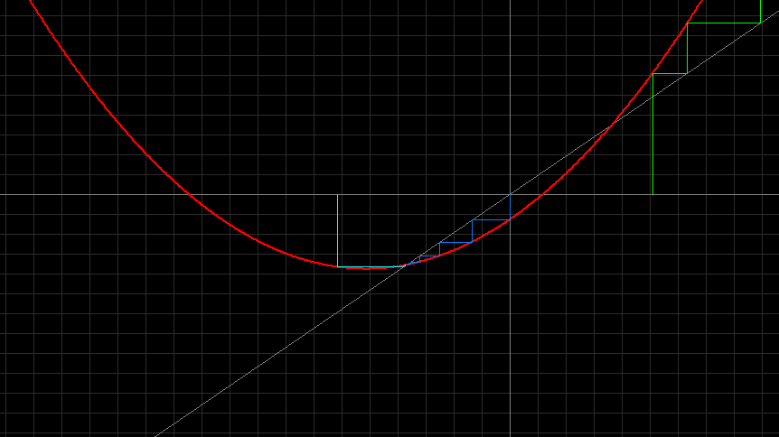

a = 0

As the graph approaches the fixed point from the left, the fixed point is stable because the iterations approach 0. However after the graph reaches the fixed point and continues to grow positive, the fixed point becomes asymptotically unstable as the iterations run away from the fixed point .

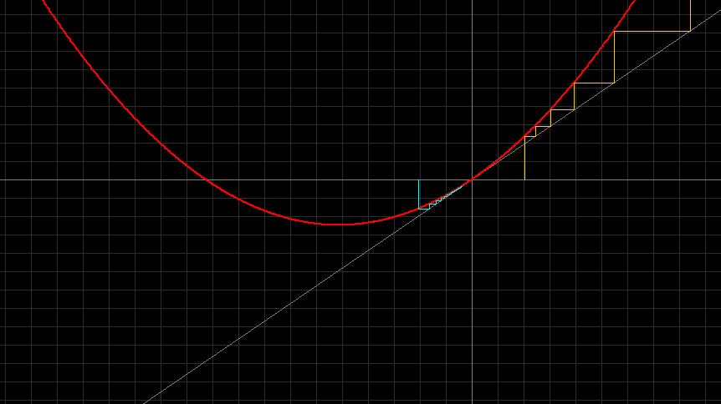

a = 0.13

The graph does not appear to have any fixed points, but the iterations all run away from the graph so it is unstable.

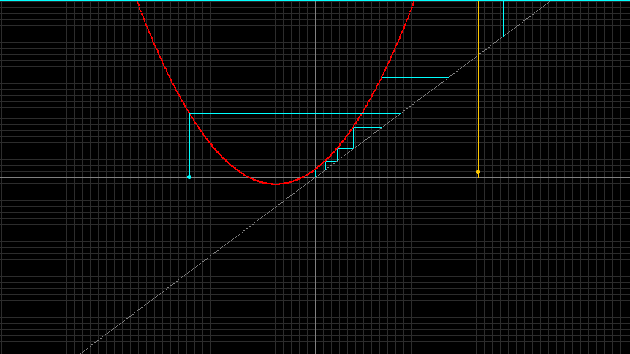

1. Suppose you want to make an investment that will pay for your child's college education. You figure you will need $42,000 when your child starts college, 12 years from now. You can buy a long term certificate of deposite or CD that pays a 6 per cent annual interest compounded monthly. What size CD should you buy?   
   *Hint:* Use the linear equation x1 -> (1.0 + 0.06/12)\*x1 . To get this equation use the Linear 1D in the Map library of PHASER and set the parameters appropriately.

A CD of $20,480.30 should be bought.

This is seen below on the graph of the linear equation x1 -> ax1+b

where a = (1.0 + 0.06/12) and b = 0. At the point where the y of the graph is ($)42,000, x = ($)20,480.3.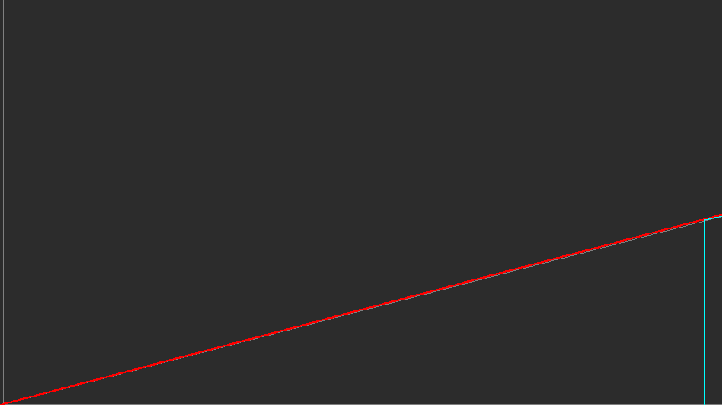

1. Consider the map x1 -> 0.375\*x1 + 1.5/x1 - 0.5/(x1\*x1\*x1). Iterate this map (derived by Alkalsadi around 1450AD) with the starting value 1.5 until 15 digits settle down. How many iterations are required? Now, count the number of all the additions, multiplications and divisions you have made to obtain your approximation to sqrt(2).

2 iterations are required. 14 total operations were made, including additions, subtractions, multiplications, and divisions.

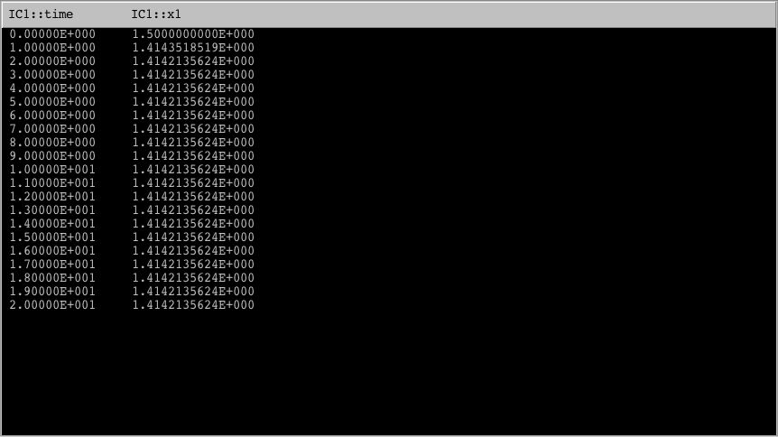

Next do the same with Newton's method using x1 ->0.5\*(x1 + 2.0/x1). Which method requires fewer number of iterations? Which method requires fewer number of operations to compute sqrt(2) to the same precision?

3 iterations are required. 9 total operations were made, including additions, subtractions, multiplications, and divisions.

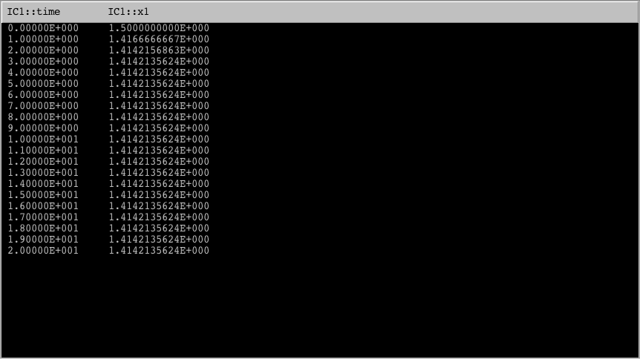

The Alkalsadi method required fewer iterations (2 versus Newton’s=3), but Newton’s method required fewer operations (9 versus Alkalsadi’s=14), proving that Newton’s method was faster to approximate $\sqrt{2}$.

1. Show that sqrt(2) is a fixed point of the MAP of Alkalsadi given in the previous problem. Show that the fixed point is asymptotically stable using the Linearization Theorem. What is the value of the derivative at the fixed point?   
   Optional: Can you explain why this MAP converges faster than the Newton iteration?

Sqrt(2) is a fixed point because of the following:

f( $\sqrt{2})$ = $0.375\left(\sqrt{2}\right)+ \frac{1.5}{\sqrt{2}}$– $\frac{0.5}{{(\sqrt{2})}^{3}}$

= 0.53 + 1.061 – 5.657

= $\sqrt{2}$

This shows that x\* = f(x\*), or in other words $\sqrt{2}$ = f($\sqrt{2})$, making it a fixed point.

The fixed point of $\sqrt{2}$ is asymptotically stable because of the following:

F’( $\sqrt{2})$ = 0.375 – 1.5 + $\frac{1.5}{{(\sqrt{2})}^{4}}$

= 0.375 – 1.5 + 0.375

= -0.75

If the result is less than one, then the fixed point is asymptotically stable. For F’( $\sqrt{2})$ the result is -0.75, which is less than one (even if you take its absolute value), showing that it is asymptotically stable.