Sevika Singh

20th September, 2012

CSC210- Homework 3

1. *Retirement funds:* Suppose you want to save 800,000 dollars over the next 30 years. To this end, suppose that you open a savings account that pays 10 percent annual simple interest. How many dollars per year should you deposit into your account to achive your goal when you retire in 30 years? Use the Linear-1D MAP in Phaser with the appropriate parameter values. It may be difficult to find the exact parameter values to have 800,000 dollar; if you a little more money when you retire, that is fine.

$4870 should be put in every year. The chart shows about $800,000 after 30 years.

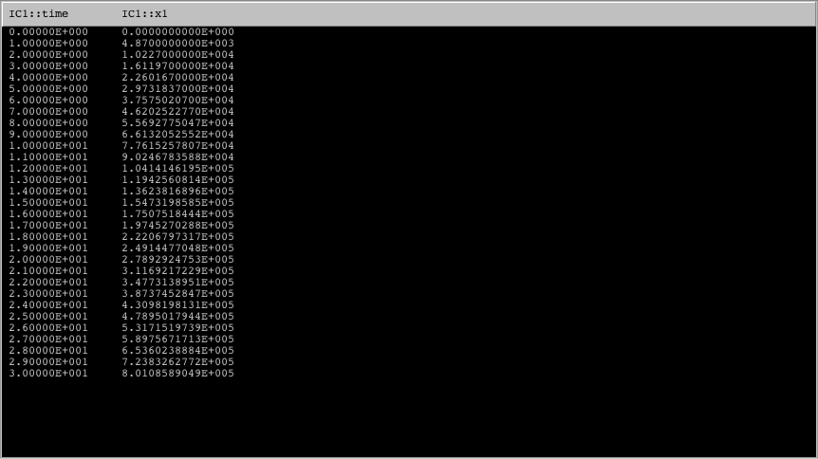

1. *Fixed points of the Logistic MAP:* Find all fixed points of the Logistic map as a function of the parameter r ( answer: x = 0 and x = 1 - 1/a) For which values of a these fixed points are biologically relevant?

Fixed points:

x = 0 and x = 1 -1/a

When a >= 1 the fixed points are biologically relevant. The first fixed point is relevant for all a’s. The second fixed point becomes biologically relevant (X*>=0) when a>= 1.

Using the Linearization Theorem, determine the values of the parameter a for which the fixed point at the origin is asymptotically stable or unstable. Next do the same for the second fixed point.

* F = $ax-{ax}^{2}$
* $\frac{dF}{dx}$ (x) = a – 2ax
* $\frac{dF}{dx}$ (0) = a 🡪 So if a<1 then x*=0 is asymptotically stable.

If a=1 then stability is unknown.

If a>1 it is unstable.

* $\frac{dF}{dx}$ (1 – 1/a) = a -2a(1 – 1/a)

= a -2a +2 = 2-a

* |2-a| < 1 🡪 if a<3 then x* = 1 – 1/a is asymptotically stable

if a > 3 then it is unstable

Note that for a = 3, the positive fixed point has derivative -1 and thus the Linearization Theorem does not apply. Using PHASER determine if this fixed point is asymptotically stable or unstable for a = 3.

The fixed point is asymptotically stable at 3, as seen below in the graph as the iterations go closer to the fixed point.

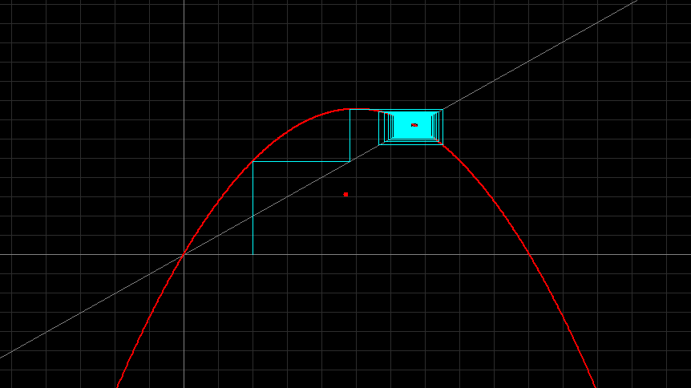

1. *Sensitive dependence on initial conditions:* In the Logistic model, first set a = 2.9. Now take two initial population sizes and determine the population densities after 50 generations. Suppose that you make 0.001 percent error in the determination of the initial population sizes. Determine the relative percentage error in the population densities after 50 generations. Repeat the same experiment with the growth rate a = 3.9.

a = 2.9

The population density after 50 generations is 0.65539511742 (as seen below). If a 0.001 percent error was made, the relative percentage error after 50 generations would be -1.942339768 x 10^-6% for a negative error, and 1.942339768 x 10^-6% as seen below.

Negative error

* 0.65539511742 – 0.65539513015 = -1.237 x 10^-8

(-1.237 x 10^-8) / 0.65539511742 = -1.942339768 x 10^-8

(-1.942339768 x 10^-8) X 100 = -1.942339768 x 10^-6

Positive error

* 0.65539511742 – 0.65539510469 = 1.237 x 10^-8

(1.237 x 10^-8) / 0.65539511742 = 1.942339768 x 10^-8

(1.942339768 x 10^-8) X 100 = 1.942339768 x 10^-6

population size = 0.3 -%error = 0.299997 +%error = 0.300003

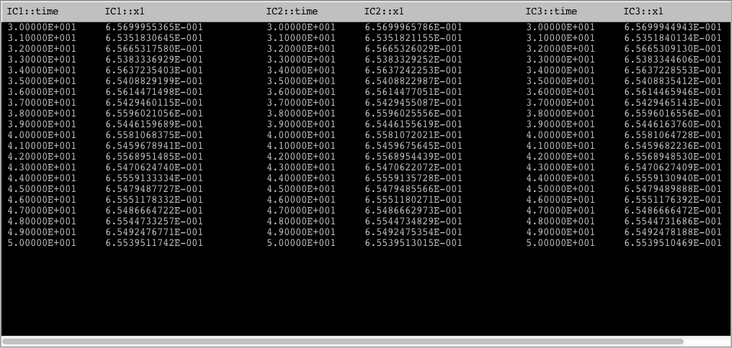

a = 3.9

The population density after 50 generations is 0.87141548193 (as seen below). If a 0.001 percent error was made, the relative percentage error after 50 generations would be 1.504435392 % for a negative error, and 67.10021756 % as seen below.

Negative error

* 0.87141548193 – 0.85830559901 = 0.01310988292

0.01310988292 / 0.87141548193 = 0.01504435392

0.01504435392 X 100 = 1.504435392

Positive error

* 0.87141548193 – 0.28669379766 = 0.5847216843

0.5847216843 / 0.87141548193 = 0.6710021756

0.6710021756 X 100 = 67.10021756

population size = 0.3 -%error = 0.299997 +%error = 0.300003

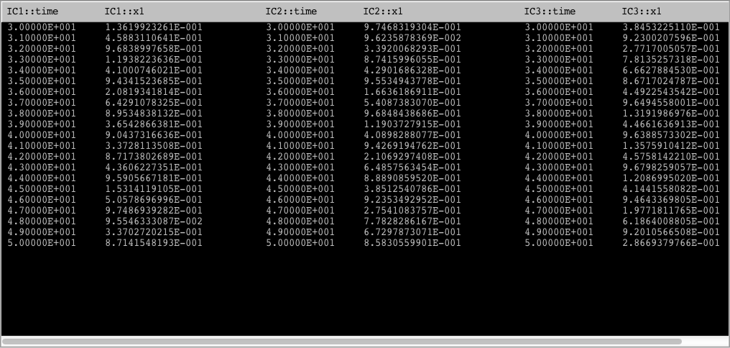

1. *Logistic vs. Logistic*: Note that in the Equation -> MAP Library of Phaser, there are two versions of the logistic MAP:  
   Logistic MAP: x1->a x1 (1 - x1)   
   Logistic III MAP: x1 -> a x1 - a x1 x1  
   These two maps are mathematically identical (just open up the parantheses). On the computer, however, they can behave differently.
2. Set a = 2.8 and compute 100 iterates of the initial condition 0.23 first using Logistic MAP and next using Logistic III MAP. In the Xi Values view, look at the two sets of numbers. Do the numbers look the same at each iterate?

Yes, the numbers look the same at each iterate.

1. Now set a = 3.9, compute 100 iterations of the same initial condition with both versions of the Logistic. Do the numbers look the same? If not, at what iterate the values have no digits in common? What do you make of this puzzling, and disturbing, computational experiment? For a possible hint, read about floating-point arithmetic; see, for example, [Wikipedia article](http://en.wikipedia.org/wiki/Floating_point).

The numbers look the same until you get to the 22nd iteration, where they begin to alter. After this point, as the iterations increase, the alterations increase as well. This is because the computer uses floating-point representation, in which it stores an approximation to real numbers, rather than the exact number. So after a few iterations, very small errors are made by the computer because it can’t be perfectly accurate. After more iterations occur, the error keeps multiplying, and so the small errors ruin the calculations after several iterations.

1. *Beverton-Holt Stock-recruitment model:*   
   **xn+1 = rxn/[1 + ((r - 1)/k)xn]**   
   This is a biologically important fisheries model containing two parameters r (growth rate) and k (carrying capacity). Despite its complicated form, this model has simple dynamics. We assume that both parameters take on non-negative values. Enter this model into Phaser.
2. To understand the geometric meanings of the parameters, Fix k (say at 1) and vary r make a Gallery of growth curves using the stair-step view of PHASER (study the Phaser Tutorials Lesson 6 and Lesson 13 to learn about the Gallery and making SlideShow). You may want to take big window size (-1 , 15; -1, 15) to see what happens as the population gets large. Next, fix r = 1.5 and vary k. Describe biologically what you observe in these two sequences. Note: In this model varying the parameters is not dangerous (unlike the logistic model).

Here, the carrying capacity is stable, but the growth rate is not. In the first two instances, where the growth rate is less than 1, the fixed point (but always greater than 0), the population increases more slowly, until it reaches the fixed point, where the population grows much more rapidly. In the second two instances (where the growth rate is greater than 1, or the fixed point) the population grows rapidly, until it reaches the fixed point, and then grows much more slowly.

k = 1; r = 0.5, 0.9, 1.5, 2 (top left, right, bottom left, right)

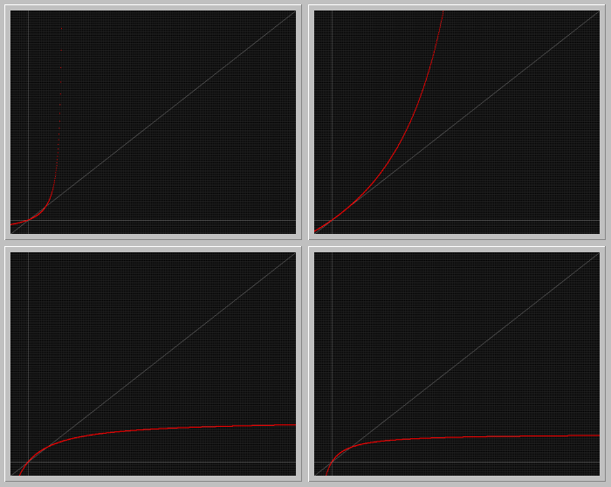

Here, the growth rate is stable, but the carrying capacity is not. All of these graphs show faster population increase until the graph reaches the fixed point, in which the population growth slows and increases much more slowly.

r = 1.5; k = 0.2, 1, 2, 5 (top left, right, bottom left, right)

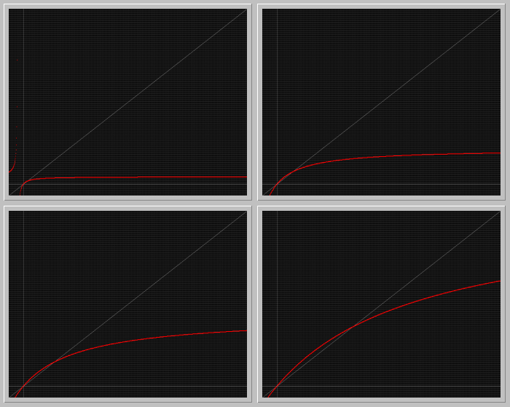

1. Find the fixed points of the model as a function of the parameters. For what ranges of the parameters they are biologically significant?

The fixed points are x*=0 and x*=k. They are biologically significant when k > 0. The first fixed point is significant for all values.

1. Determine the stability type of the fixed points. Can the positive fixed point become unstable as the parameter r or k is increased?

The fixed point x=0 is unstable. The fixed point x=k is asymptotically stable. The positive fixed point cannot become unstable if r or k are increased, as long as they are positive it will be stable.

1. Write a summary of the possible dynamics of a population described by the Beverton-Holt model and interpret your findings in biological terms.

The Beverton-Holt model represents possible population growth. It represents at what level population growth becomes constant, and at what levels the growth increases or declines. I found that as long as the carrying capacity is always greater than zero, the population has the ability to grow. However, if the growth rate is greater than 0, but less than one, the population increases rapidly after the carrying capacity is met. If the growth rate is greater than one though, the population slowly increases, and becomes steadier with time after the carrying capacity is met.