Sevika Singh

27th September, 2012

CSC 210 Homework 4

1. *Period-doubling everywhere:* In the Logistic MAP, set the parameter a = 3.83. Fix Start time= 2500, Stop Time=3100 and initial condition 0.2. Draw the Stair-Step diagram to see period-3 solution. Check the numbers in Xi-Values view to make sure that the numbers repeat every fourth iteration. Now, change the value of the parameter a carefully to make this solution to bifurcate to a period-6 solution. Change a a bit more to obtain a period-12 solution. Submit your parameter values, Xi values, and the Stair step diagrams.

Period-3 Solution

Xi Values show that the numbers repeat every fourth iteration. (Cycle start is highlighted)

a = 3.83

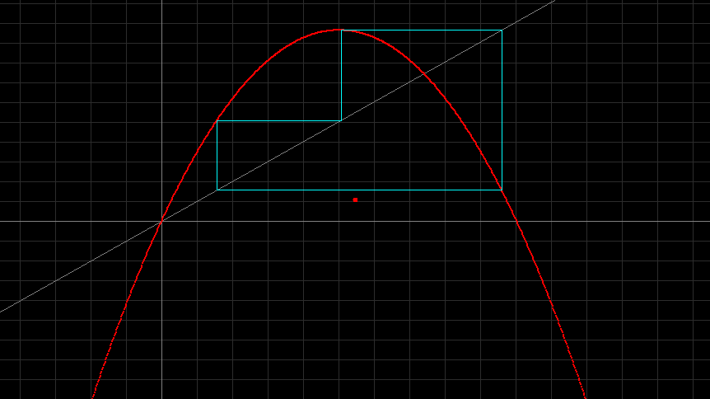

Xi Values

3.07500E+003 5.0466648741E-001

3.07600E+003 9.5741659752E-001

3.07700E+003 1.5614931568E-001

3.07800E+003 5.0466648741E-001

3.07900E+003 9.5741659752E-001

3.08000E+003 1.5614931568E-001

3.08100E+003 5.0466648741E-001

3.08200E+003 9.5741659752E-001

3.08300E+003 1.5614931568E-001

Period-6 Solution

Xi values show that numbers repeat every 7th iteration. (Cycle start is highlighted)

a = 3.845

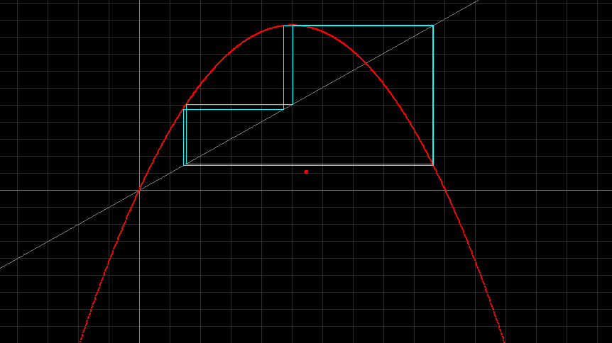

xi-Values

3.07500E+003 5.0092957812E-001

3.07600E+003 9.6124667748E-001

3.07700E+003 1.4323202718E-001

3.07800E+003 4.7184537917E-001

3.07900E+003 9.5820213512E-001

3.08000E+003 1.5399533897E-001

3.08100E+003 5.0092957812E-001

3.08200E+003 9.6124667748E-001

3.08300E+003 1.4323202718E-001

3.08400E+003 4.7184537917E-001

3.08500E+003 9.5820213512E-001

3.08600E+003 1.5399533897E-001

3.08700E+003 5.0092957812E-001

3.08800E+003 9.6124667748E-001

3.08900E+003 1.4323202718E-001

3.09000E+003 4.7184537917E-001

3.09100E+003 9.5820213512E-001

3.09200E+003 1.5399533897E-001

Period-12 Solution

Xi values show that numbers repeat every 13th iteration. (Cycle start is highlighted)

a = 3.849

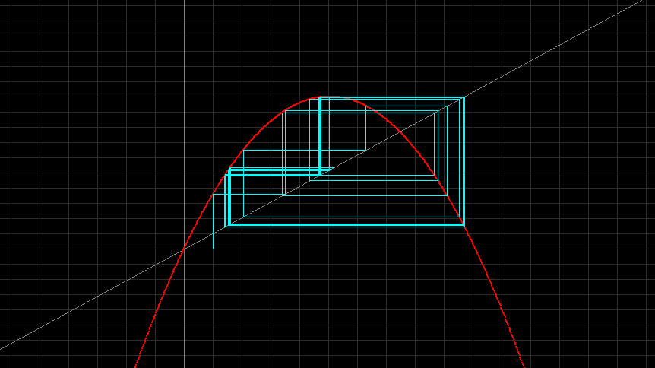

xi-Values

3.07500E+003 1.3987883045E-001

3.07600E+003 4.6308374874E-001

3.07700E+003 9.5700454582E-001

3.07800E+003 1.5837420678E-001

3.07900E+003 5.1304020520E-001

3.08000E+003 9.6159548928E-001

3.08100E+003 1.4214204685E-001

3.08200E+003 4.6933815098E-001

3.08300E+003 9.5863136655E-001

3.08400E+003 1.5264083074E-001

3.08500E+003 4.9783584738E-001

3.08600E+003 9.6223197299E-001

3.08700E+003 1.3987883051E-001

3.08800E+003 4.6308374889E-001

3.08900E+003 9.5700454587E-001

3.09000E+003 1.5837420663E-001

3.09100E+003 5.1304020480E-001

3.09200E+003 9.6159548932E-001

3.09300E+003 1.4214204671E-001

3.09400E+003 4.6933815059E-001

3.09500E+003 9.5863136646E-001

3.09600E+003 1.5264083106E-001

3.09700E+003 4.9783584825E-001

3.09800E+003 9.6223197301E-001

3.09900E+003 1.3987883045E-001

1. *Ricker model:*   
   **xn+1 = xn * exp(r*(1- xn/k))**   
   This is a biologically important fisheries model containing two parameters r (growth rate) and k (carrying capacity). We assume that both parameters take on non-negative values.

* Fix the carrying capacity at k=1, and vary the growth rate r. Describe how the growth curve changes.

All 8 graphs below represent k= 1, and r = 0.5, 1.2, 1.8, 2.5 (top left, right, bottom left, right, respectively for each set of stair-step then xi vs time graphs). It is seen that with the lower growth rate, the initial population growth is slower, then the population levels off more slowly with time. The higher the growth rate, the faster the initial population growth is, and the decline is much more rapid before the leveling off.

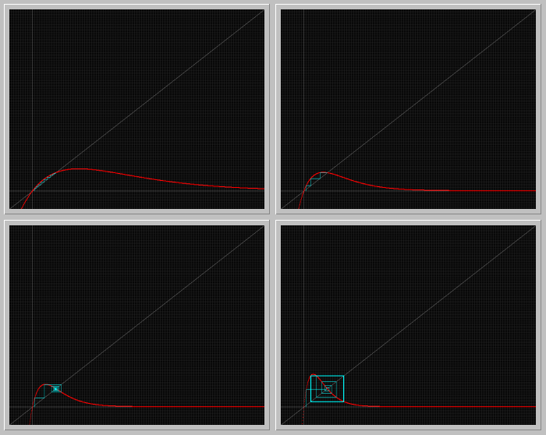

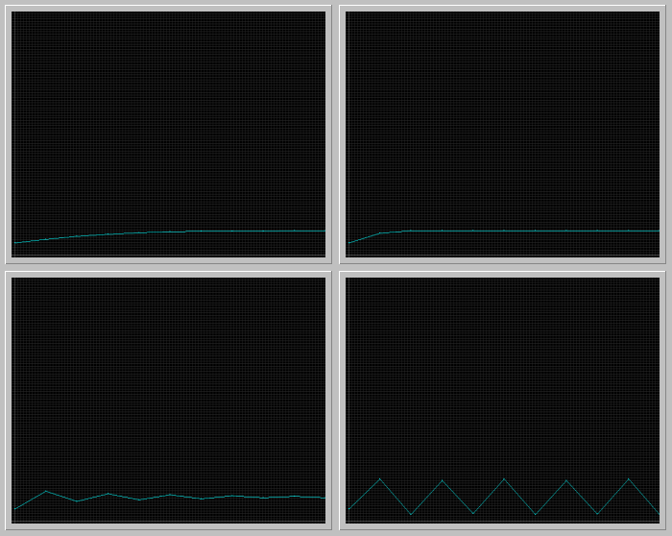

* Fix the growth rate r = 2, and vary k. How does the growth curve depend on k?

All 8 graphs below represent r = 2, and k = 0.5, 1, 2, 3 (top left, right, bottom left, right, respectively for each set of stair-step then xi vs time graphs). The greater the k (carrying capacity), the larger the graph has the ability to grow. So the larger the k, the bigger the grow curve peaks.

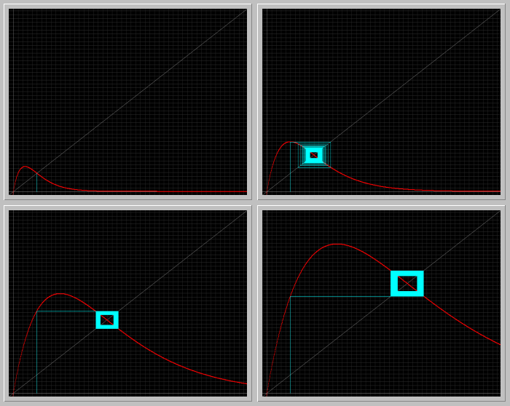

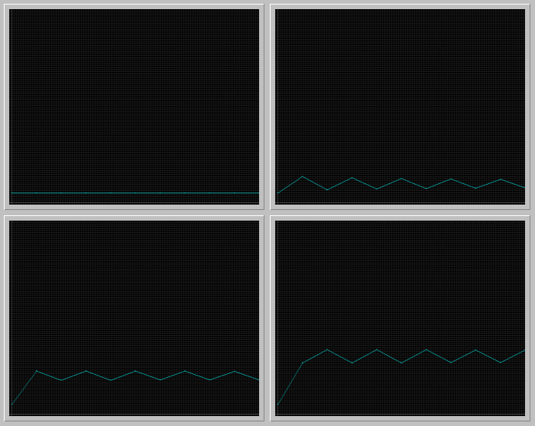

* Construct the bifurcation diagram of the Ricker MAP by fixing k = 1, and vary r. (see Figure 5 on the link above.) Locate a value of r for which the map has a periodic orbit of period 3.

r = 3.15

* What are the values of the population size on this orbit?

2.7, 0.012, 0.28

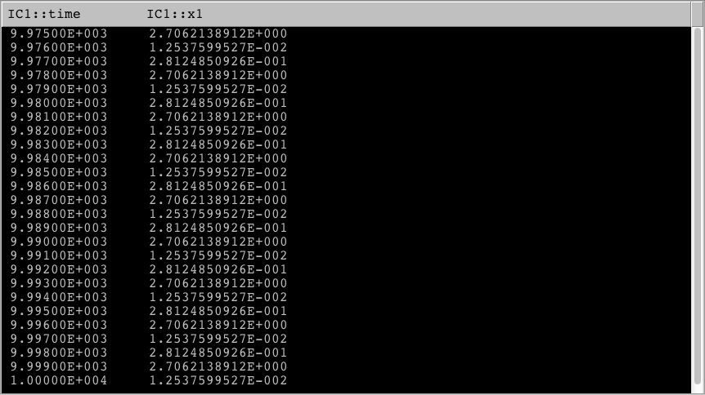

* For which value of r this period-3 solution undergoes a period-doubling bifurcation?

3.16

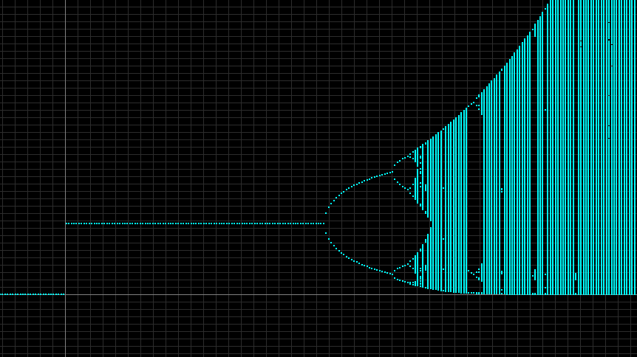

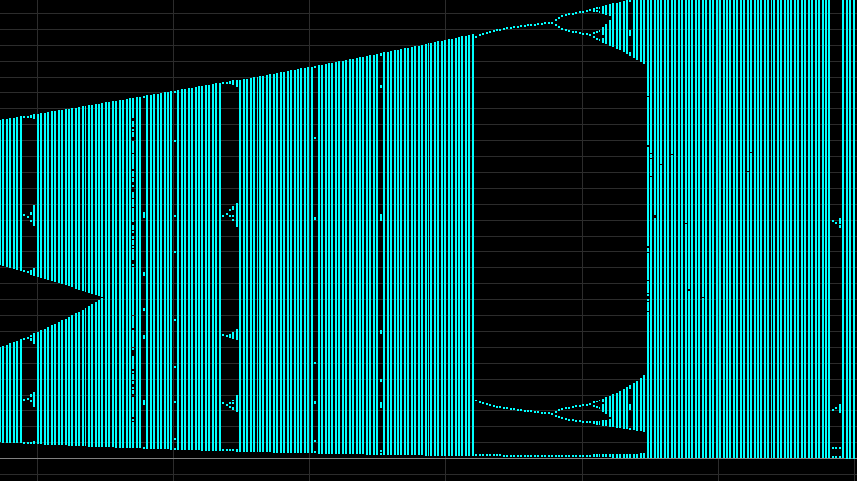

Period 3 doubling bifurcation

1. *Bifurcation diagram for Discrete Predator-Prey:*  You should see the following bifurcation diagram:

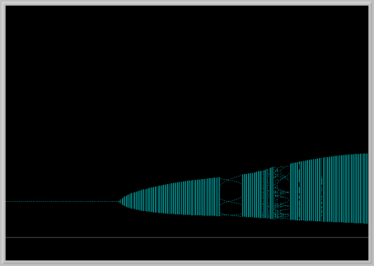

In this diagram, parameter b is fixed and a is varied. The horizontal axis is the parameter a and the vertical axis is the x1 variable (prey). Notice that the prey population is periodic with period 6 in a small window of the bifurcation diagram. Pick an a value in this window and for this value of the parameter a, plot the prey and predator in the Xi vs. Time window, and also in the Phase Portrait view. Interpret your pictures in biological terms.

a = 3.2; The pictures demonstrate a population that steadily fluctuates over time. That is, the population constantly goes through a cycle of increasing to a peak, and then decreasing until it has the resources to repopulate again.

Xi vs. time Phase Portrait

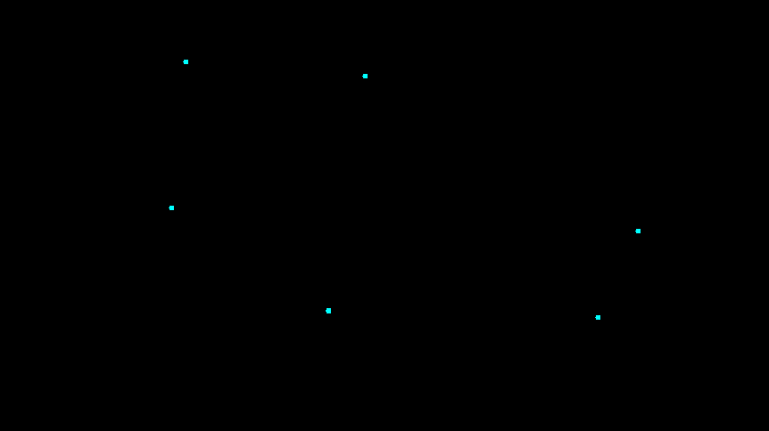 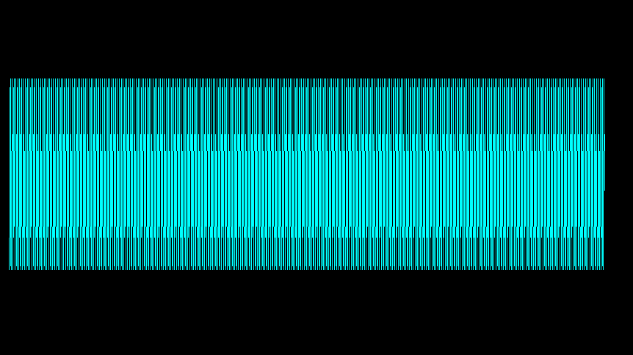

(zoomed in)

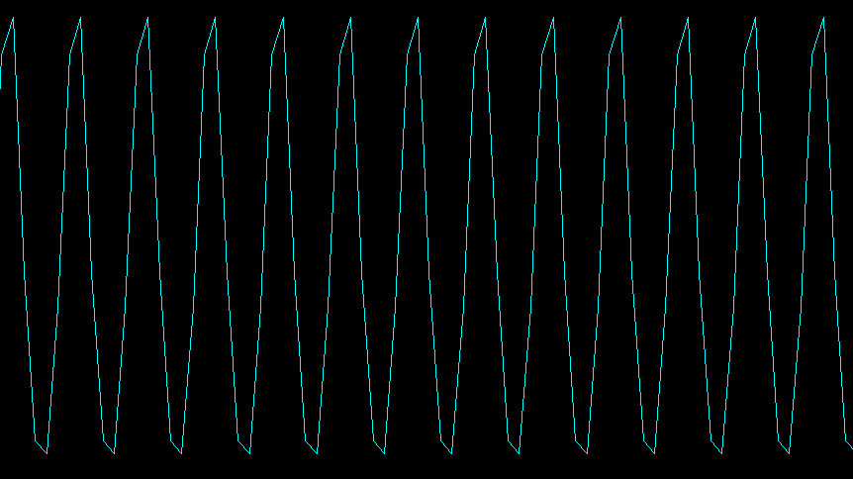 (points connected)

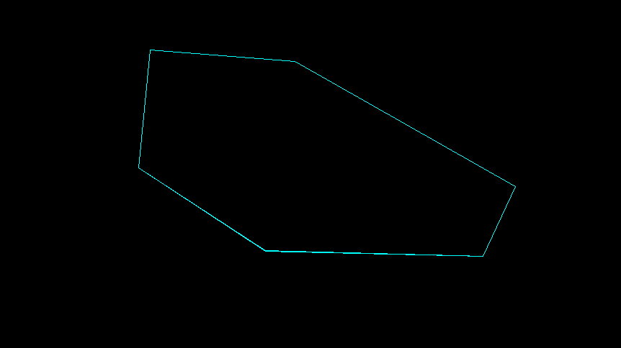

1. *Nicholson-Bailey model:* The following pair of difference equations is a famous model that describes the intereaction of host-parasitoid populations (one insect feeds on another):  
   **Hn+1 = k Hn e( -a Pn)   
   Pn+1 = c Hn [1 - e( -a Pn) ]**

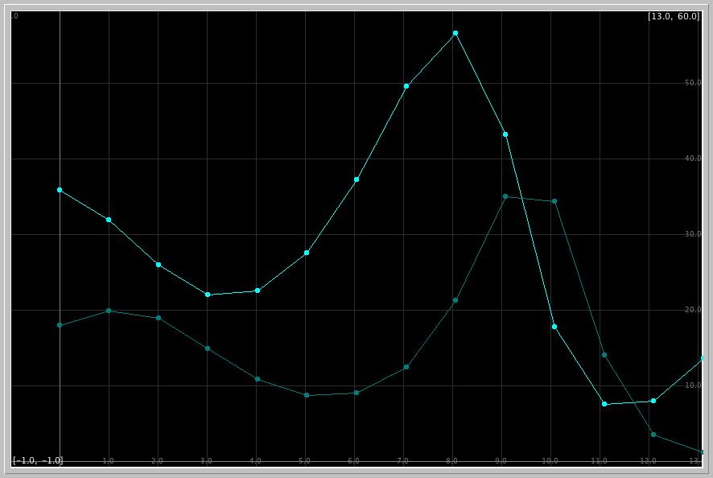

What is the experimental count of the host and parasitoid in the seventh generation in the paper of DeBach and Smith? What does the Phaser simulation of the Nicholson-Bailey model predict for these counts? What are the relative errors in the model predictions?

-Experimental count in 7th generation from paper:

Host: 47

Parasitoid: 14

-Phaser simulation prediction:

Host: 49

Parasitoid: 12

-Relative errors in model predictions:

Host: 4.26% error

Parasitoid: 14.29% error

Work:

47 – 49 = -2 14 – 12 = 2

|-2| / 47 = 0.04255 |2| / 14 = 0.14286

0.04255 * 100 = 4.255 🡪 4.26 0.14286 * 100 = 14.286 🡪 14.29

1. Read as much of the [Review article from NATURE](http://www.math.miami.edu/~hk/csc210/week4/May_Nature_76.pdf) as you can. This could be difficult reading for you, but do not be discouraged. Extract a statement of your choice, or formulate a problem, and illustrate it using PHASER.

* Equation 3 of the article illustrates the Logistic map, which is a map that models population growth growing purely exponentially. This is seen below:

$$x_{n+1}={ax}_{n}(1- x_{n})$$

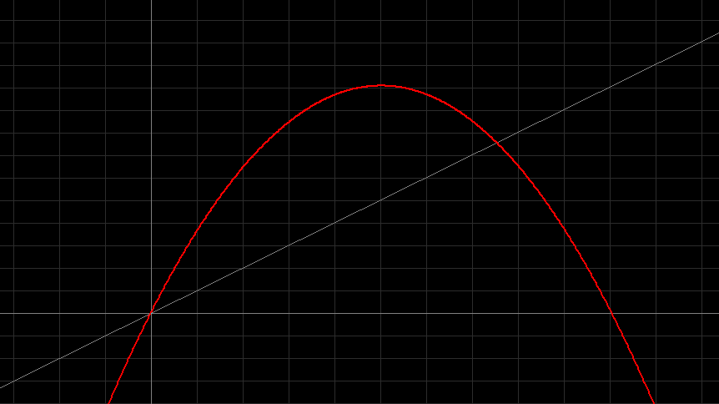

* However, equation 9 illustrates finding population values that occur every second generation (fixed points with period 2). These fixed points can be found algebraically through the equation:

${x*}_{2}$ = $F^{2}$ (${x*}_{2})$

* The fixed points can also be found graphically, where the map of $F^{2}$ (x) intersects the 45 $°$ line. This is seen below! (Circled in yellow)

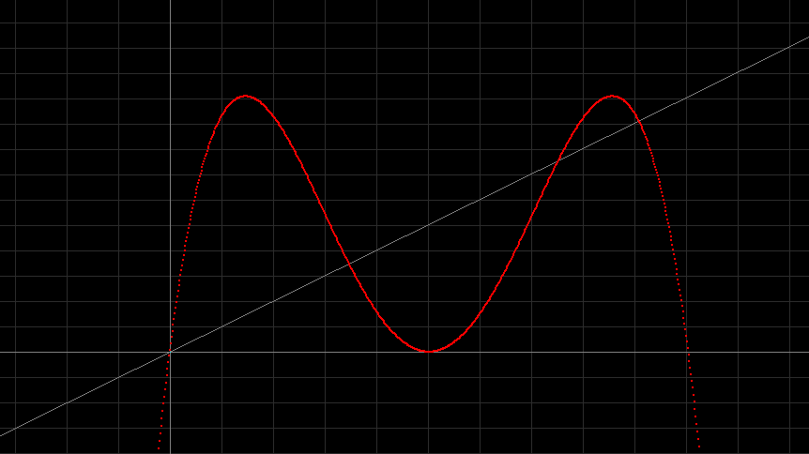

* The stability of the period 2 cycle seen above depends on the slope of the curve $(F^{2}(x))$ at the two points (that are created at the stage of the function F(x) becomes more steeply humped and its fixed point x* may become unstable).
* We can also determine the stability based on the outcomes from the Phaser simulation, as seen below: