Sevika Singh

10/4/12

HWK 5- CSC 210

1. **Computing e:** Read Tutorial 1 in PHASER for computing e using the initial-value problem x' = x, x(0) = 1. Recall that the exact solution of the initial-value problem x' = x, x(0) = x_0 is x(t) = x_0 e^t. Using the method in this tutorial, compute sqrt(e), 2.1e^3, and -1/e. (hints: stop your computations at the appropriate time; you can solve for negative time; you can change the initial condition)

* Sqrt(e)
  + Change time to 0.5, and keep all of the rest of the initial conditions the same, and you will get the sqrt(e), which is 1.6487:

xi-values

4.00000E-001 1.491824697641287E+000

4.10000E-001 1.506817785112871E+000

4.20000E-001 1.521961555618652E+000

4.30000E-001 1.537257523548300E+000

4.40000E-001 1.552707218511356E+000

4.50000E-001 1.568312185490189E+000

4.60000E-001 1.584073984994502E+000

4.70000E-001 1.599994193217382E+000

4.80000E-001 1.616074402192915E+000

4.90000E-001 1.632316219955402E+000

5.00000E-001 1.648721270700152E+000

* 2.1e^3
  + Change time Stop Plotting to 3, and change the initial condition of x1 to 2.1, and you will get 2.1e^3, which is 42.179 :

xi-values

2.90000E+000 3.816570527583278E+001

2.91000E+000 3.854927699074001E+001

2.92000E+000 3.893670366547082E+001

2.93000E+000 3.932802404301555E+001

2.94000E+000 3.972327725573803E+001

2.95000E+000 4.012250282928893E+001

2.96000E+000 4.052574068655829E+001

2.97000E+000 4.093303115166788E+001

2.98000E+000 4.134441495400360E+001

2.99000E+000 4.175993323228851E+001

3.00000E+000 4.217962753869672E+001

* -1/e
  + Change time Stop Plotting to -1 , and x1 to -1 (from original e conditions), and you will get -1/e, which is -0.367:

xi-values

-9.30000E-001 -3.945537103716112E-001

-9.40000E-001 -3.906278353585312E-001

-9.50000E-001 -3.867410234545113E-001

-9.60000E-001 -3.828928859751222E-001

-9.70000E-001 -3.790830381034090E-001

-9.80000E-001 -3.753110988514097E-001

-9.90000E-001 -3.715766910220559E-001

-1.00000E+000 -3.678794411714525E-001

1. **Race to the equilibrium:** Argue that the origin (x = 0) is an asymptotically stable equilibrium point of the differential equations   
   x1' = -x1,       x1' = -0.9*x1*x1*x1.

The origin a x=o is an asymptotically stable equilibrium point because of both of the derivative equations are negative. If x=0, then the equation remains as 0, so it is asymptotically stable.

For which differential equation solutions approach the origin faster? First, use the initial condition x(0) = 1 for all ODEs and plot the solutions in the Xi_vs_Time view without clearing it. Note: use the Cubic 1D ODE in the ODE library of PHASER. Does your observation of speeds hold for other initial conditions? Try at least one other initial condition.

For the first equation (x1’ = -x1, the blue graph), the equation solutions approach the origin faster, as seen below.

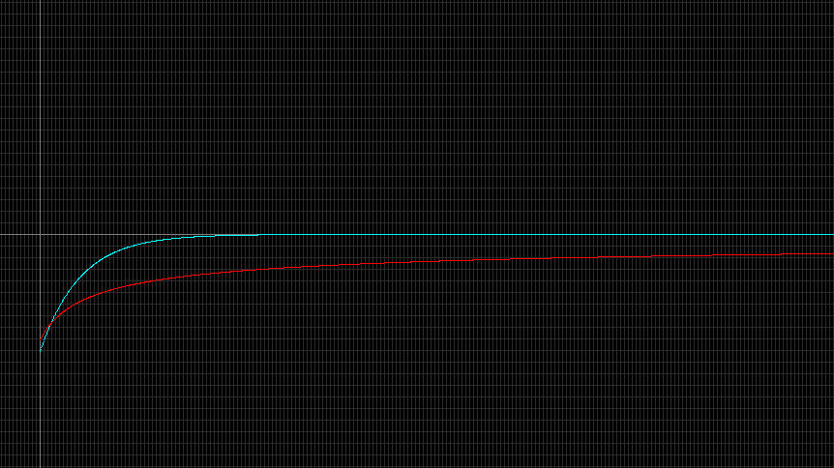

My observation holds, the further away it begins from the origin, the faster the equation solutions approach the origin, as seen by several different initial conditions in the graphs below.

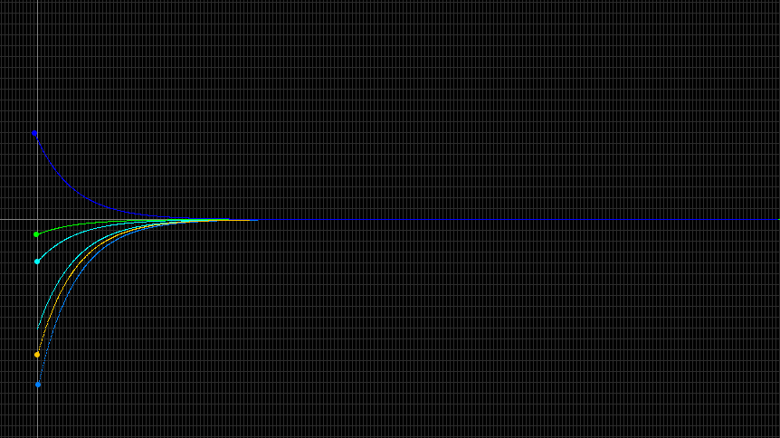

1. **Dating Shroud of Turin using C-14**: The half life of radiactive carbon C14 is known to be appproximately 5700 years. Using Phaser, determine the decay constant k in the decay differential equation x1' = k*x1. Do the calculations with two different initial conditions, say 100 and 200. Does the decay constant depend on the initial amount?

The constant k in the decay should be approximately -0.00012. the decay constant does not depend on the initial amount, because the half life will occur regardless. The half lives are shown below:

IC of x=100, half life is 50 IC of x=200, half life is 100

5.69990E+003 5.0460062710E+001 5.69990E+003 1.0092012542E+002

5.69991E+003 5.0460002158E+001 5.69991E+003 1.0092000432E+002

5.69992E+003 5.0459941606E+001 5.69992E+003 1.0091988321E+002

5.69993E+003 5.0459881054E+001 5.69993E+003 1.0091976211E+002

5.69994E+003 5.0459820502E+001 5.69994E+003 1.0091964100E+002

5.69995E+003 5.0459759951E+001 5.69995E+003 1.0091951990E+002

5.69996E+003 5.0459699399E+001 5.69996E+003 1.0091939880E+002

5.69997E+003 5.0459638847E+001 5.69997E+003 1.0091927769E+002

5.69998E+003 5.0459578296E+001 5.69998E+003 1.0091915659E+002

5.69999E+003 5.0459517744E+001 5.69999E+003 1.0091903549E+002

5.70000E+003 5.0459457193E+001 5.70000E+003 1.0091891439E+002

In 1989, fibres from the Shroud of Turin were found to contain about 92% of the level of C14 in living matter. Determine the age of the shroud using PHASER. Suppose that there was 0.6% error in the determination of the percentage of C14 in the sample of the shroud. What is the range of possible dates for the sample?

Some people do not agree with the results of the C14 dating of the Shroud.

The age of the shroud is about 690 years. The xi-values below show that after 690 years the C14 level was about 92 and about 184.

IC of x=100 IC of x=200

6.89950E+002 9.2054075909E+001 6.89950E+002 1.8410815182E+002

6.89960E+002 9.2053965444E+001 6.89960E+002 1.8410793089E+002

6.89970E+002 9.2053854979E+001 6.89970E+002 1.8410770996E+002

6.89980E+002 9.2053744515E+001 6.89980E+002 1.8410748903E+002

6.89990E+002 9.2053634050E+001 6.89990E+002 1.8410726810E+002

6.90000E+002 9.2053523586E+001 6.90000E+002 1.8410704717E+002

If there was a -0.6% (91.4% level contained) error, the age would be about 745 years. The xi-values below show that after 745 years the C14 level was about 91.4 and about 182.8

IC of x=100 IC of x=200

7.44920E+002 9.1448848757E+001 7.44920E+002 1.8289769751E+002

7.44930E+002 9.1448739018E+001 7.44930E+002 1.8289747804E+002

7.44940E+002 9.1448629280E+001 7.44940E+002 1.8289725856E+002

7.44950E+002 9.1448519542E+001 7.44950E+002 1.8289703908E+002

7.44960E+002 9.1448409804E+001 7.44960E+002 1.8289681961E+002

7.44970E+002 9.1448300066E+001 7.44970E+002 1.8289660013E+002

7.44980E+002 9.1448190328E+001 7.44980E+002 1.8289638066E+002

7.44990E+002 9.1448080590E+001 7.44990E+002 1.8289616118E+002

7.45000E+002 9.1447970852E+001 7.45000E+002 1.8289594170E+002

If there was a 0.6% error (92.6 level contained), the age would be about 635 years. The xi-values below show that after 635 years the C14 level was about 92.6 and 185

IC of x=100 IC of x=200

6.34950E+002 9.2663642166E+001 6.34950E+002 1.8532728433E+002

6.34960E+002 9.2663530969E+001 6.34960E+002 1.8532706194E+002

6.34970E+002 9.2663419773E+001 6.34970E+002 1.8532683955E+002

6.34980E+002 9.2663308577E+001 6.34980E+002 1.8532661715E+002

6.34990E+002 9.2663197381E+001 6.34990E+002 1.8532639476E+002

6.35000E+002 9.2663086185E+001 6.35000E+002 1.8532617237E+002

Do some research on the Web (see the link above, for example) and identify an objection or raise one of your own. Argue for or against the objection.

Many people feel that even though the shroud can be dated back to the correct time, this does not prove that it was wrapped on the body of Jesus. I agree with this objection. The scientific evidence can definitely point the material to the correct age, and this can be accepted as proof. However I feel that there needs to be more real evidence than just the correct timing. There is much more evidence that coincides with the theory, but nothing that can directly confirm, such as something like DNA.

1. **Another form of Logistic:** Consider the continuous anolog of the logistic model using the ODE:  
   x' = r x (1 - x/k)  
   where x(t) is the population size at time t, r (growth rate) and k (carrying capacity) are positive parameters.

* Find the equilibrium points and determine their stability types using the Linearization Theorem for the positive values of the parameters.

Equilibrium Points:

* x’= rx(1- x/k) = 0

rx = 0 1- x/k = 0

x = 0 x = k

* df/dx = r-(2rx/k)

For x = k:

df/dx(x*) = r-(2rk)/k

df/dx(x*) = r – 2r (which is < 0, while r is positive)

For r=1 and k=1.5 (as seen on the graph given), and the equilibrium point x=k:

df/dx = 1 – (2*1*1.5)/1.5

df/dx = 1 – 3/1.5

df/dx = 1- 2

df/dx = -1

When df/dx(x) < 0 then the equilibrium point is asymptotically stable.

x = 0 is unstable. x = k is asymptotically stable as long as the carrying capacity and growth rate remains positive.

* For r = 1 and k = 1.5, several solutions of this equation with various initial conditions are displayed in the picture below. Describe what happens to the population as the initial population size varies.

As the initial population varies closer to the carrying capacity, the population growth is more steady and the population becomes steady at a slower rate than if the initial population varies further away from the carrying capacity, where the growth is much faster, and it appears to become steady at a faster rate.

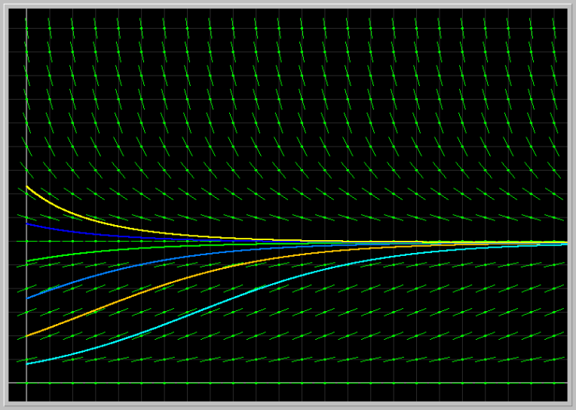

* Fix the parameter r = 1 and vary the parameter k from 0.5 to 3.0.

The graphs below have carrying capacities of 0.5, 1, 2, and 3. As the growth rate remains the same, but the carrying capacity is increased, it can be seen that the populations converge to the same point (capacity) more slowly, or that the difference between the population sizes remains larger, longer as the capacity is increased.

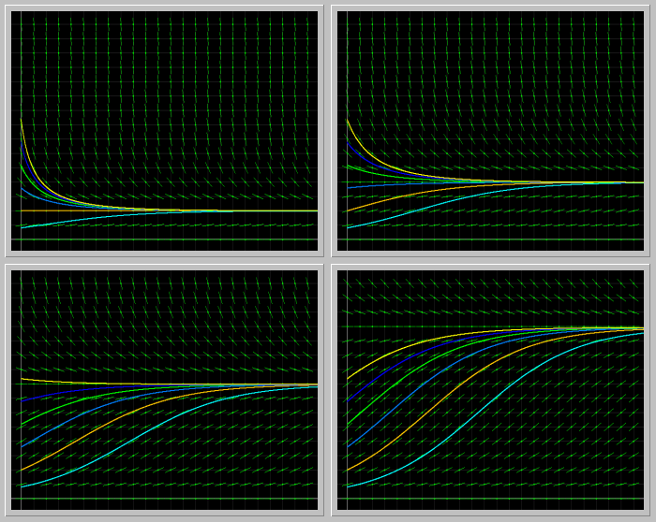

Next fix k = 1.5 and vary r from 0.5 to 4.0. Describe the results of your experiments from the biological viewpoint.

The graphs below have growth rates of 05, 1.5, 3, and 4. When the carrying capacity is fixed, and the growth rate is varied, it is seen that the greater the growth rate, the faster the populations converge to the capacity.

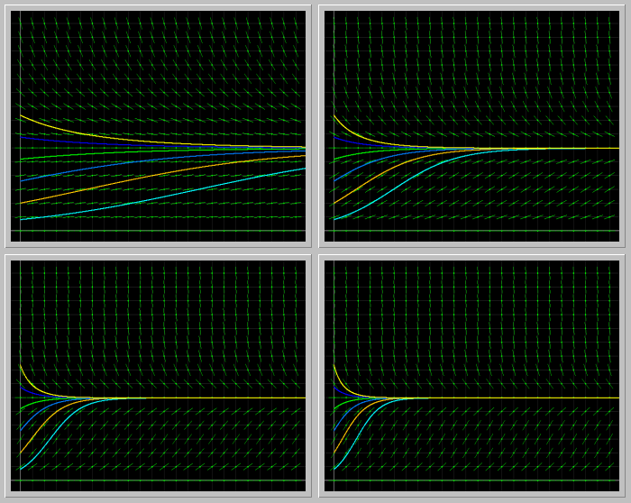

1. **Gompertz model of cancer growth:** The differential equation  
   x' = a*(exp(-b*t))*x   
   is used to describe the growth of a tumor, where x(t) is a measure of its size (e.g. weight or number of cells), and a and b are parameters specific to a particular tumor. To get started, let us take a = 3 and b = 2, and x(0) = 5; the solution in the XivsTime view is shown in the image below.

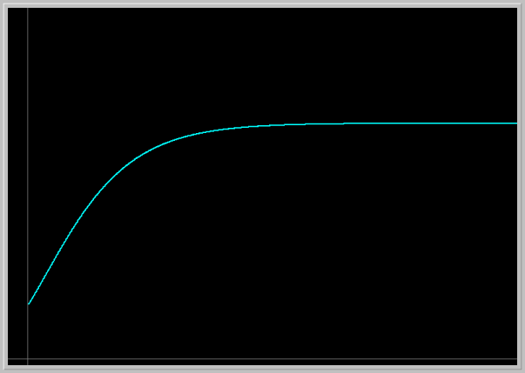

Load the image into your PHASER by clicking on the picture. Explain what this model predicts for the tumor growth.

This model predicts steady tumor growth, or a steady growth rate, until it reaches a point where the growth slows and becomes very stable, where the growth rate is very low, just above zero.

Experiment with several different initial tumor sizes. How does the future size of tumor depend on its initial size?

It would appear that the greater the initial tumor size, the faster the growth rate climbs until it reaches a capacity, or the growth rate slows and levels off. The smaller the initial tumor size, the slower the growth rate increases.

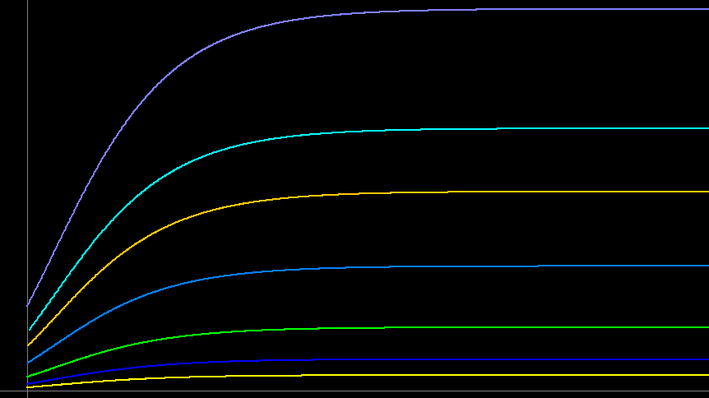

Experiment with several values of the parameters a and b. Explain the roles of these parameters in the tumor growth.

These graphs have values of the a parameter set to 0.2, 1, 3.5, 4. It would appear that this parameter affects the growth rate of the tumor as it is increased. As this parameter is increased, the growth rate increases more rapidly until it levels off. This occurs until such a high value of a is used that the graph reaches a point of extreme exponential growth (seen in the last graph, where a=4).

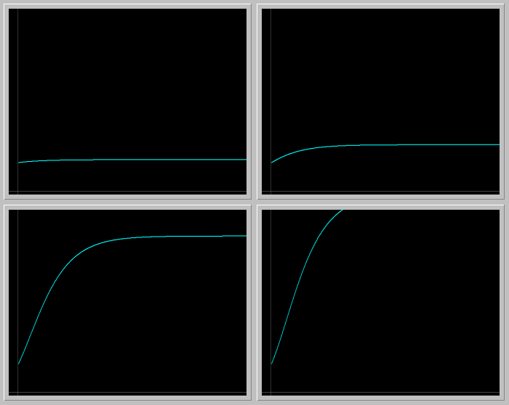

These graphs have values of the b parameter set to 1, 2.5, 3, 10. It would appear that this parameter affects the growth rate of the tumor as it is increased. As this parameter is increased, the growth rate becomes slower and steadies, or levels off much sooner. When b has a greater value, such as 1 (which is seen in the first graph) the growth seems to be unstable and has a more extreme exponential growth.

