Sevika Singh

10/9/12; Prof. Kocak

CSC 314- HWK 6

1. **Bacterial growth experiment:** A culture of 8 bacteria are placed in a test tube, and their numbers is counted daily. At first, when their numbers was small they grew at a rate of %180 per day. After a few days, their numbers stabilized at about 405.

* We will assume that the bacteria grow according to the logistic model x'=ax - bx^2. Find the equilibrium points of this differential equation. Assuming that a>0 and b>0, determine the stability types of the equilibria using the linearization theorem.

x’ = ax – bx^2

= x (a-bx)

x = 0; x = a/b : Equilibrium Points

Stability

df/dx = a -2bx

* For x = 0: df/dx(0) = a – 2b(0)

= a

Since a is always greater than 0, this point would unstable.

* For x = a/b: df/dx (a/b) = a – 2b(a/b)

= a – 2a

Since a will always be negative in this case, this point is asymptotically stable.

* Determine the numerical values of the parameters a and b for our bacterial growth. Hint: It is reasonable to assume that when their numbers is small, bacteria can grow "exponentially;" that is a = 1.80 is a good approximation. Now using the information about the equilibria, find b.

x’ = ax – bx^2

* 0 = 1.8(405) – b(405^2)
* b(405^2) = 1.8(405)
* b = (1.8(405)) / (405^2)
* b = 0.00444
* With the parameter values from above, using Phaser, determine how long it takes for the bacteria culture to grow to within %10 of the carrying capacity.

Within 10% of the carrying capacity is about 364.5, the xi values show a value quite close to that after 1.7756 days.

Xi-values

1.77200E+000 3.5926326502E+002

1.77300E+000 3.6048606082E+002

1.77400E+000 3.6171498729E+002

1.77500E+000 3.6295008864E+002

1.77600E+000 3.6419140953E+002

1. **Largest safe step size:** Consider the differential equation x'= -12x. Show, using the Linearization Theorem, that x=0 is an asymptotically stable equilibrium point.

x’ = -12x

df/dx = -12

df/dx(0) = -12; since will always be negative in this case, this point is asymptotically stable.

Now, in the XiVsTime View of Phaser, compute several solutions starting near the equilibrium point using Euler's algorithm with various step sizes. Use a large graph point size and connect points. Determine the largest step size that results in a picture where the origin looks like an asymptotically stable point. Hint: h = 0.3 does not give a correct picture.

0.08 is the largest step size that looks like an asymptotically stable point.

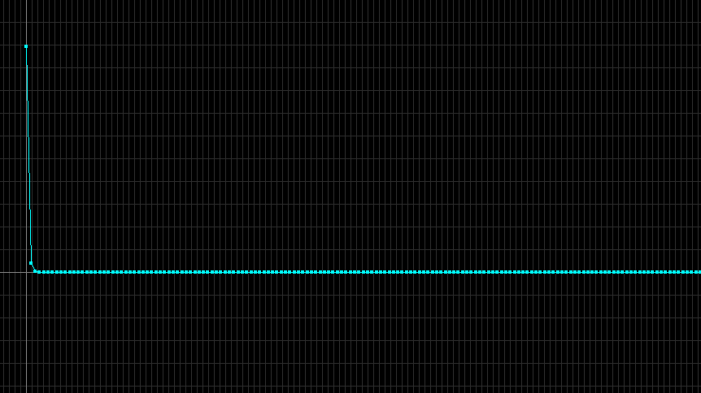

1. **Error vs. step size in Euler:** We showed in class that the global error bound in Euler's algorithm is proportional to the step size. Now, in PHASER solve the initial-value problem x' = x, x(0) = 1 to compute x(1) = e = 2.7182818284590452354, using Euler's algorithm with six different step sizes. Using your favorite plotting program, plot the errors against the step sizes. Do you get a linear relationship? Be careful of the scales on your graph.

It is clear that I get a linear relationship when graphing step size versus error. This is seen in the graph below, which was done using the values I calculated through Phaser (below the graph)

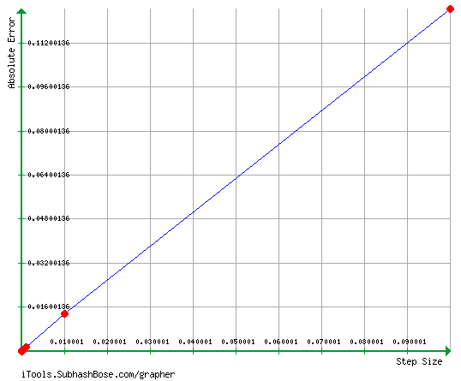

Step-size Error

|  |  |
| --- | --- |
| 0.1 | 0.124539368 |
| 0.01 | 0.013467999 |
| 0.001 | 0.001357896 |
| 0.0001 | 1.36E-04 |
| 0.00001 | 1.36E-05 |
| 0.000001 | 1.36E-06 |

1. **An explosion problem:** Here we consider the "explosion" problem x'= x^2, x(0)=1. This simple equation shows up in chemical reactions where two atoms get together to form a molecule.

* Verify that the solution of this initial-value problem is x(t) = 1/(1-t).

If the derivative of this function is equal to this function squared, then it is a solution. Lets see if that is true!

1/(1-t) = 0

Derivation: Square:

dx/dt = 🡪

Since they are the same function ( $\frac{1}{{(1-t)}^{2}})$ that means that x(t) = 1/(1-t) is a solution!

* Using Euler's Algorithm with steps h = 0.01 and h = 0.005, compute x(0.99). What is the error in your computations? Hint: What is the exact value of x(0.99) = ?

Exact value of x(0.99) is 100, as seen through the calculation with the solution of the initial-value problem below:

x(0.99) = 1/(1-0.99)

= 1/(0.01)

= 100

These are the computations of x(0.99) done through Euler’s algorithm on phaser:

h = 0.01 h = 0.005

x(0.99) = 24.326411870 x(0.99) = 36.112667396

The error for h=0.01 is 75.674 and the error for h=0.005 is 63.887

* Now in Phaser, compute x(1) with Euler using steps h = 0.01 and h = 0.005. What is the error in your calculations?

Exact value of x(1) cannot be determined, but the equation goes to infinity for x(1).

These are the computations of x(1) done through Euler’s algorithm on phaser:

h = 0.01 h = 0.005

x(1) = 30.389660091 x(1) = 52.050998906

The errors always go to infinity; as smaller step sizes are used however, you get larger values, so smaller step sizes result in less error (that you can determine with an equation that goes to infinity). This is seen above, where h=0.005 gives you a larger value than h=0.01.

1. **Nonautonomous Euler:** When the right-hand-side of a differential equation contains time t explicitly, the equation is called nonautonomous. Now, consider a differential equation of the form dx/dt = f (t, x) with x(0) = x_0. Then Euler becomes   
   x_(n+1) = x_n + h*f(x_n, t_n)   
   t_(n+1) = t_n + h .  
   Now, in the Gompertz equation x' = a*(exp(-b*t))*x, set a = 3 and b = 2, and x(0) = 5; and take step size h = 0.1. By hand compute two steps of Nonutonomous Euler on Gompertz and compare your numbers to the ones you get from PHASER.

Two steps by hand:

$x_{1}= x_{0}+h*f\left(x_{n}+t_{n}\right)$

$x_{1}$ = 5 + 0.1 * (3 $e^{-2*0}$**5)

= 5 + 1.5 🡪 6.5

$x_{2}= x_{1}+h*f\left(x_{n}+t_{n}\right)$

$x_{2}=$ 6.5 + 0.1 * (3 $e^{-2*0.1}$**6.5)

$=$ 6.5 + 1.596 🡪 8.09

Phaser Results:

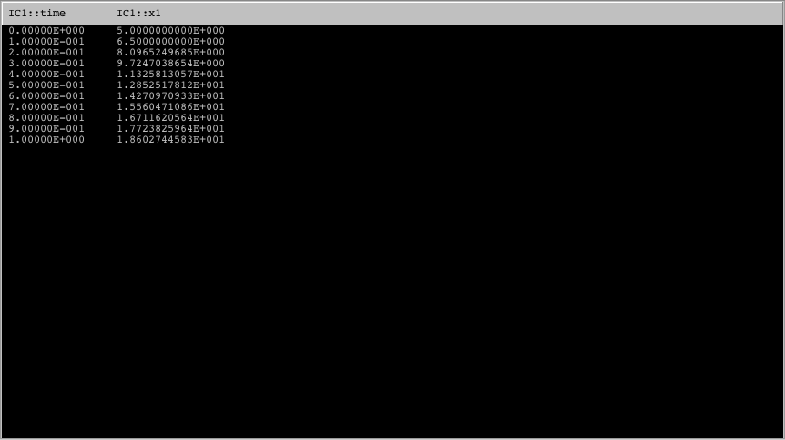

My calculations of 2 steps with nonautonomous Euler are the same as the first 2 steps as the phaser calculation. This shows that the function x(t) can be approximated using the Euler algorithm.