Sevika Singh

10/18/12

CSC 314: Hwk 7

1. **One step of Runge-Kutta(4):** Consider the initial value problem x1' = x, x(0)=1. With step size h = 1, compute, by hand using paper and pencil, one step of Runge-Kutta(4) algorithm to obtain the approximate value of x(1). Make sure you show all the intermediate numbers Ks. Now compare your answer with the one you get from Phaser.

Runge-Kutta(4) algorithm:

yn+1 = yn + ( K1 + 2K2 + 2K3 + K4) / 6 ,

where

K1 = h f( tn,   yn ),  
K2 = h f( tn + (1/2) h,   yn + (1/2) K1 ),  
K3 = h f( tn + (1/2) h,   yn + (1/2) K2 ),  
K4 = h f( tn + h,   yn + K3 )

f = x

* K1 = 1 *1 🡪 1
* K2 = 1 *1 + 1/2 * 1 🡪 1½
* K3 = 1 *1 + 1/2 * 1½ 🡪 1 ¾
* K4 = 1 *1 + 1 ¾ 🡪 2.75

x1 = 1 + (1 + 2(1.5)+2(1.75)+2.75) / 6 = 2.7083333

My calculations came out exactly the same as phaser.

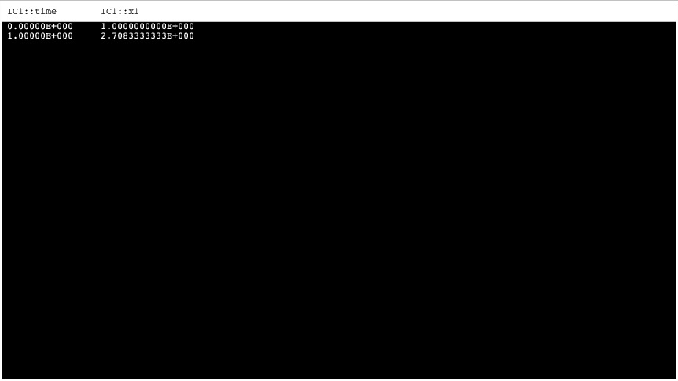

1. **Small angle approximation:**

* The Second-order differential equation given by x''=(-g/l)x is the small angle approximation to the pendulum equation by replacing sin(x) with x.
* Convert this 2nd-order ODE to a pair of first order differential equations. Enter your pair of ODEs into Phaser Custom Equation Library.

Let: x1 = x

x2 = dx/dt

* x''=(-g/l)x
* x1 = x

x2 = x’

* x1’ = x2

x2’ = (-g/l)x1

* Set the values of g and l as you please; determine the period of oscillations for 5 initial conditions. How does the period depend on the initial conditions?

According to my graphs below, as x1 and x2 are increased the period does not change. However, the amplitudes of the graphs change.

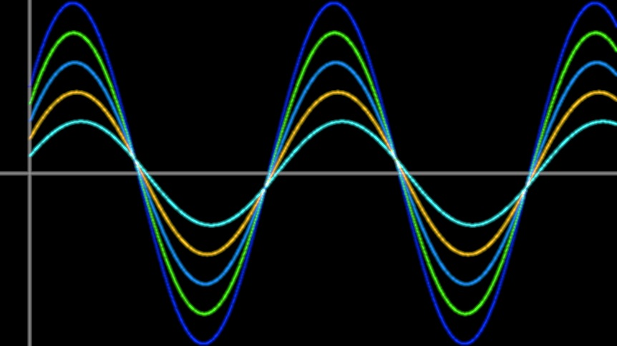

* Set g=l=1 and start the pendulum with 18 degrees displacement and release. Determine the period of the oscillations in the nonlinear pendulum equation and in the small angle approximation. What is the difference in the periods?

There is no difference in periods for an 18 degree displacement, as seen below.

Nonlinear Pendulum Equation Small Angle Approximation

Period is approximately 2π Period is approximately 2π as well

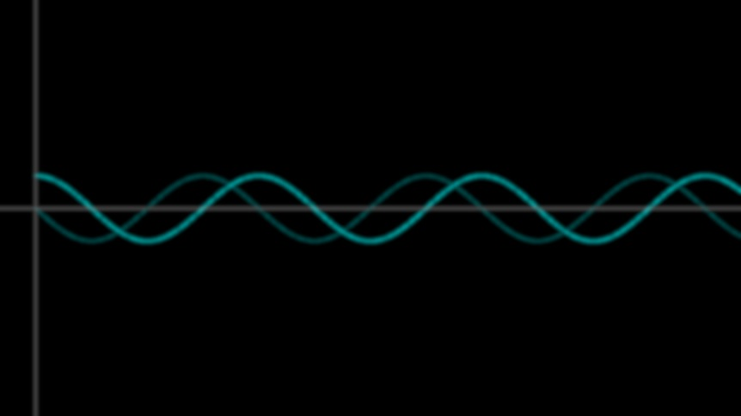 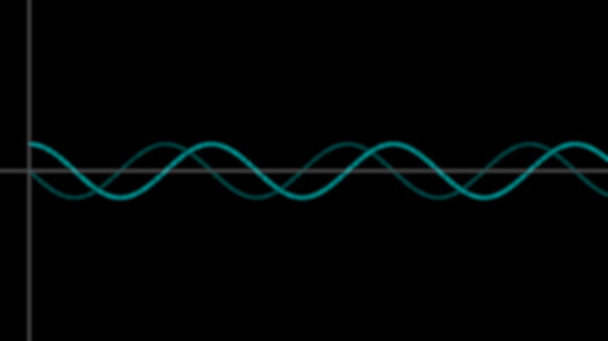

* Set g=l=1 and start the pendulum with 81 degrees displacement and release. Determine the period of the oscillations in the nonlinear pendulum equation and in the small angle approximation. What is the difference in the periods?

The difference between periods is approximately 0.92, as seen below.

Nonlinear Pendulum Equation Small Angle Approximation

Period is approximately 7.2 Period is approximately 2π

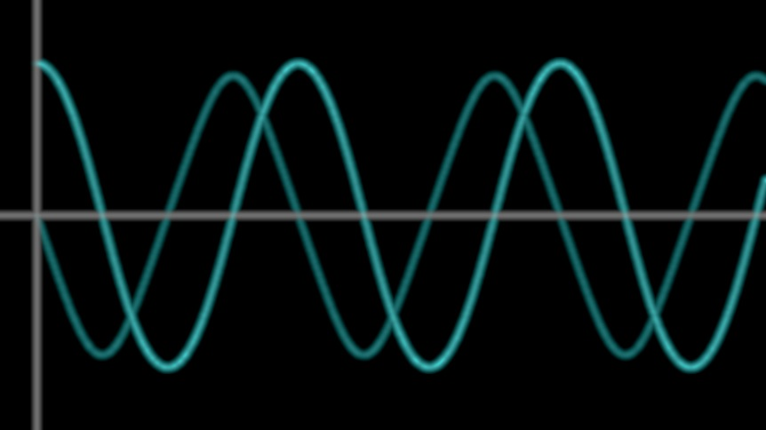 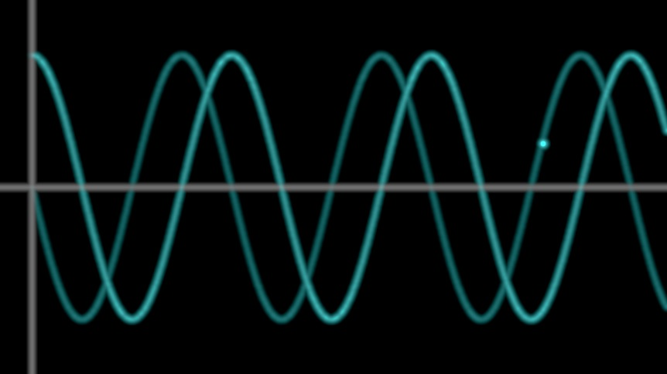

1. **Period of Pendulum:**
   1. In the pendulum equation in PHASER set m = 1.3, l = 1.2, and g = 1. What is the period of the pendulum motion starting with initial angle of 1.2 radians and zero velocity. To increase the period by 20% how much do you need to change the length of the pendulum?

The period is about 7.56 (circled in yellow).

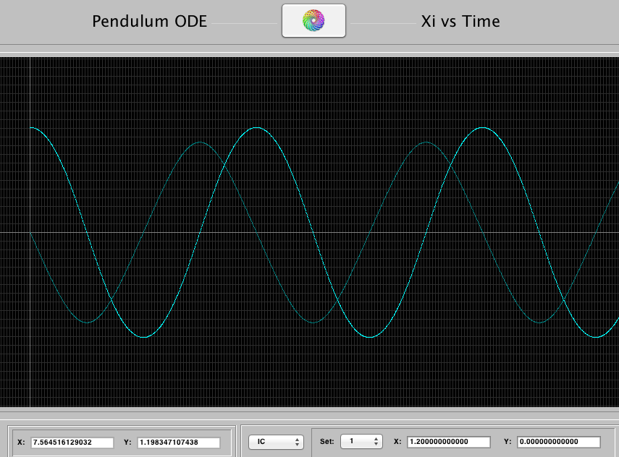

To increase the period by 20% (about 9.072) you need to increase the length by 0.52 (to get a length of 1.72)

* 1. If you take your grandfather's clock to the moon, does it slow down or speed up? By how much? (You need to look up the value of g for the moon.)

Earth: m = 1.3, l = 1.2, g = 9.78, initial angle of 1.2 radians and zero velocity.

Moon: m = 1.3, l = 1.2, g = 1.622, initial angle of 1.2 radians and zero velocity.

Earth’s period: approximately 2.4

Moon’s period: approximately 5.9

The clock would slow down on the moon. The period slows down by 3.5 when the clock goes to the moon. This seen is seen below as the moons graph (right) has less period repetitions within the same amount of time (x-axis going from 0 to 20 for both) than the earths graph (left) does.

Earth’s Pendulum Moon’s Pendulum

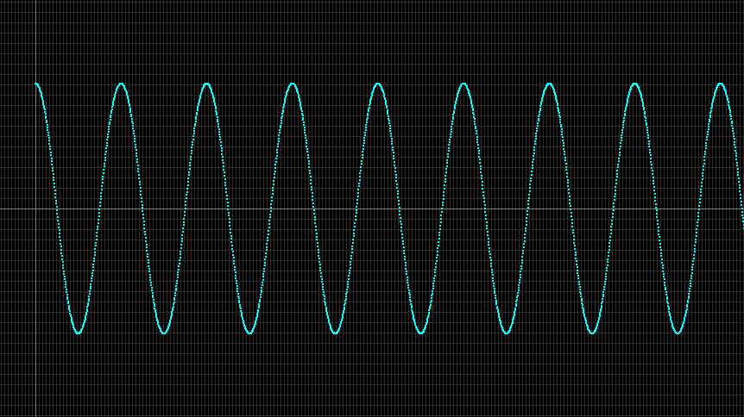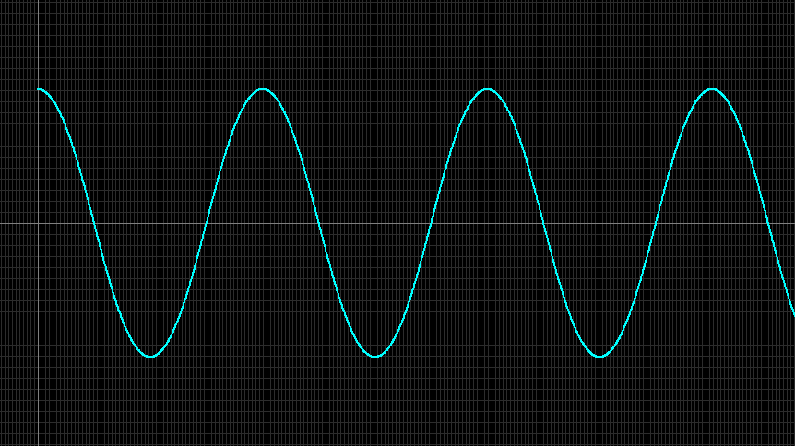

* 1. Assume that pendulum is at its stable equilibrium position. How much minimal initial velocity do you need to impart on the bob so that the pendulum goes over the top? Does this initial velocity depend on the length of the pendulum?

The minimal initial velocity is approximately 1.83 (graph of pendulum going over the top is seen below). However the initial velocity depends on the length, as a shorter length needs a higher velocity, and a longer length needs a smaller velocity.

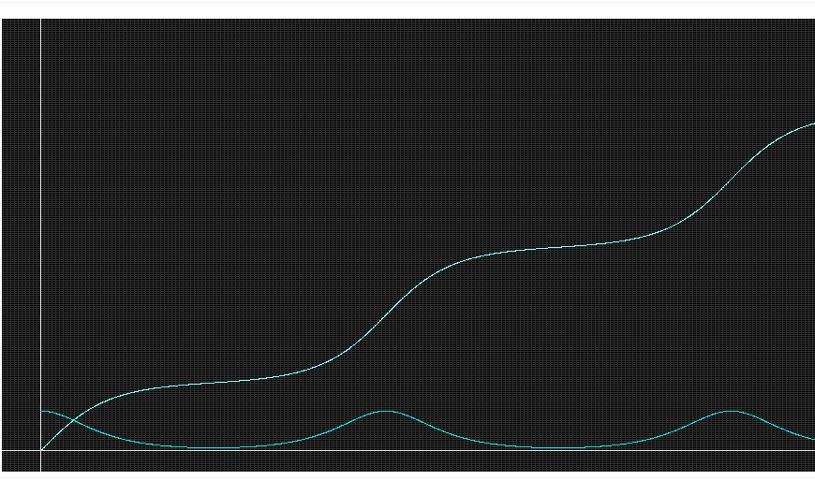

1. **A series for period:**
   1. There is no practical formula to compute the period of a planar pendulum without friction. However, the following infinite series

   
can be used to approximate the period (with zero initial velocity) to a desired accuracy by including a finite number of the terms of the series.

* 1. Now take g =1, l=1.2, the initial angular displacement of 60 degrees (no initial velocity) and using the first 3 terms of the series compute the approximate period.

T = 2π (1 + 1.1.1.

T= 7.81767

* 1. Compare your answer with the one you get from Phaser simuation.

Phaser estimates a value of approximately 7.4, with a difference by about 5% of my calculated approximation of 7.81767.

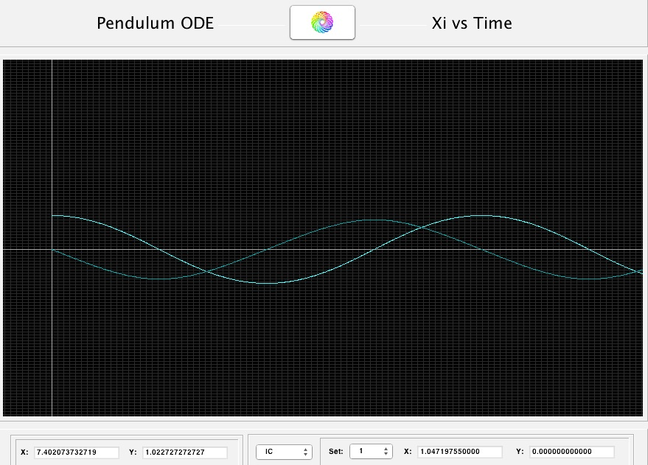

1. **R**: Go to the web site <http://www.r-project.org/> and download the appropriate version of R for your personal computer.

***R*** we going to get points for downloading this? =D (Just kidding!)