Sevika Singh

10/25/12

CSC 210- HWK 8

1. **Energy conserved:** The Energy of planar pendulum without friction is given by the function  
   E(Θ , Θ') = (1/2)m(L^2)(Θ'^2) + mgL(1- cos(Θ)).   
   This Energy function is supposed to be conserved along the solutions of the pendulum. Show this assertion by computing dE/dt using the chain rule, keeping in mind that Θ and Θ' depend on t, and the differential equations for pendulum. Observe that dE/dt = 0, so it must be constant function of t.

dE/dt (Θ , Θ') = 1/2mL^2*2 Θ” Θ’ + 0 + mgL *-sin(Θ)

dE/dt (Θ , Θ') = 1/2mL^2*2 (-g/l*sin Θ) Θ’ + 0 + mgL *-sin(Θ) Θ’

0 = 1/2mL^2*2 (-g/l*sin Θ) Θ’ + 0 + mgL *-sin(Θ) Θ’

0 = -1/2mL^2*2 (g/l*sin Θ) Θ’ + 0 + mgL *-sin(Θ) Θ’

-mL^2(g/l*sin Θ) Θ’ = mgL *-sin(Θ) Θ’

-mL^2(g/l*sin Θ) Θ’ = -mgL *sin(Θ) Θ’

-mL(g*sin Θ) Θ’ = -mgL *sin(Θ) Θ’

-mgL*(sin (Θ)) Θ’ = -mgL *(sin(Θ))Θ’

1. **Free energy from EULER:** Now, in the pendulum equation, take c= 0, m=1.1, l=1.2, g=1, the initial conditions Θ=0.6 and Θ'=0 and compute the solution for 20 time units using Euler's algorithm with step size of h=0.2. On the Time Panel of Phaser's Numerics Editor set "Skip iterations per plot" to 9 so that in the Xi Values view you will get the solution tabulated at even integer values of time: you should have 11 rows of numbers. Now, with R, use these position and velocity numbers in the formula for the Energy of the pendulum above so that you will have 11 values of the Energy function. Plot these Energy values as a function of time. Are these Energy values constant? Increasing? Decreasing?

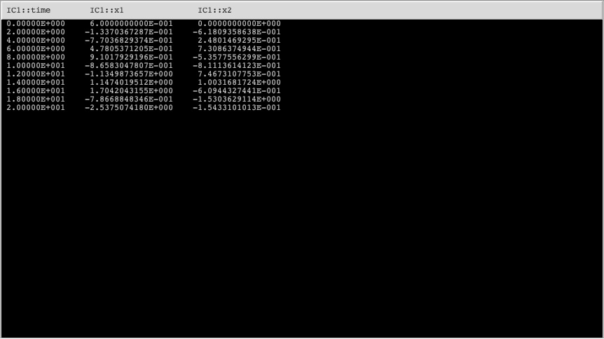

As seen below, the energy values are increasing.

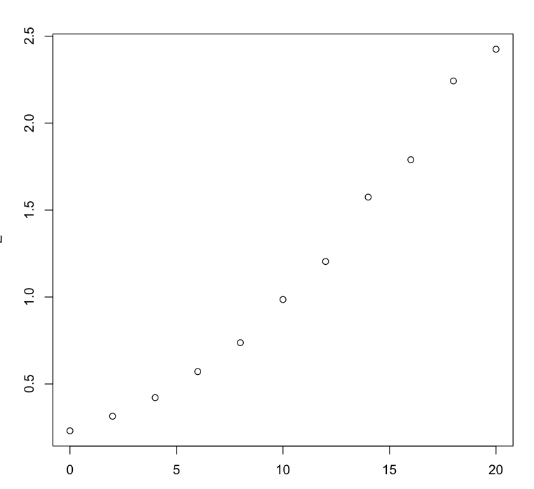

Values of the Energy Function

Time

1. **Escape velocity:** For this investigation use the Kepler ODE in the ODE Equation Library of Phaser. Suppose that a particle of mass = 1 is positioned at the coordinates (2, 0). Now we will shoot this particle with an initial vertical velocity. Find the minimum vertical velocity so that the particle escapes to infinity; that is, its orbit ceases to be an ellipse. For this problem, first you should load the equation defaults for Kepler ODE. Then set the appropriate initial conditions to follow the shapes of the orbits. You might need to use a fairly long time and a big window size to get a good estimate of the vertical escape velocity.

Minimal vertical velocity: approximately 0.999999 or 1 (as 0.999999 or 0.9 repeating equals 1).

This is seen below through various vertical velocities that were tested. Anything below 1 (or below about 0.9999), even 0.99, causes the orbit to be an ellipse. As soon as you get to a velocity of 1 (or its equivalent which is 0.9 repeating, or a decimal with a significant amount of 9’s after the decimal as seen below) the particle escapes to infinity!

0.99

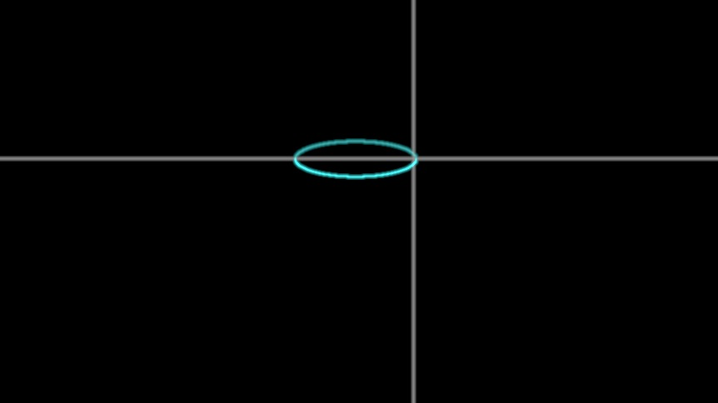

0.999999 1

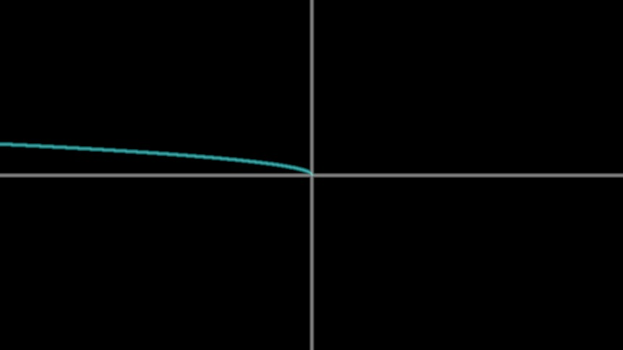 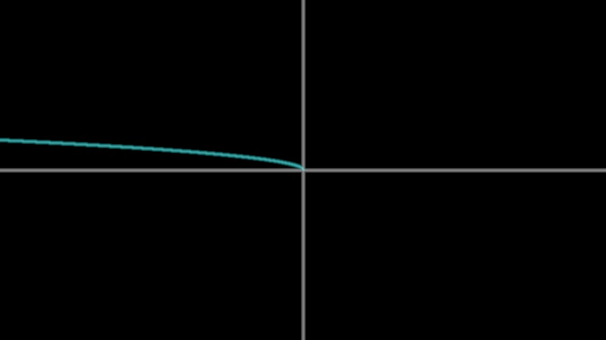

2 10

