Sevika Singh

11/1/12

CSC 210- Hwk 9

1. **Beetle model:** Download the R file beetle.R above and run (source) it. Read out the parameter values of a and b for the logistic differential equation y' = ay + by^2. Now, use these parameter values in the Cubic1D ODE differential equation in Phaser, with the appropriate initial condition, and print out the Xi values for 14 days. How do these numerical values compare with the original data values?

a = -0.002176 b = 0.669451

Original Data Values: 112, 152, 212, 258, 306, 309, 315, 310, 298, 290, 303, 295, 311, 308, 299, 309

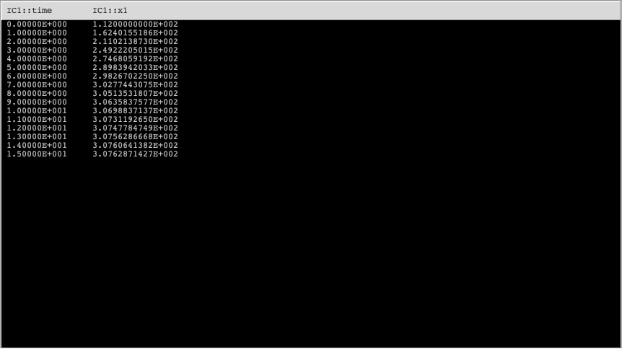It is seen by the xi-values below that the numbers are close, but slightly off at the same time. They are within close range and form a similar pattern, but Phaser creates values than form a neater function plot (which is also seen through the differences between the graphs of the values below).

R graph of data values Phaser graph of data values

 

1. **Heating of a probe:** A student held a temperature probe between her two fingers and recorded the following temperatures every 2 seconds:   
   Time     Temp   
       00     32.77   
       02     33.16   
       04     33.35   
       06     33.56   
       08     33.67   
       10     33.75   
       12     33.85   
       14     33.93   
       16     33.98   
       18     34.03   
       20     34.04
   * Plot the temps as a function of time. Is the temp leveling off? Why?

According to the graph below, the temperatures are leveling off. This is because she keeps applying heat to the probe, and after the heat in it builds up to a point (the temperature of her fingers) it wont get hotter than her fingers, so it levels off.

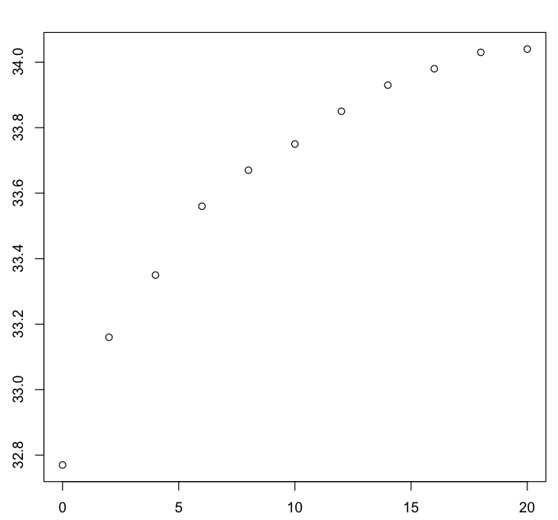

* + Plot the numerical approximation of the derivative from the data vs the temperature. Notice that this graph looks almost linear. Now compute the least squares fit line to this graph and determine the equation of the line.

Equation of the line:

y = mx + b

y = -0.1323x + 4.5096

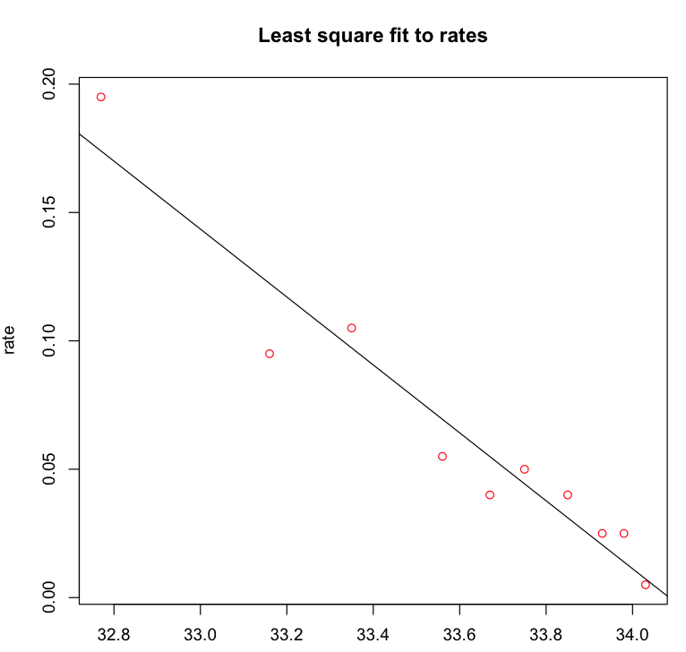

* + What is the differential equation and the initial condition governing this experiment? Put this differential equation into Phaser and plot the solution. Does the Phaser plot resemble the experimental data?
  + Hint: For this problem, modify the beetle.R program above.

Differential equation:

Y’ = -0.1323x + 4.5096

Initial condition:

32.77

Phaser plot:

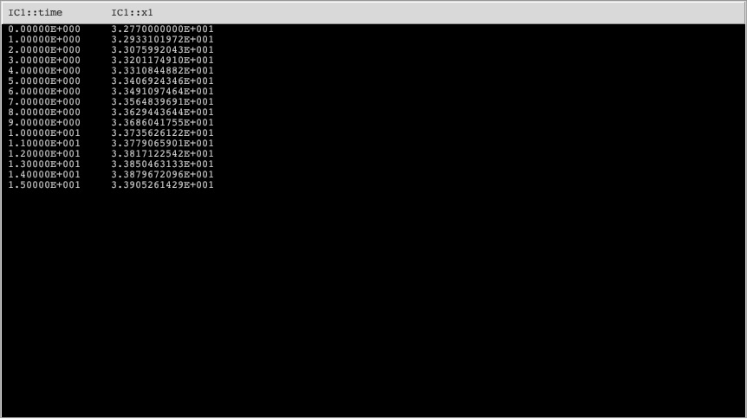



The Phaser plots resemble the experimental data. For both, the data stabilizes and levels off at approximately 34 degrees Celcius.