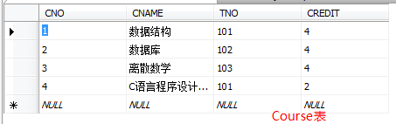create table Student

(

SNO int primary key ,

SNAME char(8) unique,

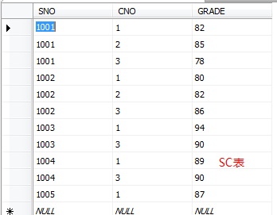 SEX CHar(2),

DEPTNO int,

);

alter table Student

add AGE int ;

create table Course

(

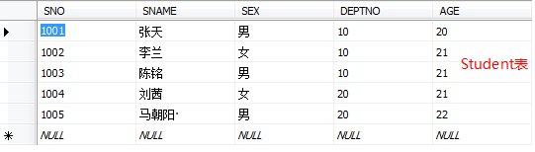 CNO int primary key ,

CNAME char(20) not null,

TNO int,

CREDIT int,

);

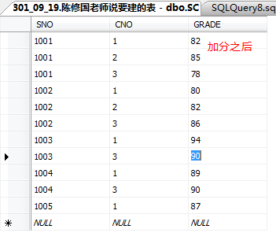create table SC

(

SNO int ,

CNO int ,

GRADE int,

primary key (SNO,CNO),

);

_____________________________唯一索引

CREATE UNIQUE INDEX SNO

ON Student (SNO);

CREATE UNIQUE INDEX CNO

ON Course (CNO);

DROP INDEX SNO on Student;

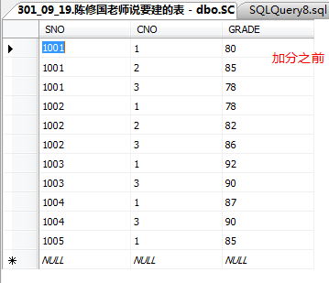DROP INDEX CNO on Course;

_____________________________视图

CREATE VIEW CS_STUDENT AS

SELECT SNAME

FROM Student

WHERE DEPTNO = '10';

DROP VIEW CS_STUDENT;

______________________________加分

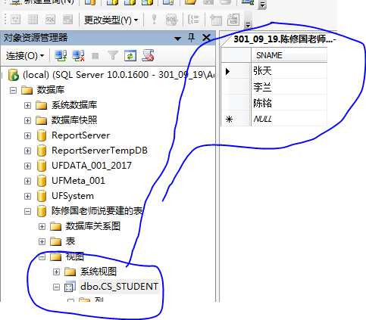UPDATE SC

SET GRADE = GRADE +2

WHERE SC.CNO in

(

select SC.CNO

from Course

where SC.CNO =Course.CNO and CNAME ='数据结构'AND TNO = 101

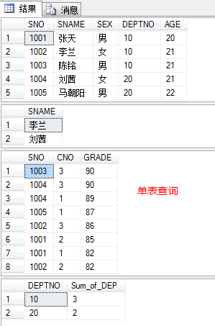 )

_____________________________单表查询

SELECT *

FROM Student;

SELECT SNAME

FROm Student

where SEX ='女';

Select *

from SC

where GRADE between 80 and 90

order by GRADE desc;

select DEPTNO, COUNT(DEPTNO) Sum_of_DEP

from Student

Group by DEPTNO;

_____________________________连接查询

SELECT SNAME,AGE

from Student,Dept

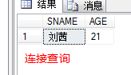where Student.DEPTNO = Dept.DEPTNO and DNAME = '信息' and SEX = '女' and AGE <22;

_____________________________嵌套查询

select SNAME

from Student

where SNO in

(

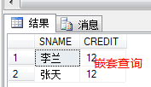 select SNO

from SC,Course

where Student.SNO=SC.SNO and SC.CNO=Course.CNO

group by SNO

having SUM(CREDIT)<10

);

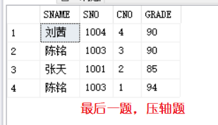select SNAME, t1.SNO,t1.CNO,t1.GRADE

from SC t1 ,Student

where t1.SNO = Student.SNO and t1.GRADE =

(

select max(t2.GRADE)

from SC t2

where t2.CNO = t1.CNO

group by t2.CNO

)