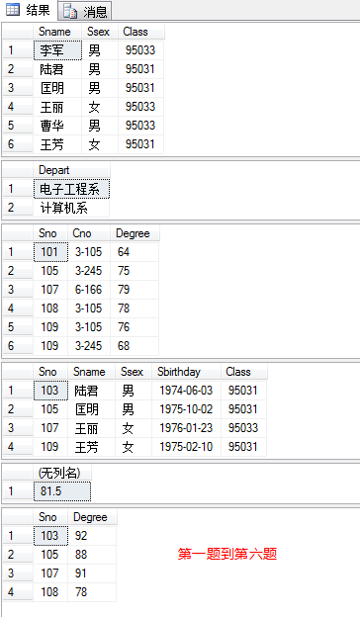1-6题

* select Sname ,Ssex,Class

from Student;

* Select distinct Depart

from Teacher;

* select \*

from Score

where Degree between 60 and 80;

* Select \*

from Student

where Class = '95031' OR Ssex = '女' ;

* select AVG(Degree)

from Score

group by Cno

having COUNT(Sno)>5 and Cno like '3%';

* select Sno,Degree

from Score

where Cno = '3-105' and Degree >(

select Sno , Degree

from Score

where Cno = '3-105' and Sno = '109'

);

7---9题

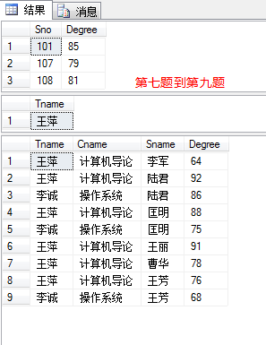Select Sno, Degree

from Teacher,Score,Course

where Course.Cno =Score.Cno and Course.

Tno = Teacher.Tno and Tname = '张旭';

select Tname

From Teacher,Course

where Course. Tno = Teacher.Tno and Cno =(

select Cno

from Score

group by Score.Cno

having COUNT(Sno)>5

);

select Tname, Cname, Sname ,Degree

from Teacher,Score,Course,Student

where Course.Cno =Score.Cno and Course. Tno

= Teacher.Tno and Student.Sno = Score.Sno

and Depart = '计算机系';

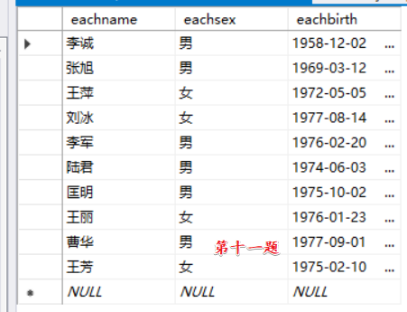第十一题

create table ALLINALL

(

eachname char(8),

eachsex char(8),

eachbirth char(20)

)

insert

into ALLINALL (eachname,eachsex ,eachbirth)

select Sname,Ssex,Sbirthday

from Student

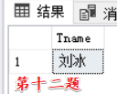insert

into ALLINALL (eachname,eachsex ,eachbirth)

select Tname,Tsex,Tbirthday

from Teacher

第十二题

select Tname

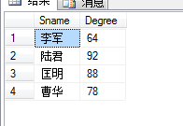from Teacher

where Tno in

( select Tno from Course where Cno not in

( select Cno from Score group by Cno))

第十三题

select Sname ,Degree

from Student,Score,Course

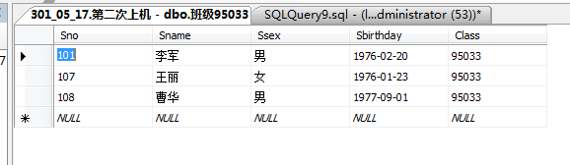where Score.Sno =Student.Sno and Course.Cno   
=Score.Cno and Cname = '计算机导论' and Ssex = '男';

第十四题

create view 班级

as

select \*

from Student

where Class ='95033';

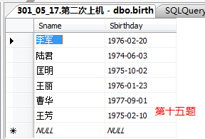第十五题

create view birth

as

select Sname,Sbirthday

from Student;

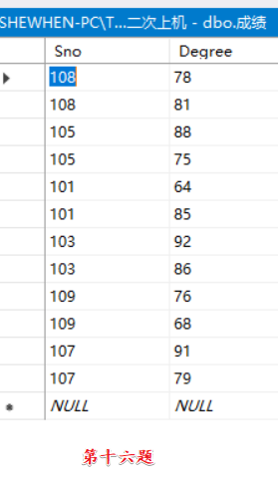第十六题

create view 成绩

as

select Student.Sno,Degree

from Student ,Score

where Student.Sno = Score.Sno

第十七题

select \*

from 班级95033 ,Score

where 班级95033.Sno=Score.Sno and Cno = '3-105';

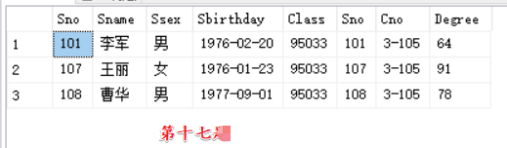

第十八题

update 班级95033

set Sname='刘晨'

where Sno = '108';

