|  |  |  |  |  |
| --- | --- | --- | --- | --- |
| **Test Number** | **Test Description** | **Input** | **Expected Results** | **Results** |
| 1 | Attempt to setup socket to listen for tcp packets | Enter the comp IP address as the IP address and select “tcp” as protocol and select “server” and select a file to write to | The window title will display “connected” with no error messages | Pass |
| 2 | Attempt to setup socket to listen for udp packets | Enter the comp IP address as the IP address and select “udp” as protocol and select “server” and select a file to write to | The window title will display “connected” with no error messages | Pass |
| 3 | Attempt to send tcp packets through socket | Enter the server computer IP address as the IP address and select ”tcp” and “client”. Select a file to read from and click “Connect” | The server side will display “disconnected” as the window title after the file has finished writing data to the file with transfer stats in the file | Pass |
| 4 | Attempt to send udp packets through socket | Enter the server computer IP address as the IP address and select ”udp” and “client”. Select a file to read from and click “Connect” | The server side program will exit after the file has finished writing data to the file with transfer stats in the file | Pass |
| 5 | Attempt to connect to invalid or empty ip address | Enter “231.43.45.23” and as the ip address and click “Connect” | An error message will display stating “Can’t connect to server” | Pass |
| 6 | Attempt to “Connect” without selecting a file | Enter a valid IP address and do not select a file. Click “Connect” | An error message will display stating “Open file failed” | Pass |
| 7 | Attempt to send two files through tcp protocol | Send a file through tcp successfully and then reconnect server and attempt to send another | Both transfers should exit successfully and the second transfer will overwrite the server file contents if the file selected is not changed | Pass |

**Test Documentation** Matthew Shew

**Test Screenshots**

***Test 1***

Figure 1.1

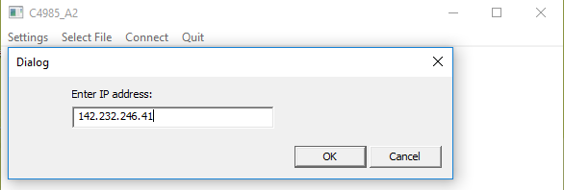

Figure 1.2

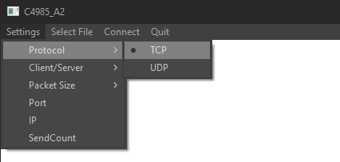

Figure 1.3

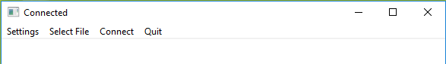

***Test 2***

Figure 2.1



Figure 2.2

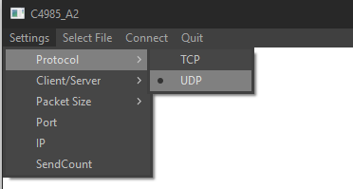

Figure 2.3



***Test 3***

Figure 3.1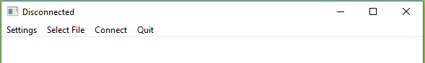

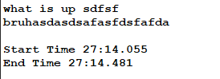Figure 3.2

***Test 4***

Figure 4

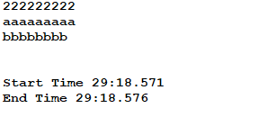

***Test 5***

Figure 5

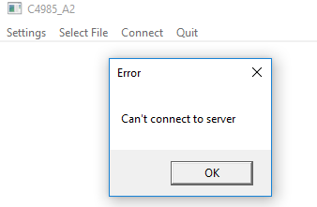

***Test 6***

Figure 6

