|  |  |  |  |  |
| --- | --- | --- | --- | --- |
| **Test Number** | **Test Description** | **Input** | **Expected Results** | **Results** |
| 1 | Attempt to start server | Run the executable 4981_a2 from command line with the parameter “server” (“./4981_a2 server”) | The command prompt will print “Listening…” and is waiting for client requests | Pass |
| 2 | Attempt to connect client | Run the executable 4981_a2 from command line with the parameter “client” (“./4981_a2 client”) | The command prompt will print “Enter a file name: “ prompting the user for input | Pass |
| 3 | Attempt to type in chat as a client | While the server is listening, make a client request for a file | The server will print to the command prompt the process id of the client making the request and the name of the file being requested | Pass |
| 4 | Attempt to hear others in chat as a client | While the server is listening, make a client request for a valid file (file.txt) and valid priority and wait for the file to be downloaded by the client | The client will successfully download and print to the screen the contents of the file, printing the duration of the download in seconds upon completion | Pass |
| 5 | Attempt to disconnect as a client | While the server is listening, make a client request for a file(notfile.txt) that does not exist on the server | The Client will receive a message stating file does not exist and the duration of the download will be printed on the screen | Pass |
| 6 | Attempt to reconnect after disconnecting as a client | While the server is listening, 2 clients will make a request for the same file(file.txt) with different priorities (1 and 5) | The Clients will successfully download and print the contents of the file to their screens with the client with higher priority (5) completing in less time | Pass |
| 7 | Attempt download a valid file for 3 clients simultaneously with different priority | While the server is listening, 3 clients will make a request for the same file(file.txt) with different priorities (1 and 5 and 10) | The Clients will successfully download and print the contents of the file to their screens with the clients finishing in order of highest priority first ( 10 -> 5 -> 1) | Pass |
| 8 | Attempt to close server gracefully | Start the server and enter “exit” into the command prompt | The program will close removing the message queue and semaphore from the os | Pass |
| 9 | Attempt to open program without specifying ‘client’ or ‘server’ | Start the program without entering “client” or “server” as a parameter | The program will close with the message “Choose client or server next time.” | Pass |
| 10 | Enter invalid priority value | Start the client and enter a file name then enter a value less than 1 or greater than 10 | The program will continue to prompt the user for a priority until a valid priority is entered | Pass |

**Test Screenshots**

***Test 1***

***Figure 1.1***

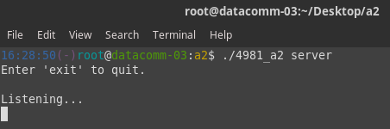

***Test 2***

***Figure 2.1***

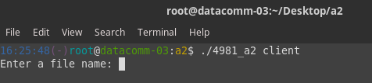

***Test 3***

***Figure 3.1***

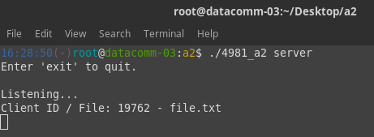

***Test 4***

***Figure 4.1***

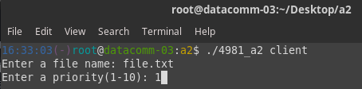

***Figure 4.2***

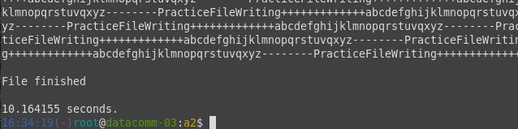

***Test 5***

***Figure 5.1***

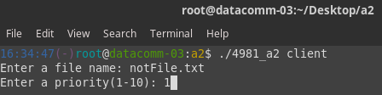

***Figure 5.2***

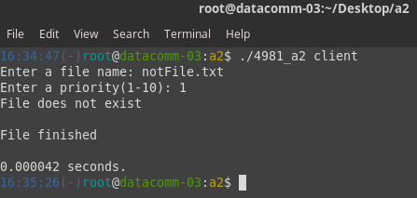

***Figure 5.3***

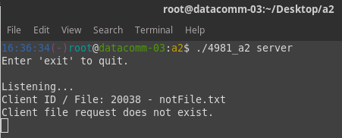

***Test 6***

***Figure 6.1***

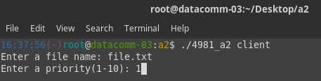

***Figure 6.2***

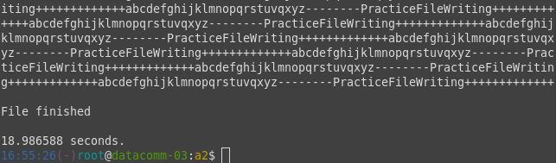

***Figure 6.3***

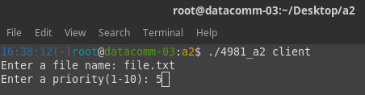

***Figure 6.4***

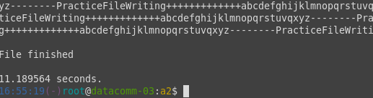

***Test 7***

***Figure 7.1***

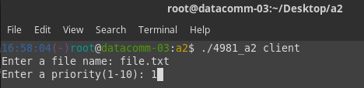

***Figure 7.2***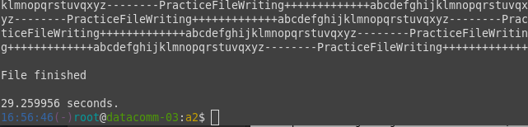

***Figure 7.3***

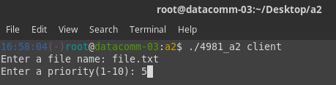

***Figure 7.4***

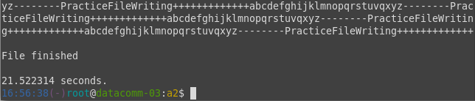

***Figure 7.5***

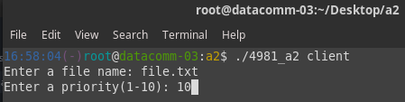

***Figure 7.6***

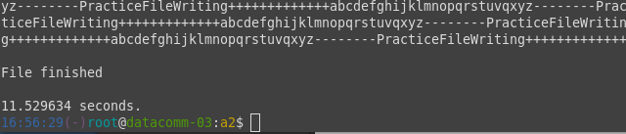

***Test 8***

***Figure 8.1***

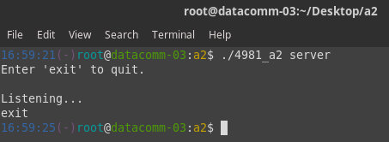

***Test 9***

***Figure 9.1***

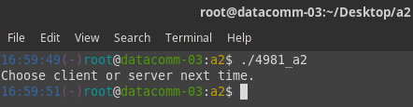

***Test 10***

***Figure 10.1***

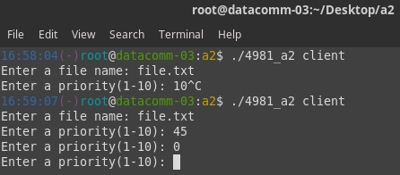

***Test 11***

***Figure 11.1***

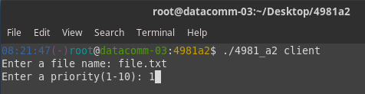

***Figure 11.2***

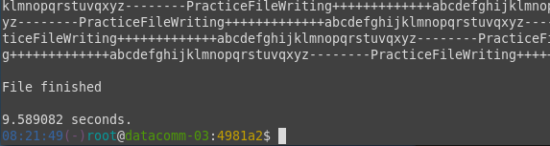

***Figure 11.3***

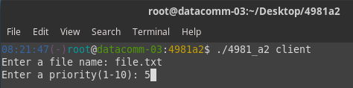

***Figure 11.4***

