

Network Programming (IE2102)
2nd Year, 1st Semester

Assignment

Design and Implementation of a Secure Multiprocessor TCP Application Server with Custom Protocol and Session Management

Submitted to
Sri Lanka Institute of Information Technology

IT24102409
Herath H.H.A.D.S.J

In partial fulfillment of the requirements for the
Bachelor of Science Special Honors Degree in Information Technology

11/04/2026
Important:
Remember
- Plagiarism is considered as a serious crime against intellectual property in academic environments.
- By including the declaration page mentioned below, you abide by the laws of the institute to accept 0 marks for the report, in case you get caught attempting plagiarism.
Annexure 1
General Formatting
- Paper size: A4
- Contents font & size: Times New Roman, size 12
- Chapter headings/sub headings font & size: Times New Roman Bold, size 12
- Page numbering:
  - Cover page should not contain any number
  - Declaration page to table of figures page should be numbered using Roman numbers at bottom center of the page
  - Content pages, references page(s) and annexes (if any) should be numbered using Arabic numbers at the bottom center of the page
- Margins: 1 inch margins on left, right, top and bottom
- Line spacing: 1 line spacing

Figure Numbering:
- Each figure should be numbered at bottom center of the figure along with a figure name.
- Figure number should start with word ‘Figure’ followed by the ‘main chapter number’ and ‘figure number within the chapter’ separated by a ‘period sign (.)’ and followed by a ‘colon (:)’.
For example,
Figure 2.6: XYZ Connector

Declaration Page:
Declaration page should contain the following. Reports that does not contain this declaration ‘AS IS’ will not be accepted as valid reports and will be awarded 0 marks.

Declaration
I certify that this report does not incorporate without acknowledgement, any material previously submitted for a degree or diploma in any university, and to the best of my knowledge and belief it does not contain any material previously published or written by another person, except where due reference is made in text.

Table of Contents

1. Hostname configuration 4
2. Network configuration 4
3. Server Execution and Port Binding Verification 2
4. User Registration and Authentication Success 3
5. Authentication Failure Handling and Account Lockout Mechanism 4
6. Concurrent Client Handling Using Forked Processes 5
7. Persistent Audit Logging Verification 6
8. Child Process Cleanup and Zombie Process Prevention 7

- Hostname configuration
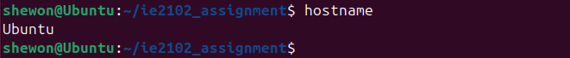
Figure 1.1
The hostname configuration displayed in Figure 1.1 verifies that the system has been correctly assigned an identity within the network. This is important for ensuring proper server deployment and enabling effective communication across networked environments.

- Network configuration

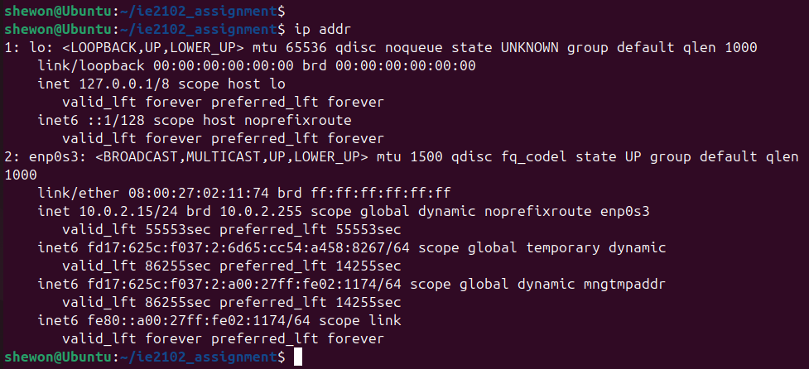
Figure 2.1
Figure 2.1 presents the system’s network settings, highlighting key details like interface configurations, addressing information, and routing paths. These elements demonstrate that the machine is ready to participate in network communication using standard protocols

- Server execution and Port Binding Verfication
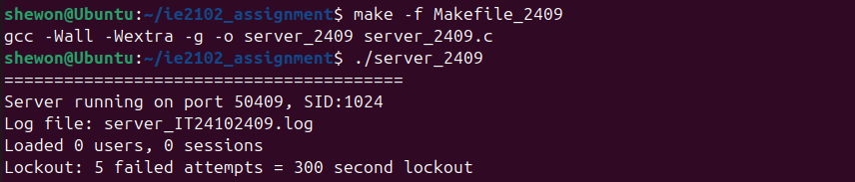
Figure 3.1

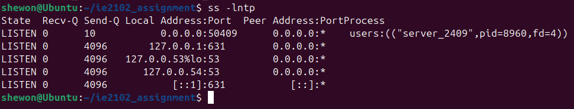
Figure 3.2
As shown in figure 3.1, the server has successfully initialized and is awaiting connections on its designated port. By verifying that the process is tied to port 50409, we can confirm that the implementation aligns perfectly with the project's technical constraints.

- User Registration and Authentication Success

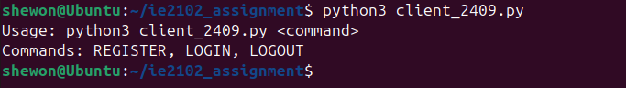
Figure 4.1
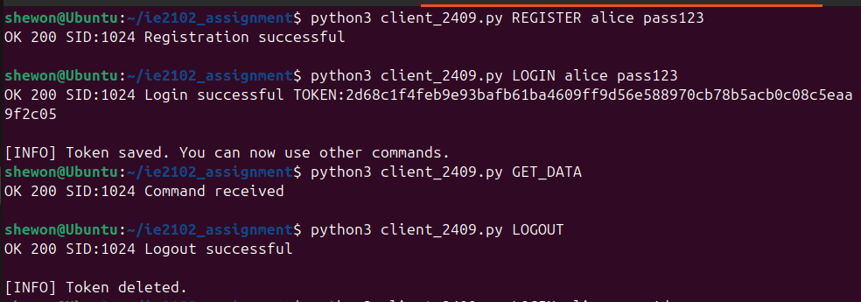
Figure 4.2
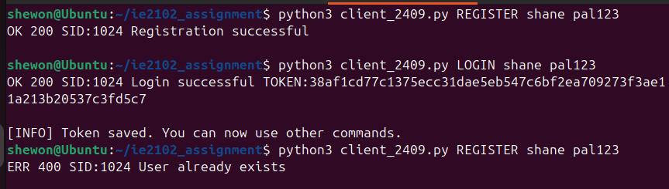
Figure 4.3
As illustrated in Figure 4.2, the system’s registration and authentication workflows are fully operational. The REGISTER command facilitates account creation by processing a unique username and password; the server performs a redundancy check to prevent duplicate accounts and secures credentials using salted hashing. Following registration, the LOGIN command handles user access. A successful match of credentials triggers the generation of a session token, validating that both the authentication logic and session management protocols are working as intended.

- Authentication Failure Handling and Account Lockout Mechanism
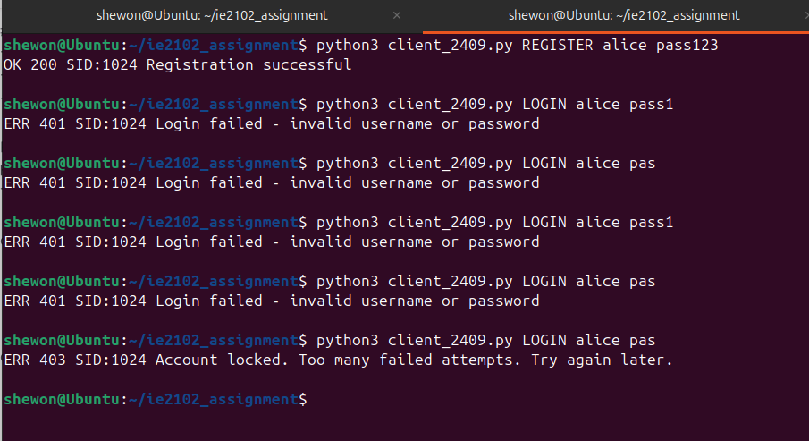
Figure 5.1
The implementation of the abuse protection mechanism is depicted in figure 5.1 The output shows the server identifying and intercepting multiple failed login attempts; once the defined threshold is exceeded, a mandatory account lockout is triggered. This security feature effectively mitigates brute-force risks by rejecting all subsequent requests, even when valid credentials are provided. As per the current design, the lockout state persists until a manual server restart is performed.

- Concurrent client handling Using Forked process
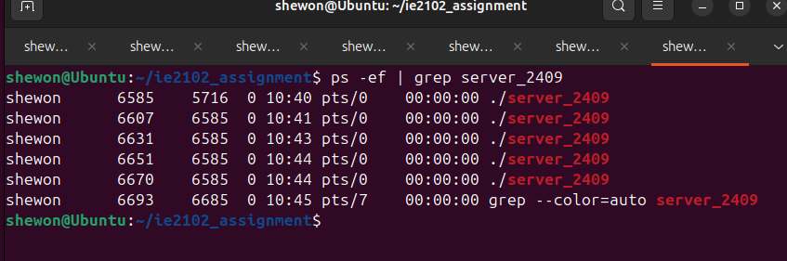
Figure 6.1 shows concurrent client handling using the fork() system call

- Persistent Audit Logging Verification
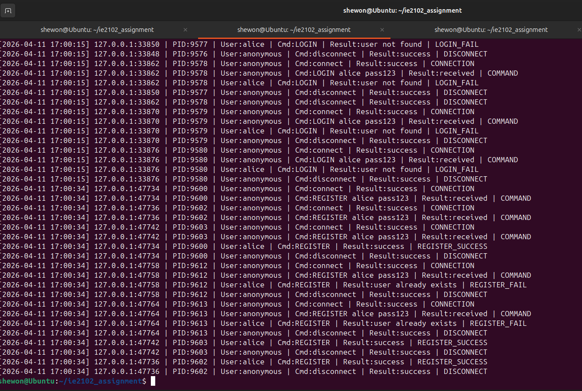
Figure 7.1
The figure 7.1 verifies the implementation of the audit logging system within server_IT24102409.log. The output shows that for every request, the server records the time, originating IP/port, associated process, and command results. This structured logging approach ensures full compliance with the assignment's tracking and accountability standards.

- Child Process Cleanup and Zombie Process Prevention
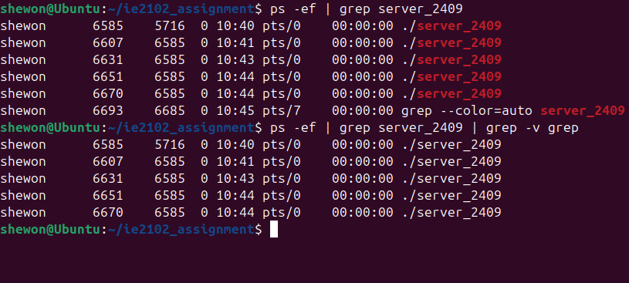
Figure 8.1
As shown in Figure 8.1, the server maintains multiple concurrent child processes. further validates the integrity of the process management logic; the absence of listed processes indicates that child exits are handled cleanly. By integrating SIGCHLD and waitpid(), the server ensures that no zombie processes remain, fulfilling the requirements for efficient resource cleanup.

