**05 October 2023**

1. Spring security is disable using the following:

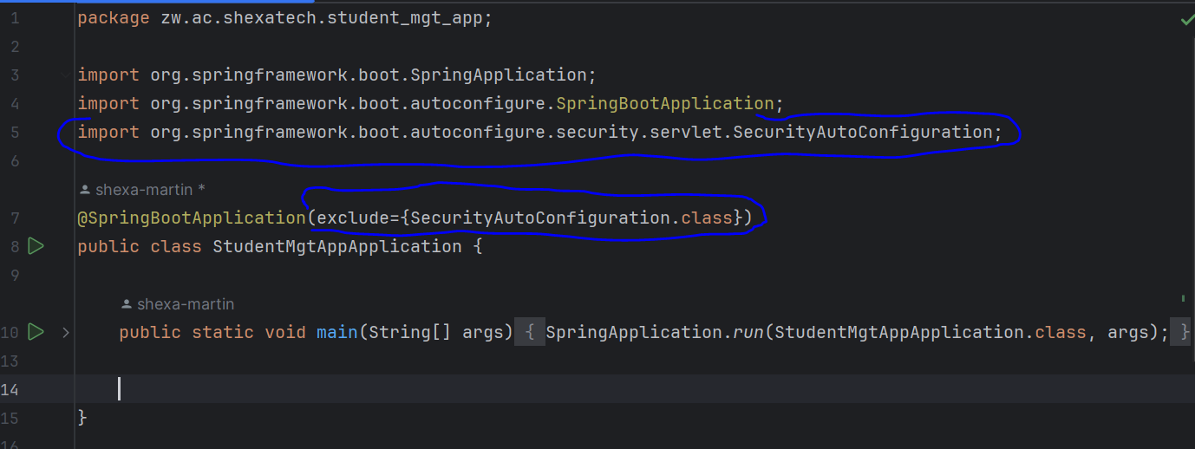

1. Global CORS configuration settings using new class in configs package ([Getting Started | Enabling Cross Origin Requests for a RESTful Web Service (spring.io)](https://spring.io/guides/gs/rest-service-cors/)):

