# SciSun Solar Simulator Testing Report

|  |  |
| --- | --- |
| **Project Number:** |  |
| **End User:** |  |
| **End User Country:** |  |

|  |  |
| --- | --- |
| **Solar Simulator Model:** | SciSun- |
| **Solar Simulator Serial Number:** | 000 |
| **Power Supply Model:** | 601- |
| **Power Supply Serial Number:** | 000 |
| **Type of Simulator:** | Continuous |
| **Manufacturer of Simulator:** | Sciencetech Inc. |
| **System Voltage Specification:** | 100 to 230 VAC, 50/60 Hz |

|  |  |
| --- | --- |
| **Performed By:** |  |
| **Date [YYYY-MM-DD]:** |  |
| **Reviewed By:** |  |
| **Date of Issue [YYYY-MM-DD]:** |  |

|  |  |  |
| --- | --- | --- |
| **System Configuration** | **Value** | **Notes** |
| *add any info about extras/options |  |  |

## Disclaimer

The values presented in this test document have been demonstrated with your test equipment at Sciencetech under ideal measurement and environmental conditions (except where expressly noted).  Variation from these values is expected due to variables introduced during shipping and installation of the system.  The equipment is expected to meet the required performance specifications after installation if the instructions supplied are properly followed, however some variation from the values reported in this report is normal and expected.  In order to verify and calibrate your equipment for values such as absolute irradiance or sun value it is recommended that a calibrated reference cell be used.

## Measurement Equipment

|  |  |  |  |
| --- | --- | --- | --- |
| **Measurement Equipment** | **Model** | **Serial No.** | **Calibration Date [YYYY-MM-DD]** |
| **Solar Reference Cell:** |  |  |  |
| **Source Meter:** |  |  |  |
| **Spectroradiometer Model:** | 9055-S-SOLARX /SD/P | 030-0013 |  |
| **Temperature Sensor:** |  |  |  |

## Solar Simulator Specifications

|  |  |  |  |
| --- | --- | --- | --- |
|  | **Value** | **Units** | **Notes** |
| **AM Filter:** |  |  | AM Filter Part Number: XXX-XXXX  Batch: XXXXX |
| **Power supply setting for**  **1 Sun (1000 W/m2) AM1.5G:** |  | % | Attenuator Setting: XX  Mesh Filter: XX |
| **Power supply setting for**  **2 Sun (2000 W/m2) AM1.5G:** |  | % | Attenuator Setting: XX  Mesh Filter: XX |
| **Maximum Irradiance Capability:** |  | W/m2 | Power Supply Setting: XX.X%  Attenuator Setting: XX  Mesh Filter: XX |
| **Minimum Irradiance Capability:** |  | W/m2 | Power Supply Setting: XX.X%  Attenuator Setting: XX  Mesh Filter: XX |
| **Field of View:** | 8.16 | Degrees | According to ASTM E927-19 3.2.1 definition. |
| **Total Lamp Age:** |  | Hours | Total lamp time at end of alignment and QC testing. |
| **Warm Up Time:** |  | Minutes | Warm-up time to steady state output. |
| **Ambient Temperature During Classification:** |  | Celsius |  |
| **Measurement Date [YYYY-MM-DD]:** |  | |  |
| **Classified Target Area:** | 50x50 | mm | The classified target area is centered on the illuminated area. |
| **Distances** | | | |
| **Working Distance, A:** | 380 | mm | Fig. 1 |
| **Test Plane Depth, B:** | 4 | mm | Fig. 1 |

## Distance to Target

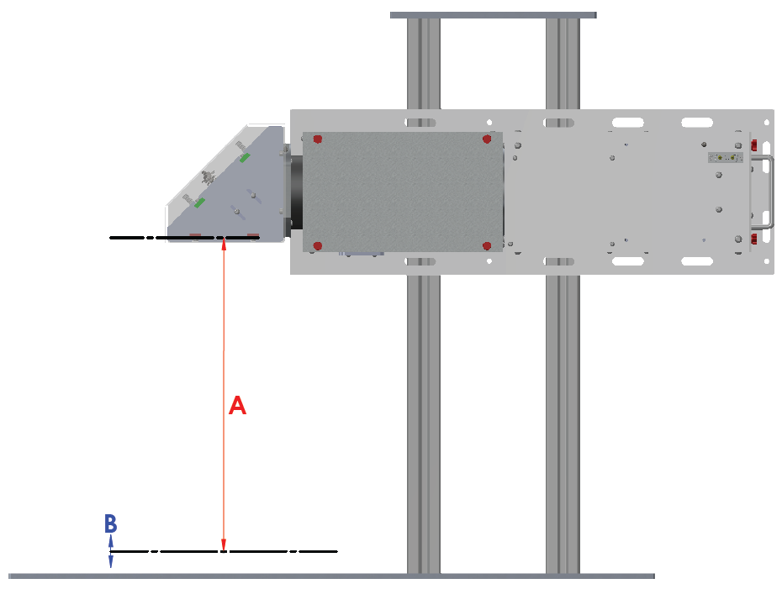

Figure 1: A is the working distance. B is the test plane depth. Working Distance is the distance from last surface to uniform plane (when the SciSun is incorporated into a workstation stand, the Working Distance is the distance from the inside top surface of the chamber to the uniform plane). Distance does not include manual shutter. Your system may not be exactly as pictured above.

Without Workstation Stand

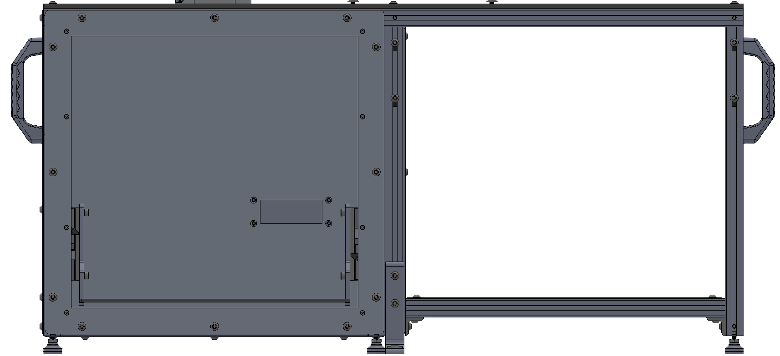

A

B

With Workstation Stand

## Spatial Non-Uniformity Report

Spatial non-uniformity was measured in accordance to ASTM E927-19 standards at an intensity of 1 sun. Validation performed measuring the short-circuit current of a silicon cell.

|  |  |  |
| --- | --- | --- |
|  | **Value** | **Units** |
| **Date of Measurement [YYYY-MM-DD]:** |  |  |
| **Detector Area:** |  | cm2 |
| **Number of Measurement Points:** | 64 |  |
| **Measurement Point Area:** | Total Area/No. of Points | cm2 |
| **Maximum Irradiance:** |  | Suns |
| **Minimum Irradiance:** |  | Suns |
| **Sample Standard Deviation of**  **Spatial Non-Uniformity:** |  | Suns |
| **Spatial Non-Uniformity of Irradiance:** |  | % |
| **Classification:** |  |  |

Please see accompanying data file of spatial irradiance values.

### Spatial Non-Uniformity Map

{{INSERT_PLOT_NU}}

## Spectral Irradiance Report

The spectral measurement was performed with a stepping-monochromator and silicon photodiode detector using modulated light and sensitive lock-in amplifier in accordance to ASTM E927-19 standards.

|  |  |  |
| --- | --- | --- |
|  | **Value** | **Units** |
| **Date of Measurement [YYYY-MM-DD]:** |  |  |
| **Scan Time:** |  | Minutes |
| **Number of Spectra Averaged:** |  |  |
| **Classification:** |  |  |

### Spectral Match Plot

Please see the table shown below for integrated irradiances and the corresponding classification. Please see the accompanying data file for spectral irradiance data.

{{INSERT_PLOT_SM}}

## Temporal Instability of Irradiance Report

Temporal instability of irradiance was measured in accordance to ASTM E927-19 standards at an intensity of 1 sun. Validation performed measuring the short-circuit current of a silicon cell.

|  |  |  |
| --- | --- | --- |
|  | **Value** | **Units** |
| **Date of Measurement [YYYY-MM-DD]:** |  |  |
| **Detector Area:** | 4 | cm2 |
| **Time Between Data Points:** | 0.19 | seconds |
| **Number of Power Line Cycles (NPLC):** | 1 |  |
| **Total Measurement Points:** | 20 |  |
| **Maximum Irradiance:** |  | Suns |
| **Minimum Irradiance:** |  | Suns |
| **Temporal Instability of Irradiance:** |  | % |
| **Classification:** |  |  |

### Temporal Instability of Irradiance Plot

Please see accompanying data file of temporal instability data points.

{{INSERT_PLOT_TI}}