XYZ High Density Via Rom Compiler User Manual
Contents

Chapter 1 Product Overview
This chapter provides an overview of the embedded memories of High Density Via Rom Compiler memory compiler.

1.1 Memory Compilers

1.2 Compiler Naming Convention
The following table shows the structure of the name for the compiler.
Table 1-1 Compiler Naming Rule Description
Name Segment | Character in “XYZHDVOSR” | Description
Technology & Process | XYZ | Process Node
Product type | HD | High Density
Ports | VO | Via Rom
Product subfamily | SR | Compiler

1.3 Expanded Instance Naming Rules
XYZHS1PRF1024X32M4B2VT0W0C1T0P0S0R0A0ME0E0_HSHC
The breakdown of the name is as follows, see Table for details:
XYZ HS 1P RF 1024 X 32 M4 B2 VT0 W0 C1 T0 P0 R0 S0 A0 ME0 E0 _ HSHC
1 2 3 4 5 6 7 8 9 10 11 12 13 14 15 16 17 18 19
Table 1-2 Breakdown of Automatic Naming Calculation
Auto-Name Segment | Description | Taken From:
1 | Process | Process node (XYZ)
2 | Memory Type | Base compiler name (HS, UHS, HD, UHD)
3 | Memory Type | Base compiler name (1P, SP, 2P, DP)
4 | Memory Type | Base compiler name (RF: Register File, SR: SRAM Compiler/Compiler)
5 | NW value | User-specified Number of Words (NW) value
6 | NB value | User-specified Number of Bits (NB) value
7 | M | User-specified Column Mux (CM) value
8 | B | User-specified Bank (BK) value
9 | VT | Periphery Vt option(0: ELVT, 1:ULVT, 2:LVT, 3: SVT)
10 | W<0,1> | Write Enable Bit (1 on, 0 off)
11 | C<0,1> | Center Decode (Always 1)
12 | T<0,1,2,3> | Bist mux enable & Scan Chain enable & Mbist enable (0 Bist Mux off / Scan Chain off/ Mbist off, 1 Bist Mux on / Scan Chain off/ Mbist off, 2 Bist Mux on / Scan Chain on/ Mbist off, 3 Bist Mux on / Scan Chain on/ Mbist on)
13 | P<0,1,2,3,4> | Power gating enable & Dual Rail enable (0 Power Gating off / Dual Rail off, 1 Power Gating on / Dual Rail off, 2 Power Gating off / Dual Rail on, 3 Power Gating on / Dual Rail on / Periphery Off off, 4 Power Gating on / Dual Rail on / Periphery Off on)
14 | R<0,1,2> | Memory Redundancy (0 No Redundancy, 1 Column Redundancy, 2 Column & Row Redundancy)
15 | S<0,1> | Self Time Bypass(0 off, 1on)
16 | A<0,1,2,3> | Read & Write Assist(0 Write Assist off / Read Assist off, 1 Write Assist on/ Read Assist off, 2 Write Assist off / Read Assist on, 3 Write Assist on / Read Assist on)
17 | ME<0,1> | Memory Gating(0 off, 1 on)
18 | E<0,1> | Anti-Signature(0 off, 1 on), only support ROM
19 | <HC, HSHC> | Bitcell type(HC, HSHC)

1.4 Compiler Features
Memory compilers support the following features:

1.4.1 Periphery Transistor Threshold Voltage Option
The default setting and available options of Periphery_Vt are shown in the following table.
Table 1-3 Periphery Vt Settings
Compiler Name | High Density Via Rom Compiler
SVT | Default
LVT | Low
ULVT | UltraLow
The devices used by different Periphery_Vt options are listed in the following table.
Table 1-4 Devices in Periphery Vt
Compiler Name | High Density Via Rom Compiler
SVT | lvtll and lvt, ulvtll, ulvt
LVT | lvt and lvtll, ulvtll, ulvt
ULVT | ulvt and lvtll, lvt, ulvtll

1.4.2 Performance Shape
Memory compilers provide multiple performance shapes. The following table lists the parameters used to enable these options.
Table 1-5 Performance Shape Settings
Feature | Description
Center Decode | If “center decode” feature is enabled(C1), it can improve instance performance but increase area. There is one repair elements.  If “center decode” feature is disabled(C0), it can improve instance area but decrease performance. There is one repair elements.  The Center decode of this version is always True.
Banks | Defining the number of banks of memory.
Column Mux | Providing different aspect ratio of memory.

1.4.3 CEN-Gating
Table 1-6 CEN-Gating
Feature | Description
CEN-Gating | By default, the A input pins are not gated by the CEN pin may increase toggle power. In this case, CEN requires a relatively small setup time.  To reduce the toggle power of the input pins, users can enable the CEN-Gating feature; however, the setup time of CEN may increase.

1.4.4 Power Gating
Table 1-7 Power Gating Mode
Power Gating Setting | Product Mode | Function Description
Disabled | Default | LS (Light Sleep) - Control the WL driver source biasing to reduce static power.  Active high. The output state remains unchanged.
Enabled | Advanced | LS (Light Sleep) - Control the WL driver source biasing.  DS (Deep Sleep) - Control the periphery circuit power gating, bitcell array hold the original data and memory outputs remain Logic Low.  SD (Shut Down) - Control the periphery circuit and bitcell array power gating, it performs a complete shutdown, bitcell array lose original data, and memory outputs remain Logic Low.

1.4.5 Self Time Bypass
Memory compilers support the Self Time Bypass mode.
In this mode (T_ICLKBYP=1), the memory’s internal self-timing loop is breakdown, and memory operation timing is controled by external CLK. It’s for memory debug purpose.

1.4.6 Timing Margin Control
Memory compilers provide the Timing Margin Control feature.
The read operation time of ROM is controlled by Timing Margin.The read operation process of single-end ROM is as follows:
- The read bit line be precharged to logic 1.
- The word line transitions to a high voltage level, and the read bit line precharge signal is disabled.
- The internal signal of the bitcell pulls down or keep the corresponding bit line through the transmission gate, then read bit line will pulled down to logic 0 or keep logic 1.
- The single end sense amplifier is activated to drive read bit line`s voltage to output data.
Read operations in ROM require a certain amount of time to ensure their completion. In fact, there is a negative correlation between the capacity and yield of ROM, meaning that a larger capacity often indicates a lower yield.
As the capacity increases, ROM bitcell exhibits varying variability, leading to distinct characteristics in its read capabilities. This variability can be mitigated by extending the duration of read operations. This underscores the trade-off between memory speed and yield/reliability: a longer delay enhances read robustness but slows down the operational speed.
Memory compiler controls the operating frequency of the compiler and the robustness of ROM read operations through Timing Margin Control.
Table 1-8 Timing Mode Settings
Timing Mode | Description
DEFAULT | Recommended for operation at (VDD nom) ± 10% Nominal Voltage
Memory compiler provides the enable signal through the TMEH/TMEL pin. The TMEH/TMEL pin allows for the selection between internal default margin control and external margin control. When TMEH/TMEL is low, the instance uses the default self-timing control.
There are Timing Margin Control bus pins available in the memory compiler. TMH/TML are used to trade-off between speed and robustness (yield). It is required that external access to all TMH/TML pins, including TMEH/TMEL, is provided for debug and yield analysis purposes.
When TMEH/TMEL is high, instance margin could be adjusted by the Timing input pins. The margin sequentially increases as TMH/TML sequentially decrease from All 1 to All 0, but the access time and cycle time will be sequentially enlarged as the pins driven from All 1 to All 0.
The Timing Margin Control settings are user-adjustable. The user-side TMH/TML interface is uniformly encoded, ensuring that all compilers have the same default TMH/TML value. Users can configure the settings from the options shown in the table below according to their application requirements.
Table 1-9 Default TM Bus Settings
Periphery_Vt | Mux | Default TMH[3:0] | Default TML[5:0]
SVT | 8 | 1000 | 000100
SVT | 16 | 1000 | 000100
SVT | 32 | 1000 | 000100
SVT | 64 | 1000 | 000100
LVT | 8 | 1100 | 001100
LVT | 16 | 1100 | 001100
LVT | 32 | 1100 | 001100
LVT | 64 | 1100 | 001100
ULVT | 8 | 1100 | 001100
ULVT | 16 | 1100 | 001100
ULVT | 32 | 1100 | 001100
ULVT | 64 | 1100 | 001100
Note: For additional characterization data of TM settings, users can contact the Support Team.

Chapter 2 Compiler Profile

2.1 Specifications
The specifications of High Density Via Rom Compiler.

2.1.1 Pin Description
Table 2-1 Input Pin Description
Signal | Enabled | Description
A [m-1:0] | Always | Address input.
CEN | Always | Chip Enable input. The memory is enabled and can perform read/write operations when CEN is Logic Low; the memory is disabled when it is Logic High.
CLK | Always | External Clock input.
T_ICLKBYP | Self Time Bypass feature | This pin must be controlled by software/firmware in silicon.  In this mode (T_ICLKBYP=1), the memory’s internal self-timing loop is breakdown, and memory operation timing is controled by external CLK. It’s for memory debug purpose.
TME | Always | This pin must be controlled by software/firmware in silicon.  Timing Margin Control Enable input.  TME = 0, select the default Timing Margin Control setting;  TME = 1, select the external Timing Margin Control pin setting.
TMH [3:0] | Always | This pin must be controlled by software/firmware in silicon.  Precharge Timing Margin Control Input bus.  The setting of TMH[3:0] controls the Tcq and Tcyc value of memory.  TMH[3:0] = 4’b0000 is the slowest operating mode.
TML [5:0] | Always | This pin must be controlled by software/firmware in silicon.  Discharge Timing Margin Control Input bus.  The setting of TML[5:0] controls the Tcq and Tcyc value of memory.  TML[5:0] = 6’b001000 is the slowest operating mode.
SD | Power Gating feature | Shut Down Mode Contorl Input. This pin turns off the power supply to the periphery. Rom can always retain the memory data.
ASE | Anti Signature feature | Anti Signature Enable Input. When user specify the programmed rom code, ROM will store the anti signature code. Anti signature code is calculated using a dedicated encryption algorithm. When ASE set to logic HIGH, the anti signature code will be available on the output pins independent of address being applied.

Table 2-2 Output Pin Description
Signal | Enabled | Description
Q [n-1:0] | always | Data Output bus.
PUR | Power Gating feature | “Power Up Ready” pin is used to reduce the peak power during wake-up from SD modes when instances are cascaded. When memory is in operation, this flag pin must be high.
Note: In the table above, m represents the maximum number of addresses supported by the compiler, and n represents the maximum number of bits supported by the compiler.

2.1.2 Compiler Range Information
Table 2-3 Compiler Range
Column  Mux | Bank | Word  Step | Word  Min | Word  Max | Bit  Step | Bit  Min | Bit  Max | Maximum  Density
8 | 1 | 32 | 64 | 2048 | 2 | 8 | 160 | 320Kb
8 | 2 | 32 | 128 | 4096 | 2 | 8 | 160 | 640Kb
8 | 4 | 32 | 256 | 8192 | 2 | 8 | 160 | 1.25Mb
8 | 8 | 32 | 512 | 8192 | 2 | 8 | 160 | 1.25Mb
16 | 1 | 64 | 128 | 4096 | 2 | 4 | 80 | 320Kb
16 | 2 | 64 | 256 | 8192 | 2 | 4 | 80 | 640Kb
16 | 4 | 64 | 512 | 16384 | 2 | 4 | 80 | 1.25Mb
16 | 8 | 64 | 1024 | 16384 | 2 | 4 | 80 | 1.25Mb
32 | 1 | 128 | 256 | 8192 | 2 | 4 | 40 | 320Kb
32 | 2 | 128 | 512 | 16384 | 2 | 4 | 40 | 640Kb
32 | 4 | 128 | 1024 | 32768 | 2 | 4 | 40 | 1.25Mb
32 | 8 | 128 | 2048 | 32768 | 2 | 4 | 40 | 1.25Mb
64 | 1 | 256 | 512 | 16384 | 2 | 4 | 20 | 320Kb
64 | 2 | 256 | 1024 | 32768 | 2 | 4 | 20 | 640Kb
64 | 4 | 256 | 2048 | 65536 | 2 | 4 | 20 | 1.25Mb
64 | 8 | 256 | 4096 | 65536 | 2 | 4 | 20 | 1.25Mb

2.1.3 Logic Truth Tables

2.1.3.1 Memory Function Truth Table
Note: In the above truth table, the state of test signals is T_ICLKBYP=L.
NCM: Memory bit-cell contents remain unchanged.
Q-1: Maintains the state of the previous cycle.
Q: Output without CLK latency.
The following table shows the memory function truth table for this compiler.
Table 2-4 Memory Function Truth Table
Function | CLK | CEN | Q | Memory  Contents
Idle | L | X | Q-1 | NCM
Disabled | H | H | Q-1 | NCM
Read | H | L | Q | NCM

2.1.3.2 Power Mode Truth Table
The following table shows the truth table for Power mode.
Note: This function is valid when the Power Gating feature is selected.
In Periphery Off modes, the Periphery supply VDD is allowed to be powered down.
Q-1 = Memory output maintains the state of the previous cycle.
Table 2-5 Power Mode Truth Table
Mode | CEN | LS | SD | PUR | Q | Comments
Normal | 0/1 | 0 | 0 | 1 | Q-1 | Normal mode
Light Sleep | 0/1 | 1 | 0 | 1 | Q-1 | Xdec power gate,  Bitline Discharge
Shut Down  enable | X | X | 0->1 | 0 | 0 | Periphery shutdown,  array shutdown
Shut Down  disable | X | X | 1->0 | 1 | X | Periphery wakeup,  array wakeup

2.1.4 Waveform Diagrams
This section presents various timing waveforms.
Note: If CEN is Low, it must be ensured that each signal meets the timing specification relative to the clock.
If CEN is High, there is no need to meet the timing specification for each signal.
This note also applies to Power Management pins such as LS.
When CEN=1, LS can be asynchronously asserted and de-asserted.
The figure below shows the conventions used in the waveform diagrams.
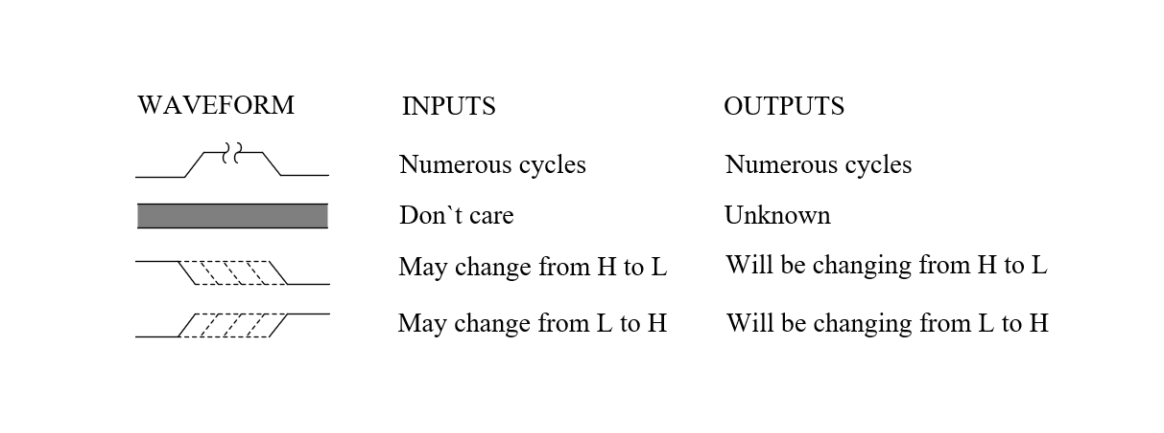
Figure 2-1 Waveform Conventions
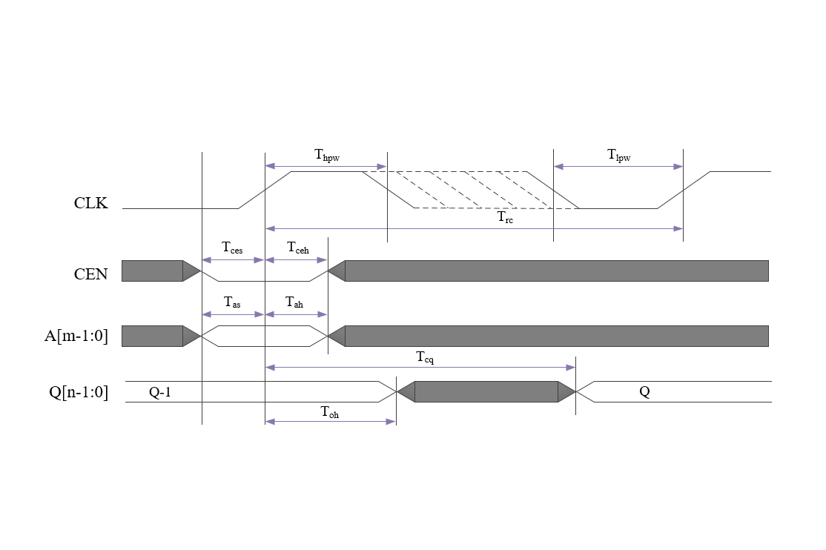
Figure 2-2 Read Cycle Timing Diagram
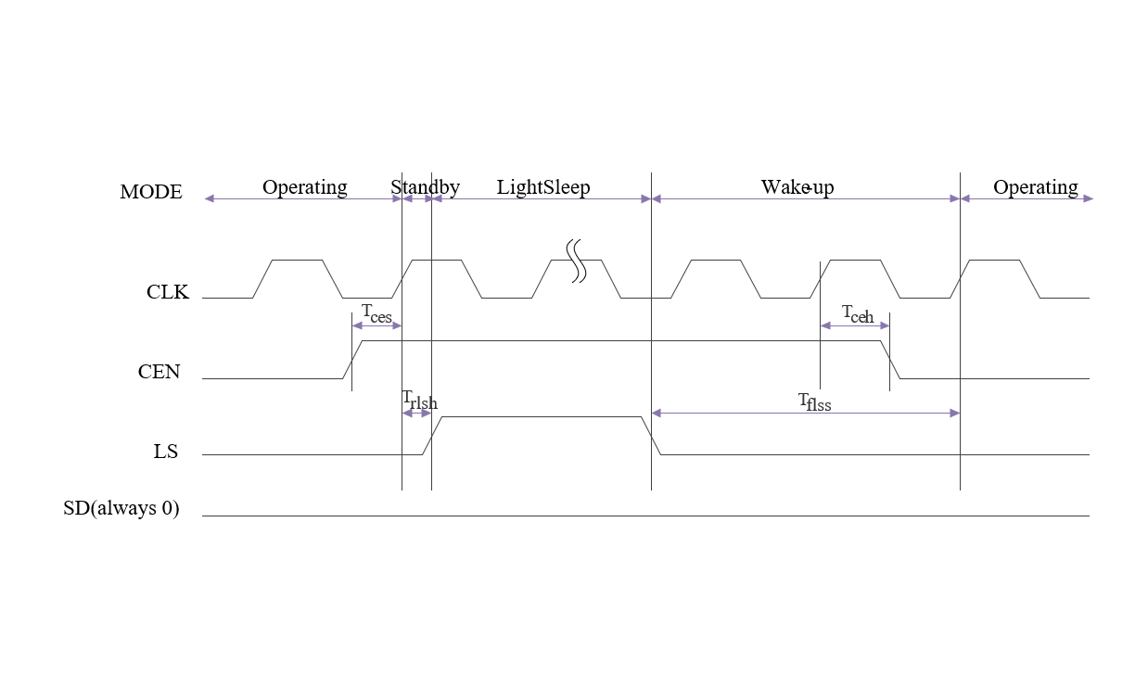
Figure 2-3 Light Sleep Mode Work Function Diagram
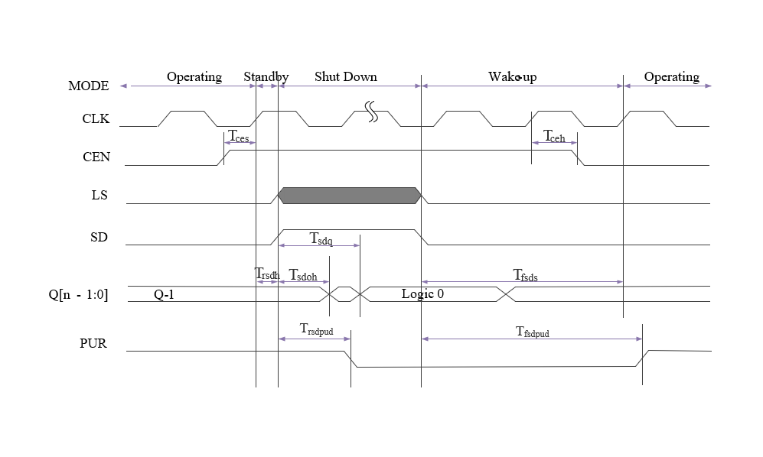
Figure 2-4 Shut Down Mode Work Function Diagram

2.1.5 Standard Operating Characterization Conditions
Table 2-6 Standard PVT Corners - Single Rail
PVT Corners | Process | VDD  (V) | VDDC  (V) | Temperature  (C) | RC Extraction
TT_0P75V_0P75V_25C_Typical | TT | 0.75 | 0.75 | 25 | Typical
TT_0P75V_0P75V_85C_Typical | TT | 0.75 | 0.75 | 85 | Typical
FFGNP_0P825V_0P825V_M40C_Cbest_CCbest_T | FFGNP | 0.825 | 0.825 | -40 | Cbest_CCbest_T
FFGNP_0P825V_0P825V_0C_Cbest_CCbest_T | FFGNP | 0.825 | 0.825 | 0 | Cbest_CCbest_T
FFGNP_0P825V_0P825V_125C_Cbest_CCbest_T | FFGNP | 0.825 | 0.825 | 125 | Cbest_CCbest_T
SSGNP_0P675V_0P675V_M40C_Cworst_CCworst_ T | SSGNP | 0.675 | 0.675 | -40 | Cworst_CCworst_T
SSGNP_0P675V_0P675V_0C_Cworst_CCworst_T | SSGNP | 0.675 | 0.675 | 0 | Cworst_CCworst_T
SSGNP_0P675V_0P675V_125C_Cworst_CCworst_ T | SSGNP | 0.675 | 0.675 | 125 | Cworst_CCworst_T
Note: VDD: Periphery Voltage;
VDDC: Array Voltage

