XYZ High Speed One Port Register File User Manual
Contents

Chapter 1 Product Overview
This chapter provides an overview of the embedded memories of High Speed One Port Register File memory compiler.

1.1 Memory Compilers

1.2 Compiler Naming Convention
The following table shows the structure of the name for the compiler.
Table 1-1 Compiler Naming Rule Description
Name Segment | Character in “XYZHS1PRF” | Description
Technology & Process | XYZ | Process Node
Product type | HS | High Speed
Ports | 1P | One Port
Product subfamily | RF | Register File

1.3 Expanded Instance Naming Rules
XYZHS1PRF1024X32M4B2VT0W0C1T0P0S0R0A0ME0E0_HSHC
The breakdown of the name is as follows, see Table for details:
XYZ HS 1P RF 1024 X 32 M4 B2 VT0 W0 C1 T0 P0 R0 S0 A0 ME0 E0 _ HSHC
1 2 3 4 5 6 7 8 9 10 11 12 13 14 15 16 17 18 19
Table 1-2 Breakdown of Automatic Naming Calculation
Auto-Name Segment | Description | Taken From:
1 | Process | Process node (XYZ)
2 | Memory Type | Base compiler name (HS, UHS, HD, UHD)
3 | Memory Type | Base compiler name (1P, SP, 2P, DP)
4 | Memory Type | Base compiler name (RF: Register File, SR: SRAM Compiler/Compiler)
5 | NW value | User-specified Number of Words (NW) value
6 | NB value | User-specified Number of Bits (NB) value
7 | M | User-specified Column Mux (CM) value
8 | B | User-specified Bank (BK) value
9 | VT | Periphery Vt option(0: ELVT, 1:ULVT, 2:LVT, 3: SVT)
10 | W<0,1> | Write Enable Bit (1 on, 0 off)
11 | C<0,1> | Center Decode (Always 1)
12 | T<0,1,2,3> | Bist mux enable & Scan Chain enable & Mbist enable (0 Bist Mux off / Scan Chain off/ Mbist off, 1 Bist Mux on / Scan Chain off/ Mbist off, 2 Bist Mux on / Scan Chain on/ Mbist off, 3 Bist Mux on / Scan Chain on/ Mbist on)
13 | P<0,1,2,3,4> | Power gating enable & Dual Rail enable (0 Power Gating off / Dual Rail off, 1 Power Gating on / Dual Rail off, 2 Power Gating off / Dual Rail on, 3 Power Gating on / Dual Rail on / Periphery Off off, 4 Power Gating on / Dual Rail on / Periphery Off on)
14 | R<0,1,2> | Memory Redundancy (0 No Redundancy, 1 Column Redundancy, 2 Column & Row Redundancy)
15 | S<0,1> | Self Time Bypass(0 off, 1on)
16 | A<0,1,2,3> | Read & Write Assist(0 Write Assist off / Read Assist off, 1 Write Assist on/ Read Assist off, 2 Write Assist off / Read Assist on, 3 Write Assist on / Read Assist on)
17 | ME<0,1> | Memory Gating(0 off, 1 on)
18 | E<0,1> | Anti-Signature(0 off, 1 on), only support ROM
19 | <HC, HSHC> | Bitcell type(HC, HSHC)

1.4 Compiler Features
Memory compilers support the following features:

1.4.1 Periphery Transistor Threshold Voltage Option
The default setting and available options of Periphery_Vt are shown in the following table.
Table 1-3 Periphery Vt Settings
Compiler Name | High Speed One Port Register File
LVT | Low
ULVT | UltraLow
The devices used by different Periphery_Vt options are listed in the following table.
Table 1-4 Devices in Periphery Vt
Compiler Name | High Speed One Port Register File
LVT | lvt and lvtll, ulvt, ulvtll, elvt
ULVT | ulvt and ulvtll, lvt, lvtll, elvt

1.4.2 Performance Shape
Memory compilers provide multiple performance shapes. The following table lists the parameters used to enable these options.
Table 1-5 Performance Shape Settings
Feature | Description
Center Decode | If “center decode” feature is enabled(C1), it can improve instance performance but increase area. There is one repair elements.  If “center decode” feature is disabled(C0), it can improve instance area but decrease performance. There is one repair elements.  The Center decode of this version is always True.
Banks | Defining the number of banks of memory.
Column Mux | Providing different aspect ratio of memory.

1.4.3 Bit Write
Table 1-6 Bit Write Enable
Feature | Description
Bit Write Enable | Memory compilers provide the Bit Write Enable feature.  - If the BWEN = 0, the corresponding bit’s data is written to the bit cell array.  - If the BWEN = 1, the corresponding bit’s data is not written to the bit cell array.

1.4.4 CEN-Gating
Table 1-7 CEN-Gating
Feature | Description
CEN-Gating | By default, the A/D/WEN/BWEN input pins are not gated by the CEN pin may increase toggle power. In this case, CEN requires a relatively small setup time.  To reduce the toggle power of the input pins, users can enable the CEN-Gating feature; however, the setup time of CEN may increase.

1.4.5 Power Gating
Table 1-8 Power Gating Mode
Power Gating Setting | Product Mode | Function Description
Disabled | Default | LS (Light Sleep) - Control the WL driver source biasing to reduce static power.  Active high. The output state remains unchanged.
Enabled | Advanced | LS (Light Sleep) - Control the WL driver source biasing.  DS (Deep Sleep) - Control the periphery circuit power gating, bitcell array hold the original data and memory outputs remain Logic Low.  SD (Shut Down) - Control the periphery circuit and bitcell array power gating, it performs a complete shutdown, bitcell array lose original data, and memory outputs remain Logic Low.

1.4.6 Interface Dual Rail
Memory compilers support the Interface Dual Rail feature.
Users can enable independent voltage rails for the input/output interface logic and the internal periphery logic + array at the instance level. Level shifters are used in the input interface logic. This option is controlled by setting the Interface Dual Rail feature. For more information, see “Standard Operating Characterization Conditions” in Chapter 2. This option allows the array to remain within the safe operating voltage range of VDD nom +/- 10%.
When the Interface Dual Rail feature is selected, Light Sleep mode is also supported. After the dual-rail option is enabled, Deep Sleep and Shut Down modes can be enabled independently when the Power Gating feature is selected. When the Periphery Off feature is further selected, periphery power shutoff can be enabled. For more information, see “Periphery Off” in this chapter.

1.4.7 Redundancy
Memory compilers can generate memory instances with built-in redundancy for memory repair purposes.
Redundancy is enabled via the Redundancy feature.
When the `Column Redundancy feature` is selected, column redundancy is enabled;
When the `Row Redundancy feature` is selected, both row and column redundancy resources are provided.
Table 1-9 Repair Elements Mode
Compiler Group | Redundancy Architecture
Register File | Column Redundancy Resources
SRAM Compiler | Column Redundancy Resources  Row Redundancy Resources
Rom Compiler | nan
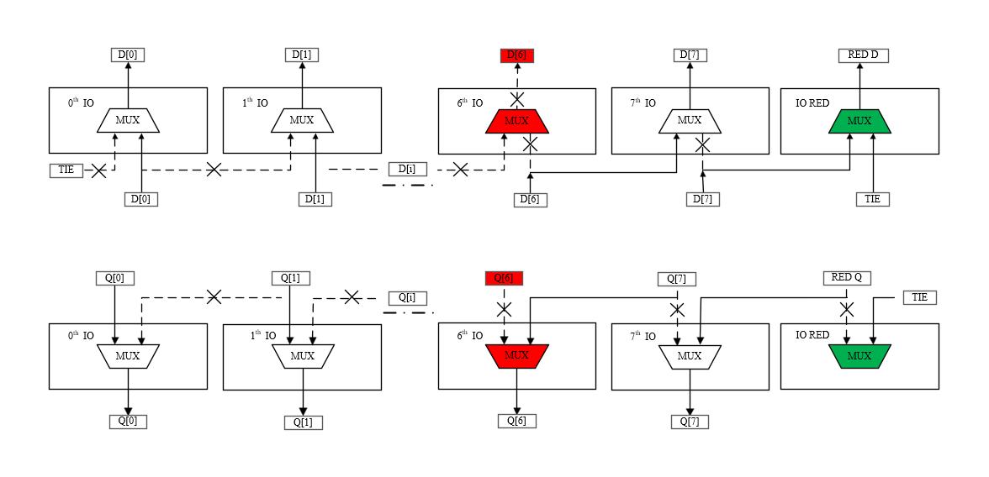
Figure 1-1 Column Redundancy Replace Mechanism
Figure show an example of the column redundancy replace mechanism in a 8 bits column Mux memory instance. In the case, 6th IO needs to be repaired. Once redundancy DFF chain be configured, redundancy scheme works. Q[7] receives the output of the redundant sub-array, Q[6] receives the output of Q[7], then replacement complete. The rest IO[0]~IO[5] receive the output of themselves.
One IO where defect is detected can be replaced by redundancy. All data flip-flop which used to configure redundancy logic to column redundant substitution. The redundant substitution of configure choose based on memory`s bit width of input data bus.
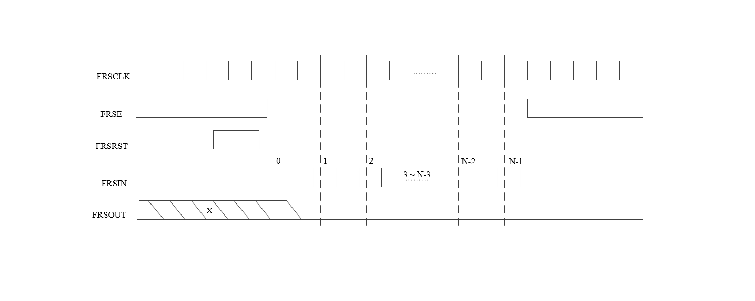
Figure 1-2 Column Redundancy Waveform
Figure shows the scan sequence of 1 column redundant substitution is followed by least significant bit of io address (0), then io address increasing until most significant bit of io address (N-2) is captured, and finally redundancy enable signal (N-1) is the last signal of scan sequence.

1.4.8 Self Time Bypass
Memory compilers support the Self Time Bypass mode.
In this mode (T_ICLKBYP=1), the memory’s internal self-timing loop is breakdown, and memory operation timing is controled by external CLK. It’s for memory debug purpose.

1.4.9 Timing Margin Control
Memory compilers provide the Timing Margin Control feature.
The read and write operation time of SRAM is controlled by Timing Margin.The read operation process of differential SRAM is as follows:
- The word line transitions to a high voltage level, and the bit line precharge signal is disabled.
- The internal signal of the bitcell pulls down the corresponding bit line through the transmission gate, creating a small voltage difference.
- The differential sense amplifier is activated to amplify this voltage difference to the full-scale voltage difference.
The write operation process of differential SRAM is as follows:
- The word line is activated, and the input data is driven to the bit line pair, maintaining logic 0 and 1 respectively.
- The bit line of logic 0 pulls down the memory storage node of the bitcell through the transmission gate.
- The storage node changes logic 1 to logic 0 through the cross-couple structure
Both read and write operations in SRAM require a certain amount of time to ensure their completion. In fact, there is a negative correlation between the capacity and yield of SRAM, meaning that a larger capacity often indicates a lower yield.
As the capacity increases, SRAM bitcell exhibits varying variability, leading to distinct characteristics in its read and write capabilities. This variability can be mitigated by extending the duration of read and write operations. This underscores the trade-off between memory speed and yield/reliability: a longer delay enhances read robustness but slows down the operational speed.
Memory compiler controls the operating frequency of the compiler and the robustness of SRAM read and write operations through Timing Margin Control.
Table 1-10 Timing Mode Settings
Timing Mode | Description
DEFAULT | Recommended for operation at (VDD nom) ± 10% Nominal Voltage
Memory compiler provides the enable signal through the TME pin. The TME pin allows for the selection between internal default margin control and external margin control. When TME is low, the instance uses the default self-timing control.
There are Timing Margin Control bus pins available in the memory compiler. TM are used to trade-off between speed and robustness (yield). It is required that external access to all TM pins, including TME, is provided for debug and yield analysis purposes.
When TME is high, instance margin could be adjusted by the Timing input pins. The margin sequentially increases as TM sequentially decrease from All 1 to All 0, but the access time and cycle time will be sequentially enlarged as the pins driven from All 1 to All 0.
The Timing Margin Control settings are user-adjustable. The user-side TM interface is uniformly encoded, ensuring that all compilers have the same default TM value. Users can configure the settings from the options shown in the table below according to their application requirements.
Table 1-11 Default TM Bus Settings
Periphery_Vt | Mux | Default TM[3:0]
LVT | 2 | 0100
LVT | 4 | 0100
ULVT | 2 | 0100
ULVT | 4 | 0011
Note: For additional characterization data of TM settings, users can contact the Support Team.

Chapter 2 Compiler Profile

2.1 Specifications
The specifications of High Speed One Port Register File.

2.1.1 Pin Description
Table 2-1 Input Pin Description
Signal | Enabled | Description
A [m-1:0] | Always | Address input.
D [n-1:0] | Always | Data input.
BWEN [n-1:0] | Bit Write feature | Bit Write Enable. Bit Write is enabled when BWEN is Logic Low. When the Bit Write feature is included, write operation can be performed by enabled I/Os bits.
WEN | Always | Global Write Enable input. The memory is in the Write cycle when the Global Write Enable input is Logic Low; the memory is in the Read cycle when it is Logic High.
CEN | Always | Chip Enable input. The memory is enabled and can perform read/write operations when CEN is Logic Low; the memory is disabled when it is Logic High.
CLK | Always | External Clock input.
FRSIN | Redundancy feature | Faulty Repair Register Scan Input. Redundancy Scan input bit.
FRSE | Redundancy feature | Faulty Repair Register Scan Enable Input. Redundancy Scanning enable, active high.
FRSRST | Redundancy feature | Faulty Repair Register Scan Asynchronous Reset Input. Before memory normal access, FRSRST must be performed a high to low(negative edge) control signal.
FRSCLK | Redundancy feature | Faulty Repair Register Scan Clock.
T_ICLKBYP | Self Time Bypass feature | This pin must be controlled by software/firmware in silicon.  In this mode (T_ICLKBYP=1), the memory’s internal self-timing loop is breakdown, and memory operation timing is controled by external CLK. It’s for memory debug purpose.
TME | Always | This pin must be controlled by software/firmware in silicon.  Timing Margin Control Enable input.  TME = 0, select the default Timing Margin Control setting;  TME = 1, select the external Timing Margin Control pin setting.
TM[3:0] | Always | This pin must be controlled by software/firmware in silicon.  Timing Margin Control Input bus.  The setting of TM[3:0] controls the Tcq and Tcyc value of memory.  TM[3:0] = 4’b0000 is the slowest operating mode.
LS | Always | Light Sleep Mode Contorl Input. When the memory is disabled and this pin is set logic High, the memory enters low leakage mode. The output state remains unchanged.
DS | Power Gating feature | Deep Sleep Mode Control Input. This pin turns off the periphery power supply while retaining the memory contents. The outputs of the memory are pulled low.
SD | Power Gating feature | Shut Down Mode Contorl Input. This pin turns off the power supply to the periphery and memory core, and does not retain the memory data.

Table 2-2 Output Pin Description
Signal | Enabled | Description
Q [n-1:0] | always | Data Output bus.
FRSOUT | Redundancy feature | Faulty Repair Register Scan Output. It is used to output the Faulty Repair Register Scan bit. When the Power Gating feature mode is selected, its content will be lost if the power supply of the periphery is turned off.
PUR | Power Gating feature | “Power Up Ready” pin is used to reduce the peak power during wake-up from DS and SD modes when instances are cascaded. When memory is in operation, this flag pin must be high.
Note: In the table above, m represents the maximum number of addresses supported by the compiler, and n represents the maximum number of bits supported by the compiler.

2.1.2 Compiler Range Information
Table 2-3 Compiler Range
Column  Mux | Bank | Word  Step | Word  Min | Word  Max | Bit  Step | Bit  Min | Bit  Max | Maximum  Density
2 | 1 | 8 | 16 | 512 | 2 | 8 | 288 | 144Kb
2 | 2 | 8 | 32 | 1024 | 2 | 8 | 288 | 288Kb
4 | 1 | 16 | 32 | 1024 | 1 | 8 | 144 | 144Kb
4 | 2 | 16 | 64 | 2048 | 1 | 8 | 144 | 288Kb

2.1.3 Logic Truth Tables

2.1.3.1 Memory Function Truth Table
Note: In the above truth table, the state of test signals is T_ICLKBYP=L.
After Power up, before starting normal memory operation (read/write), a Negedge(1->0) must be performed on FRSRST first.
NCM: Memory bit-cell contents remain unchanged.
Q-1: Maintains the state of the previous cycle.
Q: Output without CLK latency.
Table 2-4 Memory Function Truth Table
Function | CLK | CEN | WEN | BWEN | D | Q | Memory  Contents
Idle | L | X | X | X | X | Q-1 | NCM
Disabled | H | H | X | X | X | Q-1 | NCM
Read | H | L | H | X | X | Q | NCM
Write | H | L | L | L | Data-in | Q-1 | Data-in
Write Mask | H | L | L | H | X | Q-1 | NCM

2.1.3.2 Power Mode Truth Table
The following table shows the truth table for Power mode.
Note: This function is valid when the Power Gating feature is selected.
In Periphery Off modes, the Periphery supply VDD is allowed to be powered down.
Q-1 = Memory output maintains the state of the previous cycle.
Table 2-5 Power Mode Truth Table
Mode | CEN | LS | DS | SD | PUR | Q | Comments
Normal | 0/1 | 0 | 0 | 0 | 1 | Q-1 | Normal mode
Light Sleep | 0/1 | 1 | 0 | 0 | 1 | Q-1 | Xdec power gate,  Bitline Discharge
Deep Sleep  enable | X | X | 0->1 | 0 | 0 | 0 | Periphery shutdown
Deep Sleep  disable | X | X | 1->0 | 0 | 1 | X | Periphery wakeup
Shut Down  enable | X | X | X | 0->1 | 0 | 0 | Periphery shutdown,  array shutdown
Shut Down  disable | X | X | X | 1->0 | 1 | X | Periphery wakeup,  array wakeup

2.1.3.3 Redundancy Scan Mode Truth Table
The following table shows the truth table for Redundancy Scan mode.
Note: When FRSCLK is not running, please keep it at H or L.
Table 2-6 Redundancy Scan Mode Truth Table
Function | FRSCLK | FRSE | FRSIN | CEN | FRSRST | FRSOUT
Disable | X | X | X | H | L | X
Normal | X | L | X | L | L | X
Scan | L->H | H | Fuse_Data | X | L | X
Reset | X | X | X | X | H | L

2.1.4 Waveform Diagrams
This section presents various timing waveforms.
Note: If CEN is Low, it must be ensured that each signal meets the timing specification relative to the clock.
If CEN is High, there is no need to meet the timing specification for each signal.
This note also applies to Power Management pins such as LS.
When CEN=1, LS can be asynchronously asserted and de-asserted.
The figure below shows the conventions used in the waveform diagrams.
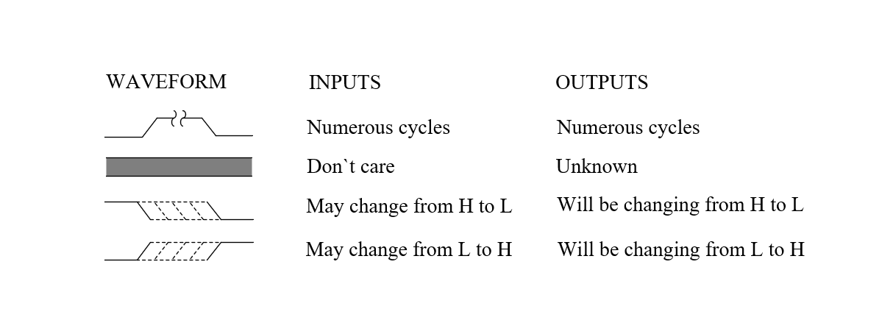
Figure 2-1 Waveform Conventions
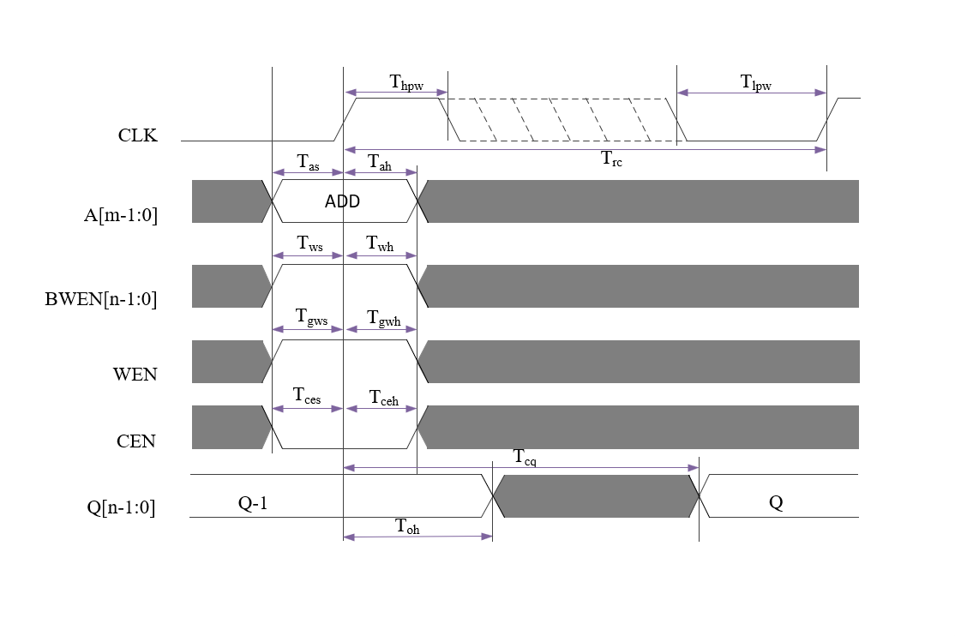
Figure 2-2 Read Cycle Timing Diagram
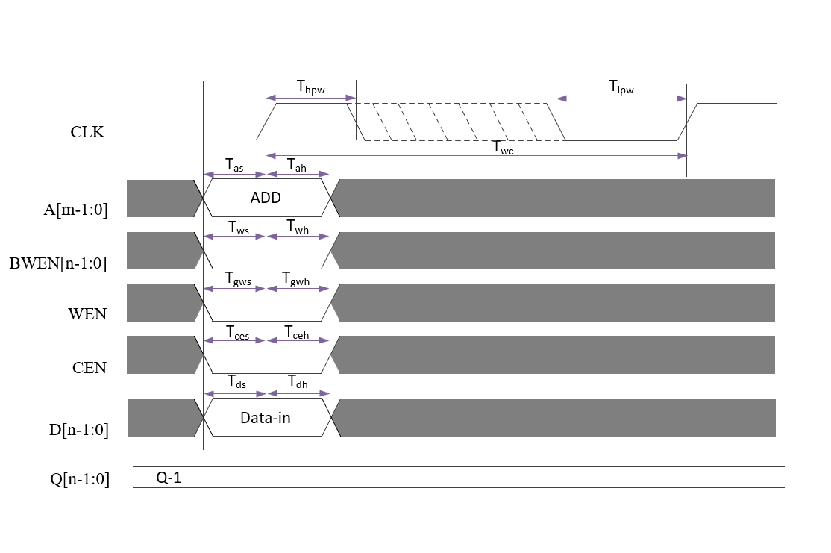
Figure 2-3 Write Cycle Timing Diagram
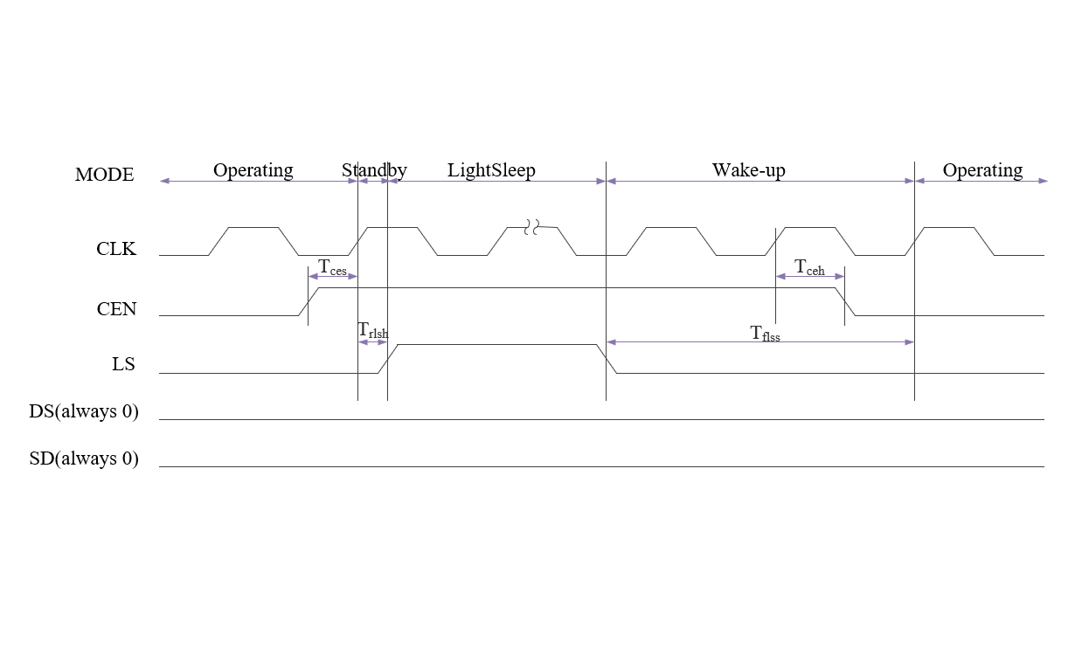
Figure 2-4 Light Sleep Mode Work Function Diagram
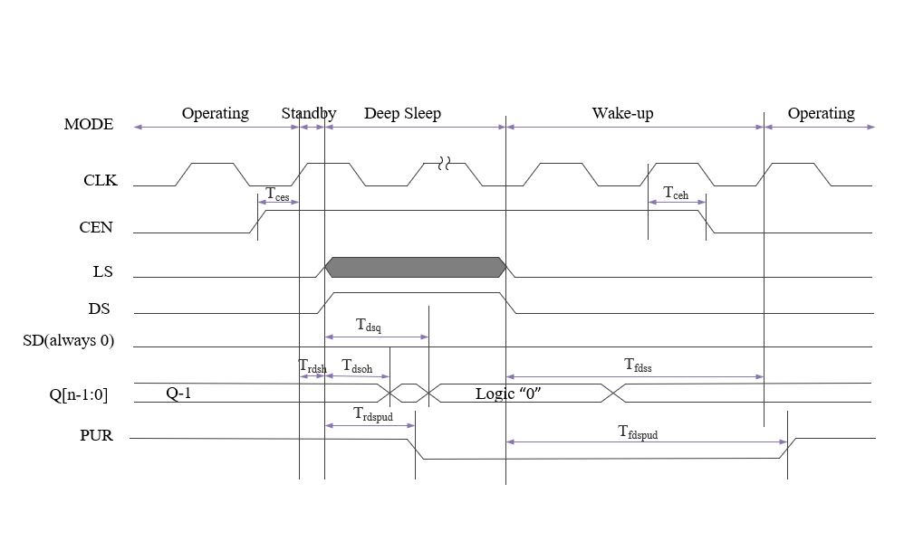
Figure 2-5 Deep Sleep Mode Work Function Diagram
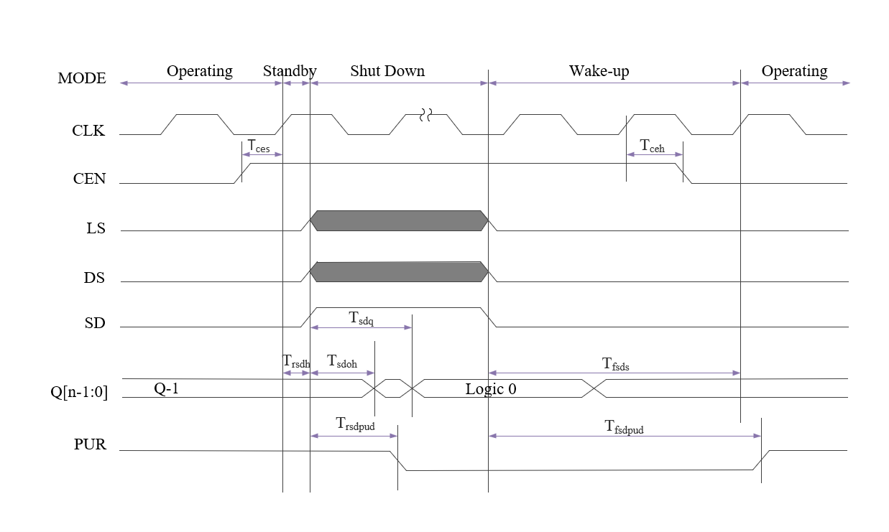
Figure 2-6 Shut Down Mode Work Function Diagram

2.1.5 Standard Operating Characterization Conditions
Note: VDD: Periphery Voltage;
VDDC: Array Voltage
Table 2-7 Standard PVT Corners - Single Rail
PVT Corners | Process | VDD  (V) | VDDC  (V) | Temperature  (C) | RC Extraction
TT_0P75V_0P75V_25C_Typical | TT | 0.75 | 0.75 | 25 | Typical
TT_0P75V_0P75V_85C_Typical | TT | 0.75 | 0.75 | 85 | Typical
FFGNP_0P825V_0P825V_M40C_Cbest_CCbest_T | FFGNP | 0.825 | 0.825 | -40 | Cbest_CCbest_T
FFGNP_0P825V_0P825V_0C_Cbest_CCbest_T | FFGNP | 0.825 | 0.825 | 0 | Cbest_CCbest_T
FFGNP_0P825V_0P825V_125C_Cbest_CCbest_T | FFGNP | 0.825 | 0.825 | 125 | Cbest_CCbest_T
SSGNP_0P675V_0P675V_M40C_Cworst_CCworst_ T | SSGNP | 0.675 | 0.675 | -40 | Cworst_CCworst_T
SSGNP_0P675V_0P675V_0C_Cworst_CCworst_T | SSGNP | 0.675 | 0.675 | 0 | Cworst_CCworst_T
SSGNP_0P675V_0P675V_125C_Cworst_CCworst_ T | SSGNP | 0.675 | 0.675 | 125 | Cworst_CCworst_T

