1. 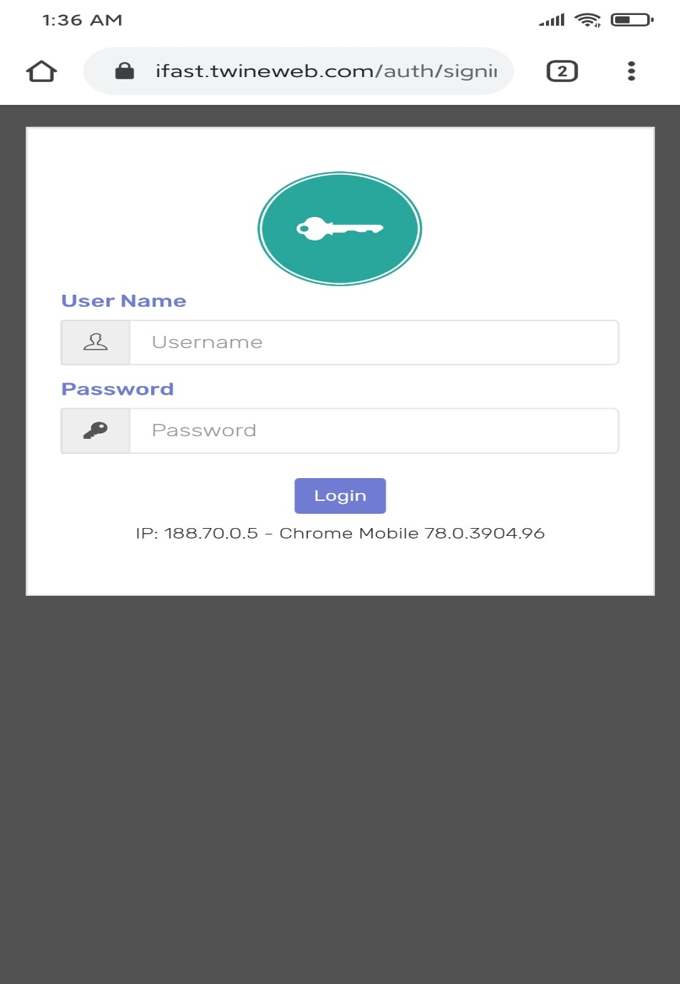Login form I need simple design. Not too much i need speed.

When click login user need to redirect two step login form page.

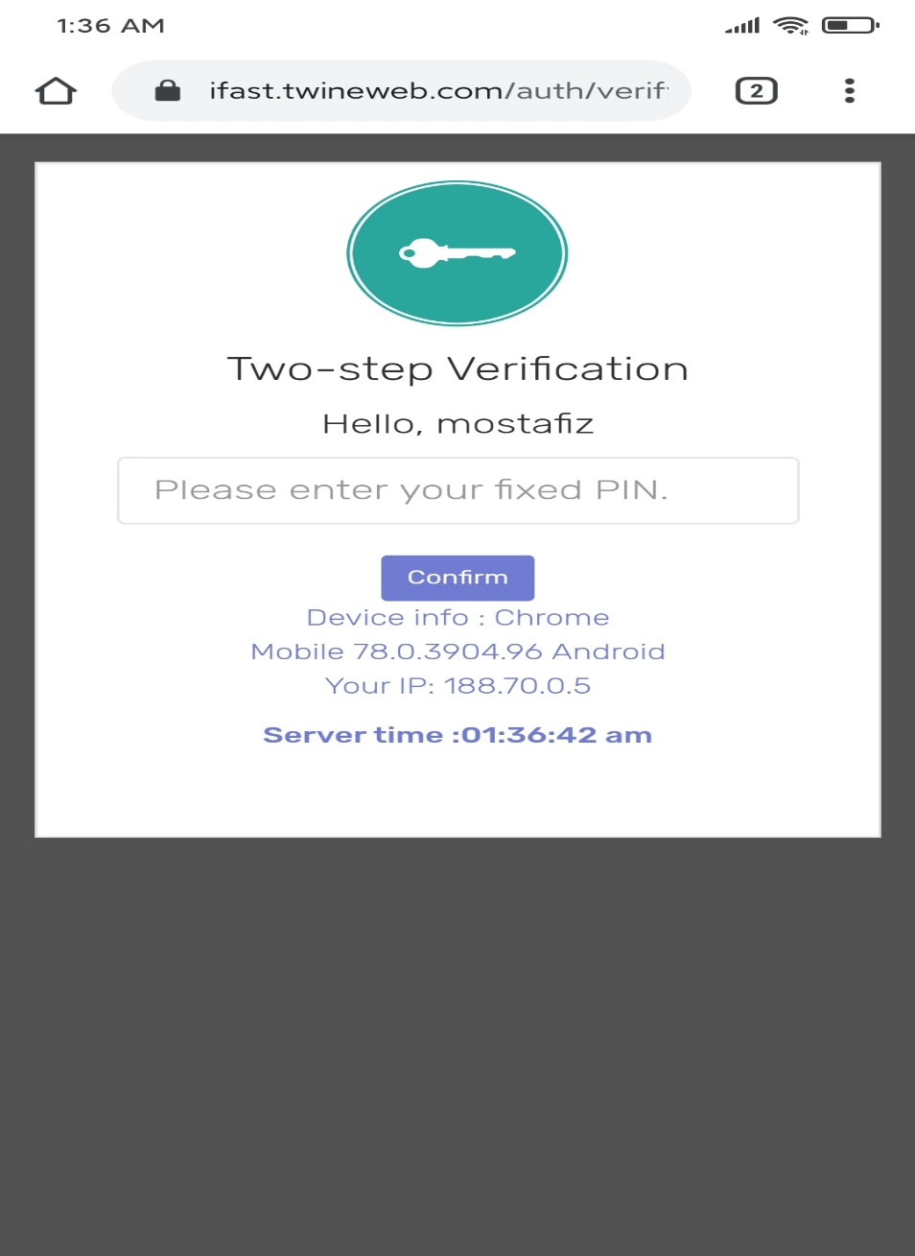Two step page its need simple page. Not too much design one input box to verify two step pin.

After submit the correct pin redirect to dashboard.

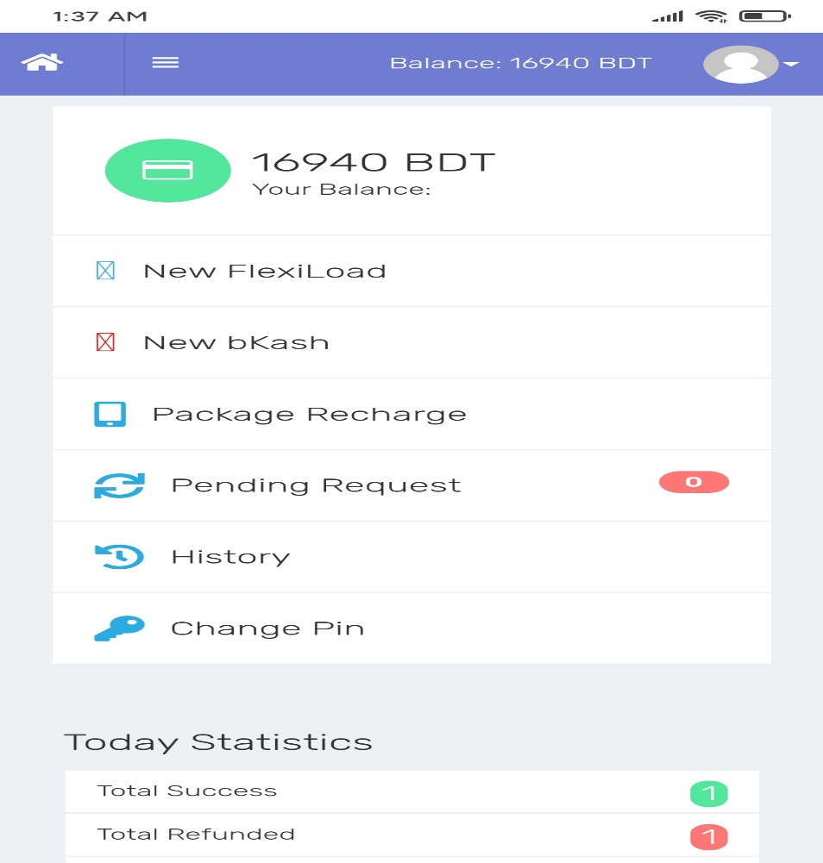

Dashboard i need div where one is menu

New bKash

New Flexi

Pending Request

History

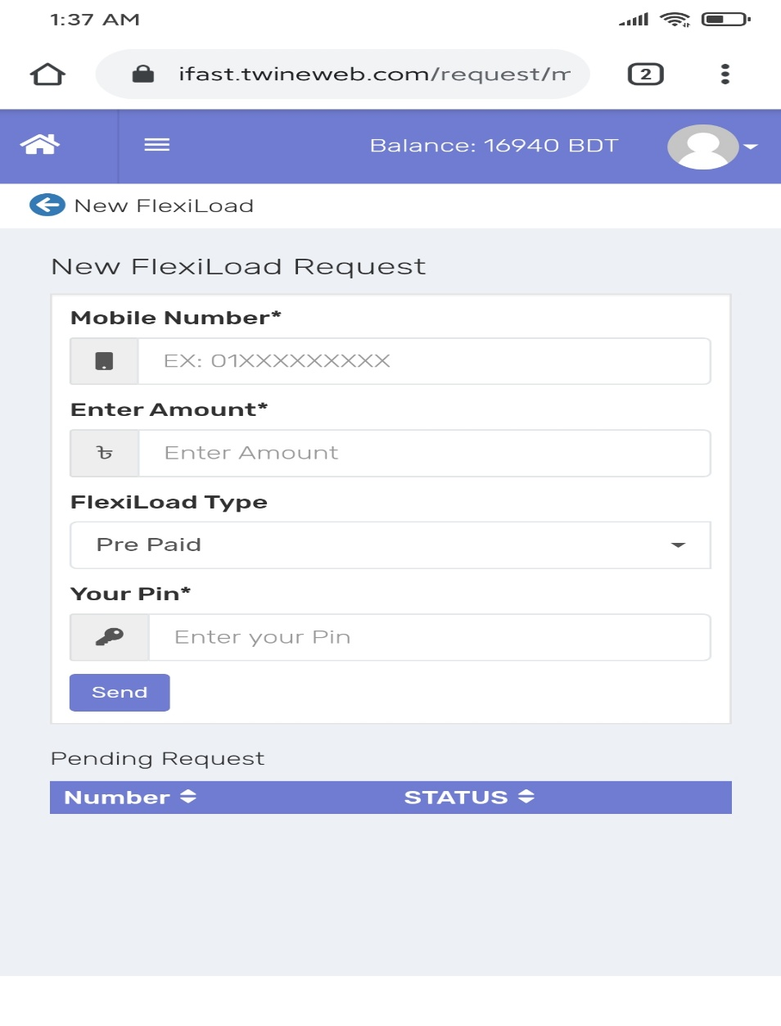The form when click new flexiload coming this form

User can submit data with some verification. And it will insert in to the mysql database.

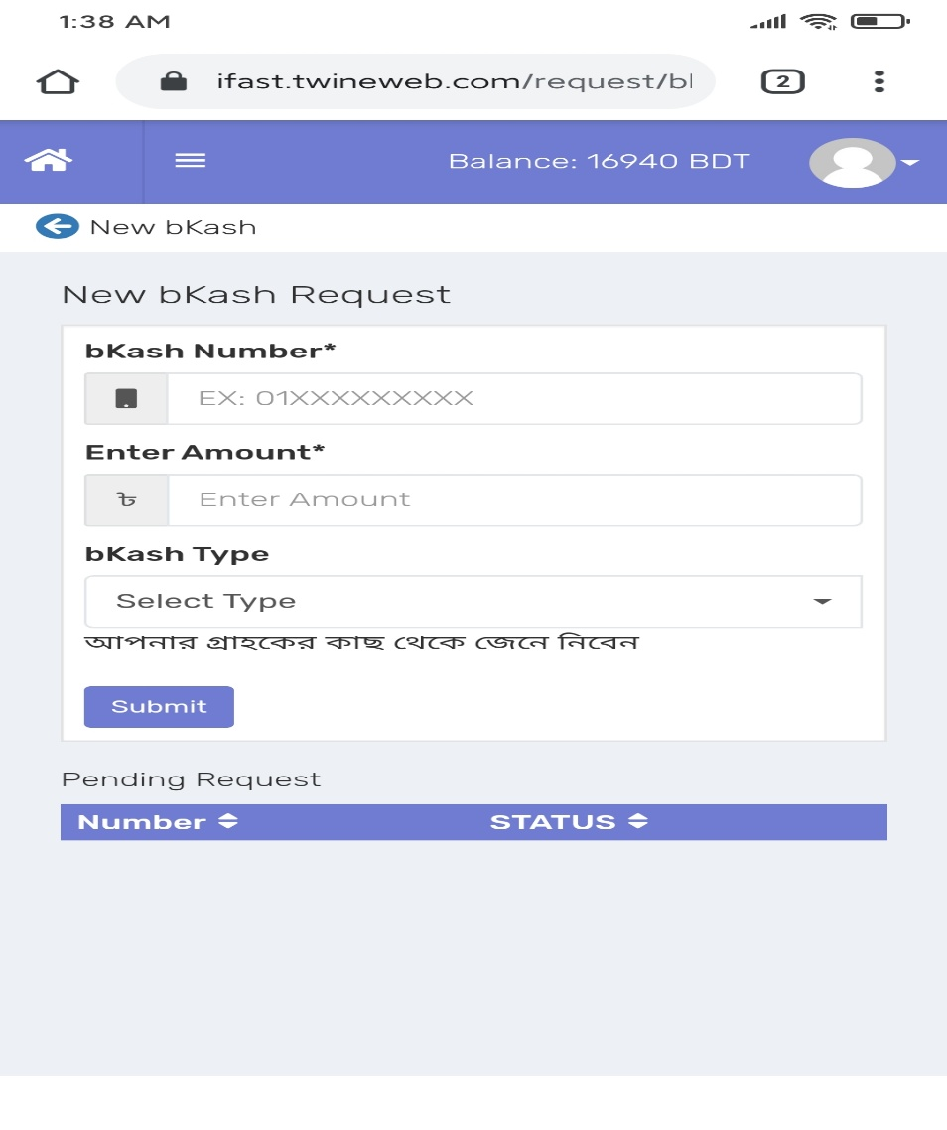When user click to new bkash then coming this form and some verification and insert data to the MySQL.