<http://www.scholarpedia.org/article/Gestalt_principles>

**Gestalt principles**, or gestalt laws, are rules of the organization of perceptual scenes. When we look at the world, we usually perceive complex scenes composed of many groups of objects on some background, with the objects themselves consisting of parts, which may be composed of smaller parts, etc. How do we accomplish such a remarkable perceptual achievement, given that the visual input is, in a sense, just a spatial distribution of variously colored individual points? The beginnings and the direction of an answer were provided by a group of researchers early in the twentieth century, known as Gestalt psychologists. Gestalt is a German word meaning 'shape' or 'form'. Gestalt principles aim to formulate the regularities according to which the perceptual input is organized into unitary forms, also referred to as (sub)wholes, groups, groupings, or Gestalten (the plural form of Gestalt). These principles mainly apply to [vision](http://www.scholarpedia.org/article/Vision), but there are also analogous aspects in auditory and somatosensory perception. In [visual perception](http://www.scholarpedia.org/article/Visual_Cognition), such forms are the regions of the visual field whose portions are perceived as grouped or joined together, and are thus segregated from the rest of the visual field. The Gestalt principles were introduced in a seminal paper by Wertheimer (1923/1938), and were further developed by Köhler (1929), Koffka (1935), and Metzger (1936/2006; see review by Todorović, 2007). For a modern textbook presentation, including more recent contributions, see Palmer (1999).

Proximity principle

Figure [2](http://www.scholarpedia.org/article/Gestalt_principles#fig:Todorovic-Gestalt_principles-Figure_2.jpg)a contains six patches,each of which is perceived as a visual unit, a figure on a common ground. However, they are also collectively the elements of a higher-order visual unit, the horizontal row. According to Gestalt theory, this type integration of individual components into a superordinate whole can be accounted for by the **proximity principle**: elements tend to be perceived as aggregated into groups if they are near each other.

[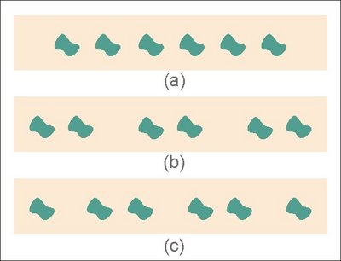](http://www.scholarpedia.org/article/File:Todorovic-Gestalt_principles-Figure_2.jpg)

[](http://www.scholarpedia.org/article/File:Todorovic-Gestalt_principles-Figure_2.jpg)

Figure 2: Proximity principle.

The effect of varying proximity is illustrated in Figure [2](http://www.scholarpedia.org/article/Gestalt_principles#fig:Todorovic-Gestalt_principles-Figure_2.jpg)b. Due to the change of distance between some of the components, here the patches are perceived not just collectively as a sextuple, but also as being subdivided into a triple of doublets, an organization that in Wertheimer's notation is designated as 12/34/56.

Note that a number of other potential partitions of the set in Figure [2](http://www.scholarpedia.org/article/Gestalt_principles#fig:Todorovic-Gestalt_principles-Figure_2.jpg)b exist, such as into a doublet of triples (123/456), or into a quartet and a pair (1234/56), or even into combinations of non-adjacent items such as 16/25/34/, or 135/246 etc. However, it is extremely hard, if not impossible, to actually *perceive* groupings of patches other than 12/34/56 in this figure. On the other hand, it is not impossible to see some subdivisions in Figure [2](http://www.scholarpedia.org/article/Gestalt_principles#fig:Todorovic-Gestalt_principles-Figure_2.jpg)a. For example, with deliberate effort and concentrated attention one may eventually succeed in mentally partitioning the row of patches into three pairs. However, such a percept is usually only partially and locally successful (one clearly sees only one or two segregated pairs), appears contrived, and is fleeting. In contrast, perceiving the same partition in Figure [2](http://www.scholarpedia.org/article/Gestalt_principles#fig:Todorovic-Gestalt_principles-Figure_2.jpg)b is spontaneous and effortless, and the percept is global and [stable](http://www.scholarpedia.org/article/Stability). Attention may contribute to figural perception, but, except in special cases, its role is usually limited: generally, it is not attention that creates the forms, but rather the forms, organized in accord with Gestalt principles, that draw attention.

With a different spatial distribution of the six components, such as in Figure [2](http://www.scholarpedia.org/article/Gestalt_principles#fig:Todorovic-Gestalt_principles-Figure_2.jpg)c, another naturally perceived partition into sub-wholes arises, denoted as 1/23/45/6. The partition 12/34/56, although arguably simpler and more regular, is hard to perceptually realize in Figure [2](http://www.scholarpedia.org/article/Gestalt_principles#fig:Todorovic-Gestalt_principles-Figure_2.jpg)c: it would violate the proximity principle, as it would involve grouping together some elements across relatively larger distances, but assigning other, relatively near elements, into different groups.

Common fate principle

The **common fate principle** states that elements tend to be perceived as grouped together if they move together. Thus if some of the elements in Figure [2](http://www.scholarpedia.org/article/Gestalt_principles#fig:Todorovic-Gestalt_principles-Figure_2.jpg) would begin to displace they would be perceived as a group, even across larger distances. This is shown in Figure 3, in the following manner. If you move the cursor within the area of this figure, some of the patches will move up some distance, and if you then click on the left mouse button, they will move down. Repeatedly pressing and releasing the left mouse button provides a simple demonstration of the grouping power of the common fate principle.

[](http://www.scholarpedia.org/article/File:Vuota.png)

|  |
| --- |
| Figure 3: Common fate principle. |

Similarity principle

The **similarity principle** claims that elements tend to be integrated into groups if they are similar to each other. It is illustrated in Figure [3](http://www.scholarpedia.org/article/Gestalt_principles#fig:Todorovic-Gestalt_principles-Figure_3.jpg)a-e, in which proximity is held constant, since the individual figures are at (approximately) the same distance from each other, as in Figure 2a. Nevertheless, they are perceptually partitioned into three adjacent pairs, due to the similarity of visual attributes such as lightness (Figure [3](http://www.scholarpedia.org/article/Gestalt_principles#fig:Todorovic-Gestalt_principles-Figure_3.jpg)a), color (Figure [3](http://www.scholarpedia.org/article/Gestalt_principles#fig:Todorovic-Gestalt_principles-Figure_3.jpg)b), size (Figure [3](http://www.scholarpedia.org/article/Gestalt_principles#fig:Todorovic-Gestalt_principles-Figure_3.jpg)c), orientation (Figure [3](http://www.scholarpedia.org/article/Gestalt_principles#fig:Todorovic-Gestalt_principles-Figure_3.jpg)d), or shape (Figure [3](http://www.scholarpedia.org/article/Gestalt_principles#fig:Todorovic-Gestalt_principles-Figure_3.jpg)e).

[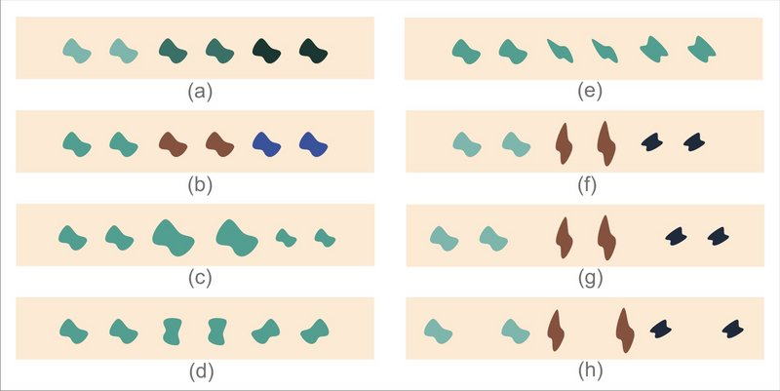](http://www.scholarpedia.org/article/File:Todorovic-Gestalt_principles-Figure_3.jpg)

[](http://www.scholarpedia.org/article/File:Todorovic-Gestalt_principles-Figure_3.jpg)

Figure 3: Similarity principle.

The 12/34/56 partition becomes more salient when the within-group similarities and between-group differences are compounded, by making the doublets similar / different in more than one visual attribute ( Figure [3](http://www.scholarpedia.org/article/Gestalt_principles#fig:Todorovic-Gestalt_principles-Figure_3.jpg)f). An important manipulation, studied already by Wertheimer (1923), is to vary both similarity and proximity, in order to investigate their joint effects on perceived groupings. Note that by increasing the distance between elements 2 and 3, and elements 4 and 5 (as in Figure [2](http://www.scholarpedia.org/article/Gestalt_principles#fig:Todorovic-Gestalt_principles-Figure_2.jpg)b), the salience of the 12/34/56 organization is strengthened (Figure [3](http://www.scholarpedia.org/article/Gestalt_principles#fig:Todorovic-Gestalt_principles-Figure_3.jpg)g), since similarity and proximity co-operate by favoring the same organization. On the other hand, when the inter-element distances are changed as in Figure [2](http://www.scholarpedia.org/article/Gestalt_principles#fig:Todorovic-Gestalt_principles-Figure_2.jpg)c, the resulting perceptual organization, Figure [3](http://www.scholarpedia.org/article/Gestalt_principles#fig:Todorovic-Gestalt_principles-Figure_3.jpg)h, is less clear, because similarity still favors partition 12/34/56, but proximity favors partition 1/23/45/6. This type of manipulation can thus be used to quantify the effects of different Gestalt principles and compare their strength.

Continuity principle

The display in Figure [4](http://www.scholarpedia.org/article/Gestalt_principles#fig:Todorovic-Gestalt_principles-Figure_4.jpg)a can be described as consisting of a number of elements arranged in three sub-wholes or branches, converging at X. According to the principle of proximity, one would expect branch BX to group with branch CX, but instead it groups with branch AX, forming the sub-whole AXB.

[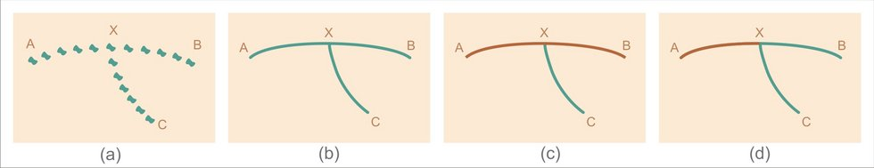](http://www.scholarpedia.org/article/File:Todorovic-Gestalt_principles-Figure_4.jpg)

[](http://www.scholarpedia.org/article/File:Todorovic-Gestalt_principles-Figure_4.jpg)

Figure 4: Continuity principle.

This grouping is an instance of the **continuity principle**: oriented units or groups tend to be integrated into perceptual wholes if they are aligned with each other. The principle applies in the same way for elements arranged along lines (Figure [4](http://www.scholarpedia.org/article/Gestalt_principles#fig:Todorovic-Gestalt_principles-Figure_4.jpg)a) as well as for patterns built from corresponding lines themselves (Figure [4](http://www.scholarpedia.org/article/Gestalt_principles#fig:Todorovic-Gestalt_principles-Figure_4.jpg)b). The balance between continuity and proximity in the formation of salient sub-wholes may be shifted by varying similarity, which can be accomplished by coloring different branches differently. Thus coloring BX same as AX but different from CX makes AXB a still more salient unit (Figure [4](http://www.scholarpedia.org/article/Gestalt_principles#fig:Todorovic-Gestalt_principles-Figure_4.jpg)c), whereas coloring BX same as CX but different than AX tends to increase the saliency of CXB (Figure [4](http://www.scholarpedia.org/article/Gestalt_principles#fig:Todorovic-Gestalt_principles-Figure_4.jpg)d).

Closure principle

Figure [5](http://www.scholarpedia.org/article/Gestalt_principles#fig:Todorovic-Gestalt_principles-Figure_5.jpg)a-b is constructed by adding some appropriate elements to Figure [4](http://www.scholarpedia.org/article/Gestalt_principles#fig:Todorovic-Gestalt_principles-Figure_4.jpg)a-b. Whereas in Figure [4](http://www.scholarpedia.org/article/Gestalt_principles#fig:Todorovic-Gestalt_principles-Figure_4.jpg)a and Figure [4](http://www.scholarpedia.org/article/Gestalt_principles#fig:Todorovic-Gestalt_principles-Figure_4.jpg)b the component BX is grouped with AX, in Figure [5](http://www.scholarpedia.org/article/Gestalt_principles#fig:Todorovic-Gestalt_principles-Figure_5.jpg)a and Figure [5](http://www.scholarpedia.org/article/Gestalt_principles#fig:Todorovic-Gestalt_principles-Figure_5.jpg)b there is a tendency for this component to rather group with CX, both BX and CX being sides of shape BCX, which itself constitutes one half of a bow-tie shaped figure. This is an instance of the **closure principle**: elements tend to be grouped together if they are parts of a closed figure. However, in this particular example, continuity is still relatively effective, and is in strong competition with closure. Using similarity, the salience of BCX as a visual sub-whole can be increased, as in Figure [5](http://www.scholarpedia.org/article/Gestalt_principles#fig:Todorovic-Gestalt_principles-Figure_5.jpg)c, or decreased, as in Figure [5](http://www.scholarpedia.org/article/Gestalt_principles#fig:Todorovic-Gestalt_principles-Figure_5.jpg)d.

[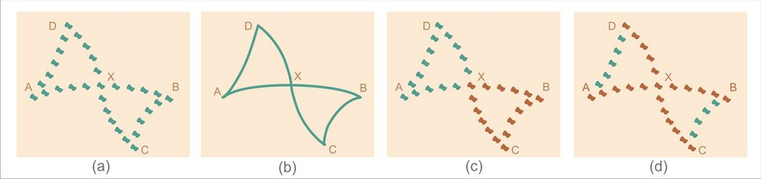](http://www.scholarpedia.org/article/File:Todorovic-Gestalt_principles-Figure_5.jpg)

[](http://www.scholarpedia.org/article/File:Todorovic-Gestalt_principles-Figure_5.jpg)

Figure 5: Closure principle.

Note that the patterns in Figure [4](http://www.scholarpedia.org/article/Gestalt_principles#fig:Todorovic-Gestalt_principles-Figure_4.jpg)a and Figure [4](http://www.scholarpedia.org/article/Gestalt_principles#fig:Todorovic-Gestalt_principles-Figure_4.jpg)b, although physically contained in Figure [5](http://www.scholarpedia.org/article/Gestalt_principles#fig:Todorovic-Gestalt_principles-Figure_5.jpg)a and Figure [5](http://www.scholarpedia.org/article/Gestalt_principles#fig:Todorovic-Gestalt_principles-Figure_5.jpg)b, are hard to see there: they can be sought out with directed attention, but do not appear spontaneously as natural visual wholes. The reason for this is not simply that more elements are added in the display. This is demonstrated in Figure 7, in which the pattern in *a* is readily discernible in *b* in spite of many added elements, but is practically invisible in *c*, *d*, and *e*, although geometrically it is just as present there (and in the same place) as in *a* and *b*. The loss of the visual identity of the pattern is due to the effectiveness of the Gestalt principles, mainly continuity and closure, according to which its elements are perceptually integrated with other present elements, and assigned to other, new visual wholes. One way in which its visual identity can be recovered is by simply changing its color to make it dissimilar from the surround. For a demonstration, position the cursor anywhere within the area of Figure 7. Note also that when the cursor is removed from the figure and the pattern again assumes the same color as the added elements, it quickly (though not necessarily instantaneously) fades from view, and no effort of attention can restore it to a salient visual whole. For a further demonstration, hold the left mouse button depressed while positioned within the area of the figure, which will remove the pattern and reveal only the added elements. A classical study of such 'hidden figure' effects was reported by Gottschaldt (1926).

[](http://www.scholarpedia.org/article/File:Vuota.png)

|  |
| --- |
| Figure 7: Camouflage. |

These examples are instances of *camouflage*, the phenomenon in which objects are hidden from view but not by being occluded: instead, they are perceptually subdivided (broken up internally) and repartitioned, that is, their parts are grouped with parts of the surrounding environment. As used by animals in the struggle for survival and by humans in warfare, the power of Gestalt principles thus makes it possible for organisms and things which are in plain sight to become effectively invisible and therefore undetectable by adversaries. Thus whether a physical object that is optically present exists or does not exist visually, depends on the interplay of perceptual laws.

Good gestalt principle

The pattern in Figure [6](http://www.scholarpedia.org/article/Gestalt_principles#fig:Todorovic-Gestalt_principles-Figure_7.jpg)a is readily partitioned into two components, a straight line and a wavy line that cross each other. This perceptual decomposition is strengthened by similarity (Figure [6](http://www.scholarpedia.org/article/Gestalt_principles#fig:Todorovic-Gestalt_principles-Figure_7.jpg)b). An alternative decomposition of Figure [6](http://www.scholarpedia.org/article/Gestalt_principles#fig:Todorovic-Gestalt_principles-Figure_7.jpg)a into two abutting corners, depicted in Figure [6](http://www.scholarpedia.org/article/Gestalt_principles#fig:Todorovic-Gestalt_principles-Figure_7.jpg)c, does not seem to arise spontaneously; this can be explained by noting that it would violate the continuity principle. However, an appeal to continuity does not explain why the partition in Figure [6](http://www.scholarpedia.org/article/Gestalt_principles#fig:Todorovic-Gestalt_principles-Figure_7.jpg)d does not spontaneously arise easily in Figure [6](http://www.scholarpedia.org/article/Gestalt_principles#fig:Todorovic-Gestalt_principles-Figure_7.jpg)a either, although both of its components are continuous lines.

[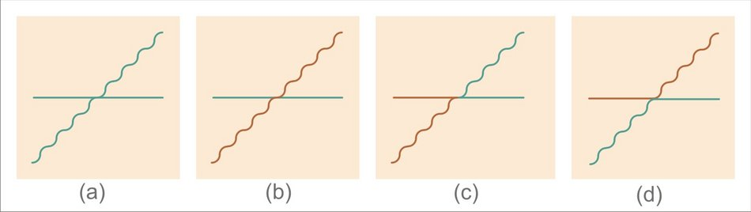](http://www.scholarpedia.org/article/File:Todorovic-Gestalt_principles-Figure_7.jpg)

[](http://www.scholarpedia.org/article/File:Todorovic-Gestalt_principles-Figure_7.jpg)

Figure 6: Good Gestalt principle 1.

In another, related example, Figure [7](http://www.scholarpedia.org/article/Gestalt_principles#fig:Todorovic-Gestalt_principles-Figure_8.jpg)a spontaneously decomposes into a semi-wheel with curved cogs touching a rectangular 'snake'. However, this perceptual outcome actually violates the continuity principle, because at the point at which the two components touch, this decomposition involves angles, instead of following the directions of the crossing continuous lines. An even clearer decomposition is achieved by introducing similarity as well (Figure [7](http://www.scholarpedia.org/article/Gestalt_principles#fig:Todorovic-Gestalt_principles-Figure_8.jpg)b). However, similarity can also be used to enhance a radically different decomposition into two crossing twisted threads, favored by continuity, as indicated in Figure [7](http://www.scholarpedia.org/article/Gestalt_principles#fig:Todorovic-Gestalt_principles-Figure_8.jpg)c.

[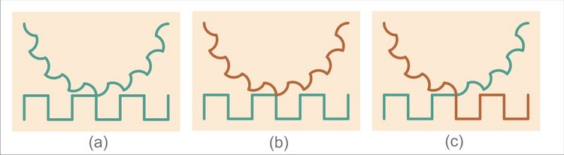](http://www.scholarpedia.org/article/File:Todorovic-Gestalt_principles-Figure_8.jpg)

[](http://www.scholarpedia.org/article/File:Todorovic-Gestalt_principles-Figure_8.jpg)

Figure 7: Good Gestalt principle 2.

According to the Gestalt viewpoint, the dominant percepts in Figure [6](http://www.scholarpedia.org/article/Gestalt_principles#fig:Todorovic-Gestalt_principles-Figure_7.jpg)a and Figure [7](http://www.scholarpedia.org/article/Gestalt_principles#fig:Todorovic-Gestalt_principles-Figure_8.jpg)a are instances of the **good Gestalt principle**: elements tend to be grouped together if they are parts of a pattern which is a good Gestalt, meaning as simple, orderly, balanced, unified, coherent, regular, etc as possible, given the input. In this sense, the straight line and the wavy line perceived in Figure [6](http://www.scholarpedia.org/article/Gestalt_principles#fig:Todorovic-Gestalt_principles-Figure_7.jpg)a are better forms than the pairs of lines in Figure [6](http://www.scholarpedia.org/article/Gestalt_principles#fig:Todorovic-Gestalt_principles-Figure_7.jpg)c and Figure [6](http://www.scholarpedia.org/article/Gestalt_principles#fig:Todorovic-Gestalt_principles-Figure_7.jpg)d, and in Figure [7](http://www.scholarpedia.org/article/Gestalt_principles#fig:Todorovic-Gestalt_principles-Figure_8.jpg)a the cog wheel and the snake are better forms than the hybrid shapes in Figure [7](http://www.scholarpedia.org/article/Gestalt_principles#fig:Todorovic-Gestalt_principles-Figure_8.jpg)c, that would be generated in Figure [7](http://www.scholarpedia.org/article/Gestalt_principles#fig:Todorovic-Gestalt_principles-Figure_8.jpg)a by conforming to the continuity principle at the crossing point. In such cases global regularity takes precedence over local relations. This principle is also called the 'law of good form' or the 'law of Prägnanz', a German word that translates roughly as salience, incisiveness, conciseness, impressiveness, or orderliness.

Past experience principle

In some cases the visual input is organized according to the **past experience principle**: elements tend to be grouped together if they were together often in the past experience of the observer. For example, we tend to perceive the pattern in Figure [8](http://www.scholarpedia.org/article/Gestalt_principles#fig:Todorovic-Gestalt_principles-Figure_9.jpg)a as a meaningful word, built up from strokes which are grouped to form particular letters of the Roman alphabet (such as 'm', 'i', 'n', etc). Note that the individual letters are rather clearly and distinctly perceived as 'natural' parts of the connected figure, and are only slightly easier to discern and discriminate if further individuated through separation (Figure [8](http://www.scholarpedia.org/article/Gestalt_principles#fig:Todorovic-Gestalt_principles-Figure_9.jpg)b) or coloration (Figure [8](http://www.scholarpedia.org/article/Gestalt_principles#fig:Todorovic-Gestalt_principles-Figure_9.jpg)c). However, in addition to this standard segmentation into letters, the pattern Figure [8](http://www.scholarpedia.org/article/Gestalt_principles#fig:Todorovic-Gestalt_principles-Figure_9.jpg)a has many other alternate partitions, such as the one demonstrated through separation and coloration in Figure [8](http://www.scholarpedia.org/article/Gestalt_principles#fig:Todorovic-Gestalt_principles-Figure_9.jpg)d and Figure [8](http://www.scholarpedia.org/article/Gestalt_principles#fig:Todorovic-Gestalt_principles-Figure_9.jpg)e. But, in contrast to the standard segmentation, discerning and discriminating these alternate components (some of which are 'non-letters') within Figure [8](http://www.scholarpedia.org/article/Gestalt_principles#fig:Todorovic-Gestalt_principles-Figure_9.jpg)a is a cumbersome task, similar to the laborious search for the hidden shape in Figures 6c-e; furthermore, the standard segmentation is to some extent perceivable even in Figure [8](http://www.scholarpedia.org/article/Gestalt_principles#fig:Todorovic-Gestalt_principles-Figure_9.jpg)e, where it competes with the segmentation based on the similarity principle. The spontaneity and ease of the standard, dominantly perceived organization of the strokes into letters, is plausibly mainly due to past experience, that is, to our familiarity with words as written in the script form of the Roman alphabet. This particular organization might not occur for observers lacking such familiarity; furthermore, the alternate partition would presumably be natural for observers used to an alphabet whose letters would correspond to the sub-wholes in Figure [8](http://www.scholarpedia.org/article/Gestalt_principles#fig:Todorovic-Gestalt_principles-Figure_9.jpg)d and Figure [8](http://www.scholarpedia.org/article/Gestalt_principles#fig:Todorovic-Gestalt_principles-Figure_9.jpg)e. Note also that in print perhaps the most potent Gestalt principle is proximity: simply inserting larger blank spaces between words than between letters (a device not used in antiquity) helps group together the letters correctly, and establish *words* as the salient visual units in the text. The importance of blank spaces is demonstrated by the difficulty wehavewhenreadingtextnotseparatedbyblanks an dev enmor ew henbl an kspa cesap pea rinwr ongpl aces.

[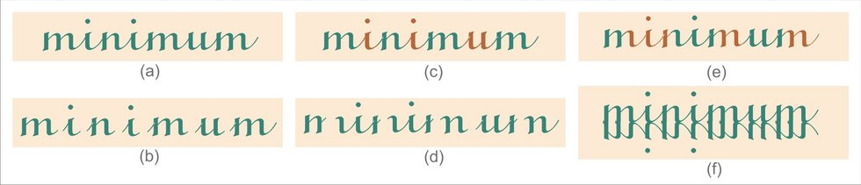](http://www.scholarpedia.org/article/File:Todorovic-Gestalt_principles-Figure_9.jpg)

[](http://www.scholarpedia.org/article/File:Todorovic-Gestalt_principles-Figure_9.jpg)

Figure 8: Past experience principle 1.

Although acknowledged by the gestaltists, the experience-based principle was deemed of secondary importance, compared with the other, stimulus-based principles, and easily dominated by them. As an example, in the pattern in Figure [8](http://www.scholarpedia.org/article/Gestalt_principles#fig:Todorovic-Gestalt_principles-Figure_9.jpg)f, in which a slightly overlapping inverted version is added, the original stimulus is much harder to see, due to the appearance of numerous new salient sub-patterns, generated by continuity and closure.

Auditory Gestalten

Similar as in vision, issues of organization, grouping, and segmentation arise in the auditory domain as well (Bregman, 1990; Kubovy & van Valkenburg, 2001). The acoustic input is just a one-dimensional temporally varying air pressure waveform, but based on it we can perceive an auditory scene involving multiple sources of human speech, vocal and instrumental music, animal sounds and other nature noises, occasionally all occurring at the same time, each with its own sub-phrasing and structure. Some visual Gestalt principles directly apply in the acoustic domain, but mainly in a temporal rather than spatial form. For example, silence or background noise, interrupted by a loud sound, followed again by silence or noise, is an auditory analogue of a figure on a ground. Similarly, a regular series of identical short clicks is an analogue of Figure [2](http://www.scholarpedia.org/article/Gestalt_principles#fig:Todorovic-Gestalt_principles-Figure_2.jpg)a, with equal temporal intervals between sound events playing the role of equal spatial distances. With deliberate attention, one can mentally superimpose a structure on this sequence, such as hearing consecutive pairs of clicks, as in 12/34/56. However, such a phenomenal segmentation is achieved much more naturally and easily by simply increasing the intervals between some clicks, analogously to Figure [2](http://www.scholarpedia.org/article/Gestalt_principles#fig:Todorovic-Gestalt_principles-Figure_2.jpg)b. This is an instance of an auditory temporal analogue of the visual spatial proximity principle; there is also a spatial auditory variant, involving pairs of identical sounds separated by equal intervals, but coming from different directions, such as left, left/in front, in front/right, right. Auditory analogues of instances of the visual similarity principle, as illustrated in Figure [3](http://www.scholarpedia.org/article/Gestalt_principles#fig:Todorovic-Gestalt_principles-Figure_3.jpg), are also readily established, but with differences and similarities of color, size etc being replaced by differences and similarities of loudness, pitch, and timbre of sounds. Auditory analogues of some other Gestalt principles may also be constructed.

Contemporary work

[](http://www.scholarpedia.org/article/File:Todorovic-Gestalt_principles-Figure_10.jpg)

[](http://www.scholarpedia.org/article/File:Todorovic-Gestalt_principles-Figure_10.jpg)

Figure 9: Past experience principle 2.

The principles described above, together with others not illustrated here, such as the **symmetry principle** (symmetrical components will tend to group together), the **convexity principle** (convex rather than concave patterns will tend to be perceived as figures), and others, are part of the classical heritage of perception studies. In contemporary research, of which only a few examples will be noted below, the seminal insights and issues raised by the gestaltists are developed and extended in various directions.

For example, contrary to the classical views, more recent research has indicated that even such a basic feature as figure-ground articulation may in some instances be based on experience (Peterson & Skow-Grant, 2003). For example, although in displays with two homogeneous regions, neither of which surrounds the other, assignment to figure and ground is often ambiguous, in some cases in which one region resembles an object, such as a tree in Figure [9](http://www.scholarpedia.org/article/Gestalt_principles#fig:Todorovic-Gestalt_principles-Figure_10.jpg), that region is preferably perceived as figure.

Palmer and colleagues have developed some new principles of visual field organization. For example, Palmer (1992) has proposed the **common region principle**: elements tend to be grouped together if they are located within the same closed region. An illustration is provided in Figure [10](http://www.scholarpedia.org/article/Gestalt_principles#fig:Todorovic-Gestalt_principles-Figure_11.jpg)a. It depicts the same spatial distribution of elements which, in Figure [2](http://www.scholarpedia.org/article/Gestalt_principles#fig:Todorovic-Gestalt_principles-Figure_2.jpg)c, elicited the grouping 1/23/45/6; however, with superimposed closed contours the preferred grouping becomes 12/34/56.

Palmer & Rock (1994) proposed the **element connectedness principle**: elements tend to be grouped together if they are connected by other elements. This principle is illustrated in Figure [10](http://www.scholarpedia.org/article/Gestalt_principles#fig:Todorovic-Gestalt_principles-Figure_11.jpg)b. Like Figure [10](http://www.scholarpedia.org/article/Gestalt_principles#fig:Todorovic-Gestalt_principles-Figure_11.jpg)a, Figure [10](http://www.scholarpedia.org/article/Gestalt_principles#fig:Todorovic-Gestalt_principles-Figure_11.jpg)b is also based on Figure [2](http://www.scholarpedia.org/article/Gestalt_principles#fig:Todorovic-Gestalt_principles-Figure_2.jpg)c, but, due to some elements being connected, the preferred perceived grouping is 12/34/56.

[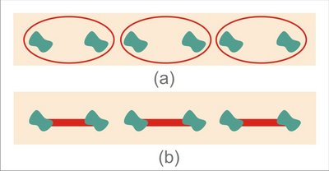](http://www.scholarpedia.org/article/File:Todorovic-Gestalt_principles-Figure_11.jpg)

[](http://www.scholarpedia.org/article/File:Todorovic-Gestalt_principles-Figure_11.jpg)

Figure 10: Principles of common region and element connectedness.

Researchers have also presented computational models of some Gestalt principles (Kubovy & van der Berg, 2008), studied their possible [neural](http://www.scholarpedia.org/article/Neuron) bases (Sasaki, 2007; Han et al., 2005; Qiu & von der Heydt, 2005; Roelfsema, 2006), and attempted to relate them to natural image statistics (Geisler et al., 2001; Elder & Goldberg, 2002).

Unresolved issues

As formulated by Wertheimer, Gestalt principles involve a 'ceteris paribus' (all other things being equal) clause (Palmer, 1999). That is, each principle is supposed to apply given that the other principles do not apply or are being held constant. In case two (or more) principles apply for the same input, and they favor the same grouping, it will tend to become strengthened; however, if they disagree, usually one wins or the organization of the percept is unclear. Several examples of the domination of one principle over another are presented above. However, although it has been addressed to some extent in the literature (e.g. see Kubovy & van der Berg, 2008), the significant theoretical problem of how to predict which principle will win in which circumstances remains to be worked out in much more detail.

Gestalt principles are usually illustrated with rather simple drawings, such as those above. Ideally, it should be possible to apply them to an arbitrarily complex image and, as a result, produce a hierarchical parsing of its content that corresponds to our perception of its wholes and sub-wholes. This ambitious goal is yet to be accomplished.

It has been suggested that most Gestalt principles are special instances of the overarching Good Gestalt principle, in the sense that being continuous, closed, similar etc are ways of being maximally good, ordered, simple etc. However, although this idea achieves some explanatory economy and unity, it does so at the cost of clarity and operationalizability: whereas it may be relatively simple to point out the presence of continuity, closure, etc, it is more difficult to establish what exactly makes a pattern visually good, simple, unified etc.

One important issue which was not discussed much in classical literature is the origin of Gestalt principles. Why is it that the perceptual input is organized in accord with proximity, continuity, closure etc? The gestaltists tended to favor the notion that these principles are among the fundamental properties of the perceptual system, providing the basis of our ability to make sense of the sensory signals. An opposed view is that the Gestalt principles are heuristics derived from some general features of the external world, based on our experience with things and their properties (Rock, 1975): objects in the world are usually located in front of some background (figure-ground articulation), have an overall texture different from the texture of the background (similarity), consist of parts which are near each other (proximity), move as a whole (common fate), and have closed contours (closure) which are continuous (continuity). In sum, although these principles have been discussed for more than 80 years and are presented in most perception textbooks, there are still a number of issues about them that need to be resolved.

Glass patterns

|  |
| --- |
|  |
| |  | | --- | | Recommend this on Google |   Leon Glass and Matthew A. Smith (2011), Scholarpedia, 6(8):9594. | [doi:10.4249/scholarpedia.9594](http://dx.doi.org/10.4249/scholarpedia.9594) | revision #91322 [[link to/cite this article](http://www.scholarpedia.org/w/index.php?title=Glass_patterns&action=cite&rev=91322)] |

**Curator** and Contributors

1.00 - [**Leon Glass**](http://www.scholarpedia.org/article/User:Leon_Glass)

* [Leon Glass, Department of Physiology, McGill University, CANADA](http://www.scholarpedia.org/article/User:Leon_Glass)
* [Matthew A. Smith, Department of Ophthalmology, University of Pittsburgh, Pittsburgh, PA, USA](http://www.scholarpedia.org/article/User:Matthew_A._Smith)

[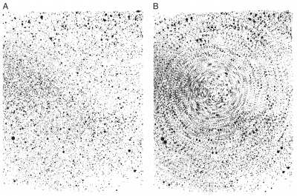](http://www.scholarpedia.org/article/File:GP_originals.jpg)

[](http://www.scholarpedia.org/article/File:GP_originals.jpg)

Figure 1: Glass patterns. **A**, A set of random dots created by Leon Glass in 1969 by randomly dropping paint on paper. **B**, That same set of random dots with a transparency of itself copied, rotated, and overlaid.

**Glass patterns** are formed from the superimposition of two random dot patterns: an original and a second pattern generated following a linear or nonlinear transformation of the original. Though each set is random, a variety of different spatial patterns such as circles, spirals, hyperbolae, can be generated by introducing correlations between the two sets of dots. Figure 1A is a random dot pattern formed by randomly dropping paint on paper, and Figure 1B is the image formed from the superimposition of Figure 1A upon itself following a rotation (Glass, 1969). In this image, for each dot there is a corresponding "partner" dot that lies along the circumference of a circle centered at the point of rotation of the two images. The visual system is able to decode these correlations, thereby perceiving the underlying global transformation.

|  |
| --- |
| Contents [[hide](http://www.scholarpedia.org/article/Glass_patterns)]   * [1 Variants](http://www.scholarpedia.org/article/Glass_patterns#Variants) * [2 Physiological Basis of Perception](http://www.scholarpedia.org/article/Glass_patterns#Physiological_Basis_of_Perception) * [3 Future Challenges](http://www.scholarpedia.org/article/Glass_patterns#Future_Challenges) * [4 History](http://www.scholarpedia.org/article/Glass_patterns#History) * [5 References](http://www.scholarpedia.org/article/Glass_patterns#References) * [6 External Links](http://www.scholarpedia.org/article/Glass_patterns#External_Links) |

Variants

By carrying out other transformations, different geometries can be readily generated. First consider linear transformations given by

*x*=*ax*cos*θ*−*by*sin*θ*

*y*=*ax*sin*θ*+*by*cos*θ*

where (*x*,*y*) are the coordinates of the original dot and (*x*′,*y*′) are the coordinates of the transformed dot following a scaling of the *x*-coordinate by an amount *a* , a scaling of the *y*-coordinate by an amount *b* , and a rotation of the image about the origin by an angle *θ* (Glass and Perez, 1973).

For the linear transformations, the geometries of the perception can be determined from the eigenvalues of the linear transformation. The eigenvalues are given by

*λ*±=( (*a*+*b*)cos*θ*±√((*a*−*b*)2−(*a*+*b*)2sin2*θ) ) /2*

If the eigenvalues are pure imaginary numbers, then the transformation corresponds to a rotation; if the eigenvalues are complex numbers then the image is a spiral, corresponding to a focus; it the eigenvalues are real with the same sign, then the image corresponds to a node in nonlinear [dynamics](http://www.scholarpedia.org/article/Dynamical_Systems); and if the eigenvalues are real with different signs, then the resulting hyperbolic image corresponds to a saddle point. If the transformation transports each dot too far away from its original position, then we can no longer perceive the underlying geometry.

[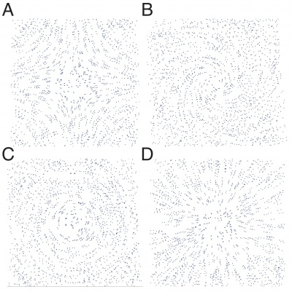](http://www.scholarpedia.org/article/File:GP_examples.jpg)

[](http://www.scholarpedia.org/article/File:GP_examples.jpg)

Figure 2: Example Glass patterns. **A**, hyperbolic or "saddle" pattern, a=0.95 / b=1.05 /

*θ*

=0. **B**, spiral pattern, a=1.05 / b=1.05 /

*θ*

=5. **C**, concentric or circular pattern, a=1 / b=1 /

*θ*

=5. **D**, radial or "starburst" pattern, a=1.05 / b=1.05 /

*θ*

=0

These transformations can be implemented easily with modern computer graphics applications (see [External Links](http://www.scholarpedia.org/article/Glass_patterns#External_Links) below). Figure 2 shows several images generated by using this transform on 1000 randomly positioned dots, generating hyperbolic (Figure 2A), spiral (Figure 2B), concentric (FIgure 2C), and radial (Figure 2D) geometries.

There are a large number of other ways in which the images can be modified to make perception of patterns difficult (Glass and Switkes, 1973; Wilson and Wilkinson, 1998; Barlow and Berry, 2010). Some of the modifications are: parts of the image can be eliminated, each of a correlated pair of dots can be generated with different contrast or different color with respect to the background, a random term can be added to the transformation, and extraneous pairs of dots that do not conform to the transformation can be added. A theoretical understanding of the mechanisms underlying the perception of these images should be able to predict the various ranges of parameters that would lead to perception of the pattern in each of these variants.

Physiological Basis of Perception

Glass patterns contain both local correlations and global structure which can be manipulated independently. As noted in the original description of these patterns, the spatial autocorrelation function of the images captures the local structure. The local cues present in Glass patterns are quite weak because each pair of dots is embedded in a noisy and random background comprising other dot pairs. Nevertheless, a strong percept of global form arises from these sparse local cues. This suggests two stages of processing: an initial stage in which the local cues are detected, and a second stage of processing where the local cues must be integrated across the entire image to achieve a global percept.

Most physiological interpretations of Glass pattern perception have been based on Hubel and Wiesel's (1962) early description of the structure and response properties of [neurons](http://www.scholarpedia.org/article/Neuron) in visual [cortex](http://www.scholarpedia.org/article/Neocortex). They found a class of neurons called "simple cells" that were sensitive to the orientation of bars of light presented in a particular region of visual space (the "[receptive field](http://www.scholarpedia.org/article/Receptive_field)"). Furthermore, they exhibited "on" and "off" subregions of their receptive field (sensitive to increments and decrements of light, respectively). Another class of cells, "complex cells", were also responsive to elongated stimuli of a fixed orientation but with somewhat larger receptive fields that respond to the information therein in more complicated ways. They also identified a columnar structure in visual cortex, in which nearby neurons tended to prefer similar stimulus orientation, and this preference shifted smoothly across cortical space. Hubel and Wiesel proposed a hierarchical structure in which the complex cells received input from simple cells, although continuing research into the circuitry of visual cortical neurons and their inputs has revealed that the connections are far more complex than can be described by that simple wiring description (see Priebe and Ferster, 2008 for review).

Glass (1969) proposed that this anatomical structure would be able to carry out computation of the local autocorrelation function. Two correlated dots falling in the excitatory receptive field of a simple cell would lead to excitation of that simple cell. Further, correlated dots nearby would fall in the receptive fields of simple cells in the same column, whereas uncorrelated dots nearby would fall in the receptive fields of cells in other columns. The resulting strong intracolumnar excitation of the complex cells could provide a substrate for detection of the local autocorrelation functions.

[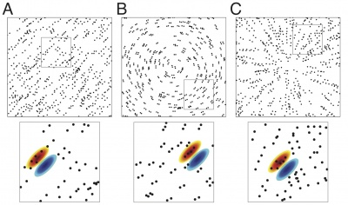](http://www.scholarpedia.org/article/File:3GP_global_local.jpg)

[](http://www.scholarpedia.org/article/File:3GP_global_local.jpg)

Figure 3: Three example Glass patterns are shown in the top row. **A**, A linear or translational pattern. **B**, A concentric pattern. **C**, A radial pattern. In the bottom row, small portions of each pattern (indicated by the gray box) have been enlarged. Despite the distinct global forms, the local structure for all three patterns appears similar to a human observer and to an example V1 receptive field (shown as the red and green Gabor).

This model appears to be consistent with subsequent physiological studies of electrical activity of neurons in the primary visual cortex (also known as [area V1](http://www.scholarpedia.org/article/Area_V1)) of macaque monkeys. Smith et al (2002) recorded action potentials from single neurons in response to dot patterns generated by superimposing a [random set](http://www.scholarpedia.org/article/Random_Sets) of dots on itself following a translation. They found that the receptive field properties of the neurons, as measured with oriented stimuli, were predictive of their preferences for Glass patterns. There was also good agreement between the experimentally recorded activity and a theoretical model of simple cells based on Hubel and Wiesel's original proposals. This model, in which pairs of dots stimulate V1 receptive fields based on their orientation and separation, successfully predicts a number of features of Glass pattern perception. For instance, consider the case of opposite polarity Glass patterns (where each dot pair is of different color or contrast). Here, a concentric pattern often evokes a kind of roughly orthogonal "radial" percept. This can be explained from that simple model: two dots of opposite polarity most effectively stimulate a neuron when they are orthogonal to the lobes of the receptive field and are separated by the spatial period of the cell (Smith et al, 2002). More research will be necessary to distinguish between a model in which V1 neurons perform a simple filtering of the visual stimulus vs. an autocorrelation. In addition, the neurons in early visual cortex do not seem capable of signaling the global form information present in Glass pattern stimuli (Smith et al, 2002; 2007), leaving the integration stage of Glass pattern perception to higher areas in visual cortex (Figure 3). There is some evidence that visual [area V4](http://www.scholarpedia.org/article/Area_V4) may serve as at least a portion of this integration stage. Neurons in area V4 are selective for concentric, radial and cross-shaped structures (Gallant et al, 1993, 1996; Kobatake and Tanaka, 1994), exactly the kind of global form sensitivity that would support Glass pattern perception.

Psychophysical experiments support the importance of autocorrelation in the processing of Glass patterns (Barlow and Berry, 2010). In support of the notion that the column may be playing a crucial role in [visual perception](http://www.scholarpedia.org/article/Visual_Cognition), Zucker (2002) proposed that excitatory interactions between individual neurons in a given "clique" of cells, all of which have similar orientation specificity and are located in a given column, might be playing an important role in contour detection. In this formulation, a "clique" of cells carries out the [averaging](http://www.scholarpedia.org/article/Averaging) operations that are necessary to compute the local autocorrelations. An alternative, although not necessarily mutually exclusive, approach to understanding Glass pattern perception has come in the form of a [neural network](http://www.scholarpedia.org/article/Neural_Networks) model of boundary and form perception. Grossberg and colleagues (Grossberg and Mingolla, 1985; Gove et al, 1995) incorporated top-down feedback, bottom-up feed forward interactions, and multiple levels of the visual hierarchy ([thalamus](http://www.scholarpedia.org/article/Thalamus), V1, V2 and V4) into their model. It is capable of providing explanations of and predictions for a large number of visual effects and illusions including Glass patterns.

Regardless of the initial mechanism for computing the local image statistics of a Glass pattern (local autocorrelations or another method), it is still necessary to integrate information from different regions of the image to form the global percept. Psychophysical studies carried out by Wilson and Wilkinson pose sharp questions about the nature of the intercolumnar information processing. By partially removing some regions of the correlated dot images, they determined that patterns with concentric structure (e.g., see Figure 1 from Wilson et al, 1997) were easier to perceive than the other types of correlated dot images, followed by radial and then translational patterns. Since the local information was the same in the various images, the differences in ability to perceive the images would be due to the integration steps. These findings were disputed by Dakin and Bex (2002), who argued that the shape of the window in which the dot images were displayed played an important role in determining the detection thresholds (see Wilson and Wilkinson, 2003 and Dakin and Bex, 2003 for further discussion). However, a number of subsequent studies have found differential sensitivity to global forms both in human psychophysics (Seu and Ferrera, 2001; Badcock et al, 2005; Palomares et al, 2010; Khuu et al, 2011) and scalp potentials (Pei et al, 2005), supporting Wilson and Wilkinson's initial findings. Wilson et al (1997) proposed a two-stage model to account for their results in which an initial oriented filtering stage (representing V1) is following by rectification and a second stage of filtering and integration. Based on their psychophysical findings, Wilson and Wikinson suggested that neurons in area V4 are a likely candidate for this integration process (Wilson et al, 1997; Wilson and Wilkinson, 1998). This model provides a plausible explanation for the means by which global form information is pooled and also can explain the variation in threshold among different patterns.

Because of its ability to measure responses simultaneously across the visual hierarchy, [functional magnetic resonance imaging](http://www.scholarpedia.org/article/Functional_magnetic_resonance_imaging) (fMRI) is an appealing means to explore the stages of Glass pattern processing. Using fMRI in human observers, Ostwald et al (2008) found support for idea that Glass patterns are processed in two stages. They showed sensitivity to global form present in Glass patterns is mediated by higher visual areas that pool the local orientation signals provided by early visual areas. However, there is some evidence that sensitivity to curvature and global form present in Glass patterns exists as early as primary visual cortex (Mannion et al, 2009; Mannion et al, 2010; Mannion and Clifford, 2011). Nonetheless, even if neurons in V1 and other early areas have some selectivity for global form characteristics, substantial integration by higher cortical areas is necessary to support the full perception of Glass patterns.

For the situation in which the dots are relatively sparse and small, thinking about an image as the union of multiple pairs of dots is probably a good way to think about the structure of the image. However, as the density and sizes of the dots increase, Glass patterns have streaky appearances in which the streaks are oriented along a path revealing the underlying structure of the field. If the pattern is not completely additive (that is, all the dots are full contrast such that overlapping dots do not sum to create a region of higher contrast where they overlap) then a simple intuition about Glass pattern detection can break down. In dynamic Glass patterns, the random positions of the dots are updated temporally to produce a rapid sequence of patterns following the same dot pairing rule. These types of patterns contain no coherent motion signal, but do suggest a "path" of motion based on the streaks produced by the dots. These motion cues are strong enough to influence the motion perception of human and monkey psychophysical observers as well as the responses of individual neurons in macaque visual cortex (Krekelberg et al, 2003) and the fMRI BOLD signal in human visual cortex (Krekelberg et al, 2005) in areas that are specialized for processing motion.

Future Challenges

The visual system is amazingly adept at perceiving structure in the visual field and interpreting it accurately in a very short time. Although the structure of Glass patterns has a certain elegance and simplicity that invites analysis, it is not clear how the outlined mechanisms would be more generally applicable to interpret more complex images. Moreover, the above discussion of the computations carried out in the perception of these images leaves out features that we know are important for perception, including [eye movements](http://www.scholarpedia.org/article/Eye_movements) and feedback interactions between different regions of the visual system. Although various models suggest that the columns are the locus for the computation of local spatial autocorrelation functions, physiological evidence for this is still lacking. Furthermore, while higher visual cortical areas have been suggested as the locus of integration of Glass pattern form cues, this has not been explored at the single neuron level.

http://en.wikipedia.org/wiki/Psychometrics

Psychometric function

From Wikipedia, the free encyclopedia

A **psychometric function** describes the relationship between a parameter of a physical [stimulus](http://en.wikipedia.org/wiki/Stimulus_(physiology)) and the responses of a person who has to decide about a certain aspect of that stimulus. Usually these sensory decisions take the form of a [two-alternative forced choice](http://en.wikipedia.org/wiki/Two-alternative_forced_choice) (2AFC). The psychometric function usually resembles a [sigmoid function](http://en.wikipedia.org/wiki/Sigmoid_function). Two different types of psychometric plots are in common use. One plots the percentage of correct responses (or a similar value) displayed on the [y-axis](http://en.wikipedia.org/wiki/Y-axis) and the physical parameter on the [x-axis](http://en.wikipedia.org/wiki/X-axis). If the stimulus parameter is very far towards one end of its possible range, the person will always be able to respond correctly. Towards the other end of the range, the person never perceives the stimulus properly and therefore the probability of correct responses is at chance level. In between, there is a transition range where the subject has an above-chance rate of correct responses, but does not always respond correctly. The [inflection point](http://en.wikipedia.org/wiki/Stationary_point) of the sigmoid function or the point at which the function reaches the middle between the chance level and 100% is usually taken as [sensory threshold](http://en.wikipedia.org/wiki/Sensory_threshold). The second type plots the proportion of "yes" responses on the y-axis, and therefore will have a sigmoidal shape covering the range [0, 1], rather than merely [0.5, 1], and we move from a subject being certain that the stimulus was not of the particular type requested to certainty that it was. This second way of plotting psychometric functions is often preferable, as it is more easily amenable to principled quantitative analysis using tools such as [probit](http://en.wikipedia.org/wiki/Probit) analysis (fitting of cumulative Gaussian distributions). However, it also has important drawbacks. First, the threshold estimation is based only on p(yes), namely on "Hit" in Signal Detection Theory terminology. Second, and consequently, it is not bias free or criterion free. Third, the threshold is identified with the p(yes) = .5, which is just a conventional and arbitrary choice.

Steady state

From Wikipedia, the free encyclopedia

A [system](http://en.wikipedia.org/wiki/System) in a **steady state** has numerous properties that are unchanging in time. This implies that for any property *p* of the system, the partial derivative with respect to time is zero:



The concept of steady state has relevance in many fields, in particular [thermodynamics](http://en.wikipedia.org/wiki/Thermodynamics), [economics](http://en.wikipedia.org/wiki/Steady_state_economy), and [engineering](http://en.wikipedia.org/wiki/Engineering). Steady state is a more general situation than [dynamic equilibrium](http://en.wikipedia.org/wiki/Dynamic_equilibrium). If a system is in steady state, then the recently observed behavior of the system will continue into the future. In [stochastic](http://en.wikipedia.org/wiki/Stochastic) systems, the probabilities that various states will be repeated will remain constant.

In many systems, steady state is not achieved until some time after the system is started or initiated. This initial situation is often identified as a [transient state](http://en.wikipedia.org/wiki/Transient_state), start-up or warm-up period.

While a dynamic equilibrium occurs when two or more reversible processes occur at the same rate, and such a system can be said to be in steady state, a system that is in steady state may not necessarily be in a state of dynamic equilibrium, because some of the processes involved are not reversible.

For example: The flow of [fluid](http://en.wikipedia.org/wiki/Fluid) through a tube or electricity through a network could be in a steady state because there is a constant flow of fluid, or electricity. Conversely, a tank being drained or filled with fluid is a system in transient state, because its volume of fluid changes with time.