SALMONELLA-HELA DUAL RNA-SEQ
Master Runbook
PRJNA280839 / GSE67758 — The Founding Dual RNA-seq Study
Project | PRJNA280839 Salmonella-HeLa Dual RNA-seq (GSE67758 subset)
Study | Westermann et al. 2016, Nature 529(7587):496-501 (PMID 26789254)
Environment | Slurm HPC (Task 1) + R/Bioconductor (Task 2)
Curriculum | MIBO8110 Applied Omics
Document type | Operational Standard Operating Procedure (SOP) Runbook
Companion document | README.md (full narrative, data provenance, biological interpretation)

Generated for internal course and reproducibility use.

0. Document Control
Field | Value
Scope | Task 1 (raw reads -> counts, HPC bash, dual RNA-seq) and Task 2 (DESeq2 + ggplot2, R)
Audience | Students and instructors running this exercise
Companion doc | README.md (study background, data provenance, known limitations)
Verification status | All accessions/references independently verified against NCBI/GEO/SRA/Ensembl/CrossRef. Scripts reviewed line-by-line and syntax-checked, not executed end-to-end.

1. Purpose & Scope
This Runbook is the step-by-step operational companion to README.md. It assumes a Slurm HPC account for Task 1 and an R/RStudio environment with Bioconductor access for Task 2.
The project: the founding dual RNA-seq study (Westermann et al. 2016), which established the concatenated-reference method this curriculum's companion PRJNA1091619 pipeline also uses. An HPC pipeline reproduces gene-level counts from raw reads; a full DESeq2 + ggplot2 analysis runs on the actual published combined host+pathogen count matrix and independently recomputes the paper's headline finding.
The source list's accession was wrong
GSE73225 (as given) is an unrelated mouse heart-valve study. The real accession was found independently: PubMed -> linked GEO records -> GSE60144 (SuperSeries) -> GSE67758 (the relevant sub-series). See README for the full correction.

2. Study Background
Field | Value
Study | Westermann AJ, et al. (2016) Dual RNA-seq unveils noncoding RNA functions in host-pathogen interactions. Nature 529(7587):496-501.
DOI | 10.1038/nature16547
PMID | 26789254
GEO SuperSeries | GSE60144
GEO sub-series used | GSE67758 (51 samples total; this project uses 8)
BioProject | PRJNA280839 (SRA study SRP057065)
Host | Homo sapiens, HeLa-S3 cell line
Pathogen | Salmonella enterica serovar Typhimurium str. SL1344
Headline finding | pinT (locus_tag ncRNA0164): sRNA induced during infection, represses invasion genes once intracellular

3. The 8-Sample Subset
GSM | Condition | Timepoint | Replicate | SRR
GSM1924778 | infected (WT) | 4h | 1 | SRR2936892
GSM1924779 | infected (WT) | 4h | 2 | SRR2936893
GSM1924787 | infected (WT) | 24h | 1 | SRR2936901
GSM1924788 | infected (WT) | 24h | 2 | SRR2936902
GSM1924793 | mock | 4h | 1 | SRR2936907
GSM1924794 | mock | 4h | 2 | SRR2936908
GSM1924802 | mock | 24h | 1 | SRR2936916
GSM1924803 | mock | 24h | 2 | SRR2936917

4. Prerequisites

4.1 Task 1 (HPC)
- Slurm account, /scratch allocation, internet egress from compute nodes.
- Modules: SRA-Toolkit, FastQC, fastp, STAR, SAMtools, Subread, MultiQC.
- Memory: 64 GB for the combined human+Salmonella STAR index -- applied FROM THE START, not discovered the hard way (see the companion PRJNA1091619 pipeline's own real OOM history).

4.2 Task 2 (R)
- R (recent 4.x) with Bioconductor access; RStudio recommended.
- Packages: ggplot2, dplyr, tidyr, tibble, pheatmap, RColorBrewer, patchwork, ggrepel, data.table, DESeq2.

5. Task 1 — Raw Reads to Counts (HPC Bash Pipeline)
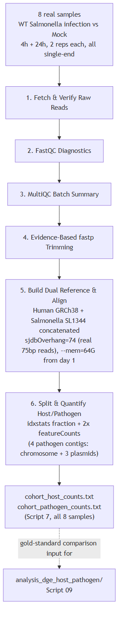
Figure 1. Raw-reads-to-counts pipeline for the 8-sample representative subset.

Step 1 — Fetch & Verify Raw Reads
sbatch 1_Fetch_And_Verify_Raw_Reads.sh

Step 2 — FastQC Diagnostics
sbatch 2_Interpret_FastQC_Diagnostics.sh

Step 3 — MultiQC Batch Summary
sbatch 3_Batch_MultiQC_Summary.sh

Step 4 — Evidence-Based fastp Trimming
sbatch 4_Evidence_Based_Fastp_Trimming.sh

Step 5 — Build Dual Reference & Align
sbatch 5_Build_Dual_Reference_And_Align.sh
- sjdbOverhang 74 = this study's own real 75bp read length - 1 (verified via SRA run metadata).
- --mem=64G and genomeParameters.txt-based idempotency from the start -- real lessons already learned on the companion PRJNA1091619 pipeline, applied proactively here.

Step 6 — Split & Quantify Host/Pathogen
sbatch 6_Split_And_Quantify_Host_Pathogen.sh
Four pathogen contigs, not one
Salmonella SL1344's reference has a main chromosome (NC_016810.1) PLUS three plasmids (NC_017718/019/720.1) -- all four must be treated as 'pathogen' in the host/pathogen read-fraction diagnostic, unlike the single-contig Mtb pipeline.

Step 7 — Automated Cohort Run (all 8 samples)
sbatch 7_Automated_Pipeline_AllSamples.sh

Step 8 — QC Report Generator
bash 8_QC_Report_Generator.sh # run locally, NOT via sbatch

6. Task 2 — DESeq2 + ggplot2 Analysis (R)
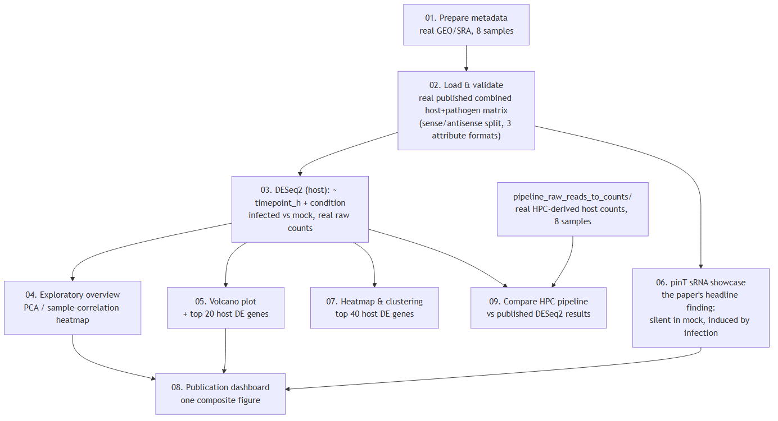
Figure 2. The analysis workflow, run on the real published combined count matrix.

Step 00-02 — Setup, Metadata, Data Loading
source("00_install_packages.R"); manage_packages("automatic")
source("01_prepare_metadata.R")
source("02_load_and_validate_counts.R")
Read Script 02's own comments before trusting its output
The published file is tab-delimited despite its .csv extension, has separate sense/antisense rows per feature (only sense is kept), and uses THREE different attribute-encoding conventions across host genes, pathogen CDS features, and pathogen sRNA features -- an extraction pattern built for only one of these would silently miss real genes, including pinT itself.

Step 03 — DESeq2 (host, the primary analysis)
source("03_differential_expression_deseq2.R")
- Design: ~ timepoint_h + condition -- controls for the real 4h/24h timepoint covariate.

Step 04 — Exploratory Overview
source("04_exploratory_overview.R")

Step 05 — Volcano Plot
source("05_volcano_and_top_genes.R")

Step 06 — pinT sRNA Showcase
source("06_pathogen_pint_showcase.R")
- Real, independently-recomputed result: pinT counts are 0/0/0/2 across all mock samples, but 191.5 mean at 4h infection and 1,837.5 mean at 24h infection.

Step 07 — Heatmap & Clustering
source("07_heatmap_and_clustering.R")

Step 08 — Publication Dashboard
source("08_publication_dashboard.R")

Step 09 — Compare HPC Pipeline vs Published Results
source("09_compare_hpc_pipeline_to_published.R")
- Corrects a real ID-format mismatch: published gene IDs carry a GENCODE version suffix (ENSG...NN), this pipeline's own Ensembl GTF does not -- stripped explicitly before joining, not silently ignored.

7. Downstream Handoff Between the Two Tasks
# On your local machine / RStudio project root, after Task 1's Script 7 completes:
mkdir -p pipeline_raw_reads_to_counts_output/counts
scp <cluster>:/scratch/<you>/PRJNA280839_salmonella_automated/counts/cohort_host_counts.txt* \
pipeline_raw_reads_to_counts_output/counts/

Appendix A — Package Reference
Package | Source | Purpose
ggplot2 | CRAN | General plotting
dplyr / tidyr / tibble | CRAN | Data manipulation and reshaping
data.table | CRAN | Fast loading of the large published count file
pheatmap / RColorBrewer | CRAN | Heatmaps and palettes
patchwork | CRAN | Composite multi-panel figures
ggrepel | CRAN | Non-overlapping plot labels
DESeq2 | Bioconductor | Primary differential expression analysis

Appendix B — Resource Allocation Reference
Script | CPUs | Memory | Wall time
1_Fetch_And_Verify_Raw_Reads.sh | 4 | 8 GB | 1 h
2_Interpret_FastQC_Diagnostics.sh | 4 | 6 GB | 45 min
3_Batch_MultiQC_Summary.sh | 4 | 8 GB | 1.5 h
4_Evidence_Based_Fastp_Trimming.sh | 4 | 8 GB | 1 h
5_Build_Dual_Reference_And_Align.sh | 8 | 64 GB | 3 h
6_Split_And_Quantify_Host_Pathogen.sh | 4 | 8 GB | 45 min
7_Automated_Pipeline_AllSamples.sh | 8 | 64 GB | 12 h
8_QC_Report_Generator.sh | 1 (local) | 4 GB | 10 min

Appendix C — Data Provenance Table
Item | Value
GEO SuperSeries / sub-series | GSE60144 / GSE67758 (51 samples total; this project uses 8)
BioProject | PRJNA280839
Publication | Westermann et al. 2016, Nature 529(7587):496-501, doi:10.1038/nature16547
Host reference | Ensembl GRCh38, release 110
Pathogen reference | NCBI RefSeq GCF_000210855.2 (ASM21085v2)
Headline gene | pinT, locus_tag ncRNA0164, chromosome NC_016810.1
Published count matrix | GSE67758_Raw_gene_wise_quantifications_Human_and_Salmonella.csv.gz

Citation
Westermann AJ, Förstner KU, Amman F, Barquist L, Chao Y, Schulte LN, Müller L, Reinhardt R, Stadler PF, Vogel J. (2016) Dual RNA-seq unveils noncoding RNA functions in host-pathogen interactions. Nature 529(7587):496-501. https://doi.org/10.1038/nature16547

