Tomato host microbiome capstone execution guide
  - Sequential raw reads to feature counts and R analysis
Field | Value
Study | Oyserman et al. (2022), Disentangling the genetic basis of rhizosphere microbiome assembly in tomato
Public data | PRJNA787039, PRJNA789467
Primary source | Open primary article
Prepared | September 2026
Teaching implementation with explicit quality gates and no fabricated metadata

Purpose
This guide turns Oyserman et al. (2022), Disentangling the genetic basis of rhizosphere microbiome assembly in tomato into a reproducible teaching workflow. The sequence follows the supplied reference scripts: raw-data processing first, ecological analysis in R second, and marker identification only after the biological evidence is defensible.
Paper: Open the primary article Public data: PRJNA787039, PRJNA789467 Validation endpoint: A cross-resolution microbial feature linked to a tomato QTL, followed by a candidate host SNP and an in-silico KASP or PolyMarker design.

Study design
The study profiled 225 bacterial 16S rhizosphere and bulk-soil samples, including two parental tomatoes and 96 recombinant inbred lines in duplicate. A replicate set also supplied 114 paired-end shotgun libraries. The publication linked ASVs, microbial genomes, functions, and microbial variants to tomato QTLs.
The 16S branch targeted V3–V4 with CCTACGGGNGGCWGCAG and GACTACHVGGGTATACTAATCC on paired MiSeq reads. The shotgun branch must trim adapters and remove reads matching a documented tomato assembly before Kraken2 or assembly. The paper used SILVA 132 and a custom Kraken database available from the authors by request.
The first analytical obligation is to reconcile the ENA or SRA run report with the paper and supplementary metadata. Public database fields may describe sequencing correctly while omitting the biological treatment, host line, plot, or block needed for inference.

Complete pipeline
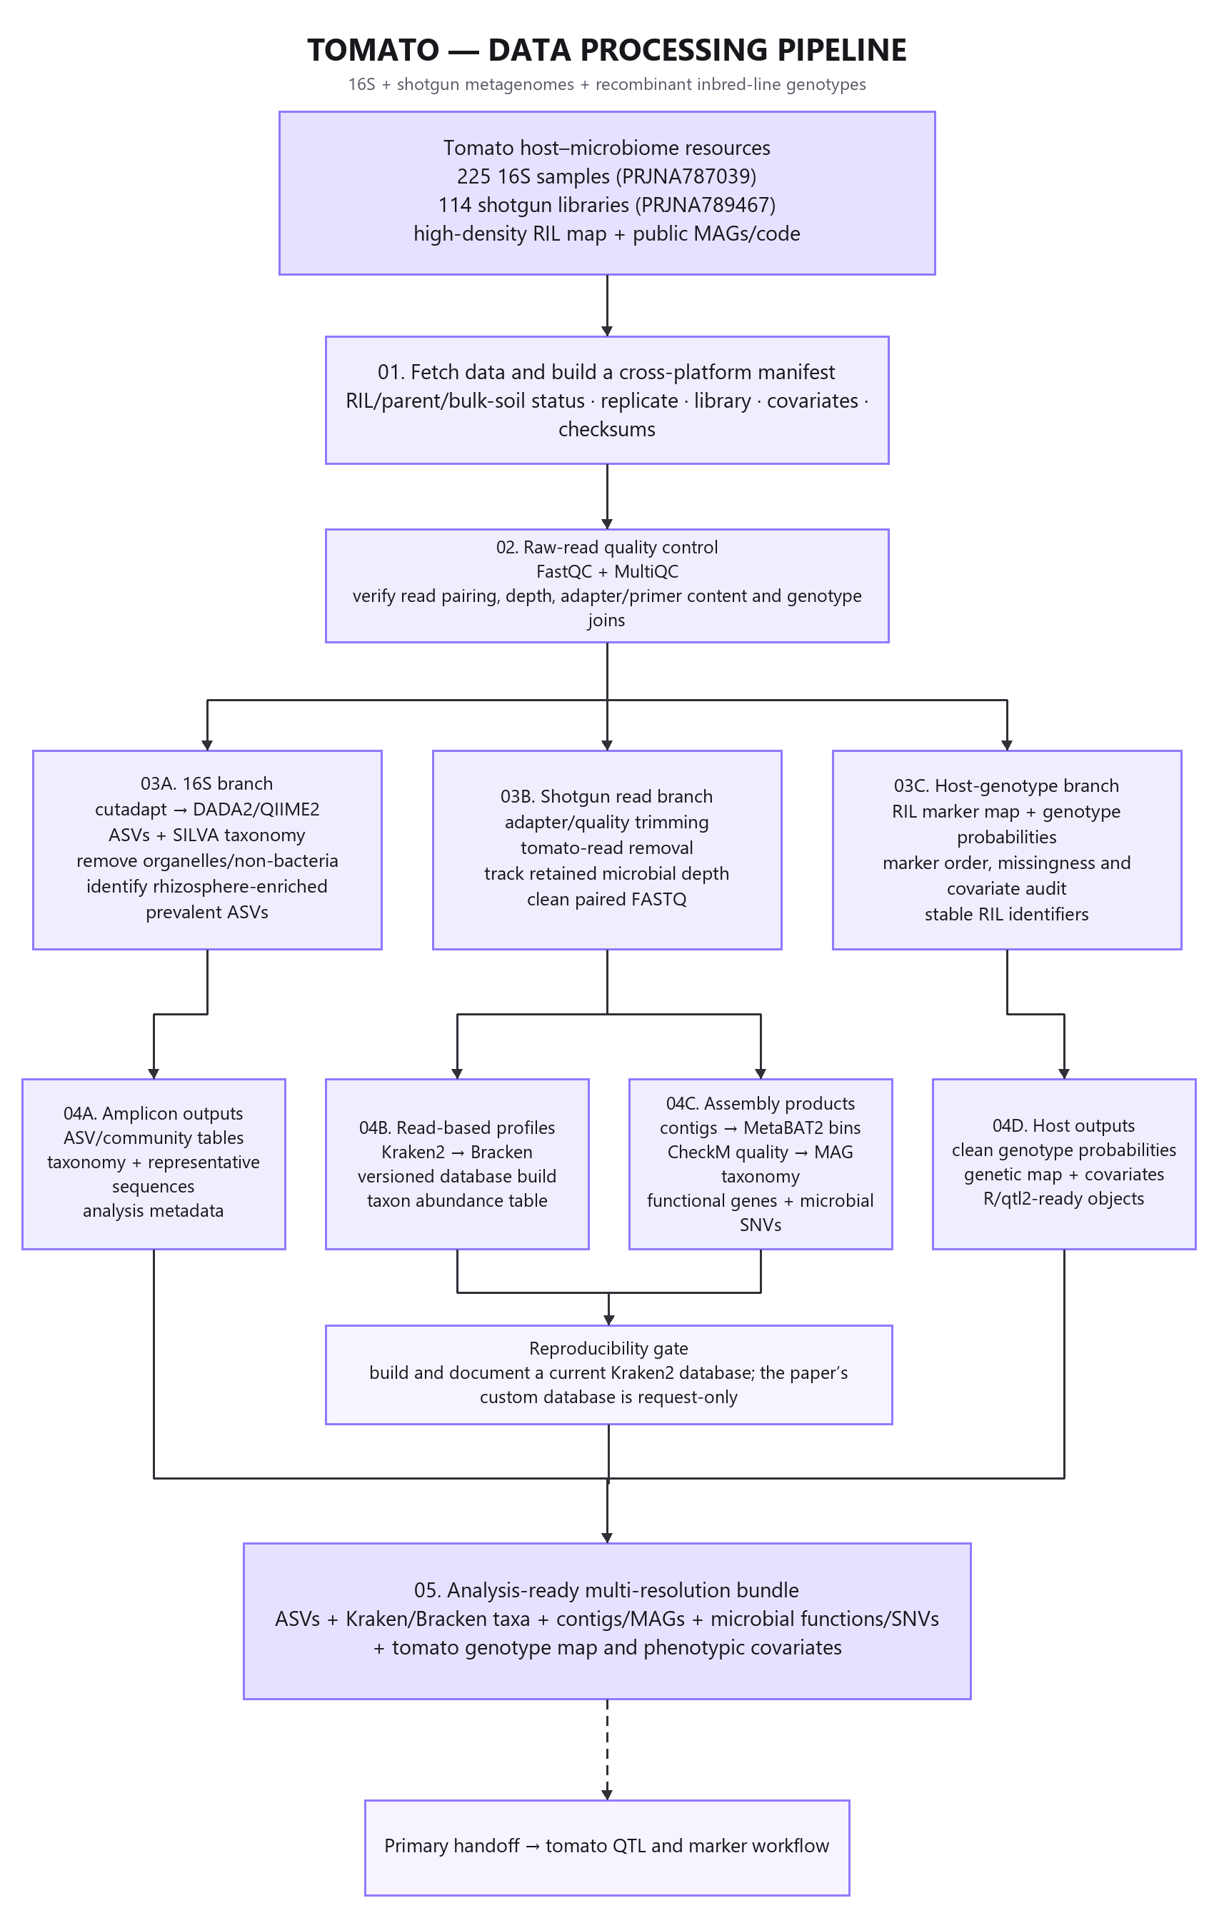
Tomato data-processing pipeline
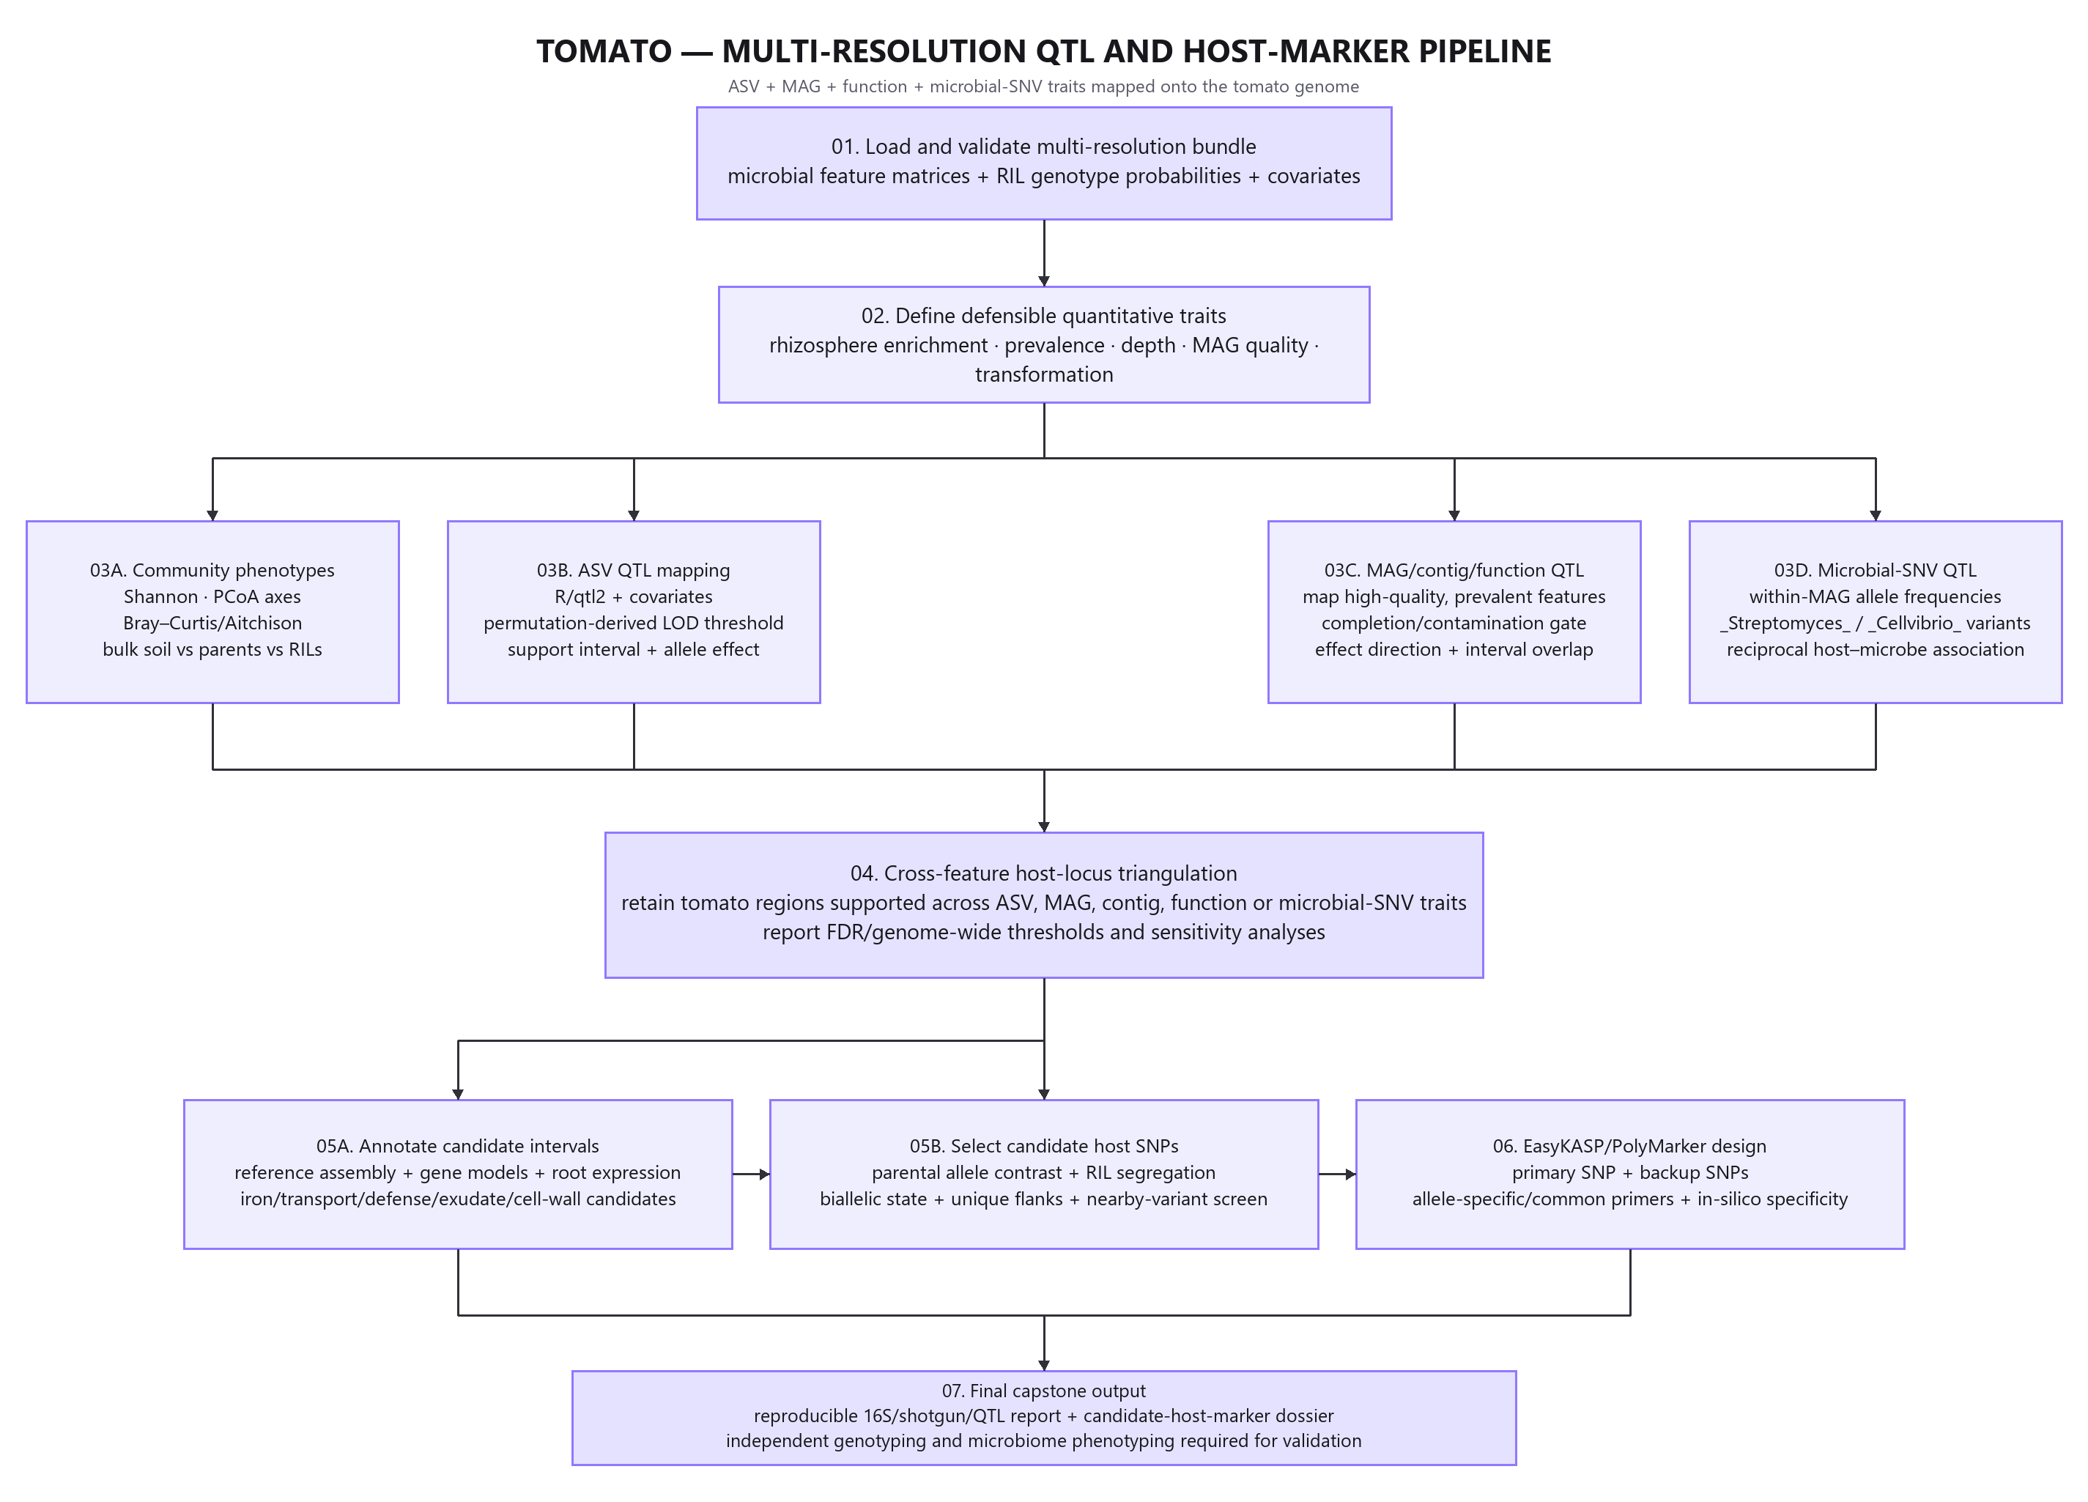
Tomato downstream analysis pipeline

Repository layout
tomato/
|-- README.md
|-- config/
| |-- project.env.example
| `-- assays.tsv
|-- data/
| |-- analysis_metadata.tsv
| `-- run_manifest.tsv created by Script 1
|-- references/
|-- pipeline_raw_reads_to_counts/
| |-- 1_Fetch_And_Verify_Raw_Reads.sh
| |-- 2_Interpret_FastQC_Diagnostics.sh
| |-- 3_Fetch_All_And_Import_To_QIIME2.sh
| |-- 4_Primer_Trim_And_Infer_ASVs.sh
| |-- 5_Classify_Taxonomy_And_Export.sh
| `-- 6_QC_Report_Generator.sh
|-- analysis_metagenomics_phyloseq/
| |-- 00_install_packages.R
| |-- 01_prepare_metadata.R through 09_publication_dashboard.R
| `-- run_analysis.R
|-- marker_identification/
|-- results/
`-- docs/

Computational preparation
Run the upstream workflow on Linux or a Linux HPC node. The active environment must expose curl, md5sum, sha256sum, FastQC, MultiQC, QIIME 2 with q2-cutadapt and q2-dada2, and BIOM. The tomato project additionally needs fastp, Bowtie2, Kraken2, Bracken, and Python 3. Record the exact versions actually used; software interfaces matter more than a nominal environment name.
Copy config/project.env.example to the ignored config/project.env. Set external work, raw-read, output, and reference paths if project defaults are unsuitable. Do not store raw reads or reference databases in Git.
Place the required QIIME reference sequence and taxonomy artifacts in references/ under the filenames declared in config/assays.tsv. Record release, URL, download date, and SHA-256 in references/reference_manifest.tsv. The pipeline stops rather than substitute an unnamed database.

Raw reads to feature counts
Step | Script | Main decision | Required evidence before continuing
1 | 1_Fetch_And_Verify_Raw_Reads.sh | Resolve public run metadata and download one pilot | Reviewed assay label, complete ENA URLs, matching deposited MD5
2 | 2_Interpret_FastQC_Diagnostics.sh | Decide whether quality truncation is needed | MultiQC reviewed, expected amplicon length and paired overlap documented
3 | 3_Fetch_All_And_Import_To_QIIME2.sh | Freeze the included run set and separate assays | Every included row reconciled to a sample and experimental unit
4 | 4_Primer_Trim_And_Infer_ASVs.sh | Remove published primers and infer ASVs | Primer retention, denoising loss, merging, and chimera rates acceptable
5 | 5_Classify_Taxonomy_And_Export.sh | Assign taxonomy and export feature counts | Database release, artifact source, and checksums recorded
6 | 6_QC_Report_Generator.sh | Approve the upstream handoff | Sample totals, feature counts, depth, controls, and exclusions reconciled

Run one file at a time. Script 1 creates data/run_manifest.tsv and downloads a pilot. Before Script 3, reconcile every included run, assay, analysis ID, biological sample, and experimental unit. Before Script 4, review the pilot and full demultiplex summaries. A paired DADA2 setting is acceptable only when the retained forward and reverse segments still overlap the expected insert.
Truncation defaults to zero because a defensible value depends on the observed run. For fungal ITS, variable biological length is expected; a fixed 16S truncation rule must not be copied across. If a run cannot merge after justified trimming, document the failure and use a validated single-end alternative or exclude it under a predefined rule.

Metadata contract
Required fields are sample_id, analysis_id, run_accession, assay, experimental_unit_id, host_group, ril_id, compartment, harvest_batch, biological_replicate, control_status. analysis_id must match a feature-table column. experimental_unit_id identifies the plant, recombinant line unit, or field plot used for inference. If multiple technical runs map to one experimental unit within an assay, merge the counts deliberately or fit a model that represents their dependence; the supplied R loader stops instead of treating them as independent replicates.
Recommended additional fields include sample title, read count, qPCR values where available, soil measurements, processing batch, extraction plate, and notes. Missing values should be explicit NA, not an empty string with ambiguous meaning.

Feature counts to R figures
Step | Script | Teaching purpose | Primary output
00 | 00_install_packages.R | Restore or create an renv lock | Reproducible R library
01 | 01_prepare_metadata.R | Validate experimental units and covariates | metadata_validated.tsv
02 | 02_load_biom_and_build_phyloseq.R | Build count and taxonomy objects | 02_phyloseq_raw.rds
03 | 03_qc_filter_and_normalization.R | Separate raw counts, proportions, CLR, and rarefaction roles | 03_analysis_objects.rds and QC summary
04 | 04_alpha_diversity.R | Analyze within-sample diversity | Per-assay alpha table and figure
05 | 05_beta_diversity.R | Analyze community structure with dispersion checks | Bray-Curtis and Aitchison tests and PCoA
06 | 06_compositionality_demo.R | Show why relative abundance is constrained | Closure summary and figure
07 | Study-specific result script | Reproduce the study's central biological handoff | Study-specific table and figure
08 | 08_differential_abundance_aldex2.R | Use a CLR-based count method for a declared contrast | ALDEx2 result table
09 | 09_publication_dashboard.R | Assemble figures and capture provenance | Dashboard, session information, and input hashes

Install packages once, inspect the resulting renv.lock, and commit the lockfile. The analysis runner sources Scripts 01 through 09 in one session so that each named object becomes the input to the next lesson.
The pipeline preserves three data views for different questions. Raw counts enter ALDEx2. Proportions support descriptive composition plots. CLR coordinates support Aitchison distances after a declared pseudocount. Rarefaction appears only in the alpha-diversity sensitivity analysis and is not reused for differential abundance.

Statistical model
The ecological model retains compartment, host group, and harvest batch. QTL analysis uses recombinant line as the experimental unit, a validated high-density host map, declared plant covariates, and permutation-derived genome-wide thresholds. Replicate microbiome measurements require a documented aggregation or mixed-model strategy.
Each beta-diversity analysis includes Bray-Curtis, an Aitchison sensitivity view, PERMANOVA, and PERMDISP. Report both the location and dispersion results. A significant PERMANOVA with heterogeneous dispersion requires cautious interpretation. Differential-abundance tables must report effect estimates and false-discovery-rate-adjusted values, including the absence of discoveries when power is limited.

Study-specific result
07_qtl_feature_showcase.R applies the publication's prevalence handoff by retaining rhizosphere ASVs observed in at least half of reviewed RIL samples. It writes a QTL-ready microbial trait table but deliberately does not fabricate host genotypes or QTL results.

Marker identification
A host SNP proceeds to assay design only when it contrasts the parents, segregates in the recombinant population, lies in a defined support interval, uses a named tomato assembly, and has unique flanking sequence. Nearby polymorphisms, repeats, and paralogs are rejection criteria. A microbial taxon from Kraken2 is not itself a KASP target.
Use marker_identification/marker_evidence_template.tsv as an audit trail. Rejected candidates are scientifically useful when the reason is recorded. Never route a microbial abundance feature into KASP; KASP genotypes a biallelic host DNA variant.

Quality review checklist
- The final included-run count agrees with the manifest and paper-defined scope.
- Every FASTQ has a verified deposited MD5 and every exported handoff has a recorded SHA-256.
- Primer sequences and reference releases are named in machine-readable configuration.
- Read retention is checked after primer removal, filtering, denoising, merging, and chimera removal.
- Negative and positive controls are identified where the public metadata provide them.
- Organellar and non-target features are removed without discarding unlabeled taxa silently.
- Biological and technical replicates are distinguished.
- Model contrasts, block restrictions, prevalence rules, pseudocount, and random seed are recorded.
- Relative abundance, qPCR load, predicted function, host association, assay design, and experimental validation use different language.
- The dashboard can be regenerated from the committed scripts and documented external inputs.

Minimum complete project
Process all feasible 16S reads and a stratified shotgun subset, document host depletion and database provenance, reproduce the common-ASV gate, integrate public QTL or MAG products, and build one defensible host-marker dossier. Full joint assembly is stretch work.
A minimum project may use a reviewed subset when full download or computation is infeasible, but the subset rule must be chosen before results are inspected and must preserve the relevant treatments, blocks, and controls.

Troubleshooting
No assay is included after Script 1. Review sample_title, experiment_title, and library_name in the ENA report. Resolve REVIEW_REQUIRED manually; do not weaken the classifier until unrelated libraries enter the project.
DADA2 loses most reads. Confirm the primer orientation, inspect forward and reverse quality independently, calculate remaining overlap, and examine whether different sequencing runs require separate error models. Do not raise error thresholds only to increase yield.
Taxonomy artifacts are missing or incompatible. Obtain the declared release in a format compatible with the installed QIIME 2 distribution, record the provenance, and rerun. Do not rename a different release to satisfy the file check.
Few ALDEx2 features pass FDR. Report effect sizes, uncertainty, sample size, and power limitations. Do not replace the method with uncorrected tests to manufacture a positive result.
The selected marker cannot be designed specifically. Reject it, document nearby variants, repeats, paralogs, or taxonomic cross-reactivity, and evaluate a prespecified backup candidate.

Primary references
- Oyserman et al. (2022), Disentangling the genetic basis of rhizosphere microbiome assembly in tomato. Primary article
- Callahan BJ et al. 2016. DADA2 high-resolution sample inference from Illumina amplicon data. DADA2 paper
- Fernandes AD et al. 2014. Unifying the analysis of high-throughput sequencing datasets with ALDEx2. ALDEx2 paper

