**SPL-1 Project Report, 2019**

**3_Guti**

**Course No: SE-305**

**Course name: Software Project Lab I**

Submitted by

**Shezan Al-Mahmud**

**BSSE Roll No. : 1023**

**BSSE Session: 2017-2018**

Supervised by

**Dr. Mohammed Shafiul Alam Khan**

**Designation: Associate Professor**

**Institute of Information Technology**



**Institute of Information Technology**

**University of Dhaka**

29-05-2019

**Table of Contents**

1. Introduction …..................................................................................................... 1

* 1. Background study ............................................................................................. 1-3
  2. Challenges .......................................................................................................... 4-5

2. Project Overview .................................................................................................. 6-8

3. User Manual ......................................................................................................... 9-10

4. Conclusion ............................................................................................................ 11

5. Appendix............................................................................................................... 11

6. References ............................................................................................................ 11

**1. Introduction**

3-Guti is a well-known game of village. Many of us have played many types of games in childhood. These games are now slowly going lost. Generally the village children play this game. It’s a tricky game and a wrong move can turn the game change.

In this game, there should be 3 beads of each player and they play against each other.

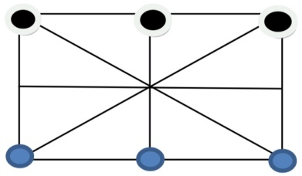

**1.1 Background study**

**For this Project I had to learn javafx and how to build GUI manually. I had to learn how to creat “anchor pane”, “border pane”, “multiple stage”, “multiple scene”. I also learned how to creat “vbox”, “hbox” and many other things.**

**For creating gaming board, I had to learn how to creat Circle and Line in javafx manually.**

For creating Cricle, I had to-

* circle[i] = **new Circle();**
* circle[i].setCenterX(x);
* circle[i].setCenterY(y);
* circle[i].setRadius(30);
* circle[i].setFill(Color.***RED);***

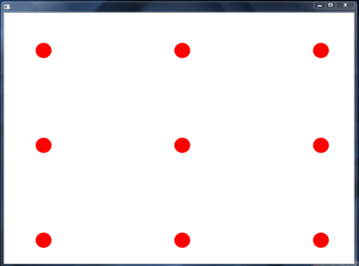

For creating Line, I had to-

* line[0][0] = **new Line();**
* line[0][0].setStartX(100);
* line[0][0].setStartY(100);
* line[0][0].setEndX(450);
* line[0][0].setEndY(100);
* line[0][0].setStrokeWidth(15);
* line[0][1] = **new Line();**
* line[0][1].setStartX(450);
* line[0][1].setStartY(100);
* line[0][1].setEndX(800);
* line[0][1].setEndY(100);
* line[0][1].setStrokeWidth(15);

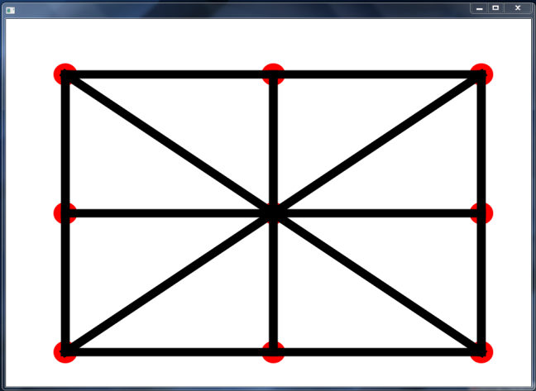

**For creating Guti, I had to learn how to creat Ellipse in javafx manually. I also had to set Ellipse on the position of Circle.**

public void drawGuti()

{

int count=0;

for(int k=0;k<9;k++)

{

if(board[k][2]!=0)

{

guti[count]=new Ellipse();

guti[count].setCenterX(board[k][0]);

guti[count].setCenterY(board[k][1]);

guti[count].setRadiusX(30);

guti[count].setRadiusY(30);

guti[count].setStrokeWidth(3);

guti[count].setStroke(Color.BLACK);

if(board[k][2]==1)

{

guti[count].setFill(Color.GREEN);

}

else

guti[count].setFill(Color.BLUE);

getChildren().addAll(guti[count]);

count++;

}

}

}

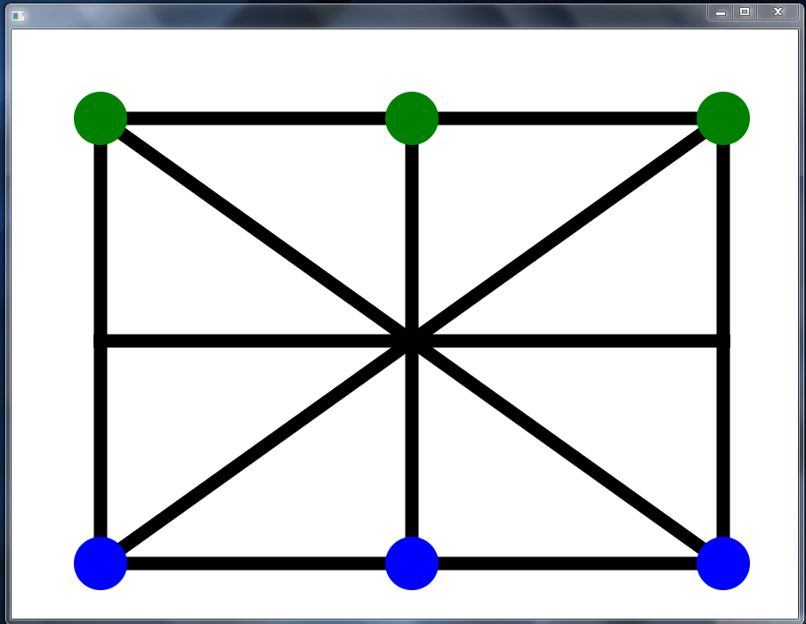

**1.2 Challenges**

**Since Ellipse’s position is on the Circle’s position. So, for moving the Guti at the right position, I had to implement Graph. Different beads follow different path of the Graph.**

public void makeGraph()

{

path[0][0]=-1;

path[0][1]=-1;

path[0][2]=-1;

path[0][3]=-1;

path[0][4]=1;

path[0][5]=4;

path[0][6]=3;

path[0][7]=-1;

path[1][0]=0;

path[1][1]=-1;

path[1][2]=-1;

path[1][3]=-1;

path[1][4]=2;

path[1][5]=-1;

path[1][6]=4;

path[1][7]=-1;

path[2][0]=1;

path[2][1]=-1;

path[2][2]=-1;

path[2][3]=-1;

path[2][4]=-1;

path[2][5]=-1;

path[2][6]=5;

path[2][7]=4;

path[3][0]=-1;

path[3][1]=-1;

path[3][2]=0;

path[3][3]=-1;

path[3][4]=4;

path[3][5]=-1;

path[3][6]=6;

path[3][7]=-1;

path[4][0]=3;

path[4][1]=0;

path[4][2]=1;

path[4][3]=2;

path[4][4]=5;

path[4][5]=8;

path[4][6]=7;

path[4][7]=6;

path[5][0]=4;

path[5][1]=-1;

path[5][2]=2;

path[5][3]=-1;

path[5][4]=-1;

path[5][5]=-1;

path[5][6]=8;

path[5][7]=-1;

path[6][0]=-1;

path[6][1]=-1;

path[6][2]=3;

path[6][3]=4;

path[6][4]=7;

path[6][5]=-1;

path[6][6]=-1;

path[6][7]=-1;

path[7][0]=6;

path[7][1]=-1;

path[7][2]=4;

path[7][3]=-1;

path[7][4]=8;

path[7][5]=-1;

path[7][6]=-1;

path[7][7]=-1;

path[8][0]=7;

path[8][1]=4;

path[8][2]=5;

path[8][3]=-1;

path[8][4]=-1;

path[8][5]=-1;

path[8][6]=-1;

path[8][7]=-1;

}

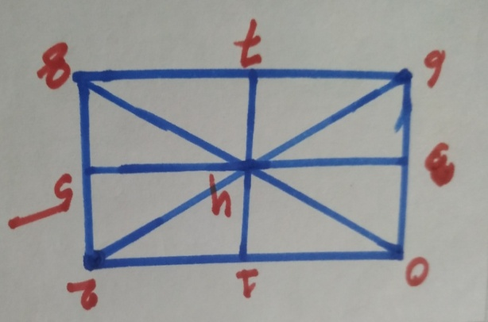 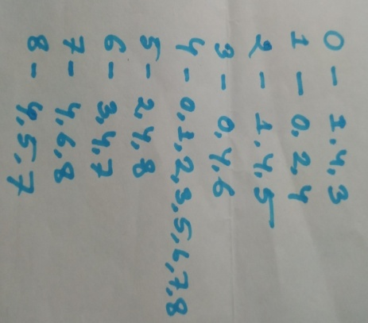

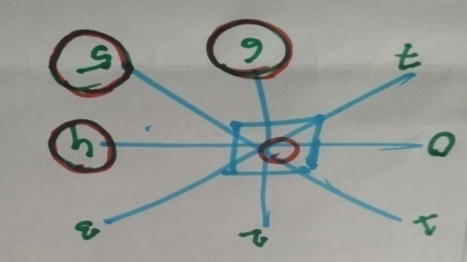 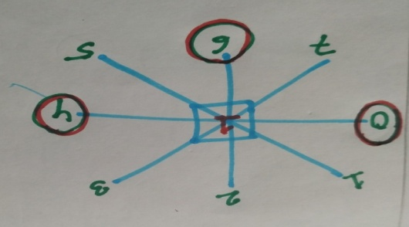

**2. Project Overview**

* In this project, it is planned to develop a game (generally known as ‘Teen Guti’).
* There should be 3 beads of each player in this game.
* The game will initially start like the image below:

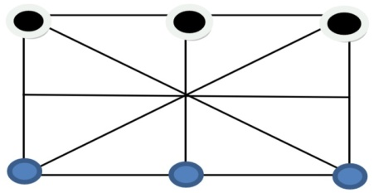

* A player can win when all the beads are aligned in a single straight line excluding the starting line. The winning positions for player-1 may look something like these:

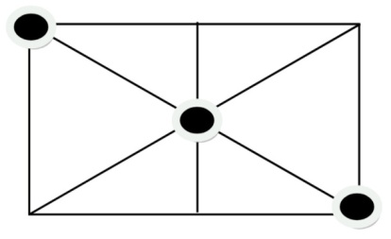

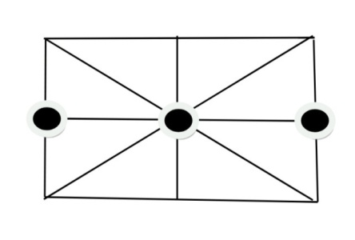

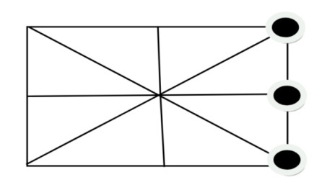

In this Project, Blue Guti for Player-1 and Green Guti for Player-2.

Here are the conditions for winning Blue Guti:

**public** **void** winCheckBlueGuti()

{

**int** flag=0;

**if**(board[0][2]==2 && board[1][2]==2 && board[2][2]==2)

{

flag=1;

}

**else** **if**(board[3][2]==2 && board[4][2]==2 && board[5][2]==2)

{

flag=1;

}

**else** **if**(board[0][2]==2 && board[3][2]==2 && board[6][2]==2)

{

flag=1;

}

**else** **if**(board[1][2]==2 && board[4][2]==2 && board[7][2]==2)

{

flag=1;

}

**else** **if**(board[2][2]==2 && board[5][2]==2 && board[8][2]==2)

{

flag=1;

}

**else** **if**(board[0][2]==2 && board[4][2]==2 && board[8][2]==2)

{

flag=1;

}

**else** **if**(board[2][2]==2 && board[4][2]==2 && board[6][2]==2)

{

flag=1;

}

**else** flag=0;

**if**(flag==1)

{

System.***out***.println("Blue Win!!");

play=**false**;

}

**else** ;

}

Here are the conditions for winning Green Guti:

**public** **void** winCheckGreenGuti()

{

**int** flag=0;

**if**(board[6][2]==1 && board[7][2]==1 && board[8][2]==1)

{

flag=1;

}

**else** **if**(board[3][2]==1 && board[4][2]==1 && board[5][2]==1)

{

flag=1;

}

**else** **if**(board[0][2]==1 && board[3][2]==1 && board[6][2]==1)

{

flag=1;

}

**else** **if**(board[1][2]==1 && board[4][2]==1 && board[7][2]==1)

{

flag=1;

}

**else** **if**(board[2][2]==1 && board[5][2]==1 && board[8][2]==1)

{

flag=1;

}

**else** **if**(board[0][2]==1 && board[4][2]==1 && board[8][2]==1)

{

flag=1;

}

**else** **if**(board[2][2]==1 && board[4][2]==1 && board[6][2]==1)

{

flag=1;

}

**else** flag=0;

**if**(flag==1)

{

System.***out***.println("Green Win!!");

play=**false**;

}

**else** ;

}

**3. User Manual**

This is the first viewing stage where player can start the their game.

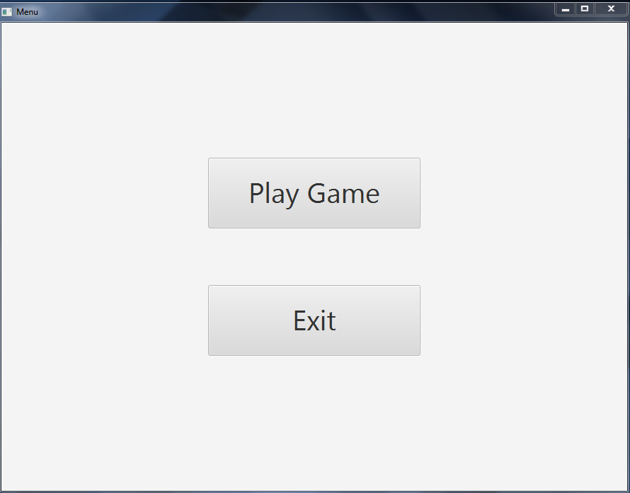

This is the stage where a player can play with Computer or play with his any friend.

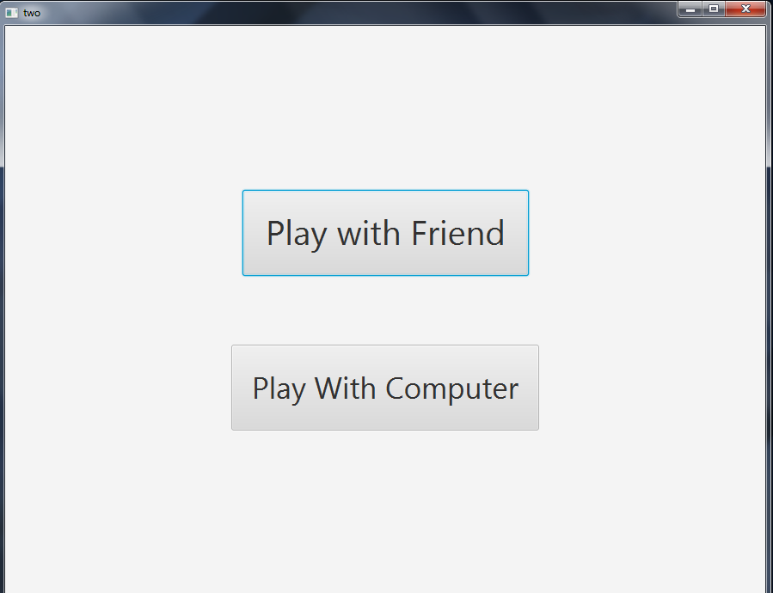

This is the sample scenario while they are playing.

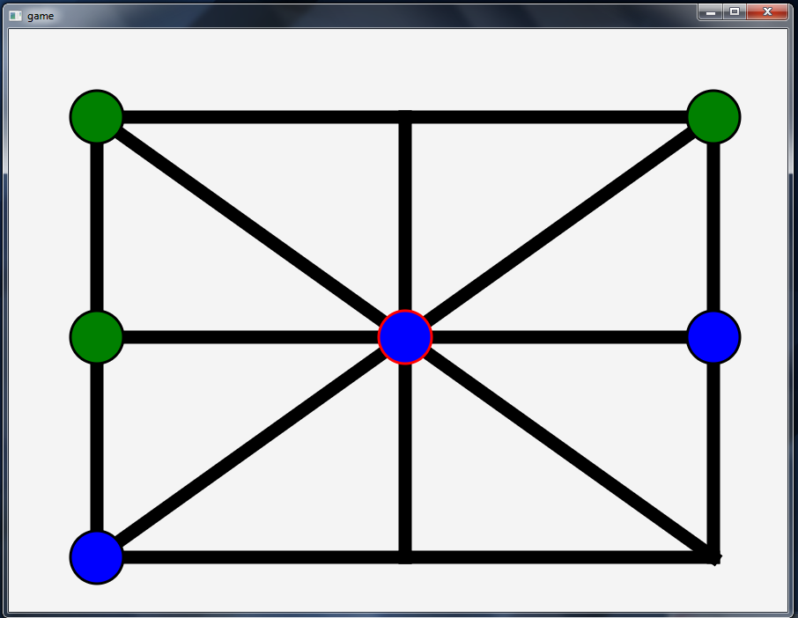

This is the sample scenario after the game is over.

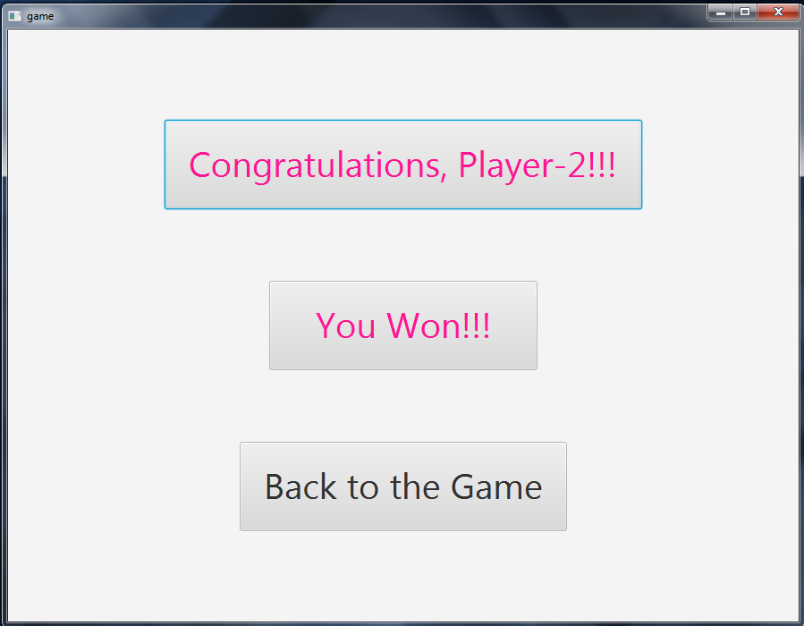

**4. Conclusion**

This Project helps me to learn javafx deeply and improve my coding skill in java. I hope it will help me to deal with difficulties in future. This project was quiet challenging and I gained a lot of experience from it. I want to thank my supervisor Dr. Mohammed Shafiul Alam Khanfor guiding me a lot during this project.

**5. Appendix**

In this Project, it is planned to develop the 3-Guti game which is able to play in two players (they can play against each other) and one player can play with Computer in easy mode.

**6. Reference**

1. <https://www.tutorialspoint.com/javafx/index.htm>

2. <https://www.youtube.com/watch?v=-fAX_idU150&list=PLrpFHrTakOxKuYA_au7QJjvv0gLPq48Us>