Table of Contents

Goal 3

Flowchart 4

Wireframe 5

Landing page 5

Default and on-click design 5

Description 6

Module 1 – Search by country 7

Default design 7

On-select design 8

Module 2 – Saved search list 10

Default design 10

On-select design 12

Module 3 – Enter zipcode 13

Default design 13

On-entering data design 14

Module 4 – Upload .csv file 15

Default design 15

Upload file design 16

Uploading file design 17

Upload failed design 18

High fidelity 19

Color Palette 19

Landing page 20

Default visual 20

On-click visual 20

Module 1 – Search by country 21

Default visual 21

On-select visual 22

Module 2 – Saved search list 23

Default visual 23

On-select visual 24

Module 3 – Enter zipcode 25

Default visual 25

On-entering data visual 25

Module 4 – Upload .csv file 26

Default visual 26

Upload file visual 26

Uploading file visual 27

Upload failed 27

Task completion 28

Success 28

Failure 28

The ‘Search By’ module

# Goal

Design a module for our client to target their advertising to internet users based on location.

# Flowchart



# Wireframe

## Landing page

### Default and on-click design

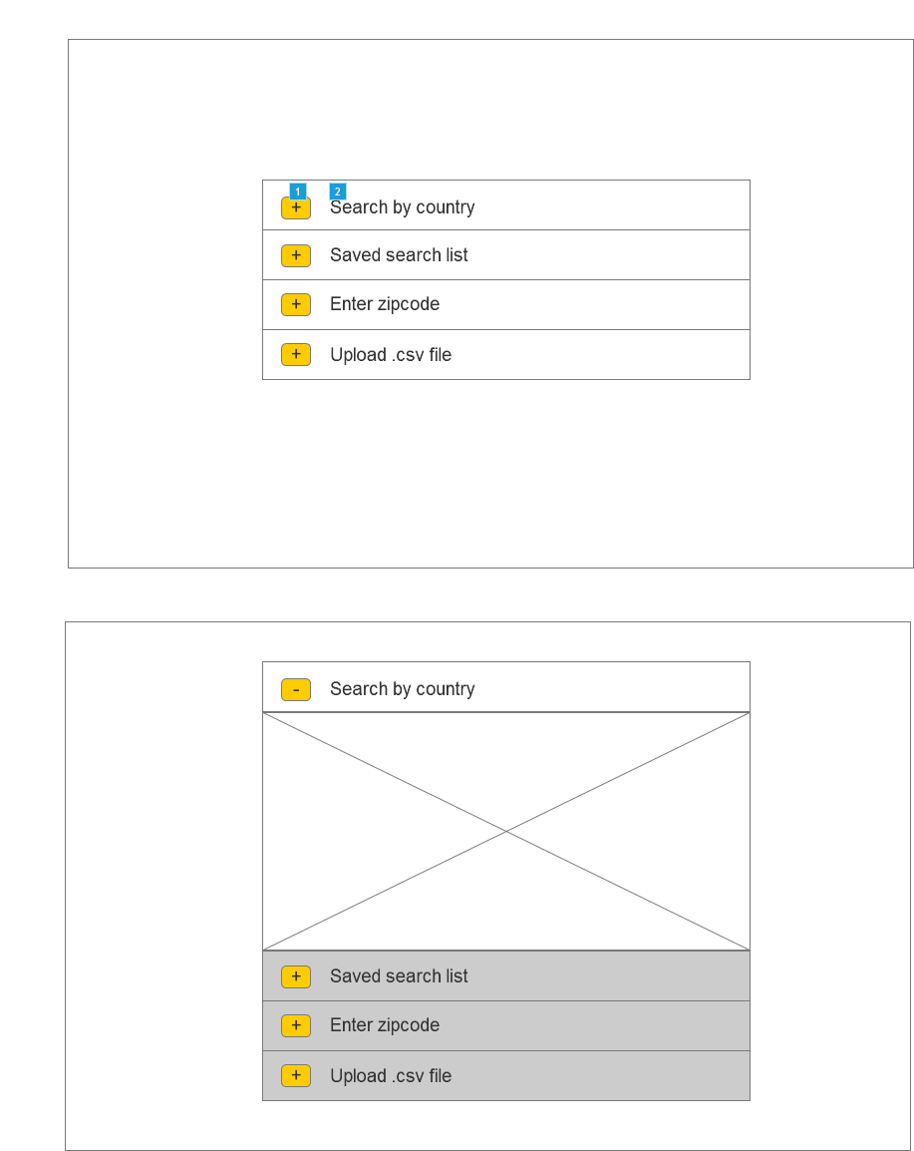

### Description

|  |  |  |  |  |
| --- | --- | --- | --- | --- |
| **Footnote** | **Name** | **Description** | **Type** | **Enabled/Disabled** |
| 1 | Accordion button | Used to maximize/minimize between different ‘Search by’ views. | Button | All 4 are enabled. |
| 2 | Accordion list | Used to maximize/minimize search option(s) tab. | Accordion list | By default: All 4 are enabled.  When one is selected (gets maximized), other 3 are disabled and minimized. |

## Module 1 – Search by country

### Default design

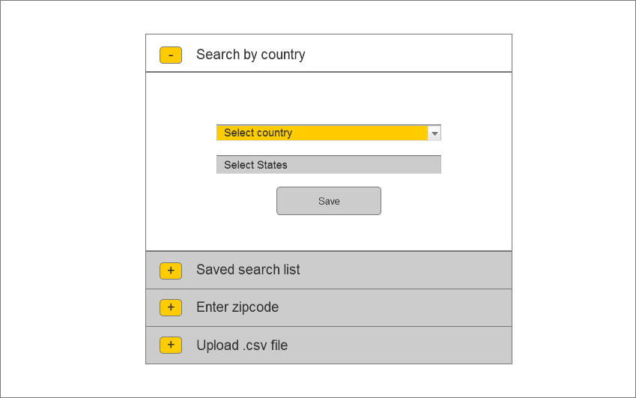

### On-select design

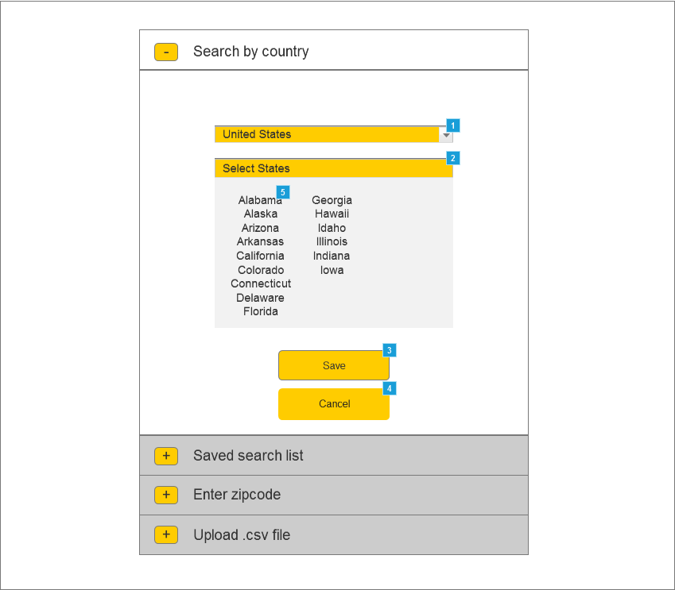

#### Description

|  |  |  |  |  |
| --- | --- | --- | --- | --- |
| **Footnote** | **Name** | **Description** | **Type** | **Enabled/Disabled** |
| 1 | Select country | Lists the different countries | Drop-down list | Always enabled. |
| 2 | Select States | Displays a list of states based on the country selected.  If the number of states exceeds 15 x 3 table, a scroll bar will appear. | Accordion list | Enabled when the country is selected, else disabled. |
| 3 | Save | Saves the current search preference. | Icon button | Enabled when one or more states are selected. |
| 4 | Cancel | Cancels the current search preference. | Button | Enabled when one or more states are selected. |
| 5 | Selection hot spot | Selects one or more states. | Hot spot | Clicking on non-selected states, selects it.  Clicking on selected states, deselects it.  Displayed with the enabled Select States list. |

## Module 2 – Saved search list

### Default design

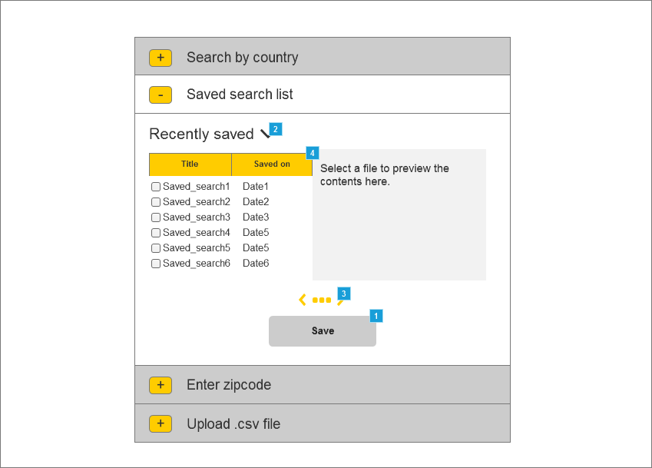

#### Description

|  |  |  |  |  |
| --- | --- | --- | --- | --- |
| Footnote | Name | Description | Type | Enabled/Disabled |
| 1 | Save | Saves the selected saved search from the list. | Button | Enabled when a saved search list is selected. |
| 2 | Sort by | Possible values:   * Recently saved * Alphabetical order | Sorting menu | Always enabled. |
| 3 | Pagination | Displays the number of pages and the navigation button. | Pagination | Enabled when there is more than one page. |
| 4 | Recently saved search list | Displays the list of saved search along with the timestamp. Allows multiple files to selected at once.  **Default sorting:**  Saved on (most recent to least)  **Secondary sorting:**  Title (alphabetically A to Z) | List box | Enabled when there is at least one saved search. Else displays a message saying 'No saved search available. |

### On-select design

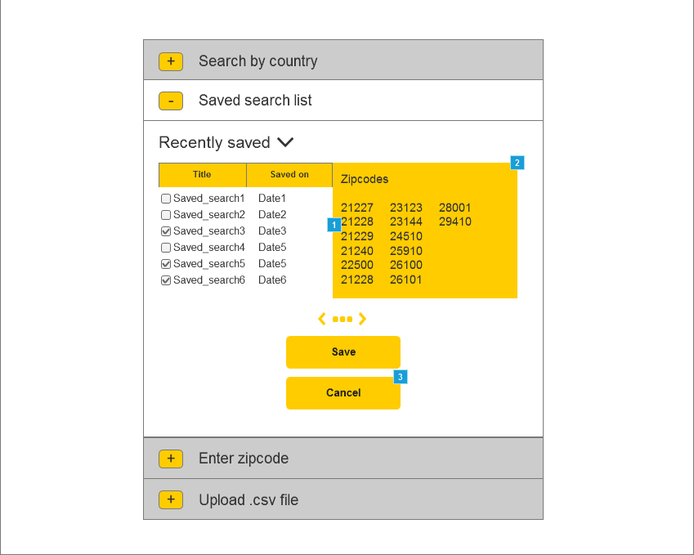

#### Description

|  |  |  |  |  |
| --- | --- | --- | --- | --- |
| Footnote | Name | Description | Type | Enabled/Disabled |
| 1 | Search list hot spot | Selection to display to preview of the file. | Hot spot | Displayed when the file is selected. |
| 2 | Preview window | Provides a preview of the saved search list file | Static text field | Displayed when the file is selected. |
| 3 | Cancel | Cancels the selection. | Button | Enabled when a saved search list is selected. |

## Module 3 – Enter zipcode

### Default design

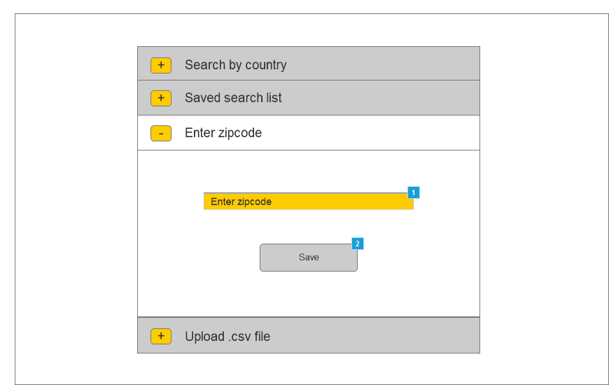

#### Description

|  |  |  |  |  |
| --- | --- | --- | --- | --- |
| **Footnote** | **Name** | **Description** | **Type** | **Enabled/Disabled** |
| 1 | Enter zipcode | To enter the zip codes. | Text input field | Always enabled |
| 2 | Save | Saves the current search preference. | Button | Enabled when all the required input fields are entered correctly. |

### On-entering data design

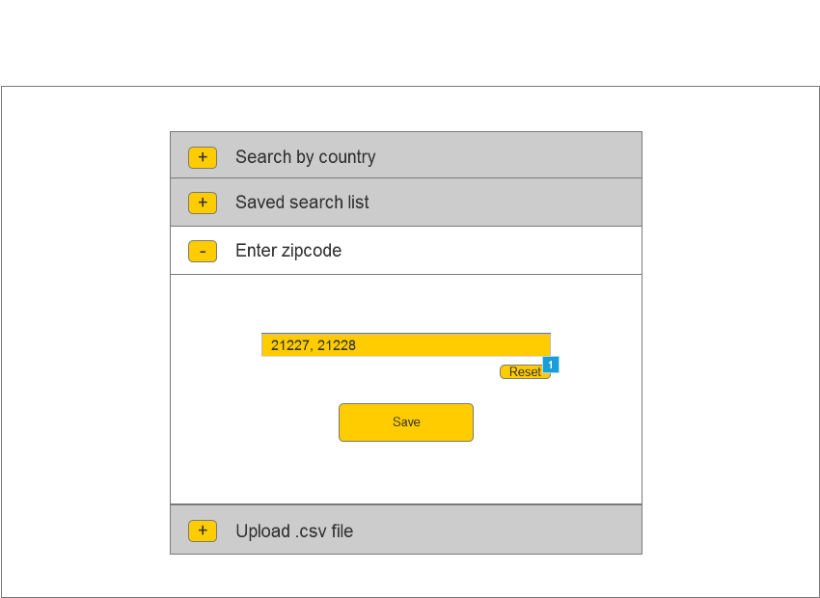

#### Description

|  |  |  |  |
| --- | --- | --- | --- |
| **Footnote** | **Name** | **Type** | **Enabled/Disabled** |
| 1 | Reset | Button | Enabled when there is one or more input in the Enter zipcode input field. |

## Module 4 – Upload .csv file

In this view, or option, the client just wants to upload a .csv file with zip codes in it

### Default design

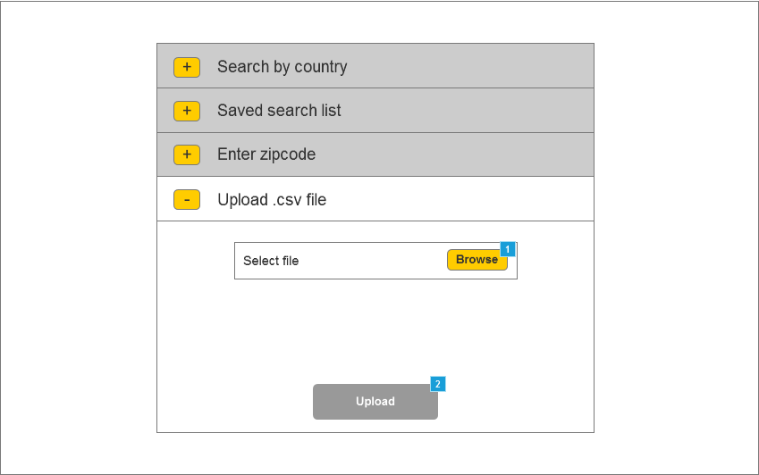

#### Description

|  |  |  |  |  |
| --- | --- | --- | --- | --- |
| **Footnote** | **Name** | **Description** | **Type** | **Enabled/Disabled** |
| 1 | Browse | On click opens a directory for browsing .csv files | Button | Always enabled except when the file is being uploaded. |
| 2 | Upload | Loads the selected saved search from the list. | Button | Enabled when the .csv file is selected |

### Upload file design

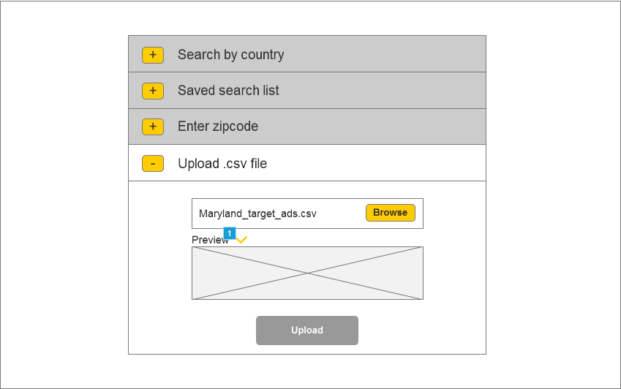

#### Description

|  |  |  |  |  |
| --- | --- | --- | --- | --- |
| **Footnote** | **Name** | **Description** | **Type** | **Enabled/Disabled** |
| 1 | Preview window | Gives a preview of the content inside the .csv file. | Static text field | Displayed when the file to be uploaded is selected. |

### Uploading file design

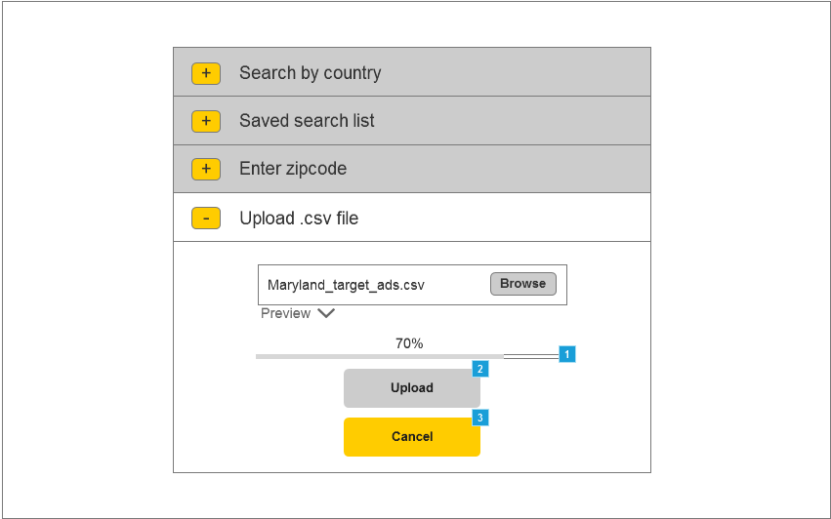

#### Description

|  |  |  |  |  |
| --- | --- | --- | --- | --- |
| **Footnote** | **Name** | **Description** | **Type** | **Enabled/Disabled** |
| 1 | Progress bar | Displays the % of upload completion. | Progress bar | Displayed when the .csv file is being uploaded. |
| 2 | Upload | Uploads the selected .csv file. | Button | Enabled when the .csv file is selected. Disabled when the .csv file is uploading. |
| 3 | Cancel | Cancels the .csv file upload. | Button | Displayed when the .csv file is uploading or when the upload fails. |

### Upload failed design

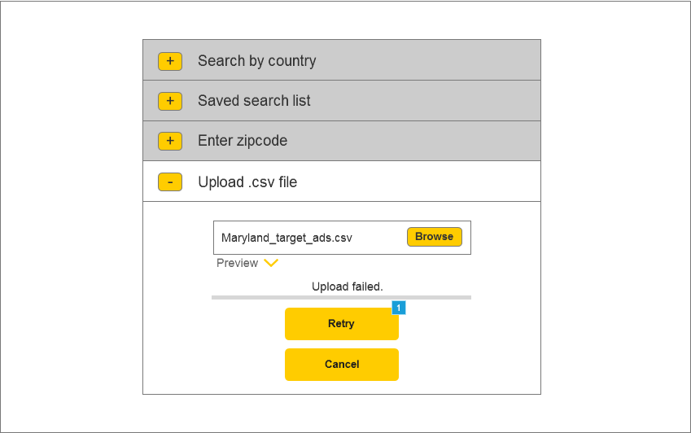

#### Description

|  |  |  |  |  |
| --- | --- | --- | --- | --- |
| **Footnote** | **Name** | **Description** | **Type** | **Enabled/Disabled** |
| 1 | Retry | Restarts uploading of the failed .csv file. | Button | Enabled when the .csv file upload fails. |

# High fidelity

## Color Palette

The color palette was inspired by the colors used in Videology’s logo.

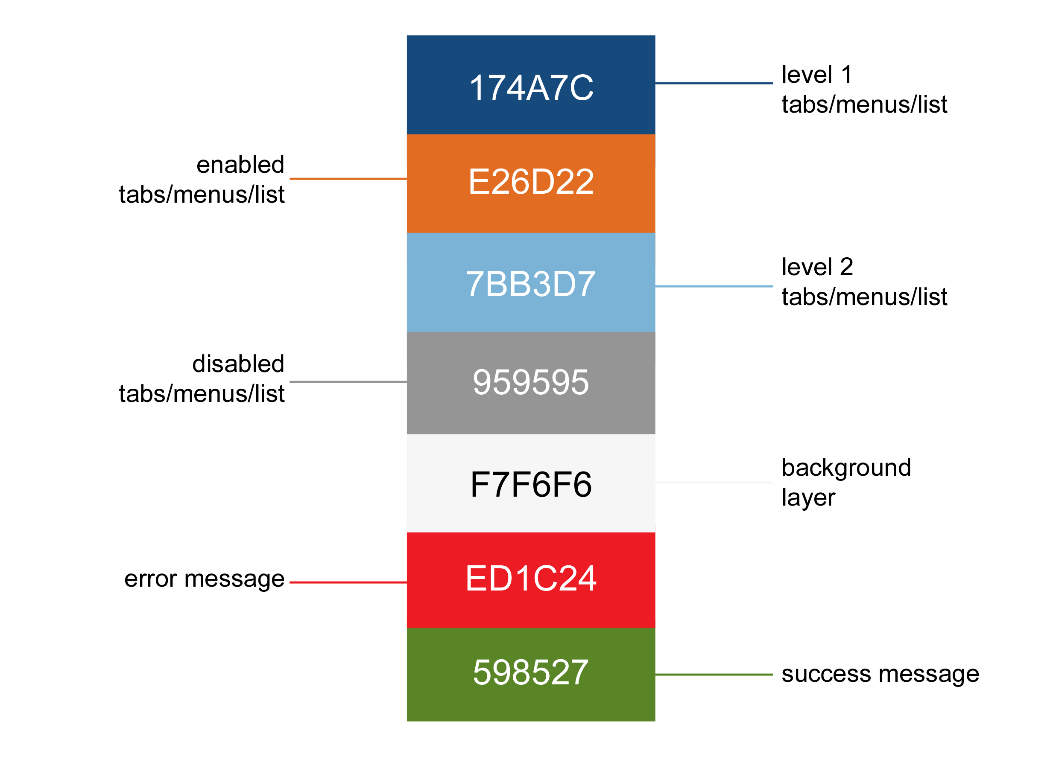

## Landing page

This would be the page once the client logs in to the ‘Users - Search by’ module.

### Default visual

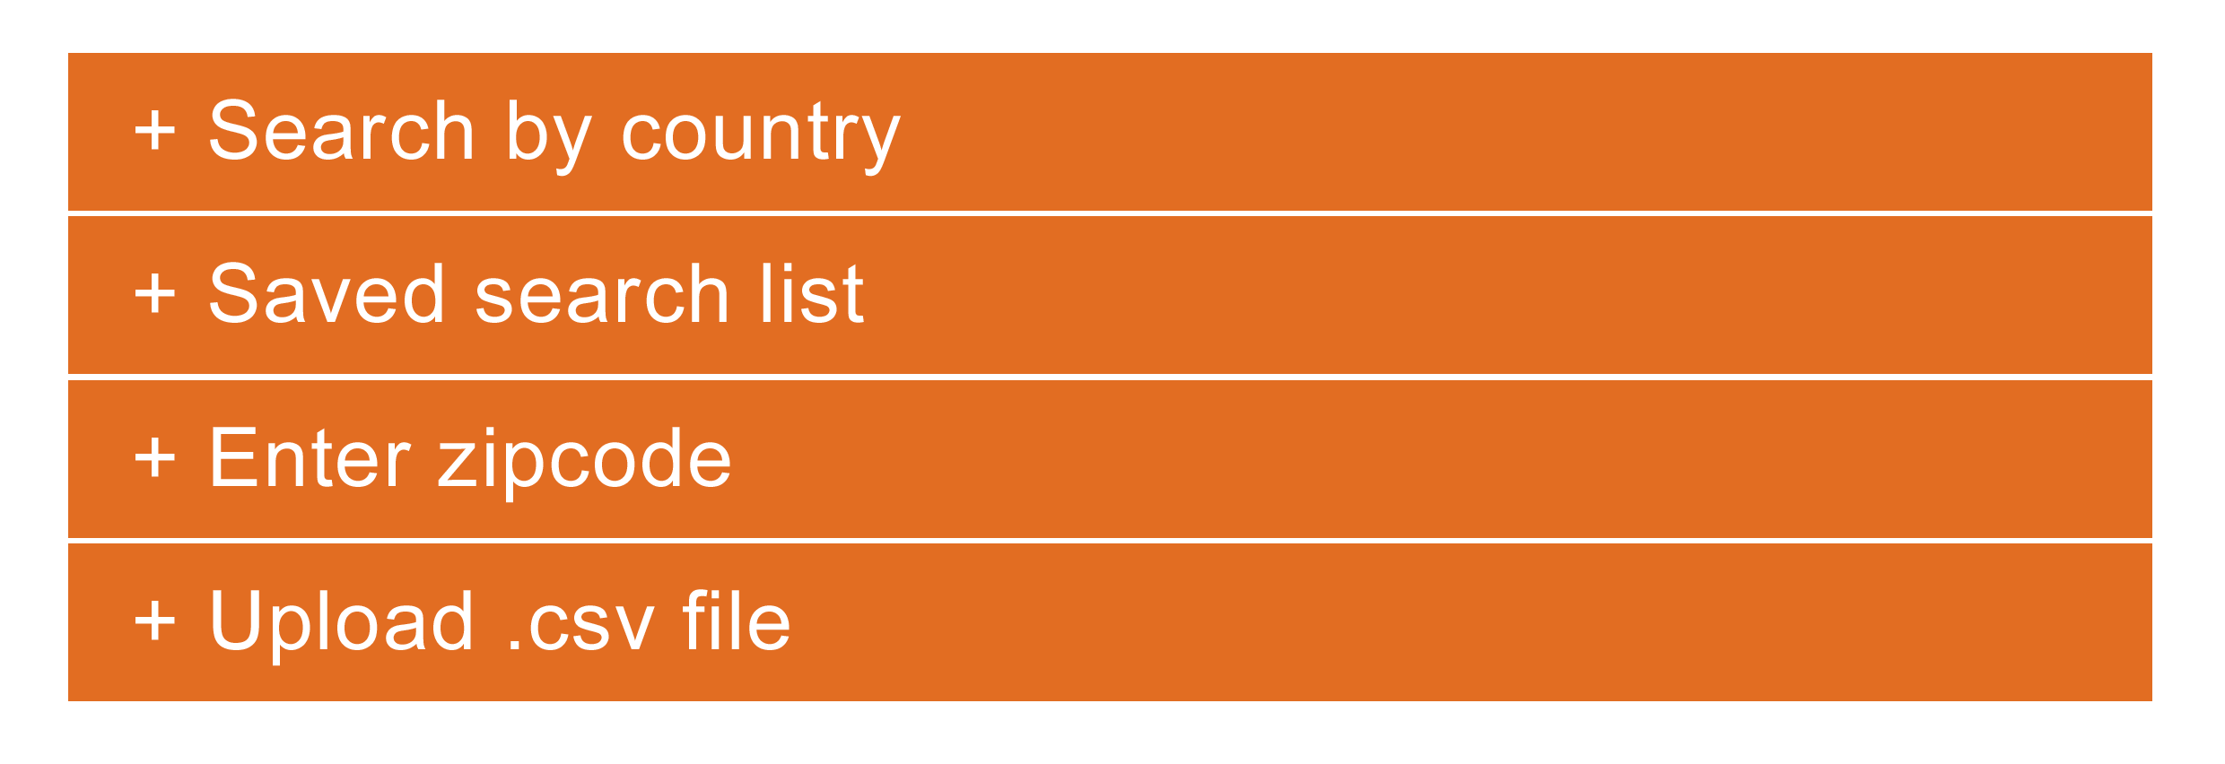

### On-click visual

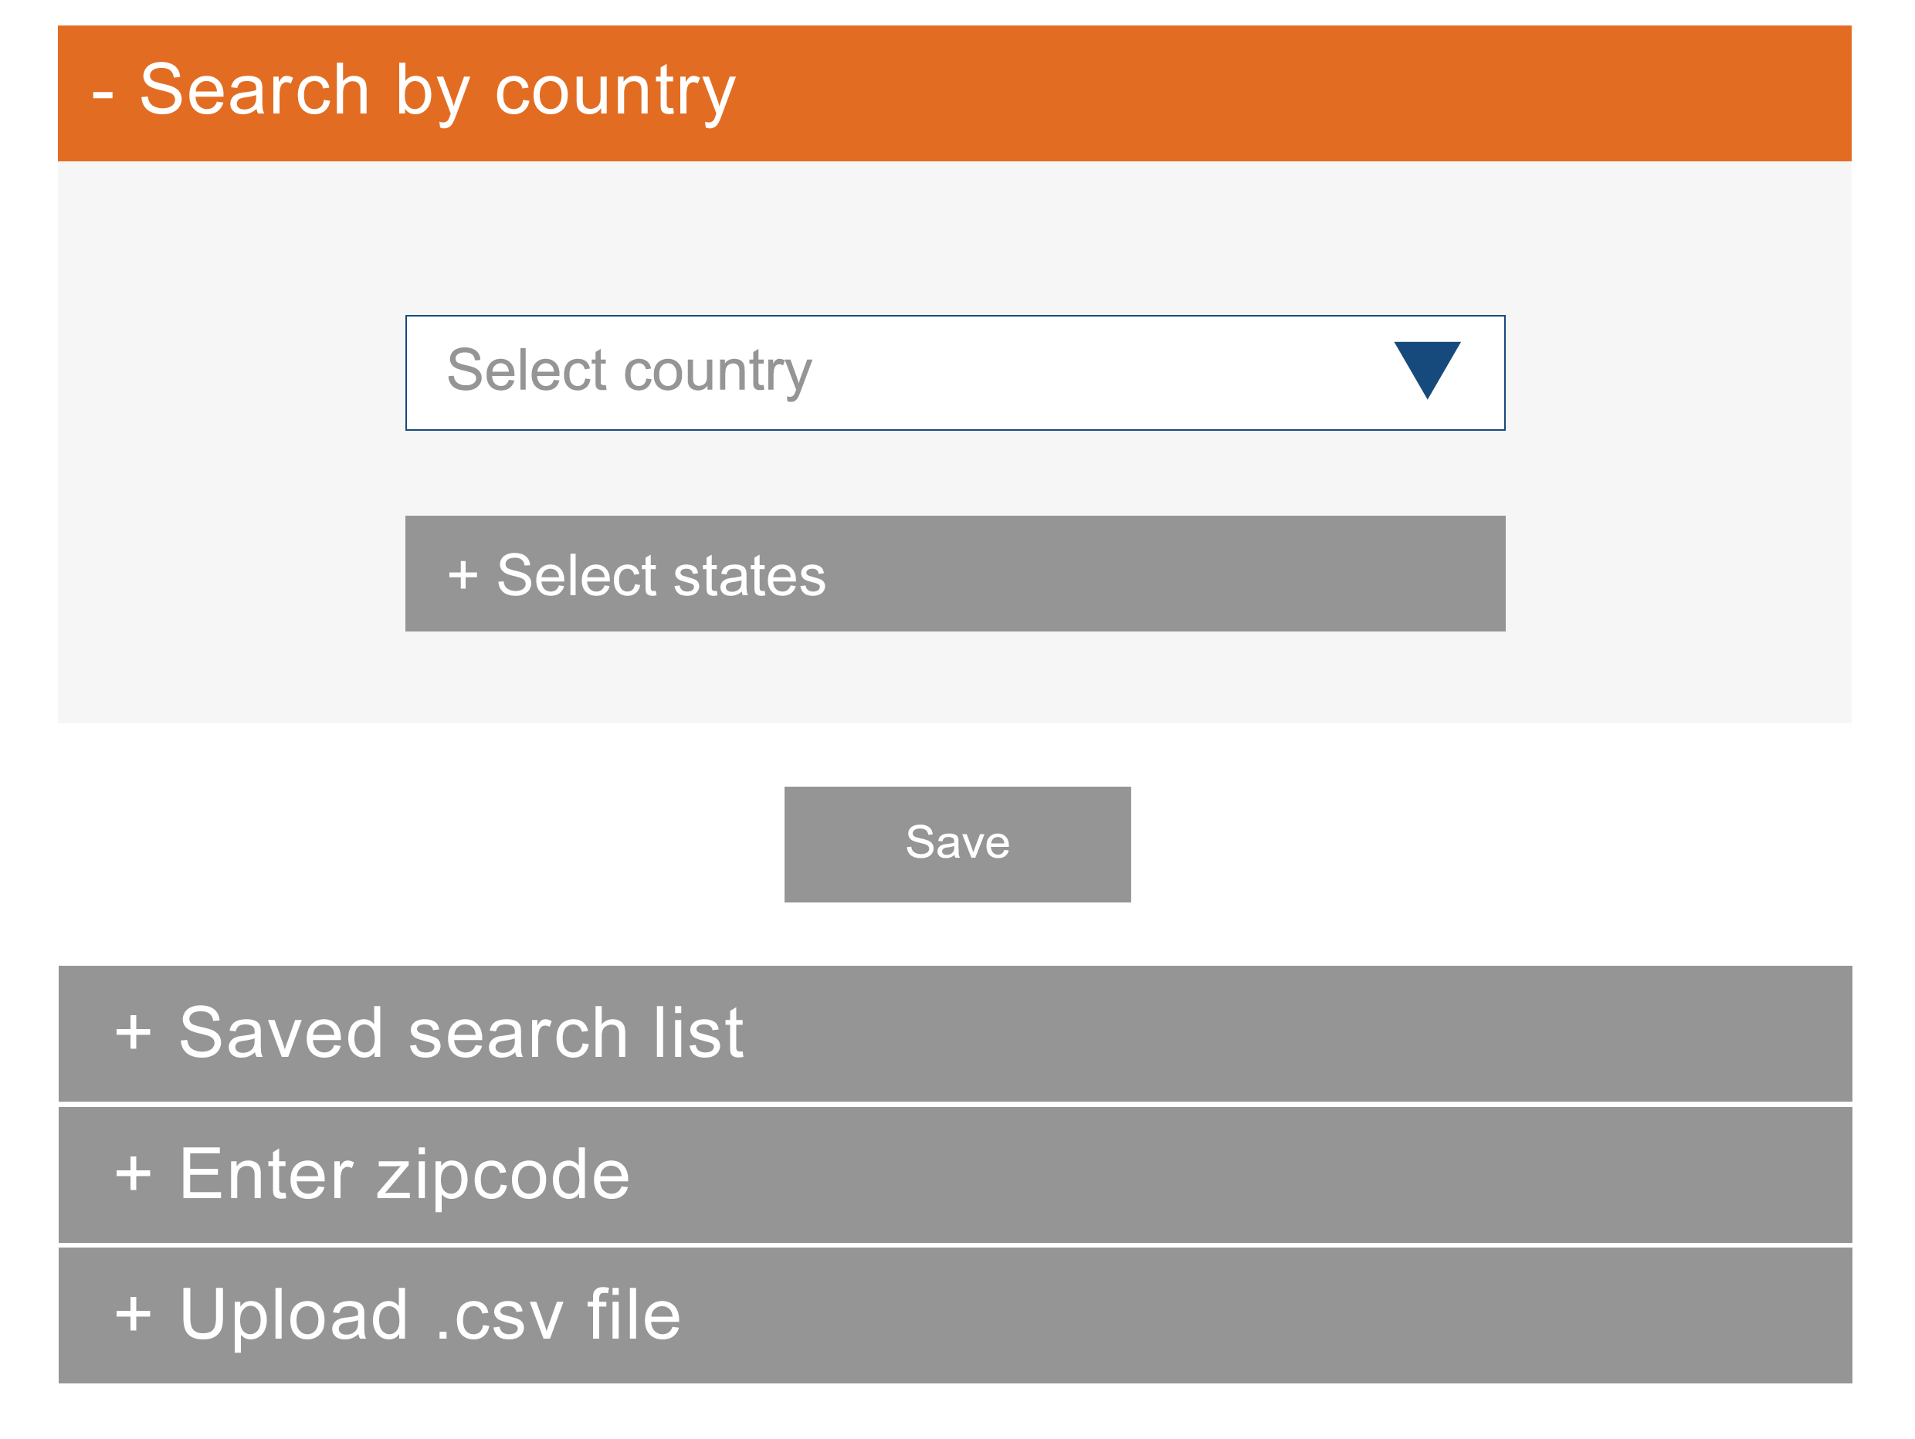

## Module 1 – Search by country

In this view the client would select a country, which would populate specific regions within that country.

### Default visual

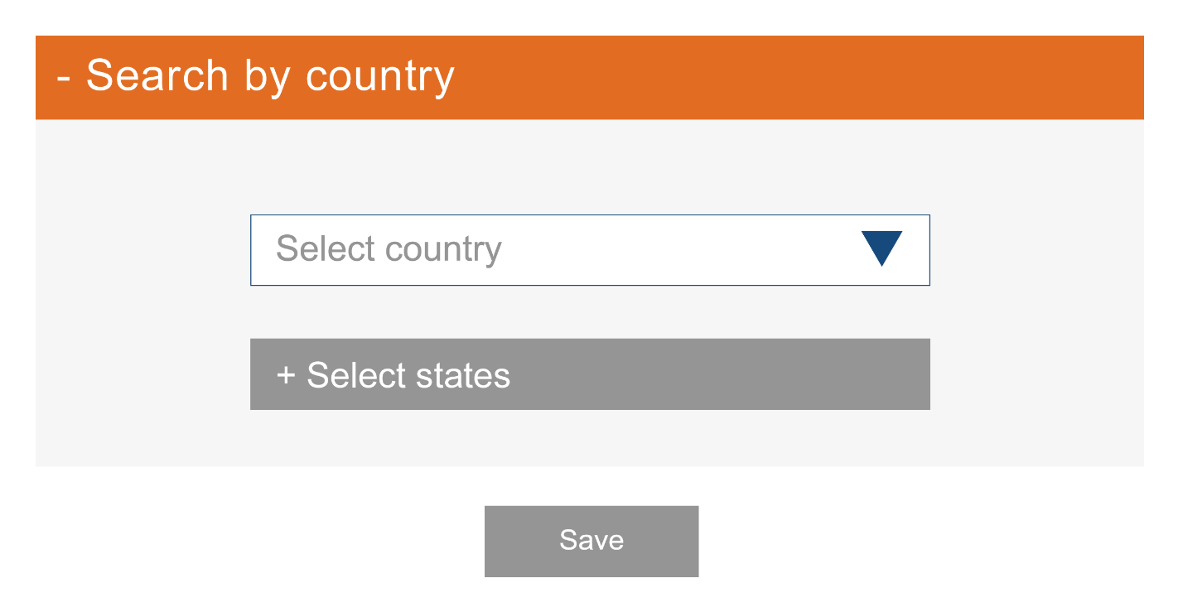

### On-select visual

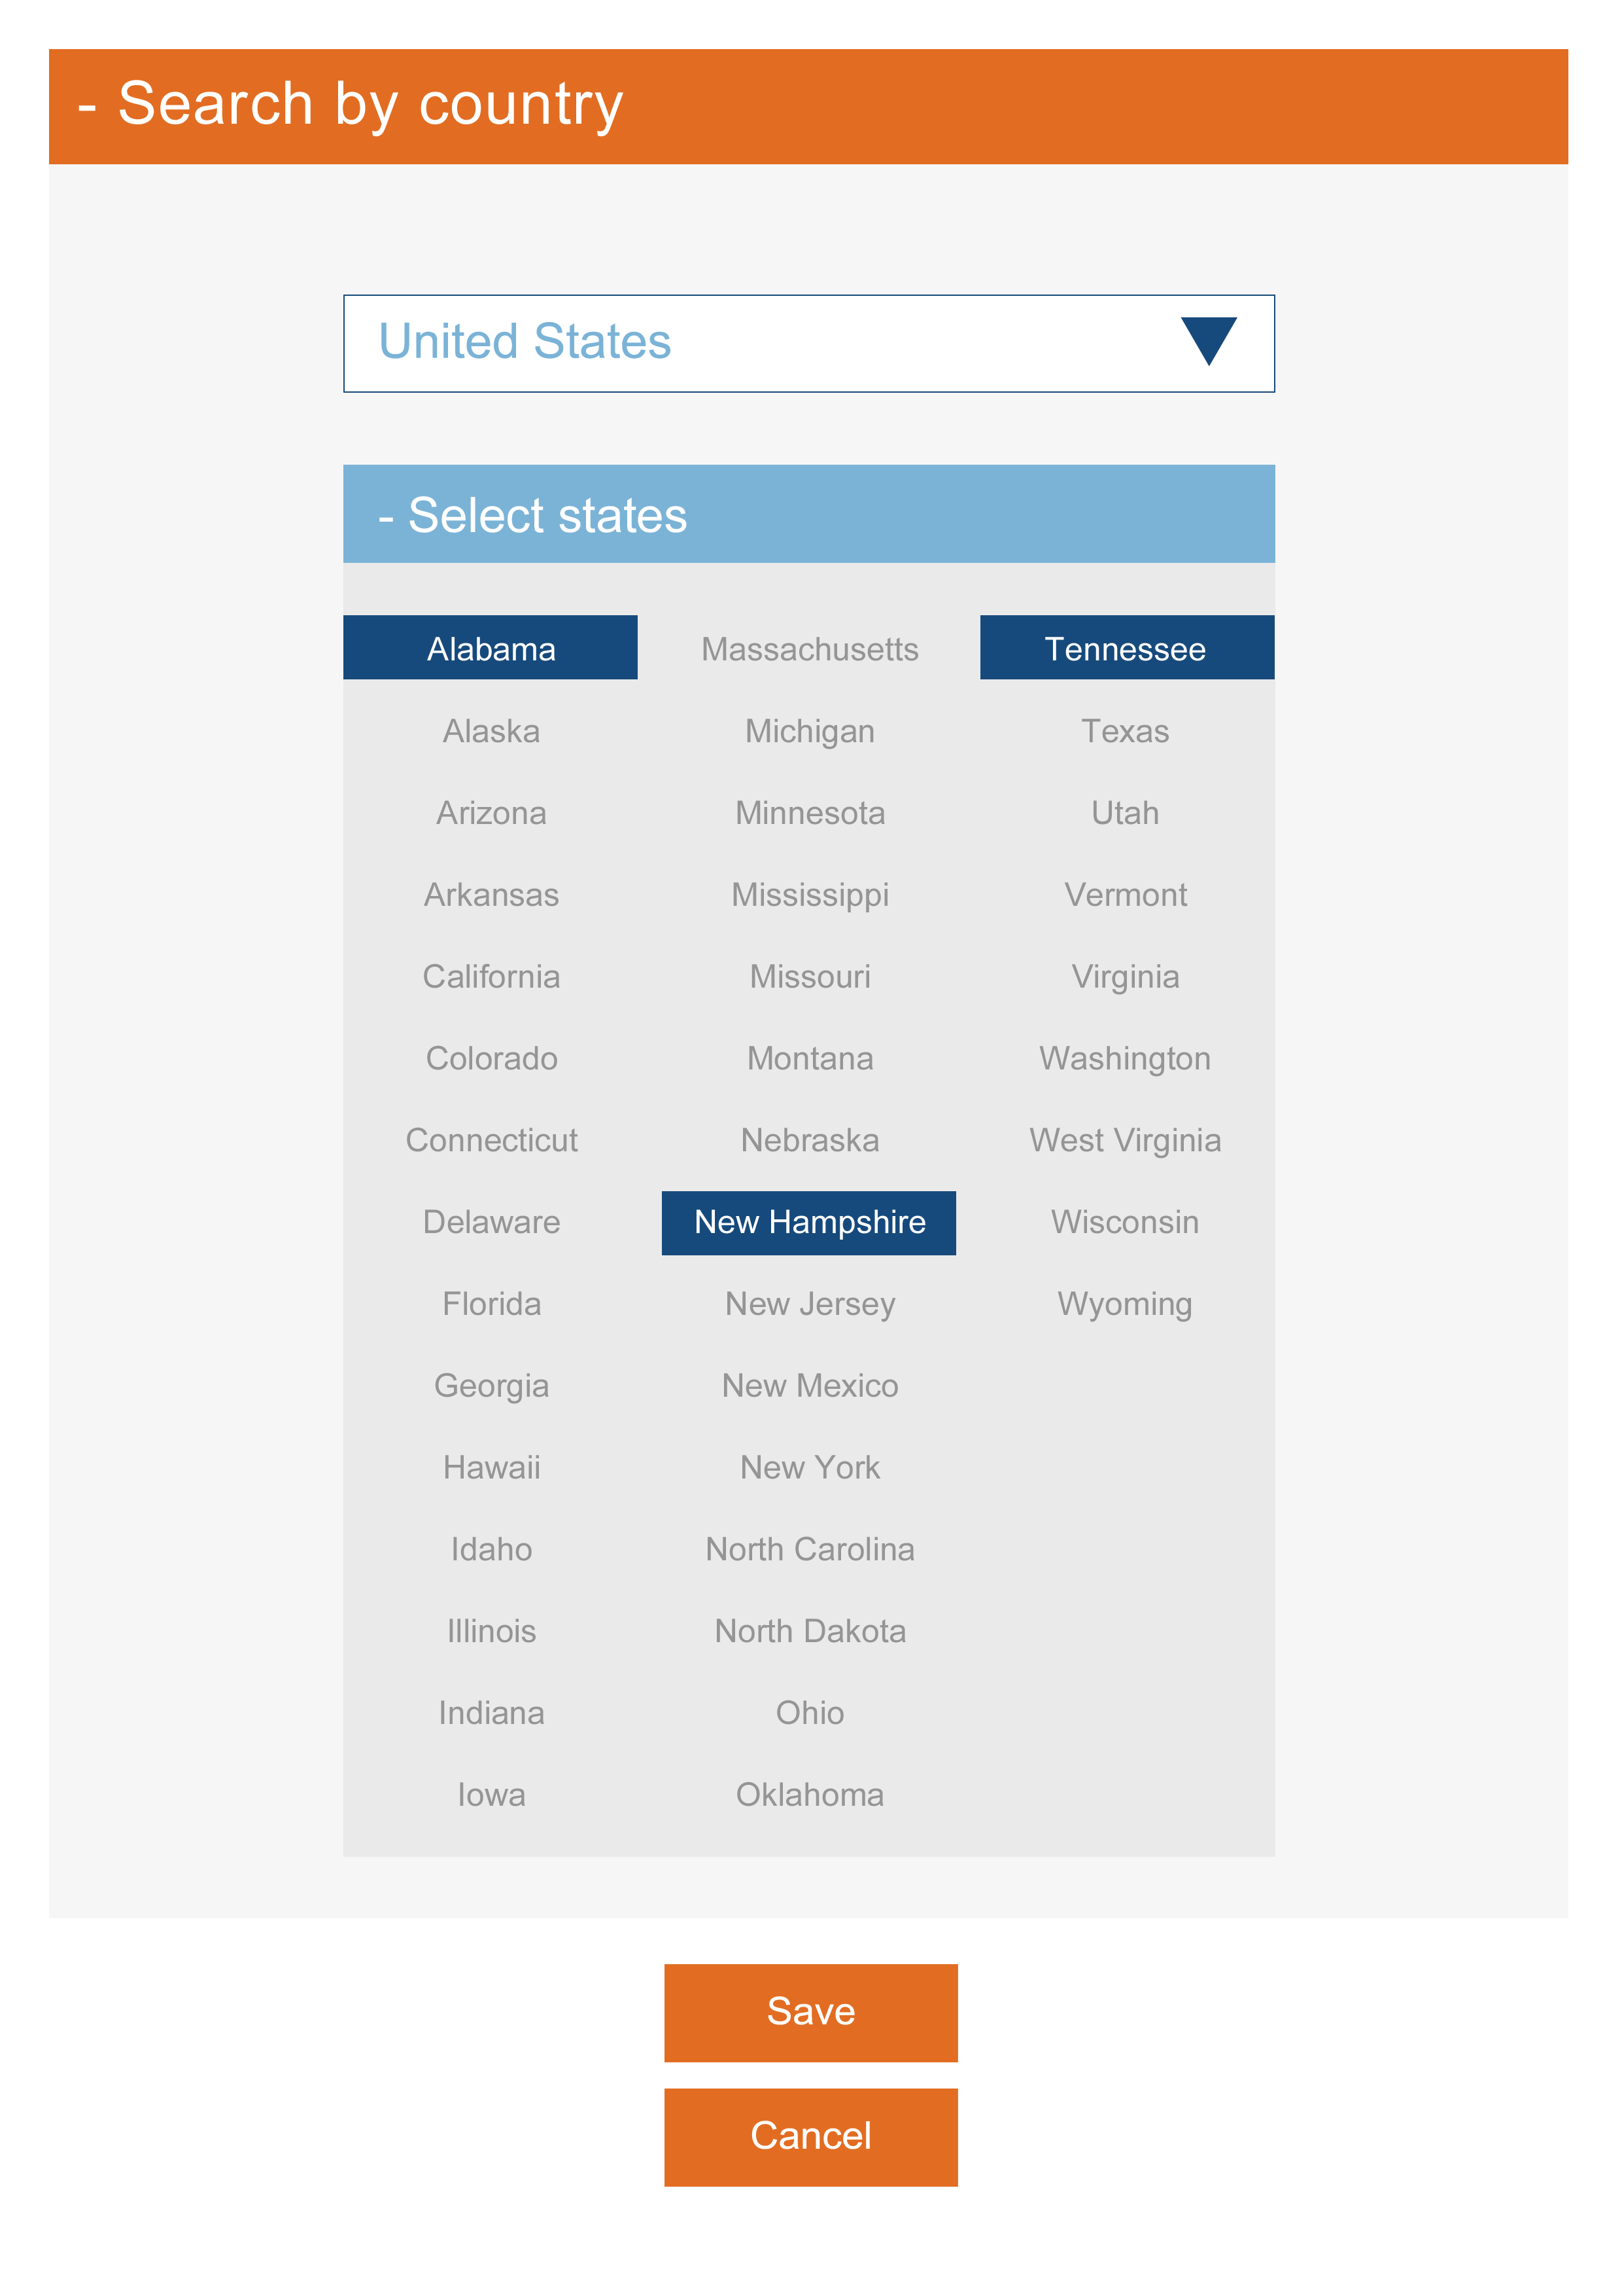

## Module 2 – Saved search list

The client would be presented with a list of saved files that contain zip codes that have previously been created. When they select a file to target, they would see what zip codes are in that list. They have the ability to select multiple files.

### Default visual

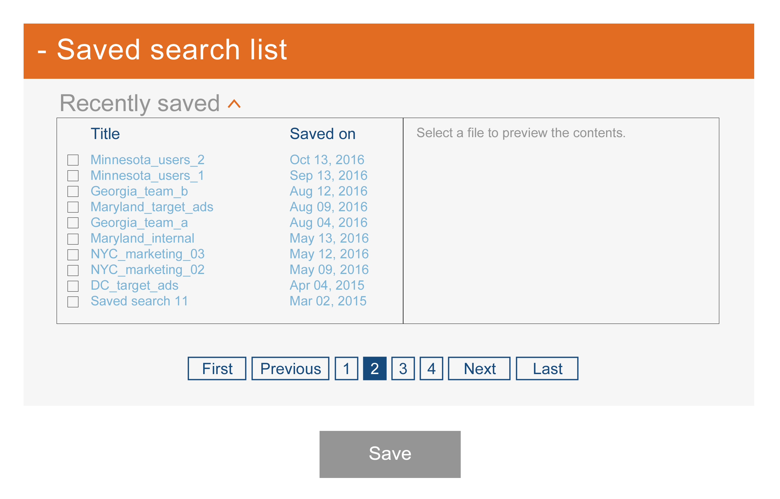

### On-select visual

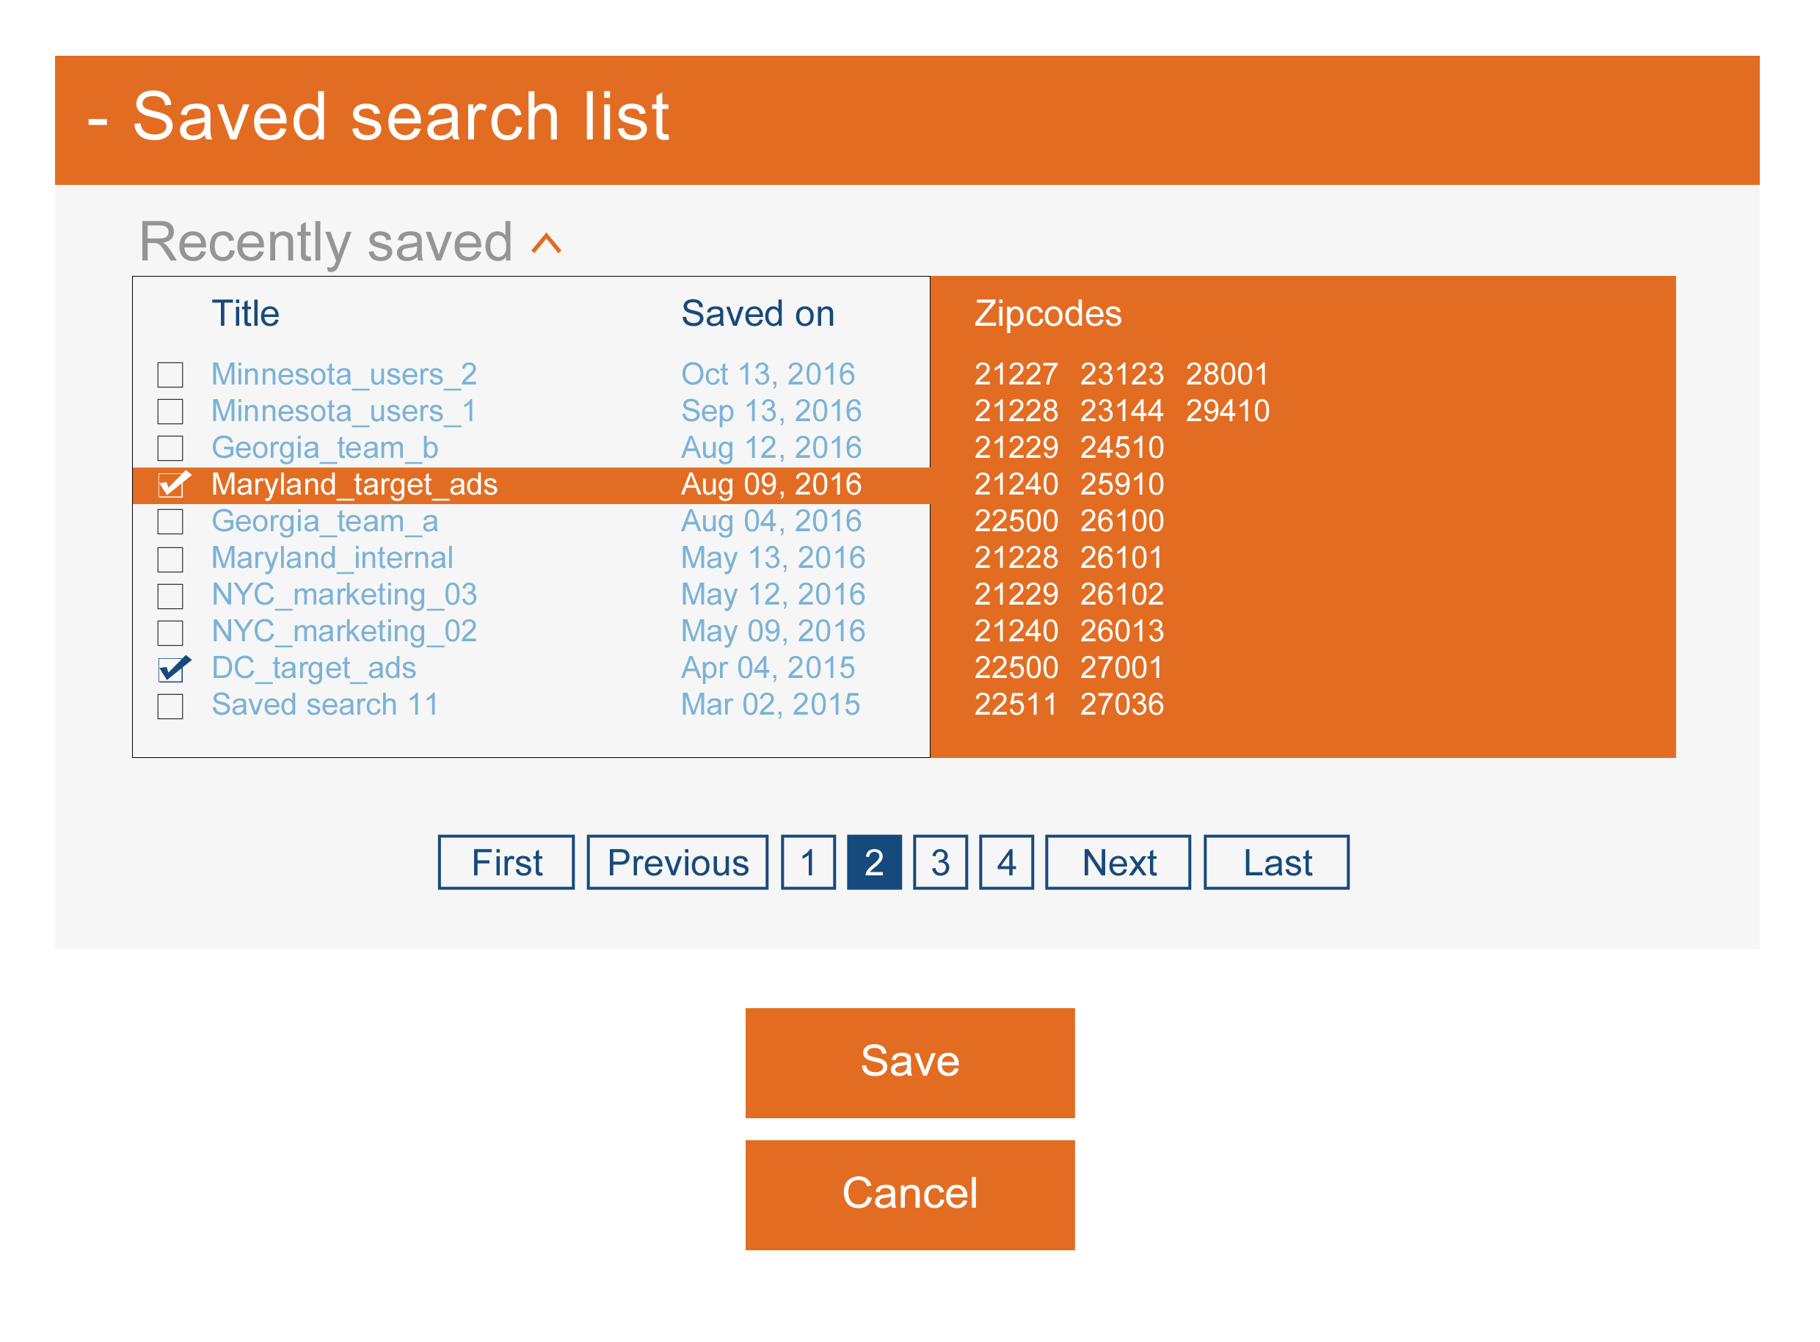

## Module 3 – Enter zipcode

In this view the user would just want a space to enter in zip codes manually that they want to target.

### Default visual

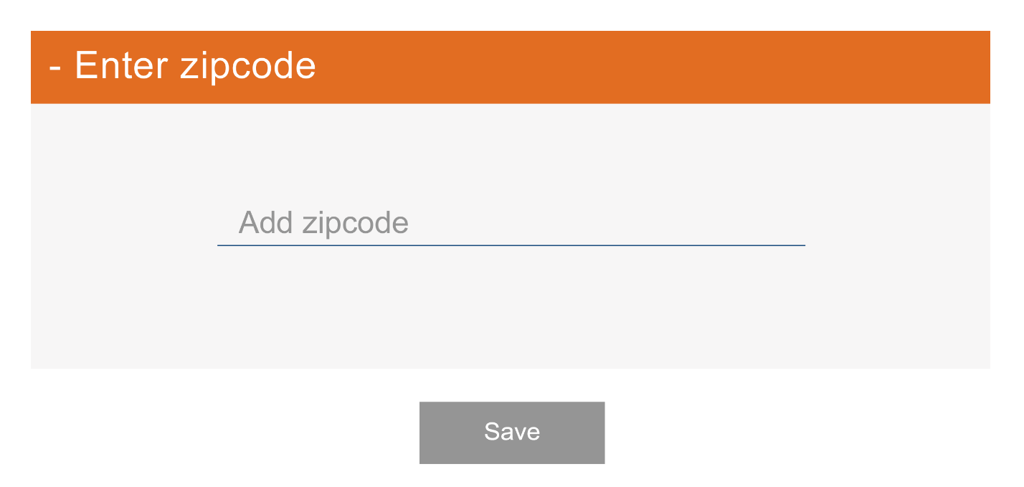

### On-entering data visual

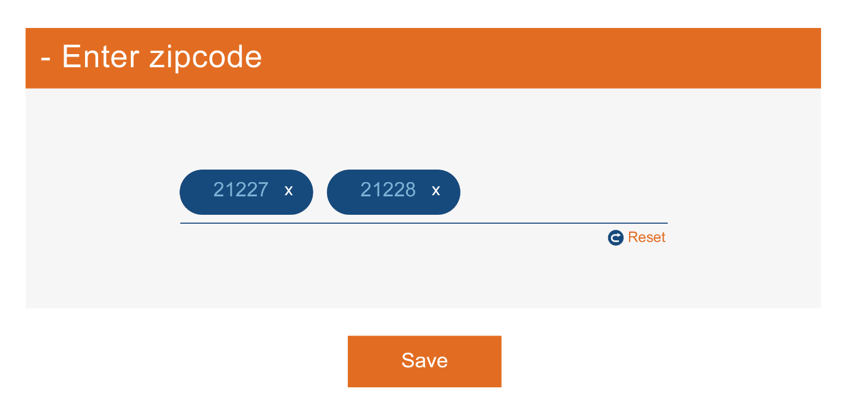

## Module 4 – Upload .csv file

In this view, or option, the client just wants to upload a .csv file with zip codes in it.

### Default visual

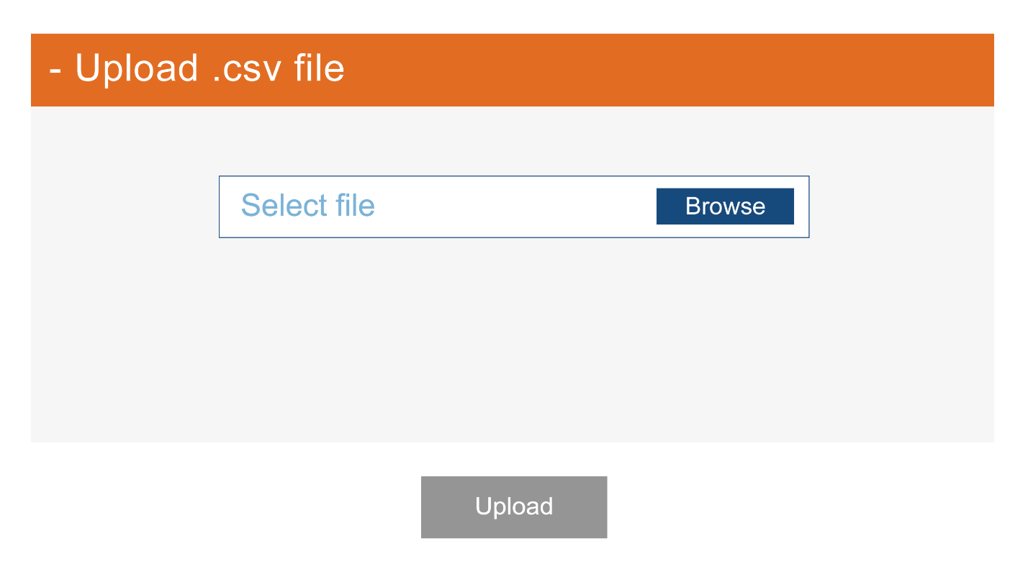

### Upload file visual

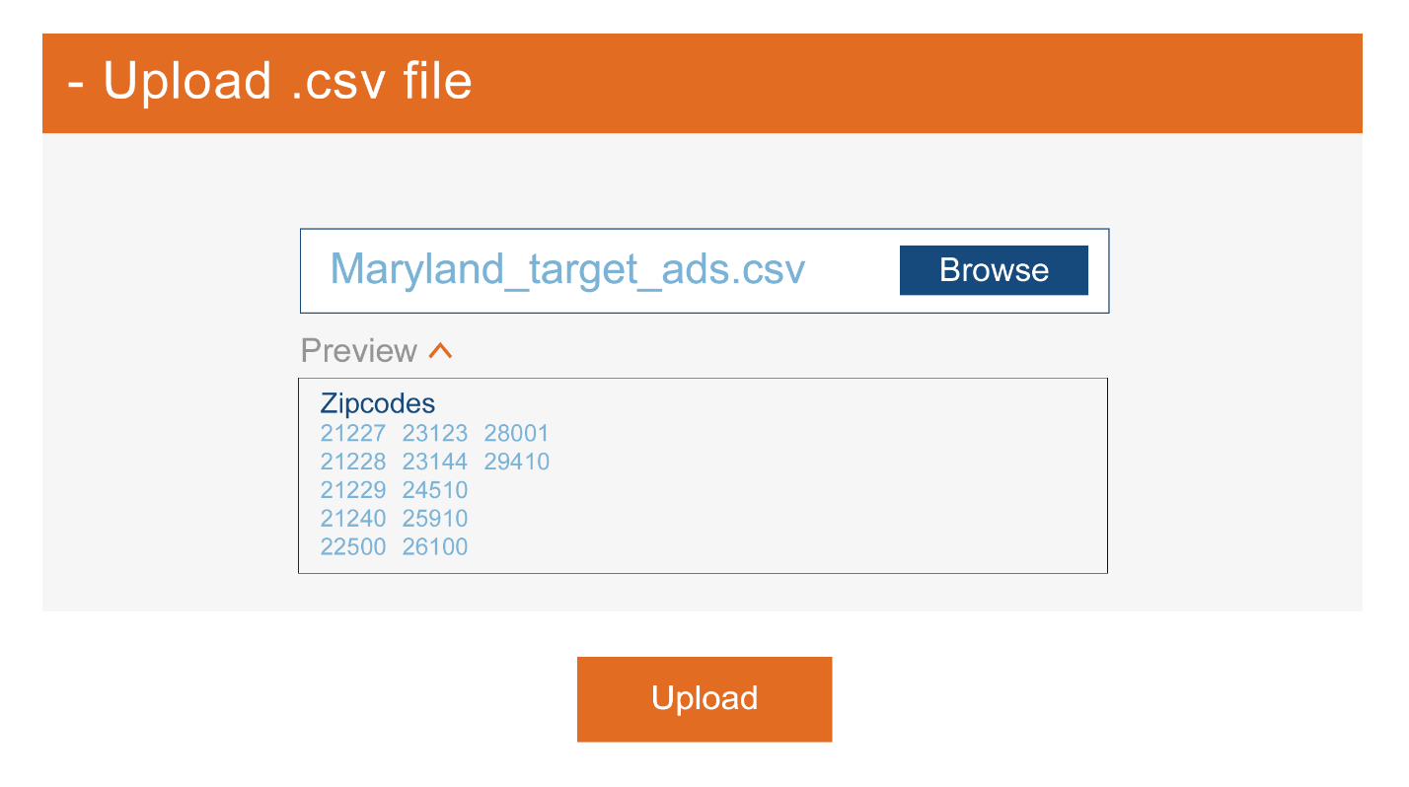

### Uploading file visual

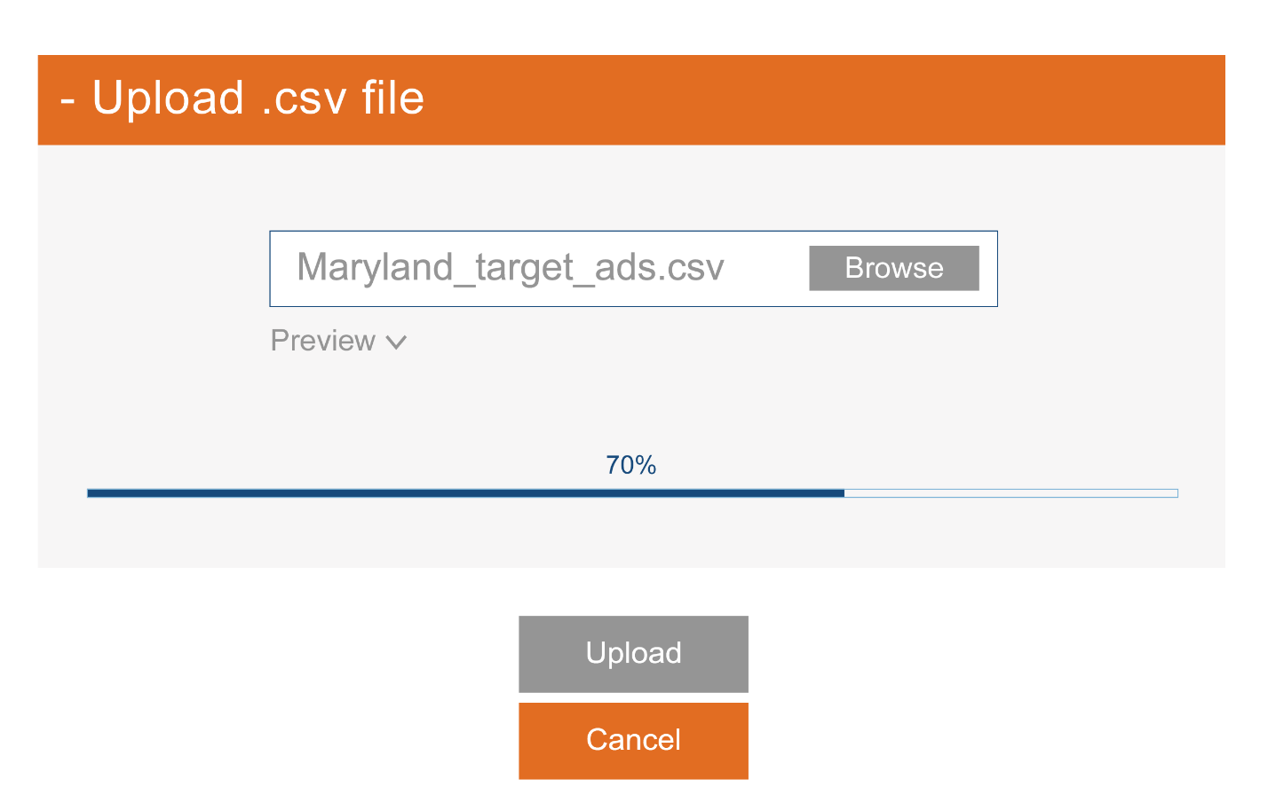

### Upload failed

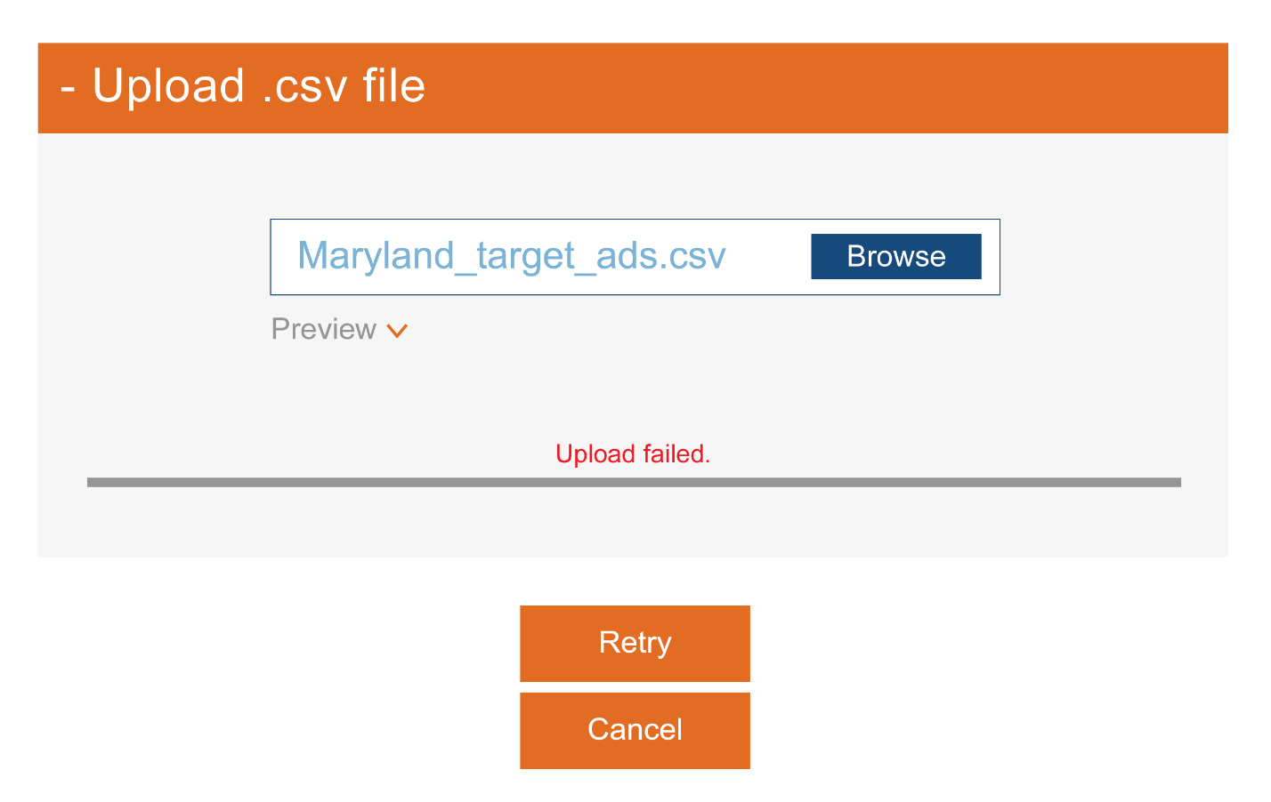

## Task completion

On completion of a particular task, either of the following two messages will be displayed on the View module.

### Success

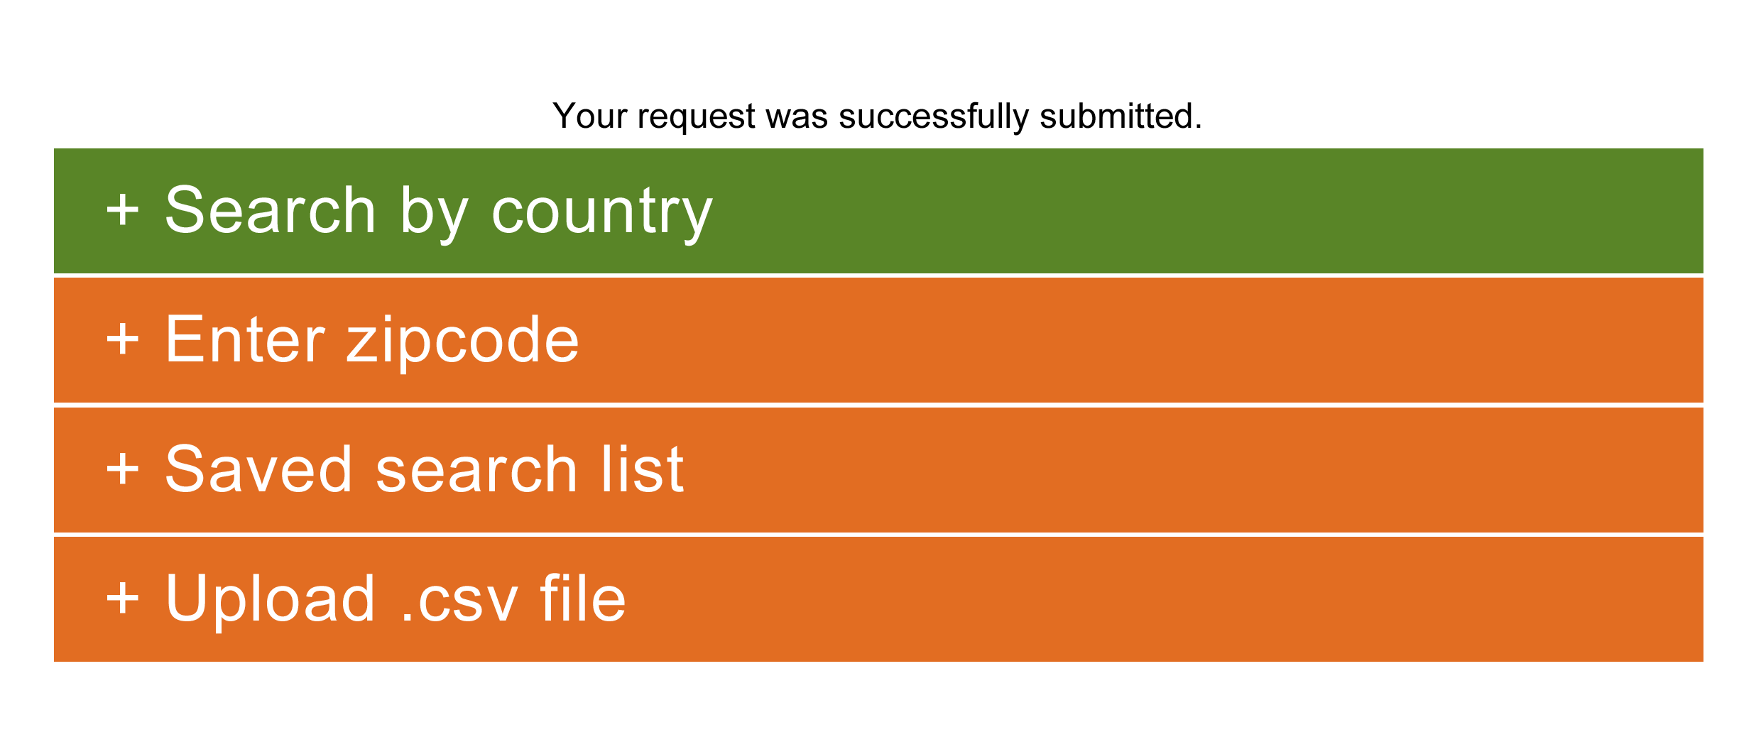

### Failure

