习题解答参考
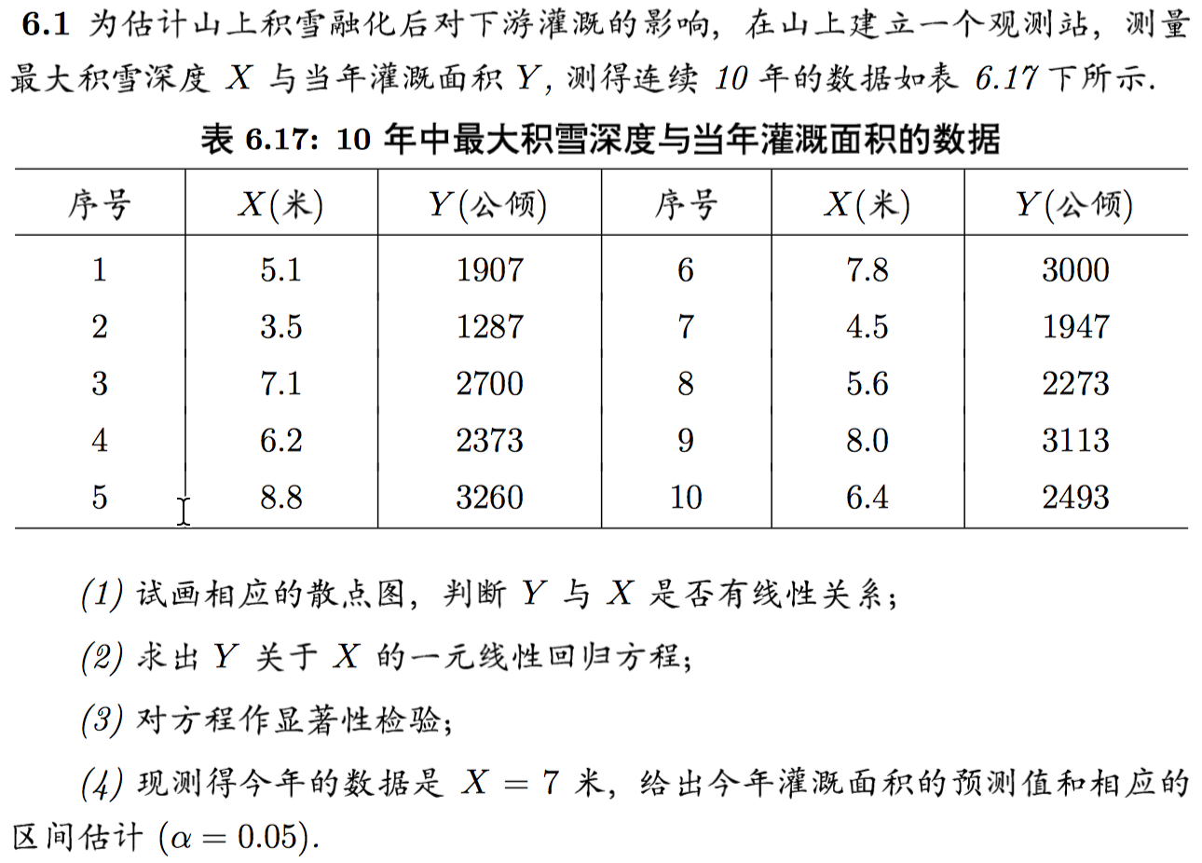
（1）
x <- c(5.1, 3.5, 7.1, 6.2, 8.8, 7.8, 4.5, 5.6, 8.0, 6.4)
y <- c(1907, 1287, 2700, 2373, 3260, 3000, 1947, 2273, 3113,2493)
plot(x,y)
（2）
lm.sol<-lm(y~1+x)
summary(lm.sol)
（4）
new <- data.frame(x=7)
lm.pred<-predict(lm.sol,new,interval="prediction")
lm.pred

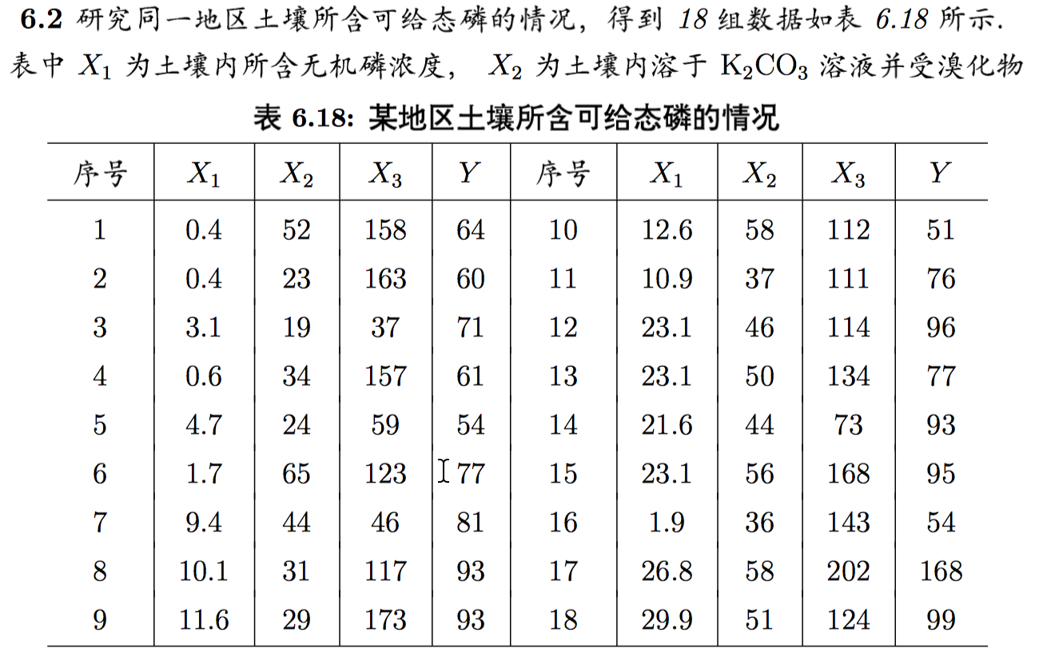
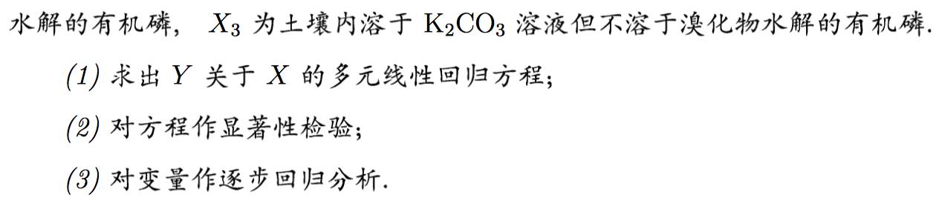
(1)
pho<-data.frame(x1 <- c(0.4,0.4,3.1,0.6,4.7,1.7,9.4,10.1,11.6,12.6,10.9,23.1,23.1,21.6,23.1,1.9,26.8,29.9), x2 <- c(52,34,19,34,24,65,44,31,29,58,37,46,50,44,56,36,58,51), x3 <- c(158,163,37,157,59,123,46,117,173,112,111,114,134,73,168,143,202,124), y <- c(64,60,71,61,54,77,81,93,93,51,76,96,77,93,95,54,168,99))
lm.sol<-lm(y~x1+x2+x3,data=pho)
summary(lm.sol)
（3）
lm.step<-step(lm.sol)
summary(lm.step)
drop1(lm.step)lm.opt<-lm(y~x1,data=pho);summary(lm.opt)
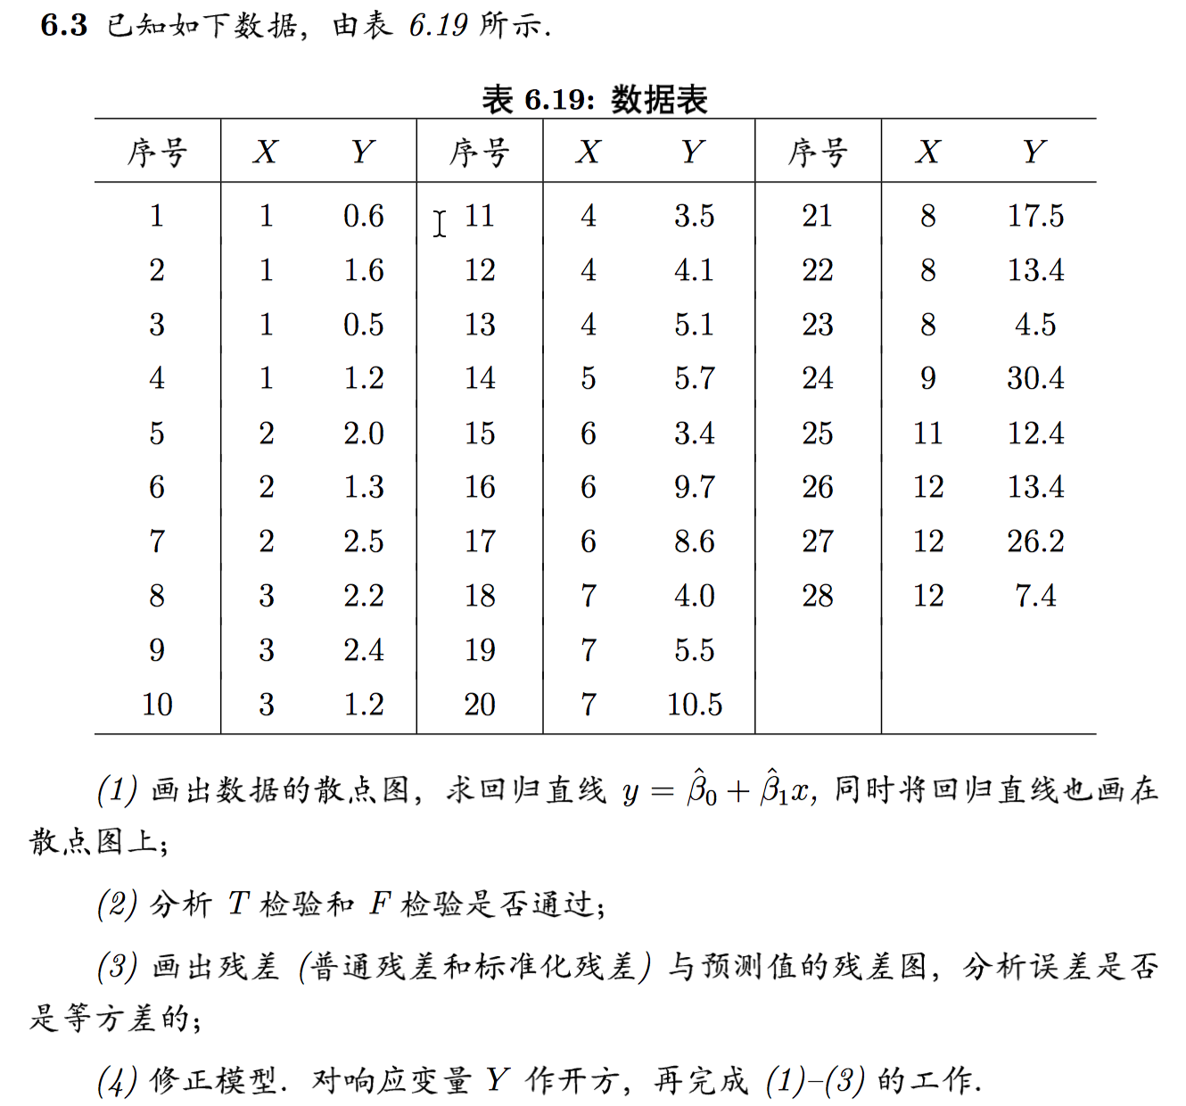
> x<-c(1,1,1,1,2,2,2,3,3,3,4,4,4,5,6,6,6,7,7,7,8,8,8,9,11,12,12,12)
> y<-c(0.6,1.6,0.5,1.2,2.0,1.3,2.5,2.2,2.4,1.2,3.5,4.1,5.1,5.7,3.4,9.7,8.6,4.0,5.5,10.5,17.5,13.4,4.5,30.4,12.4,13.4,26.2,7.4)
> plot(x,y)
> lm.sol<-lm(y~1+x)
> summary(lm.sol)

> y.yes<-resid(lm.sol)
> y.fit<-predict(lm.sol)
> y.rst<-rstandard(lm.sol)
> plot(y.yes~y.fit)

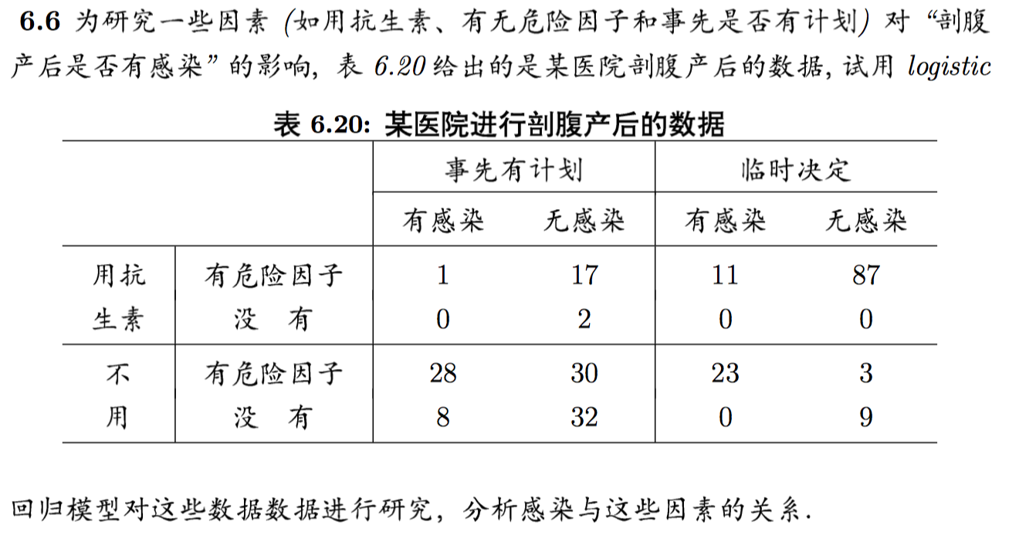
>infection<-data.frame(x1<-c(0,1,0,0,0,1,1,1),x2<-c(0,0,1,0,1,0,1,1),x3<-c(0,0,0,1,1,1,0,1),success<-c(0,0,23,8,28,0,11,1),fail<-c(9,0,3,32,30,2,87,17))
> infection$Ymat<-cbind(infection$success,infection$fail)
> glm.sol<-glm(Ymat~x1+x2+x3,family=binomial,data=infection)
> summary(glm.sol)
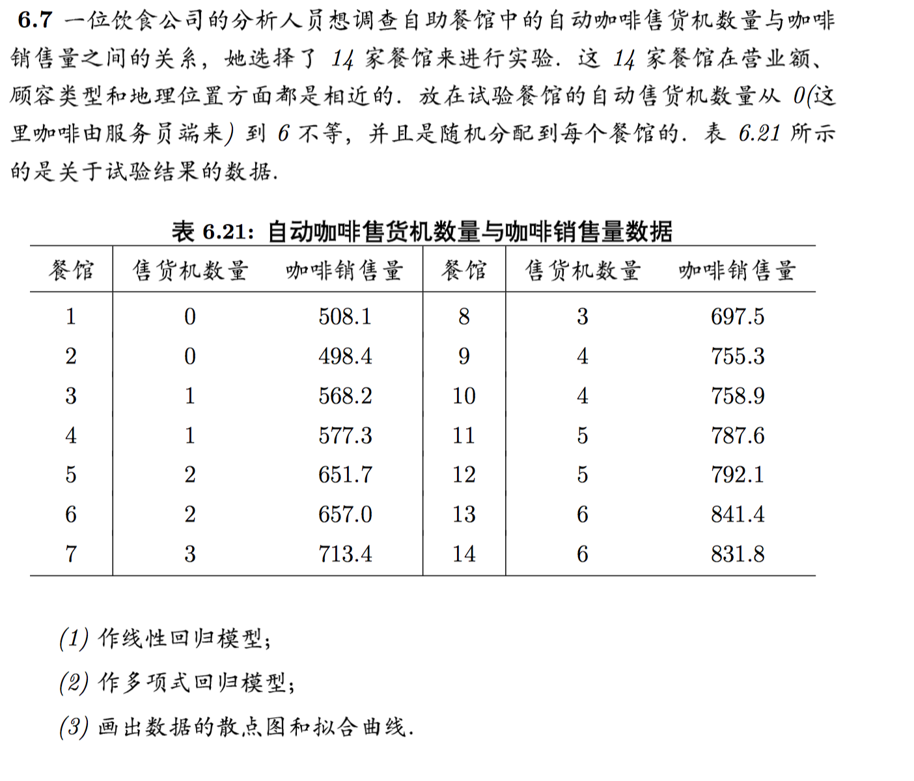
（1）
> x<-c(rep(0:6,rep(2,7)))
> y<-c(508.1,498.4,568.2,577.3,651.7,657.0,713.4,697.5,755.3,758.9,787.6,792.1,841.4,831.8)
> lm.sol<-lm(y~1+x)
> summary(lm.sol)

（2）
> lm.sol<-lm(y~1+x+I(x^2));summary(lm.sol)

(3)作散点图和拟合曲线：
> plot(x,y)
> xfit<-seq(0,6,0.01)
> yfit<-predict(lm.sol,data.frame(x=xfit))
> lines(xfit,yfit)
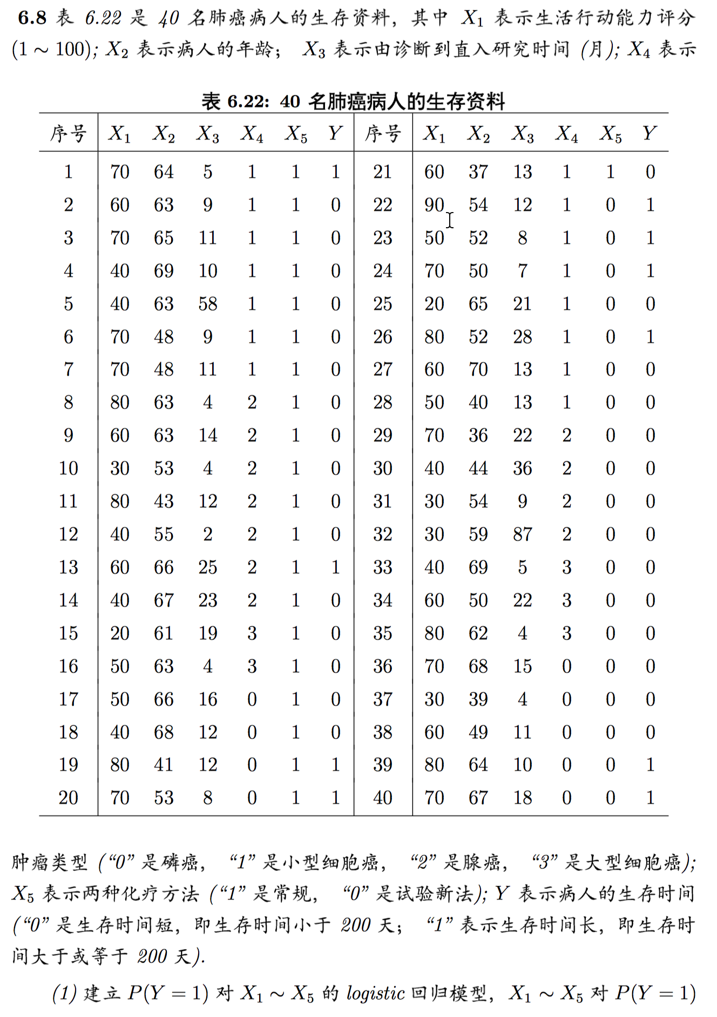

读入数据：
> cancer<-read.table("data",header=T)
> cancer
x1 x2 x3 x4 x5 y
1 70 64 5 1 1 1
2 60 63 9 1 1 0
3 70 65 11 1 1 0
4 40 69 10 1 1 0
5 40 63 58 1 1 0
6 70 48 9 1 1 0
7 70 48 11 1 1 0
8 80 63 4 2 1 0
9 60 63 14 2 1 0
10 30 53 4 2 1 0
11 80 43 12 2 1 0
12 40 55 2 2 1 0
13 60 66 25 2 1 1
14 40 67 23 2 1 0
15 20 61 19 3 1 0
16 50 63 4 3 1 0
17 50 66 16 0 1 0
18 40 68 12 0 1 0
19 80 41 12 0 1 1
20 70 53 8 0 1 1
21 60 37 13 1 1 0
22 90 54 12 1 0 1
23 50 52 8 1 0 1
24 70 50 7 1 0 1
25 20 65 21 1 0 0
26 80 52 28 1 0 1
27 60 70 13 1 0 0
28 50 40 13 1 0 0
29 70 36 22 2 0 0
30 40 44 36 2 0 0
31 30 54 9 2 0 0
32 30 59 87 2 0 0
33 40 69 5 3 0 0
34 60 50 22 3 0 0
35 80 62 4 3 0 0
36 70 68 15 0 0 0
37 30 39 4 0 0 0
38 60 49 11 0 0 0
39 80 64 10 0 0 1
40 70 67 18 0 0 1
>glm.sol<-glm(y~x1+x2+x3+x4+x5,family=binomial,data=cancer);
>summary(glm.sol)
>glm.new<-step(glm.sol)
>summary(glm.new)

