Spring 2022

Introduction to Artificial Intelligence

Homework 0

## Introduction

We suggest using the Python language to implement all programming assignments in this course. The purpose of this assignment is to help you get started with Python. We will not grade this assignment. Moreover, we will use the following exercises in your HW1.

## Setting up your environment

If you don’t have Python installed on your machine, we recommend [Google Colab](https://colab.research.google.com/).   
If you want to work on your own machine, we recommend installing [Anaconda](https://docs.anaconda.com/anaconda/install/) to manage your Python environments.

## Python tutorial

We suggest you follow this tutorial: <https://cs231n.github.io/python-numpy-tutorial/>

If you are familiar with Python, you can skip this part.

## Practice

### Exercise 1: Read an image

* Install any python packages which can read images.  
  e.g. Pillow, OpenCV
* Read their documentation to learn how to use functions.  
  e.g. imread

### Exercise 2: Read a text file and create a dictionary

* Read a text file. The text file contains information of categories and coordinates. The format is following by:

| category  category  ... |
| --- |

sample text file:

| cat 350 50 460 175  dog 500 60 630 200 |
| --- |

* Create a list of dictionaries to store the information from the text file.

e.g. [{'category': 'cat', 'coordinate': [350, 50, 460, 175]},   
 {'category': 'dog', 'coordinate': [500, 60, 630, 200]}]

### Exercise 3: Draw bounding boxes on faces and display categories

* Draw category text and box on the image. The coordinate is the top left corner of a bounding box. The coordinate is the bottom right corner.
* For Google Colab, you can get a result as follow:  
  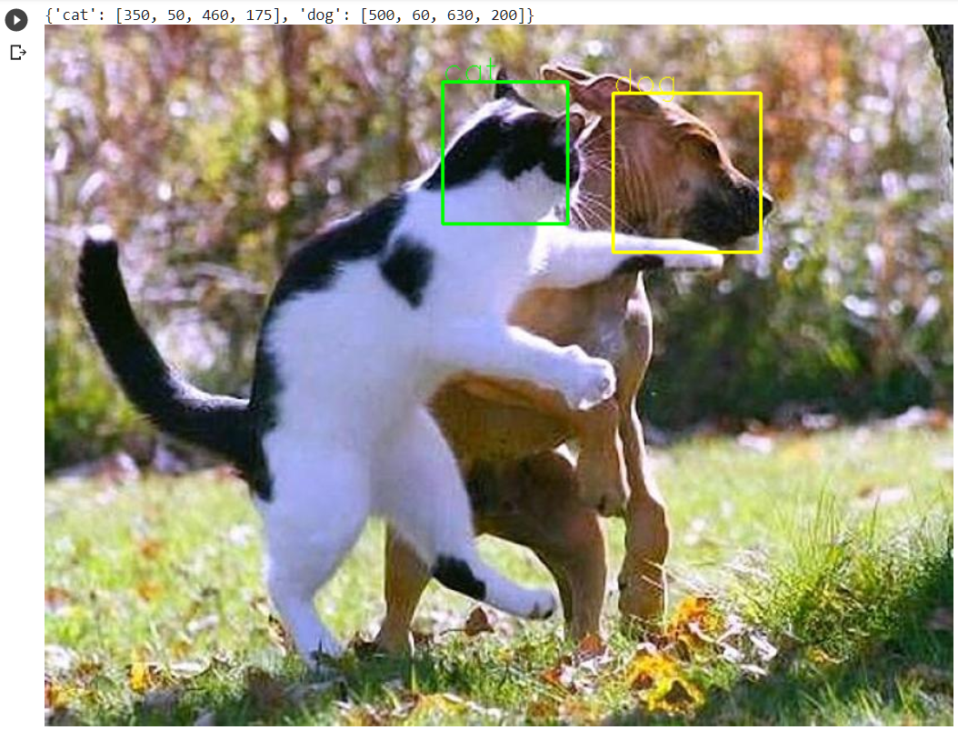

image:<https://assets.juksy.com/files/articles/89790/800x_100_w-5cbd414163b9e.jpg>

* You can get similar results if you run your code on your local machine.

### Exercise 4: Replicate the previous exercises with your own image!

## Submission

You do not have to submit this assignment.