class_4.R

Jg314

2025-01-16

x <- 1:50  
plot(x, sin(x))

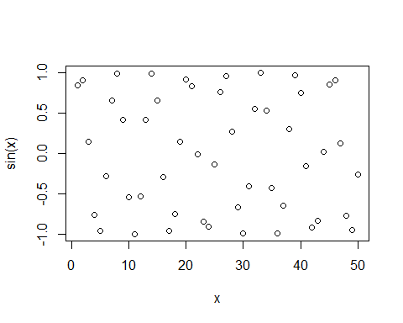

#make the plot nicer  
plot(x,sin(x),col='blue',type='l',lwd=3)

