Physical,Mental:

HIGHER, HIGHER:

->Workout:

-Zumba --Zumba is an exercise program that is based on dances and aerobic exercises, including movements of various musical styles, generally Latin American. These exercises are used to work different muscle groups, especially the arms, trunk, legs, buttocks, and back.

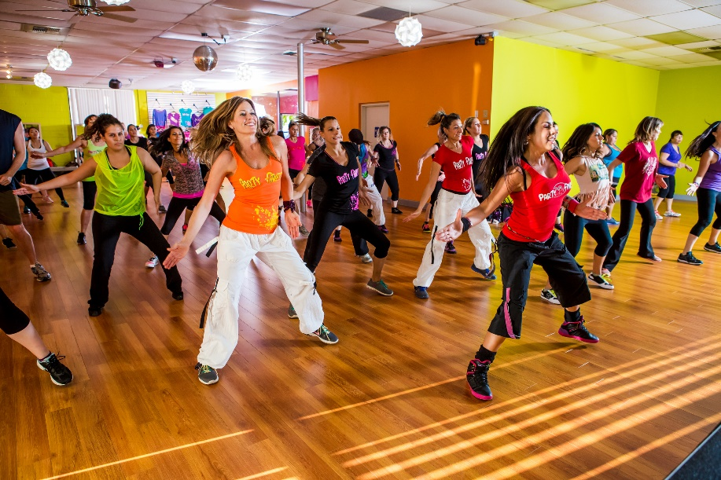

-Buti yoga—It is workout combines traditional yoga moves and tribal dance. The plyometric elements of a Buti Yoga class are cardio-intense as opposed to traditional yoga that offers a more zen approach.



-running if you can

Yoga poses:

-Surya Namaskara-- Surya Namaskara, done early morning on an empty stomach has rounds of Sun Salutation which consists of two sets, and **each set is composed of 12 yoga poses**.

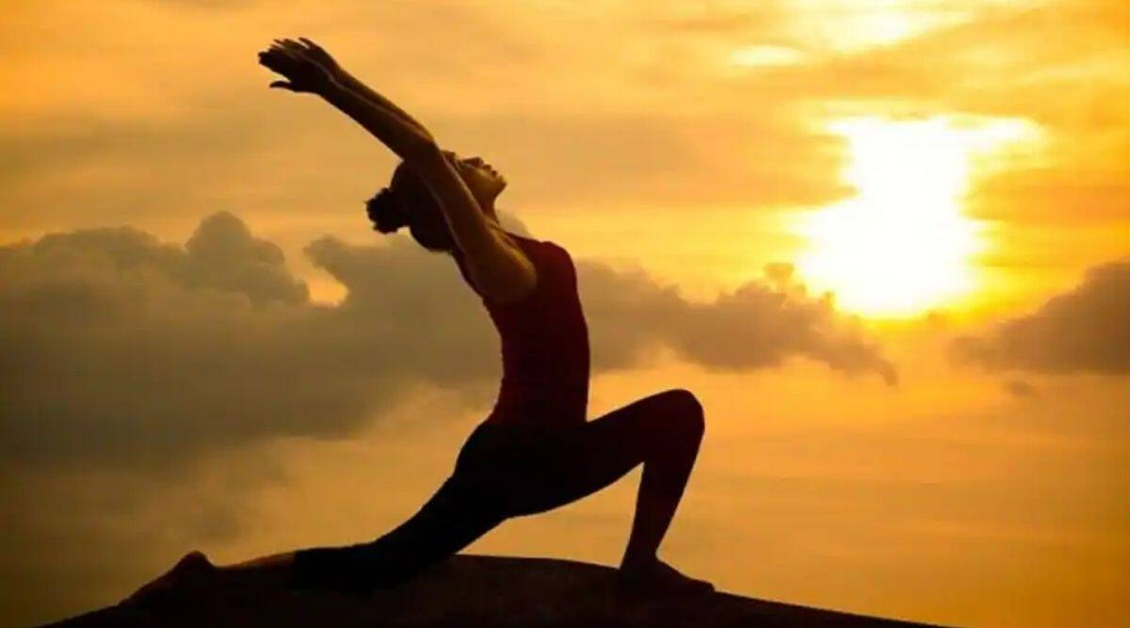

-Vajrasana-- Vajrasana pose is a simple sitting yoga pose. Breathing and meditative exercises are often done in this position, which is said to help your body become as strong as a diamond.

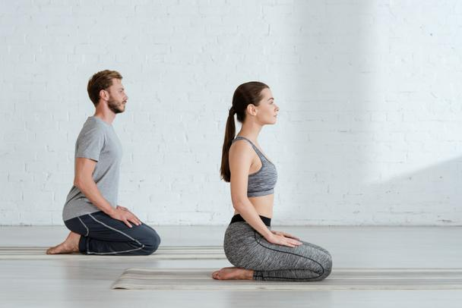

-Bhadrasana-- An excellent asana for meditation, Gracious Pose offers health benefits similar to those of Vajrasana (Thunderbolt Pose). Bhadrasana has many other benefits which one may experience on regular practice.

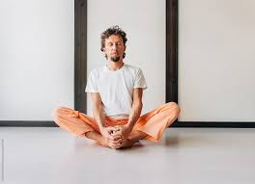

-bhujangasana-- Bhujangasana (Cobra Pose) is a heart-opening backbend that stretches your entire upper body and can provide relief if you’re experiencing back pain, tightness in your shoulders, or upper body soreness.

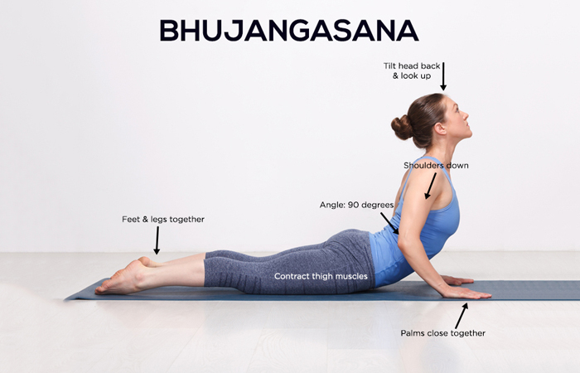

-sharvasana--Savasana helps relieve mild depression, high blood pressure, headaches, fatigue, and insomnia, according to Yoga Journal. Savasana can calm the nervous system and promote equanimity in your entire body.

Men high

Progressive relaxation--Progressive relaxation is a practice aimed at reducing tension in the body and promoting relaxation. Oftentimes, this form of meditation involves slowly tightening and relaxing one muscle group at a time throughout the body. In some cases, it may also encourage you to imagine a gentle wave flowing through your body to help release any tension. This form of meditation is often used to relieve stress and unwind before bedtime.

Visualization meditation--Visualization meditation is a technique focused on enhancing feelings of relaxation, peace, and calmness by visualizing positive scenes, images, or figures. This practice involves imagining a scene vividly and using all five senses to add as much detail as possible. It can also involve holding a beloved or honored figure in mind with the intention of embodying their qualities

Adjust sleep schedule

Start with a clear goal of improving yourself.

HIGHER,MEDIUM:

->Workout:

-Zumba --Zumba is an exercise program that is based on dances and aerobic exercises, including movements of various musical styles, generally Latin American. These exercises are used to work different muscle groups, especially the arms, trunk, legs, buttocks, and back.



-Buti yoga—It is workout combines traditional yoga moves and tribal dance. The plyometric elements of a Buti Yoga class are cardio-intense as opposed to traditional yoga that offers a more zen approach.



-running if you can

Yoga poses:

-Surya Namaskara-- Surya Namaskara, done early morning on an empty stomach has rounds of Sun Salutation which consists of two sets, and **each set is composed of 12 yoga poses**.



-Vajrasana-- Vajrasana pose is a simple sitting yoga pose. Breathing and meditative exercises are often done in this position, which is said to help your body become as strong as a diamond.



-Bhadrasana-- An excellent asana for meditation, Gracious Pose offers health benefits similar to those of Vajrasana (Thunderbolt Pose). Bhadrasana has many other benefits which one may experience on regular practice.



-bhujangasana-- Bhujangasana (Cobra Pose) is a heart-opening backbend that stretches your entire upper body and can provide relief if you’re experiencing back pain, tightness in your shoulders, or upper body soreness.



-sharvasana--Savasana helps relieve mild depression, high blood pressure, headaches, fatigue, and insomnia, according to Yoga Journal. Savasana can calm the nervous system and promote equanimity in your entire body.

Motivational podcasts

Transcendental meditation--Transcendental Meditation (TM) is a type of meditation that’s been the subject of numerous studies in the scientific community. refers to a specific practice designed to quiet the mind and induce a state of calm and peace. It involves the use of mantra and is best taught by a certified TM practitioner. This practice is for those who want an accessible approach to the depth that meditation offer.

Adjust sleep schedule if required

HIGHER,LOW: ->Workout:

-Zumba --Zumba is an exercise program that is based on dances and aerobic exercises, including movements of various musical styles, generally Latin American. These exercises are used to work different muscle groups, especially the arms, trunk, legs, buttocks, and back.



-Buti yoga—It is workout combines traditional yoga moves and tribal dance. The plyometric elements of a Buti Yoga class are cardio-intense as opposed to traditional yoga that offers a more zen approach.



-running if you can

Yoga poses:

-Surya Namaskara-- Surya Namaskara, done early morning on an empty stomach has rounds of Sun Salutation which consists of two sets, and **each set is composed of 12 yoga poses**.



-Vajrasana-- Vajrasana pose is a simple sitting yoga pose. Breathing and meditative exercises are often done in this position, which is said to help your body become as strong as a diamond.



-Bhadrasana-- An excellent asana for meditation, Gracious Pose offers health benefits similar to those of Vajrasana (Thunderbolt Pose). Bhadrasana has many other benefits which one may experience on regular practice.



-bhujangasana-- Bhujangasana (Cobra Pose) is a heart-opening backbend that stretches your entire upper body and can provide relief if you’re experiencing back pain, tightness in your shoulders, or upper body soreness.



-sharvasana--Savasana helps relieve mild depression, high blood pressure, headaches, fatigue, and insomnia, according to Yoga Journal. Savasana can calm the nervous system and promote equanimity in your entire body.

Meditate daily

MEDIUM,HIGH:

Workout:

Phy med

-Bokwa--Bokwa is a cardio-licious blend of hip-hop and step aerobics that taps into South African-style dance.The movements are in the shape of English-language letters, for example L, J, and C. Once dancers have the steps down, they can jazz it up with extra shimmies, hip bumps, or other freestylin’ moves.

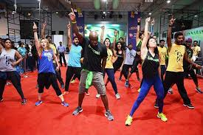

-Jazzecise--Jazzercise is a pulse-pounding, beat-pumping, body-blasting fitness program that gets you results…fast. It's a high intensity dance party that fuses cardio, strength, Pilates, hip hop, yoga and kickboxing. Burn up to 800 calories per hour in any of our 60 minute classes.



-If u can cardio/swimming

Yoga poses:

-Surya Namaskara-- Surya Namaskara, done early morning on an empty stomach has rounds of Sun Salutation which consists of two sets, and **each set is composed of 12 yoga poses**.



-Utkatasana—Utkatasana, Chair Pose or fierce pose is a standing asana in modern yoga as exercise.  The Utkatasana stimulates the heart, diaphragm, and abdominal organs.

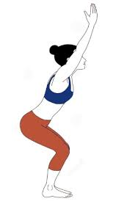

-Utthita Parsvakonasana--Utthita Parsvakonasana (Extended Side Angle Pose) is all about the extension: in your arms, your legs, and your stance. Extended Side Angle Pose is a reminder that our practices are fluid yet firm, playful yet particular—we flow through the movements while remaining strong in the postures.



-Virabhadrasana III--Warrior III adds a balance challenge to the standing Warrior sequence of yoga poses. It's an energizing pose that can help you build lower body and core strength, but also mental focus.

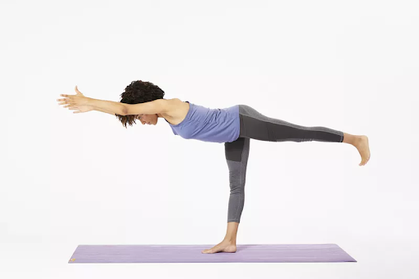

Progressive relaxation--Progressive relaxation is a practice aimed at reducing tension in the body and promoting relaxation. Oftentimes, this form of meditation involves slowly tightening and relaxing one muscle group at a time throughout the body. In some cases, it may also encourage you to imagine a gentle wave flowing through your body to help release any tension. This form of meditation is often used to relieve stress and unwind before bedtime.

Visualization meditation--Visualization meditation is a technique focused on enhancing feelings of relaxation, peace, and calmness by visualizing positive scenes, images, or figures. This practice involves imagining a scene vividly and using all five senses to add as much detail as possible. It can also involve holding a beloved or honored figure in mind with the intention of embodying their qualities

Adjust sleep schedule

Start with a clear goal of improving yourself.

MEDIUM,MEDIUM:

Workout:

Phy med

-Bokwa--Bokwa is a cardio-licious blend of hip-hop and step aerobics that taps into South African-style dance.The movements are in the shape of English-language letters, for example L, J, and C. Once dancers have the steps down, they can jazz it up with extra shimmies, hip bumps, or other freestylin’ moves.



-Jazzecise--Jazzercise is a pulse-pounding, beat-pumping, body-blasting fitness program that gets you results…fast. It's a high intensity dance party that fuses cardio, strength, Pilates, hip hop, yoga and kickboxing. Burn up to 800 calories per hour in any of our 60 minute classes.



-If u can cardio/swimming

Yoga poses:

-Surya Namaskara-- Surya Namaskara, done early morning on an empty stomach has rounds of Sun Salutation which consists of two sets, and **each set is composed of 12 yoga poses**.



-Utkatasana—Utkatasana, Chair Pose or fierce pose is a standing asana in modern yoga as exercise.  The Utkatasana stimulates the heart, diaphragm, and abdominal organs.



-Utthita Parsvakonasana--Utthita Parsvakonasana (Extended Side Angle Pose) is all about the extension: in your arms, your legs, and your stance. Extended Side Angle Pose is a reminder that our practices are fluid yet firm, playful yet particular—we flow through the movements while remaining strong in the postures.



-Virabhadrasana III--Warrior III adds a balance challenge to the standing Warrior sequence of yoga poses. It's an energizing pose that can help you build lower body and core strength, but also mental focus.



Men med

Motivational podcasts

Transcendental meditation--Transcendental Meditation (TM) is a type of meditation that’s been the subject of numerous studies in the scientific community. refers to a specific practice designed to quiet the mind and induce a state of calm and peace. It involves the use of mantra and is best taught by a certified TM practitioner. This practice is for those who want an accessible approach to the depth that meditation offer.

Adjust sleep schedule if required

MEDIUM, LOW:

Workout:

Phy med

-Bokwa--Bokwa is a cardio-licious blend of hip-hop and step aerobics that taps into South African-style dance.The movements are in the shape of English-language letters, for example L, J, and C. Once dancers have the steps down, they can jazz it up with extra shimmies, hip bumps, or other freestylin’ moves.



-Jazzecise--Jazzercise is a pulse-pounding, beat-pumping, body-blasting fitness program that gets you results…fast. It's a high intensity dance party that fuses cardio, strength, Pilates, hip hop, yoga and kickboxing. Burn up to 800 calories per hour in any of our 60 minute classes.



-If u can cardio/swimming

Yoga poses:

-Surya Namaskara-- Surya Namaskara, done early morning on an empty stomach has rounds of Sun Salutation which consists of two sets, and **each set is composed of 12 yoga poses**.



-Utkatasana—Utkatasana, Chair Pose or fierce pose is a standing asana in modern yoga as exercise.  The Utkatasana stimulates the heart, diaphragm, and abdominal organs.



-Utthita Parsvakonasana--Utthita Parsvakonasana (Extended Side Angle Pose) is all about the extension: in your arms, your legs, and your stance. Extended Side Angle Pose is a reminder that our practices are fluid yet firm, playful yet particular—we flow through the movements while remaining strong in the postures.



-Virabhadrasana III--Warrior III adds a balance challenge to the standing Warrior sequence of yoga poses. It's an energizing pose that can help you build lower body and core strength, but also mental focus.



Meditate daily

LOW HIGH:

Workout:

Phy Low

-Keep up with the good work

Yoga Poses:

-Surya Namaskara-- Surya Namaskara, done early morning on an empty stomach has rounds of Sun Salutation which consists of two sets, and **each set is composed of 12 yoga poses**.



Progressive relaxation--Progressive relaxation is a practice aimed at reducing tension in the body and promoting relaxation. Oftentimes, this form of meditation involves slowly tightening and relaxing one muscle group at a time throughout the body. In some cases, it may also encourage you to imagine a gentle wave flowing through your body to help release any tension. This form of meditation is often used to relieve stress and unwind before bedtime.

Visualization meditation--Visualization meditation is a technique focused on enhancing feelings of relaxation, peace, and calmness by visualizing positive scenes, images, or figures. This practice involves imagining a scene vividly and using all five senses to add as much detail as possible. It can also involve holding a beloved or honored figure in mind with the intention of embodying their qualities

Adjust sleep schedule

Start with a clear goal of improving yourself.

LOW MEDIUM:

Workout:

Phy Low

-Keep up with the good work

Yoga Poses:

-Surya Namaskara-- Surya Namaskara, done early morning on an empty stomach has rounds of Sun Salutation which consists of two sets, and **each set is composed of 12 yoga poses**.



Motivational podcasts

Transcendental meditation--Transcendental Meditation (TM) is a type of meditation that’s been the subject of numerous studies in the scientific community. refers to a specific practice designed to quiet the mind and induce a state of calm and peace. It involves the use of mantra and is best taught by a certified TM practitioner. This practice is for those who want an accessible approach to the depth that meditation offer.

Adjust sleep schedule if required

LOW,LOW:

Workout:

Phy Low

-Keep up with the good work

Yoga Poses:

-Surya Namaskara-- Surya Namaskara, done early morning on an empty stomach has rounds of Sun Salutation which consists of two sets, and **each set is composed of 12 yoga poses**.



Low med

Meditate daily