Table of Contents
Document Version 2
1. Purpose 3
1.1. Intended Audience 3
1.2. Intended Use 3
1.3. Scope 3
1.4. Definitions and Acronyms 3
2. Overall System Description 4
2.1. Use Case Diagrams 4
2.2. System Architecture 5
2.3. Functional Requirements 6
2.3.1. Function xxxx 6
2.3.2. Function yyyy 7
2.3.3. Function zzzz 7
3.1. Non-Functional Requirements 8
3.1.1. Non-Functional Requirement xxxx 8
4. Software Architecture 9
4.1. Static Software Architecture 9

Document Version
No | Update | Name | Date | Version
1. | Initial version |  |  | 1.0

Purpose

Intended Audience
This SRS document describes the System Requirements and Software Design for a Smart Fire Alert system, and the target audience are System and Software Engineers working on the development of this project.

Intended Use
The SRS defines the overall System Architecture and Requirements as well as the Software Architecture and Design. This document also contains the definition of the System Requirements which shall be used as the input for System Test cases and Software Unit Test cases.

Scope
The Smart Fire Alert System is designed to detect potential fire hazards and provide timely emergency alerts, particularly for elderly individuals living alone. The system supports both automatic and manual alarm activation. Upon detecting a fire, it activates safety devices and sends emergency notifications via Telegram. Sensor readings are also uploaded to ThingSpeak for remote monitoring

Definitions and Acronyms

Acronym | Description
LCD | Liquid Crystal Display
LED | Light Emitting Diode
LDR | Light Dependent Resistor

Overall System Description

Use Case Diagrams
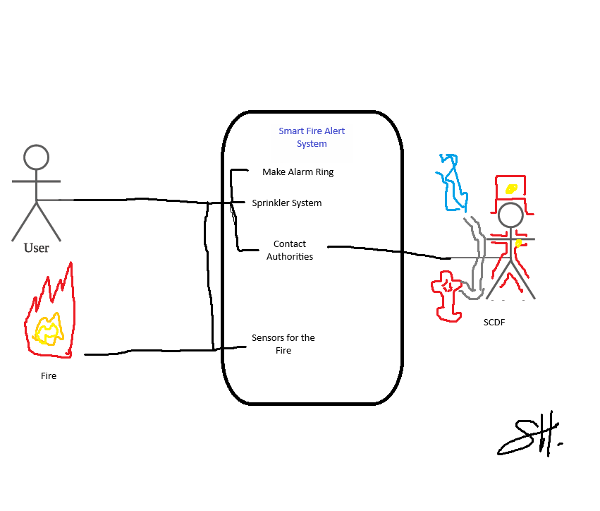

System Architecture
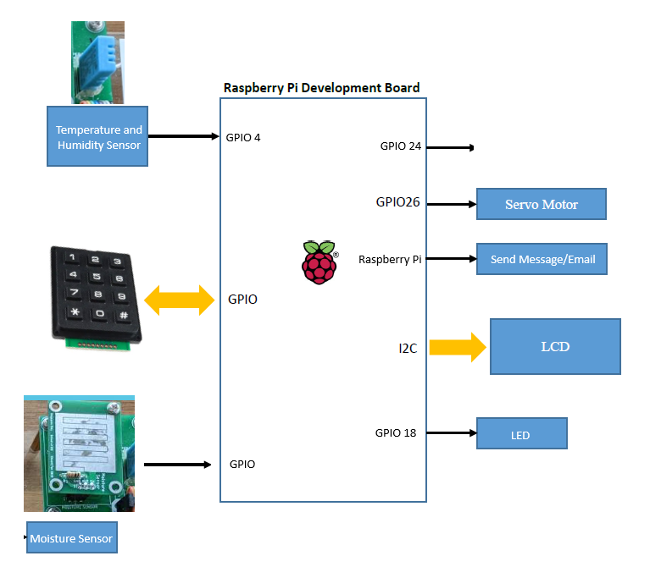

Functional Requirements

System startup and LCD display
This specifies how the system transitions from the “Sleep State” to the “Awake State” and the LCD status displayed once initialisation is complete.
REQ_ID | Requirement
REQ-01 | The system shall remain in the “Sleep State” until the slide switch is slid to the right. The system shall then transition to the “Awake State”.
REQ-02 | When the system is in “Awake State”, LCD shall display:  Line 1: “System ready :)“

Alarm activation modes
This defines the conditions under which the system shall activate the emergency response. The system supports both automatic and manual activation.
REQ_ID | Requirement
REQ-03 | Automatic Activation:  The system shall activate the Emergency Response (Section 2.3.3) when either of the following conditions is met:  - The temperature sensor detects a temperature of 60°C or higher.  - The LDR detects a significant reduction in light intensity, indicating that the sensor is obstructed by smoke.
REQ-04 | Manual Activation:  The system shall activate the Emergency Response (Section 2.3.3) upon receiving the "995" command from the Telegram chat.

Emergency response
This defines the actions performed by the system when an emergency is detected.
REQ_ID | Requirement
REQ-06 | Upon entering the Emergency response state, the system shall activate the buzzer.
REQ-07 | The system shall send a simulated emergency notification, “Fire detected!” via Telegram to the house owner, caregiver and SCDF.
REQ-08 | The system shall turn on the red LED to provide a visual indication of the emergency.
REQ-09 | The system shall activate the servo motor to operate as a water sprinkler to tame the fire while waiting for SCDF to arrive at the house.
REQ-08 | The LCD shall display an emergency message:  Line 1: “FIRE DETECTED!”  Line 2: “EVACUATE NOW”

System recovery
This defines the conditions required for the system to exit the Emergency response state and resume normal operation.
REQ_ID | Requirement
REQ-09 | The system shall use a temperature sensor to continuously monitor temperature in the surroundings.
REQ-10 | The system shall use a moisture sensor to continuously monitor moisture in the surroundings.
REQ-11 | The system shall transition to the “Awake State” only when both of the following conditions are met:  - The temperature sensor detects a temperature below 50°C.  - The moisture sensor detects the presence of water, indicating that the sprinkler has been activated.
REQ-12 | Upon transitioning to the “Awake State”, the system shall:  - Deactivate the buzzer.  - Turn off the red LED.  - Stop the servo motor that acts as a water sprinkler
REQ-13 | The LCD display shows the following message  Line1= “Fire is out”

False alarm
This defines the procedure for deactivating the Emergency response state when the user determines that the alarm was triggered falsely.
REQ_ID | Requirement
REQ-14 | In the event of a false alarm, user shall enter the code ‘123’ on the keypad to deactivate the emergency response state (2.3.3).
REQ-15 | Once the user enters the code, the system shall deactivate the following and transition to the “Awake State”:  - Buzzer  - Red LED  - Servo motor that acts as a water sprinkler
REQ-16 | Upon successful deactivation, the LCD shall display:  Line1 = “False alarm! “  Line2 =” “Alarm deactivated”

System Automatic Log Updater
This defines the automatic logging of alarm events to ThingSpeak for monitoring and record-keeping purposes.
REQ_ID | Requirement
REQ-17 | Upon deactivation of an alarm or false alarm, the system shall upload the alarm duration and the recorded temperature data to the ThingSpeak platform via the Wi-Fi module.
REQ-18

Non-Functional Requirements

Performance
The performance requirements define the maximum response time for the Smart Fire Alert System to react to different events. The requirements are defined in the table below.
REQ_ID | Requirement
NFR-01 | The system shall complete startup within 2 seconds after the power switch is turned on.
NFR-02 | The sprinkler shall activate within 3 seconds after the alarm is triggered.
NFR-03 | The LCD display shall update within 1 second after the alarm is triggered or deactivated.
NFR-04 | The LED indicator shall update within 1 second after the alarm is triggered or deactivated.
NFR-05 | The Telegram notification shall be sent to owners, caregivers and the SCDF within 5 seconds after the alarm is triggered.
NFR-06 | Fire is considered extinguished only when both of the following conditions are met continuously for at least 5 seconds:  - The temperature sensor detects a temperature below 50°C.  - The moisture sensor detects the presence of water.
NFR-07 | Upon detecting that fire has been extinguished, the alarm shall be deactivated within 3 seconds.

2.4.2 Data monitoring and logging
The Smart Fire Alert System continuously uploads sensor readings to ThingSpeak for remote monitoring. The requirement is defined below.
REQ_ID | Requirement
NFR-08 | The Smart Fire Alert System shall upload sensor readings to ThingSpeak every 15 seconds.

Software Architecture

Static Software Architecture

The Software Architecture defines the various Software Components that are developed to realize the implementation of the system requirements.

Application Layer

Hardware Abstraction Layer (HAL)

Sprint Planning
Week | Sprint | Sprint Goal | Deliverables | Github Release
1 | - | Form Scrum Team
2 | 1 | Work On SRS Document | Finish Purpose | -
3
4 | 2 |  | Finish Overall System Description
5
6 | 3 |  | Finish Software Architecture
7
8 | MST
9 - 11 |  | Submit SRS Document | Finish Listing Functional and Non – Functional  Requirements | -
12 | 4 | Work on Functional Requirements | Finished Functional Requirements | V1.0
13
14 | 5 | Work on Non-Functional Requirements | Finished Non-Functional Requirements | V2.0
15
16 | 6 | Combine Code and Test | Finished combining code and PyTest | V3.0
17
18 | Final Demo

