TAMIL NADU'S QUIET SECRET
How a Single State in India Keeps Peace Between Hindus and Muslims
By Selva Ganesh K
mysticquill.blogspot.com
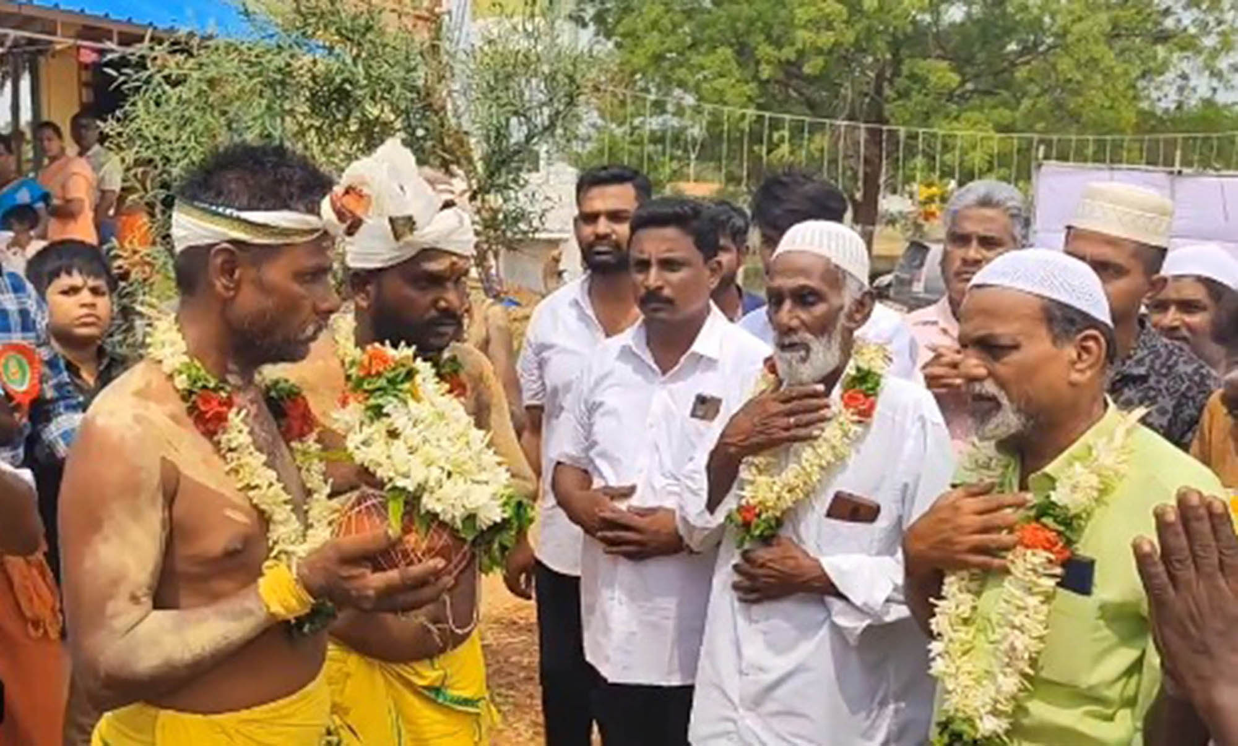
Tamil Nadu — A Hindu-majority state with one of India's lowest rates of communal violence against minorities.
In current times, we hear a lot about communal violence from every part of our planet. As far-right ideology grows, many minorities feel threatened over race, culture and religion — a world where one community dominates another through supremacist mentality. Even in India, whose national motto is "Unity in Diversity," communal violence between Hindus and Muslims is rising.

From chanting "Jai Shree Ram" inside mosques — an act the Karnataka High Court declined to prosecute, a decision now being challenged in the Supreme Court — to a BJP candidate mimicking shooting an arrow at a mosque during the Hyderabad elections, communal tensions continue to grow.

But there is a state in southern India that tells a different story.
Tamil Nadu, home to one of the world's oldest languages, has a unique culture. Despite being a Hindu majority state — with over 80% of its population Hindu and the highest number of temples in the country — it has one of the lowest recorded rates of communal violence against minorities in India.

How Islam Reached and Flourished in Ancient Tamilagam

The ancient Tamil Nadu coastline — where Arab traders first arrived in the 7th century, carrying horses, camels and precious stones.
Islam reached the ancient Tamilagam coast in the 7th century — earlier than it reached many countries that are Muslim majority today. Arab traders came to the region carrying horses, camels and precious stones, exchanging them for spices, gold and pearls. That is how Islam was introduced to this region.

In the beginning, there was a language barrier between Arabic-speaking traders and Tamil-speaking locals. So they created something remarkable — a hybrid language that both communities could understand. That language is Arabu-Tamil, and it exists even today. The interesting thing is that this hybrid language contains original Tamil words that are no longer used by most Tamils — preserved only within Tamil Muslim communities.

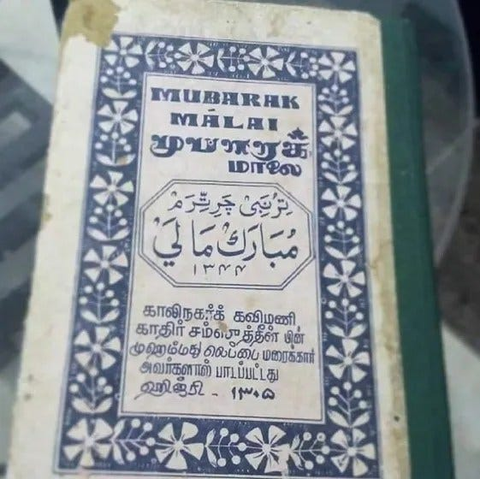
Arabu-Tamil script — a hybrid language born from 1,400 years of shared history between Arab traders and Tamil-speaking communities.
Even the famous Ibn Khordadbeh, one of the greatest geographers of the Abbasid Caliphate, documented this connection. In his book Kitāb al Masālik w'al Mamālik (Book of Roads and Kingdoms), he described how rich and wealthy the south Indian kingdoms were — proof that Arab and Muslim traders knew about ancient Tamilagam even during the Abbasid Caliphate itself. The Arab traders who chose to settle on Tamil Nadu's coastal regions made a meaningful decision: they learned Tamil.

Islam arrived in Tamil Nadu before it reached many Muslim-majority nations today — and it arrived not through conquest, but through commerce and conversation.

How Tamil United Muslims and Hindus
Despite having no prior knowledge of Tamil, Arab settlers came to love the language — while still giving importance to Arabic. Even the great Umaru Pulavar wrote the famous Seerapuranam entirely in Tamil. This epic biography of the Prophet Muhammad, written in the Tamil language, stands as a contribution to both Islamic tradition and Tamil literary heritage.

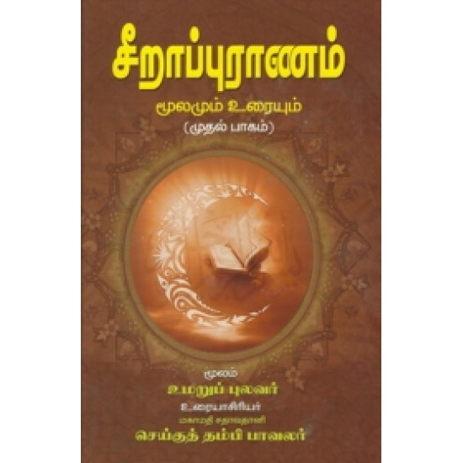
Seerapuranam — Umaru Pulavar's epic biography of the Prophet Muhammad, written entirely in Tamil. A testament to the fusion of Islamic faith and Tamil identity.
Even today, many Muslims from Tamil Nadu are proud to call Tamil their mother tongue. Tamil Muslims have always been proud of their language. They fought for Tamil in the Anti-Hindi Agitation — and historical records confirm that Tamil-speaking Muslims supported the agitation while Urdu-speaking Muslims from the north did not.

Quaid-e-Millath Muhammad Ismail Sahib fought for Tamil to be recognized as an official language. Dewan Bahadur Kalifulla Sahib, a Muslim League member, declared proudly in the Legislative Assembly that his mother tongue was Tamil and not Urdu. Abdul Rauf even sacrificed his life for Sri Lankan Tamils.

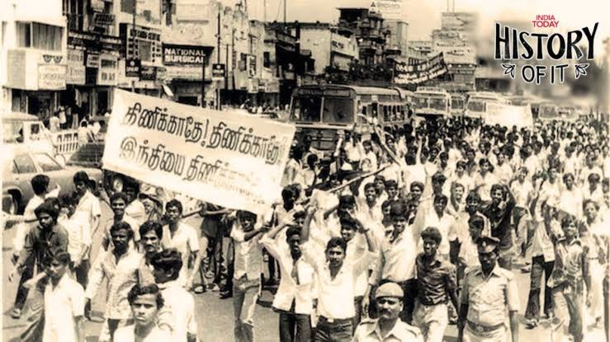
The Anti-Hindi Agitation — Tamil Muslims stood alongside Tamil Hindus in defense of their shared language, Tamil.
Tamil was not just a language to Tamil Muslims. It was identity. It was home.
Muslims and Tamils in Tamil Nadu Today
Communal violence is currently rising all over the world, and India is no exception. Due to far-right politics and Hindutva ideology, violence against Muslims, Christians and other minorities is increasing. But the state of Tamil Nadu continues to be an exception — where Tamil Hindus and Tamil Muslims live like brothers and sisters.

Even if you spend just a short time in Tamil Nadu, you will notice it. The way communities share everything during festivals. The way neighbors help each other without being asked. Even during the Jallikattu protests, Muslims stood alongside Hindus and fought for Jallikattu — because it is a proud moment for every Tamil, regardless of religion.

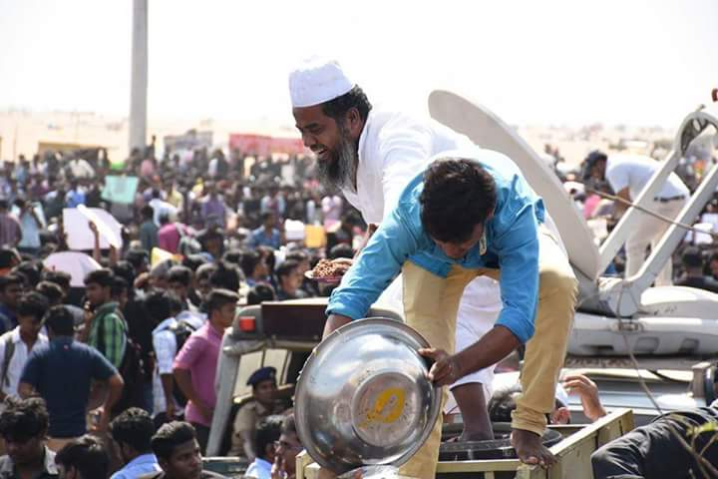
The Jallikattu protests — Muslims and Hindus stood together, united as Tamils, in one of modern Tamil Nadu's most powerful displays of communal solidarity.
I am a Tamil Hindu, born in the southern districts of Tamil Nadu. I have more Muslim friends than Hindu friends. They treated me as one of their own family members. They helped me during my toughest times. I hope Allah gives peace to them and everything they wish for.

Right now, some violence against minorities is beginning to increase even in Tamil Nadu. I hope it will not continue. I hope Hindus and Muslims here continue to live as brothers and sisters — the way they always have.

What the World Can Learn
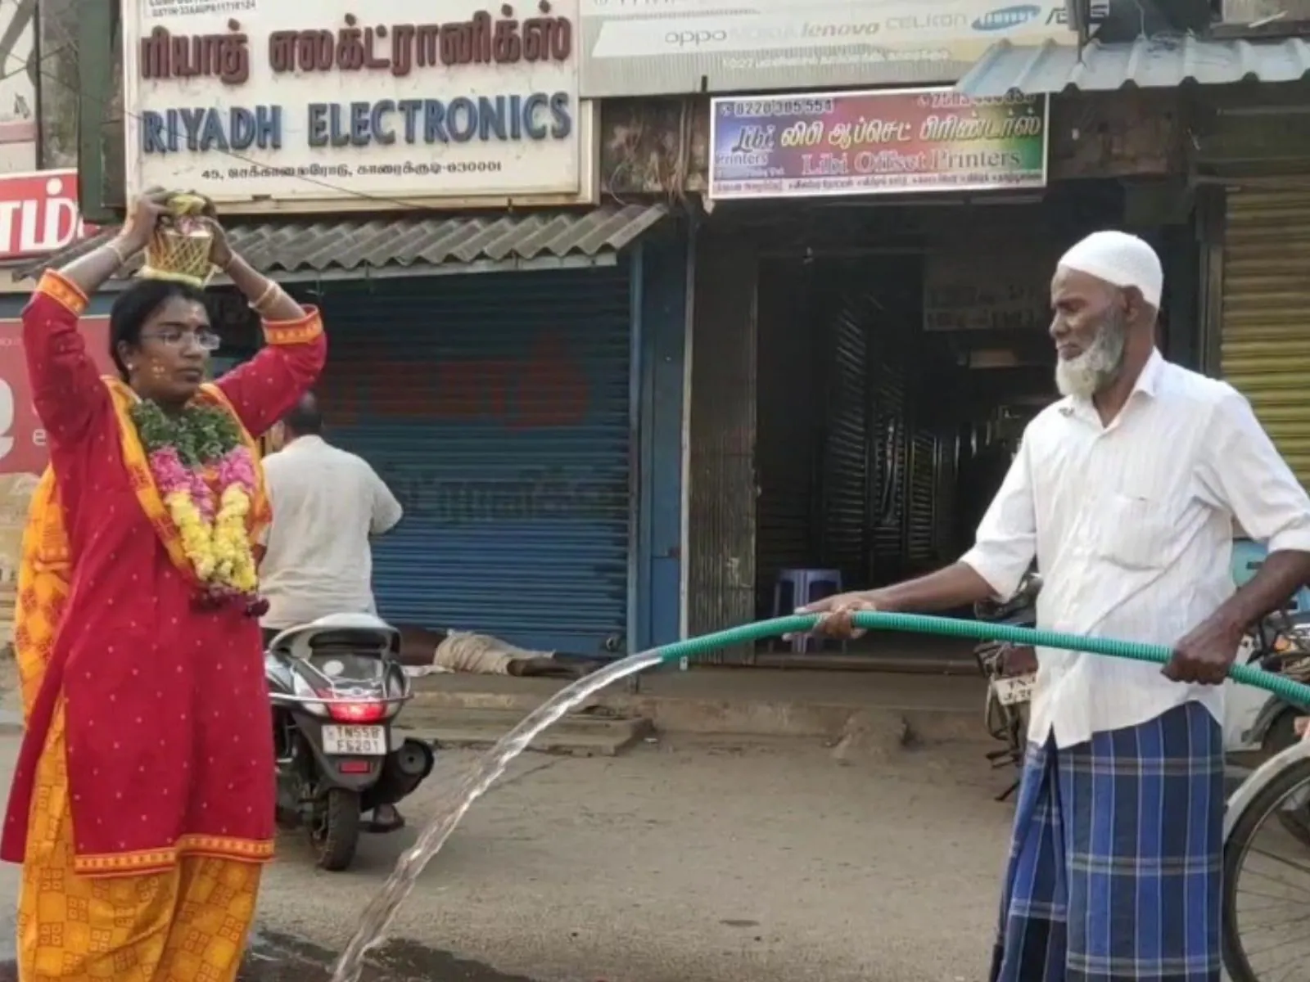
Tamil Nadu — 1,400 years of coexistence, not through policy alone, but through shared language, shared identity, and shared life.
Tamil Nadu's story is not just a regional story. It is a lesson for the world.

When people share a language, they share identity. When they share identity, they share life. Tamil Nadu did not achieve its communal harmony through government policy alone — it achieved it through 1,400 years of living together, trading together, and speaking the same language.

In a country increasingly asking what it means to be Indian, Tamil Nadu has been quietly living the answer for fourteen centuries.

