Assignment 1
File Creation Task

Task 1
Create a directory called ""my_folder"", navigate into it, and create a file named ""my_file.txt"" with some text. Then, create another file named ""another_file.txt"" with some text. Concatenate the content of ""another_file.txt"" to ""my_file.txt"" and display the updated content. Finally, list all files and directories in the current directory.

Solution 1:
The directory my_folder is created using the following command:
$ mkdir my_folder
To navigate into the folder the following command is used:
$ cd my*
NOTE: Using pattern matching in the command to avoid typing the complete folder name and save time.
The below screenshot shows the evidence.
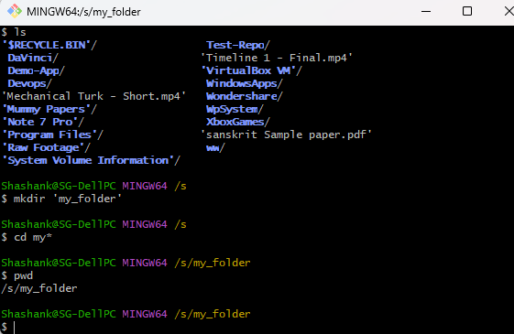

Creating a file my_file.txt using the following command and entering text in it.
$ cat > my_file.txt
This is the content in my_file.txt
Saving the file and showing the text file using the following command:
$ cat my_file.txt

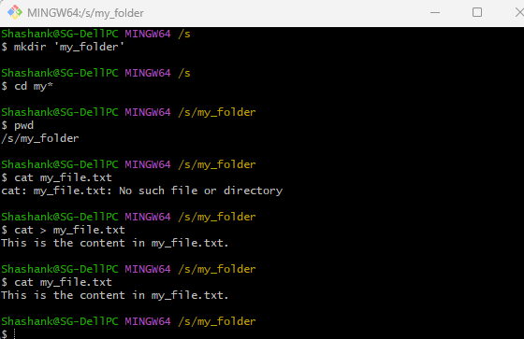

Creating the second file “another_file.txt” and entering text and saving it, using the following command:
$ cat > another_file.txt
This is the content in another_file.txt.

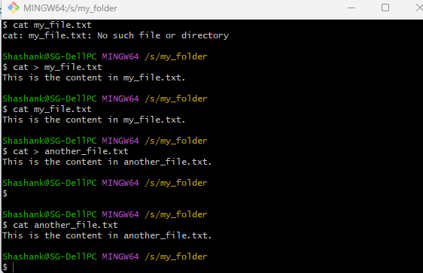
Showing the second file using the following command:
$ cat another_file.txt
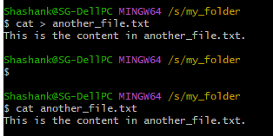
Concatenating the content of another_file.txt into my_file.txt using the following command:
$ cat another_file.txt >> my_file.txt
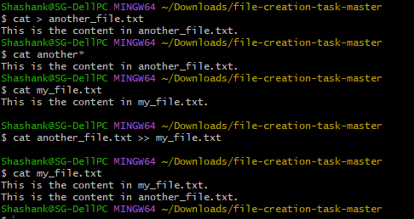
Listing all the files in the current directory using the following command.
$ ls -lart
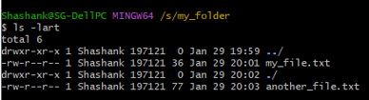

Task 2:
Create 20 files with .txt extensions and rename the first 5 files to .yml extension and Print the latest created top 5 files among the total no of files".
Solution 2:
Creating 20 files with .txt extension using the following command:
$ touch file{1..20}.txt
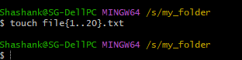
Listing all the created files using the following command:
$ ls -lart
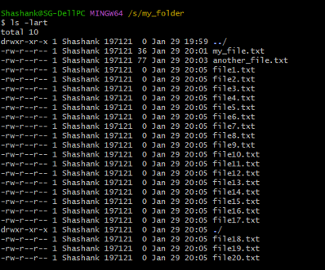
Renaming the first file to change the extension from .txt to .yml using the following command:
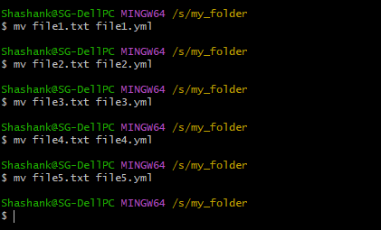
$ mv file1.txt file1.yml
$ mv file2.txt file2.yml
$ mv file3.txt file3.yml
$ mv file4.txt file4.yml
$ mv file5.txt file5.yml

Listing the top file updated files out of all files present in the directory using the following command:
$ ls -lart | grep yml

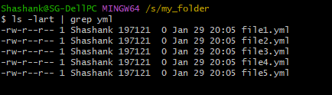

Submission:
As instructed in the assignment document, the submission has to be made via GitHub Repository.
Therefore, the following screenshot demonstrates the submission process followed by me.

Using the following commands to initialise git, add remote origin and add the files to the staging area.

$ git init
$ git remote add origin https://github.com/shgupta140-max/file-creation-task.git
$ git add .
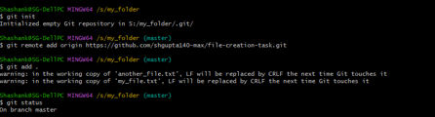

Showing the files added in the staging area using the following command:
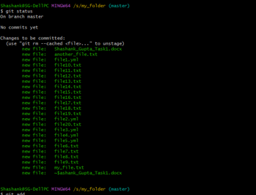
$ git status

The following command commits the changes in the git repo, using the following command:
$ git commit -m “This is the first commit to store the files on repo”
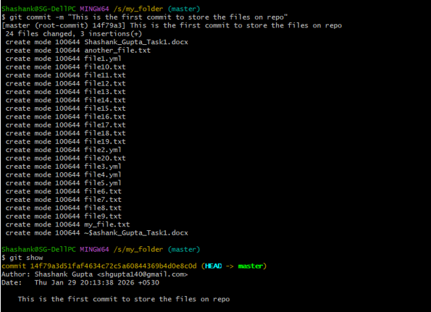

And in the end running the $ git show command to show the commit status and comment.
NOTE: The Git module has not yet been covered in the course. I completed this submission based on my own understanding. Since Git has not officially been taught, I request that Git commands and the submission process not be considered as part of the evaluation for this task.

Special Comment: I hope this time my work reflects a better understanding and improved effort.

