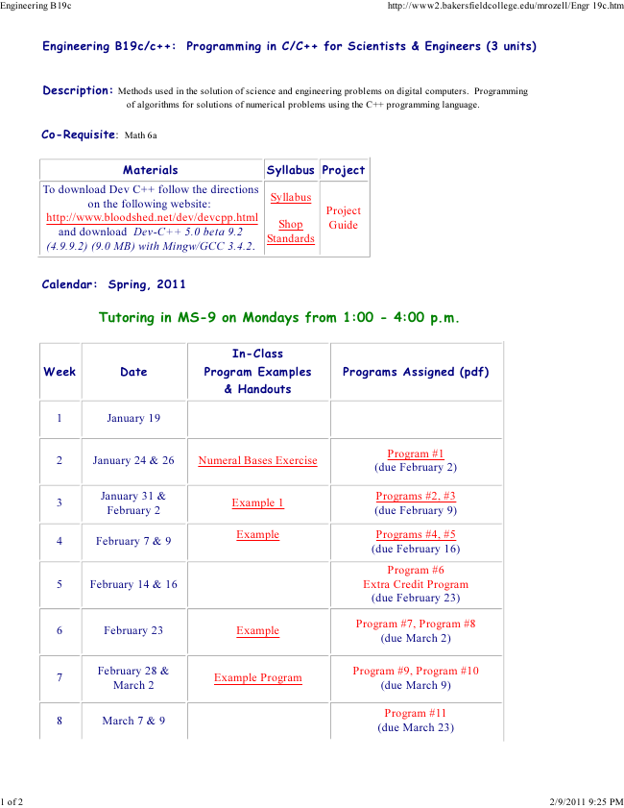

Engineering B19c http://www2.bakersfieldcollege.edu/mrozell/Engr 19c.htm

Engineering B19c/c++: Programming in C/C++ for Scientists & Engineers (3 units)

Description: Methods used in the solution of science and engineering problems on digital computers. Programming

of algorithms for solutions of numerical problems using the C++ programming language.

Co-Requisite: Math 6a

Materials Syllabus Project To download on the Dev following C++ follow website:

the directions

Syllabus

http://www.bloodshed.net/dev/devcpp.html (4.9.9.2) and download (9.0 MB) Dev-C++ with Mingw/GCC 5.0 beta 9.2

3.4.2.

Standards Shop

Project Guide

Calendar: Spring, 2011

Tutoring in MS-9 on Mondays from 1:00 - 4:00 p.m.

Week Date

1 of 2 2/9/2011 9:25 PM

In-Class Program Examples & Handouts

Programs Assigned (pdf)

1 January 19

2 January 24 & 26 Numeral Bases Exercise

Program #1 (due February 2)

3

January 31 & February 2

Programs #2, #3 (due February 9)

4 February 7 & 9

Example 1

Example Programs #4, #5

(due February 16)

5 February 14 & 16

Program #6 Extra Credit Program (due February 23)

6 February 23 Example

Program #7, Program #8 (due March 2)

7

February 28 & March 2

Program #9, Program #10 (due March 9)

8 March 7 & 9

Example Program

Program #11 (due March 23)

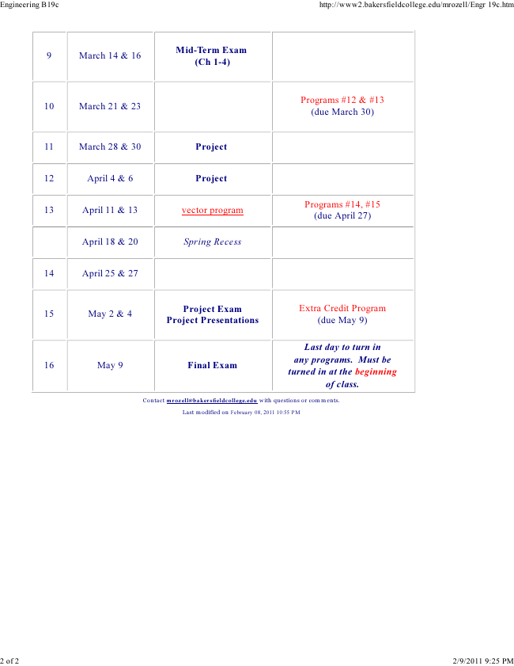

Engineering B19c http://www2.bakersfieldcollege.edu/mrozell/Engr 19c.htm

9 March 14 & 16

Mid-Term Exam (Ch 1-4)

10 March 21 & 23

Programs #12 & #13 (due March 30)

11 March 28 & 30 Project

12 April 4 & 6 Project

13 April 11 & 13 vector program

Programs #14, #15 (due April 27)

April 18 & 20 Spring Recess

14 April 25 & 27

15 May 2 & 4

Project Exam Project Presentations

2 of 2 2/9/2011 9:25 PM

Extra Credit Program (due May 9)

16 May 9 Final Exam

Last day to turn in any programs. Must be turned in at the beginning of class.

Contact mrozell@bakersfieldcollege.edu with questions or comments.

Last modified on February 08, 2011 10:55 PM