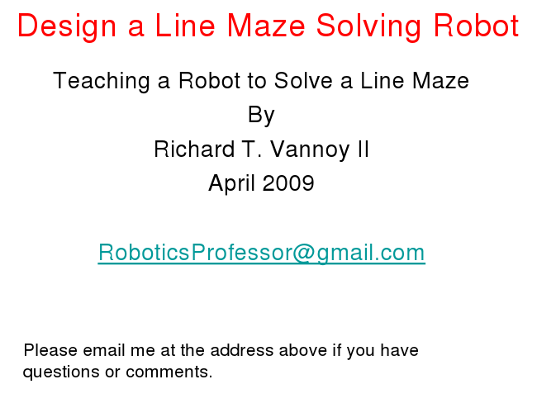

Design a Line Maze Solving Robot

Teaching a Robot to Solve a Line Maze By Richard T. Vannoy II April 2009

RoboticsProfessor@gmail.com

Please email me at the address above if you have questions or comments.

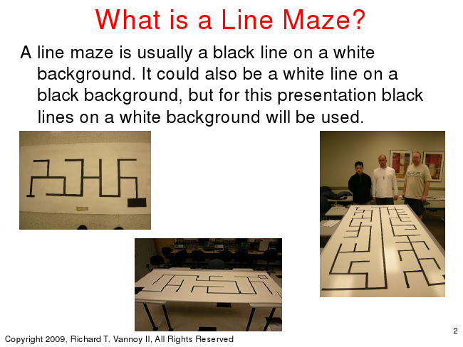

Copyright 2009, Richard T. Vannoy II, All Rights Reserved

What is a Line Maze? A line maze is usually a black line on a white

background. It could also be a white line on a black background, but for this presentation black lines on a white background will be used.

2

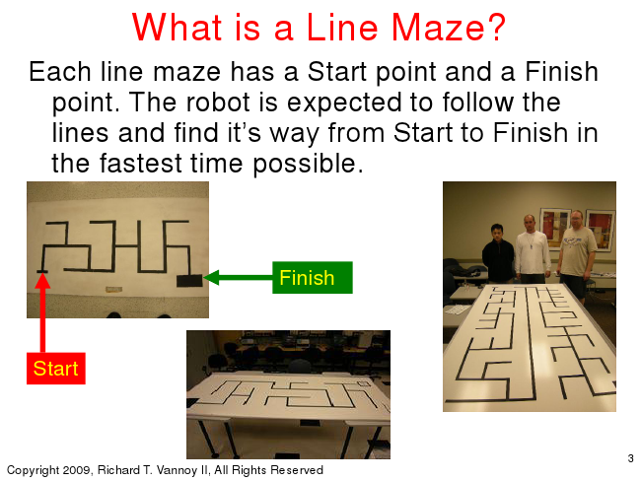

Copyright 2009, Richard T. Vannoy II, All Rights Reserved

What is a Line Maze? Each line maze has a Start point and a Finish

point. The robot is expected to follow the lines and find it‟s way from Start to Finish in the fastest time possible.

Start

Finish

3

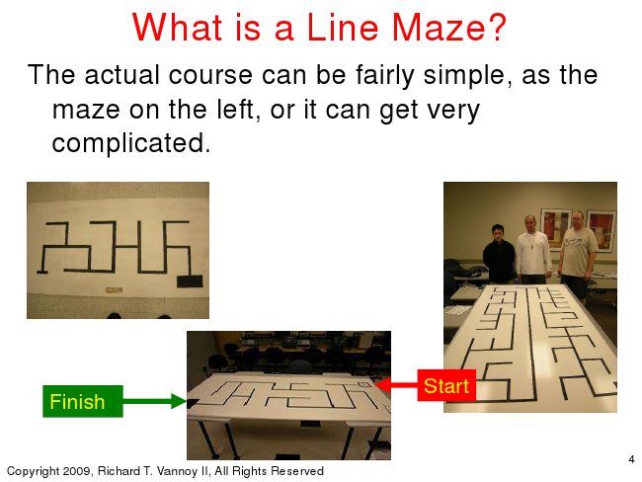

Copyright 2009, Richard T. Vannoy II, All Rights Reserved

What is a Line Maze? The actual course can be fairly simple, as the

maze on the left, or it can get very complicated.

Start Finish

4

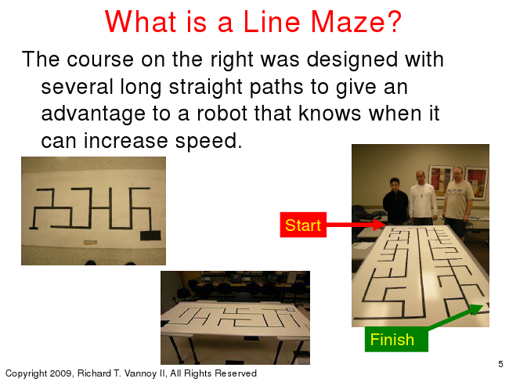

Copyright 2009, Richard T. Vannoy II, All Rights Reserved

What is a Line Maze? The course on the right was designed with

several long straight paths to give an advantage to a robot that knows when it can increase speed.

Start

Finish

5

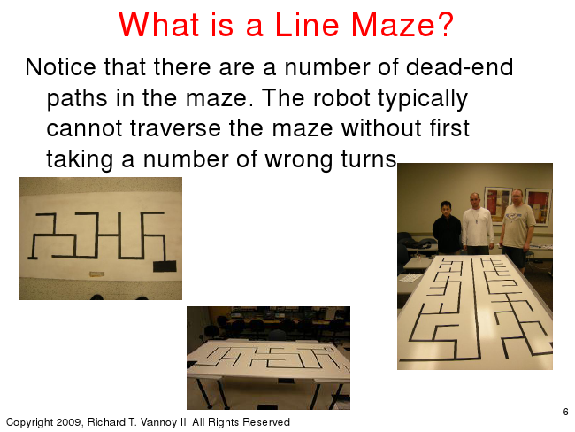

Copyright 2009, Richard T. Vannoy II, All Rights Reserved

What is a Line Maze? Notice that there are a number of dead-end

paths in the maze. The robot typically cannot traverse the maze without first taking a number of wrong turns.

6

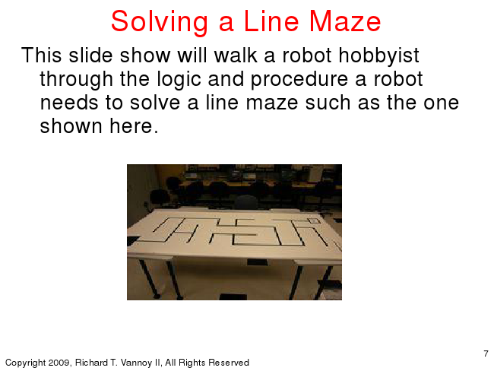

Copyright 2009, Richard T. Vannoy II, All Rights Reserved

Solving a Line Maze This slide show will walk a robot hobbyist through the logic and procedure a robot needs to solve a line maze such as the one shown here.

7

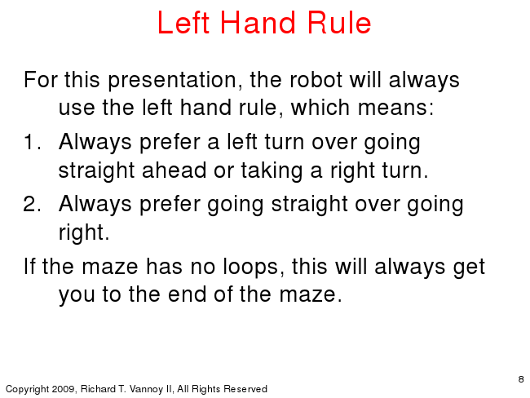

Copyright 2009, Richard T. Vannoy II, All Rights Reserved

Left Hand Rule

For this presentation, the robot will always use the left hand rule, which means: 1. Always prefer a left turn over going

straight ahead or taking a right turn. 2. Always prefer going straight over going

right. If the maze has no loops, this will always get

you to the end of the maze.

8

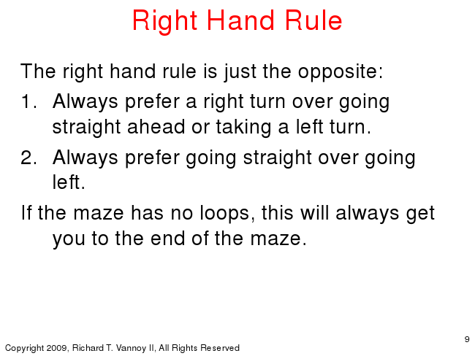

Copyright 2009, Richard T. Vannoy II, All Rights Reserved

Right Hand Rule

The right hand rule is just the opposite: 1. Always prefer a right turn over going

straight ahead or taking a left turn. 2. Always prefer going straight over going

left. If the maze has no loops, this will always get

you to the end of the maze.

9

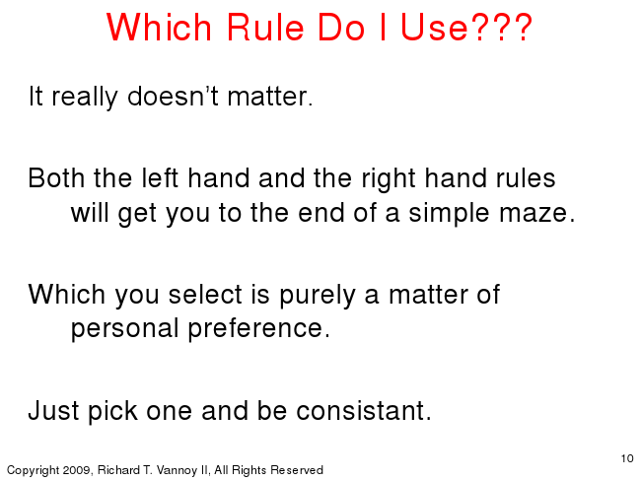

Copyright 2009, Richard T. Vannoy II, All Rights Reserved

Which Rule Do I Use???

It really doesn‟t matter.

Both the left hand and the right hand rules

will get you to the end of a simple maze.

Which you select is purely a matter of

personal preference.

Just pick one and be consistant.

10