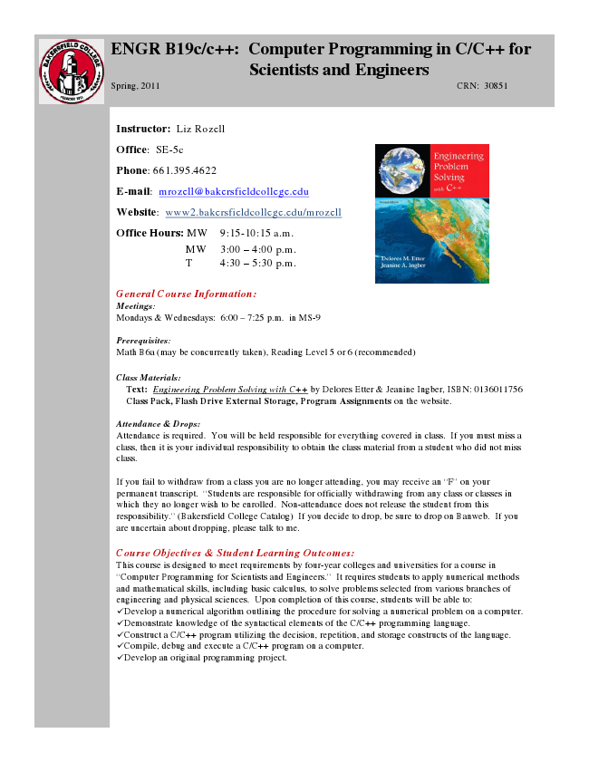

**ENGR B19c/c++: Computer Programming in C/C++ for**

**Scientists and Engineers Spring, 2011 CRN: 30851**

**Instructor: Liz Rozell**

Office: SE-5c

Phone: 661.395.4622

E-mail: mrozell@bakersfieldcollege.edu

Website: www2.bakersfieldcollege.edu/mrozell

Office Hours: MW 9:15-10:15 a.m.

MW 3:00 – 4:00 p.m. T 4:30 – 5:30 p.m.

General Course Information: Meetings: Mondays & Wednesdays: 6:00 – 7:25 p.m. in MS-9

Prerequisites: Math B6a (may be concurrently taken), Reading Level 5 or 6 (recommended)

**Class Class Materials: Materials: Text: Engineering Problem Solving with C++ by Delores Etter & Jeanine Ingber, ISBN: 0136011756 Class Pack, Flash Drive External Storage, Program Assignments on the website.**

Attendance & Drops: Attendance is required. You will be held responsible for everything covered in class. If you must miss a class, then it is your individual responsibility to obtain the class material from a student who did not miss class.

If you fail to withdraw from a class you are no longer attending, you may receive an “F” on your permanent transcript. “Students are responsible for officially withdrawing from any class or classes in which they no longer wish to be enrolled. Non-attendance does not release the student from this responsibility.” (Bakersfield College Catalog) If you decide to drop, be sure to drop on Banweb. If you are uncertain about dropping, please talk to me.

Course Objectives & Student Learning Outcomes: This course is designed to meet requirements by four-year colleges and universities for a course in “Computer Programming for Scientists and Engineers.” It requires students to apply numerical methods and mathematical skills, including basic calculus, to solve problems selected from various branches of engineering and physical sciences. Upon completion of this course, students will be able to: ✓Develop a numerical algorithm outlining the procedure for solving a numerical problem on a computer. ✓Demonstrate knowledge of the syntactical elements of the C/C++ programming language. ✓Construct a C/C++ program utilizing the decision, repetition, and storage constructs of the language. ✓Compile, debug and execute a C/C++ program on a computer. ✓Develop an original programming project.

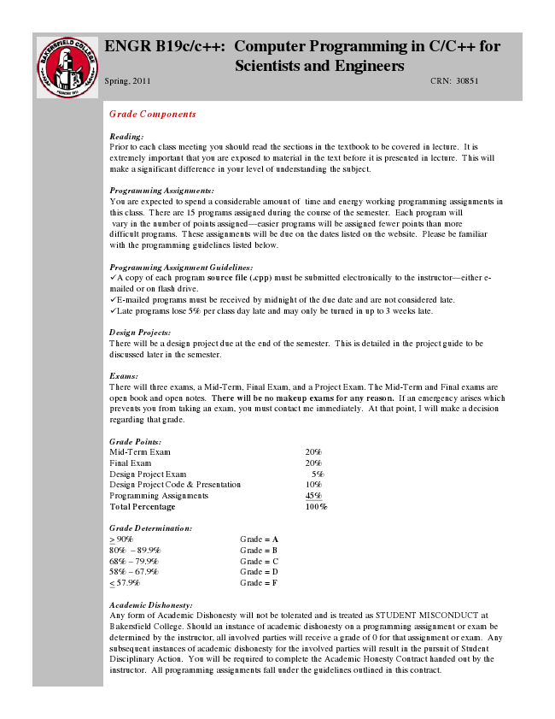

**ENGR B19c/c++: Computer Programming in C/C++ for**

**Scientists and Engineers Spring, 2011 CRN: 30851**

***Grade Components***

Reading: Prior to each class meeting you should read the sections in the textbook to be covered in lecture. It is extremely important that you are exposed to material in the text before it is presented in lecture. This will make a significant difference in your level of understanding the subject.

Programming Assignments: You are expected to spend a considerable amount of time and energy working programming assignments in this class. There are 15 programs assigned during the course of the semester. Each program will vary in the number of points assigned—easier programs will be assigned fewer points than more difficult programs. These assignments will be due on the dates listed on the website. Please be familiar with the programming guidelines listed below.

Programming Assignment Guidelines: ✓A copy of each program source file (.cpp) must be submitted electronically to the instructor—either e- mailed or on flash drive. ✓E-mailed programs must be received by midnight of the due date and are not considered late. ✓Late programs lose 5% per class day late and may only be turned in up to 3 weeks late.

Design Projects: There will be a design project due at the end of the semester. This is detailed in the project guide to be discussed later in the semester.

Exams: There will three exams, a Mid-Term, Final Exam, and a Project Exam. The Mid-Term and Final exams are open book and open notes. There will be no makeup exams for any reason. If an emergency arises which prevents you from taking an exam, you must contact me immediately. At that point, I will make a decision regarding that grade.

Grade Points: Mid-Term Exam 20% Final Exam 20% Design Project Exam 5% Design Project Code & Presentation 10% Programming Assignments 45% Total Percentage 100%

Grade Determination: > 90% Grade = A 80% – 89.9% Grade = B 68% – 79.9% Grade = C 58% – 67.9% Grade = D < 57.9% Grade = F

Academic Dishonesty: Any form of Academic Dishonesty will not be tolerated and is treated as STUDENT MISCONDUCT at Bakersfield College. Should an instance of academic dishonesty on a programming assignment or exam be determined by the instructor, all involved parties will receive a grade of 0 for that assignment or exam. Any subsequent instances of academic dishonesty for the involved parties will result in the pursuit of Student Disciplinary Action. You will be required to complete the Academic Honesty Contract handed out by the instructor. All programming assignments fall under the guidelines outlined in this contract.

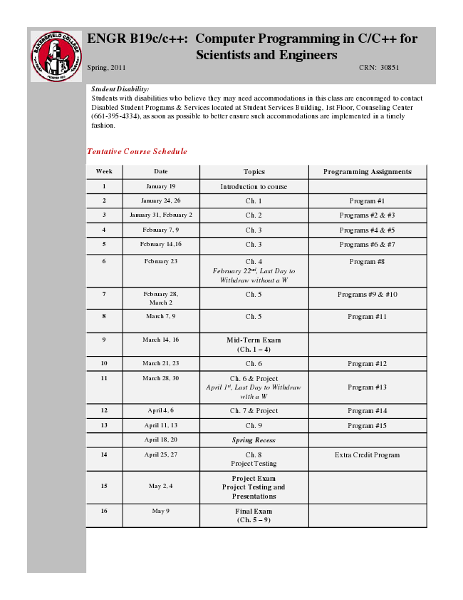

**ENGR B19c/c++: Computer Programming in C/C++ for**

**Scientists and Engineers Spring, 2011 CRN: 30851**

Student Disability: Students with disabilities who believe they may need accommodations in this class are encouraged to contact Disabled Student Programs & Services located at Student Services Building, 1st Floor, Counseling Center (661-395-4334), as soon as possible to better ensure such accommodations are implemented in a timely fashion.

***Tentative Course Schedule***

**Week Date Topics Programming Assignments**

1 January 19 Introduction to course

2 January 24, 26 Ch. 1 Program #1

3 January 31, February 2 Ch. 2 Programs #2 & #3

4 February 7, 9 Ch. 3 Programs #4 & #5

5 February 14,16 Ch. 3 Programs #6 & #7

6 February 23 Ch. 4

*February 22nd, Last Day to Withdraw without a W*

March 2

8 March 7, 9 Ch. 5 Program #11

**9 March 14, 16 Mid-Term Exam**

**(Ch. 1 – 4)**

10 March 21, 23 Ch. 6 Program #12

11 March 28, 30 Ch. 6 & Project

*April 1st, Last Day to Withdraw with a W*

Program #8

7 February 28,

March 2

Ch. 5 Programs #9 & #10

Program #13

12 April 4, 6 Ch. 7 & Project Program #14

13 April 11, 13 Ch. 9 Program #15

***April 18, 20 Spring Recess***

14 April 25, 27 Ch. 8

Project Testing

Extra Credit Program

15 May 2, 4

**Project Exam Project Testing and Presentations**

**16 May 9 Final Exam**

**(Ch. 5 – 9)**