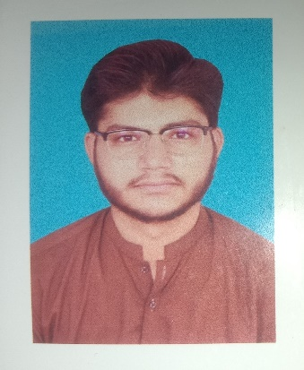
Education:
Government school Iqbal nagar
SEPTEMBER 2021
Matric in science
Aspire college Main Channu
October 2023
Fsc (pre engineering)
Government college and university Faisalabad
Sahiwal campus
2023-2027
Bs software engineering
SKILLS
• HTML5
• CSS3
• JavaScript (Basic)
• ReactJS (Beginner Level)
• Responsive Web Design (Basic)
• Basic Git & GitHub

Soft Skills
- Friendly and positive attitude
- Quick learner
- Teamwork
- Good communication skills
- Time management
- Problem-solving ability

Career Objective
Motivated and hardworking BS Software Engineering student with foundational knowledge of HTML, CSS, JavaScript, and ReactJS. Eager to gain practical experience through internships or entry-level opportunities where I can enhance my technical skills and contribute to real-world projects.

Languages :
- English
- Urdu

CONTACT NO: 03181657803
EMAIL: shazerali27@gmail.com
ADDRESS: IQBAL NAGAR
M.SHAHZAR

