# Create Chatbot in Python

Project Title: Create Chatbot in Python

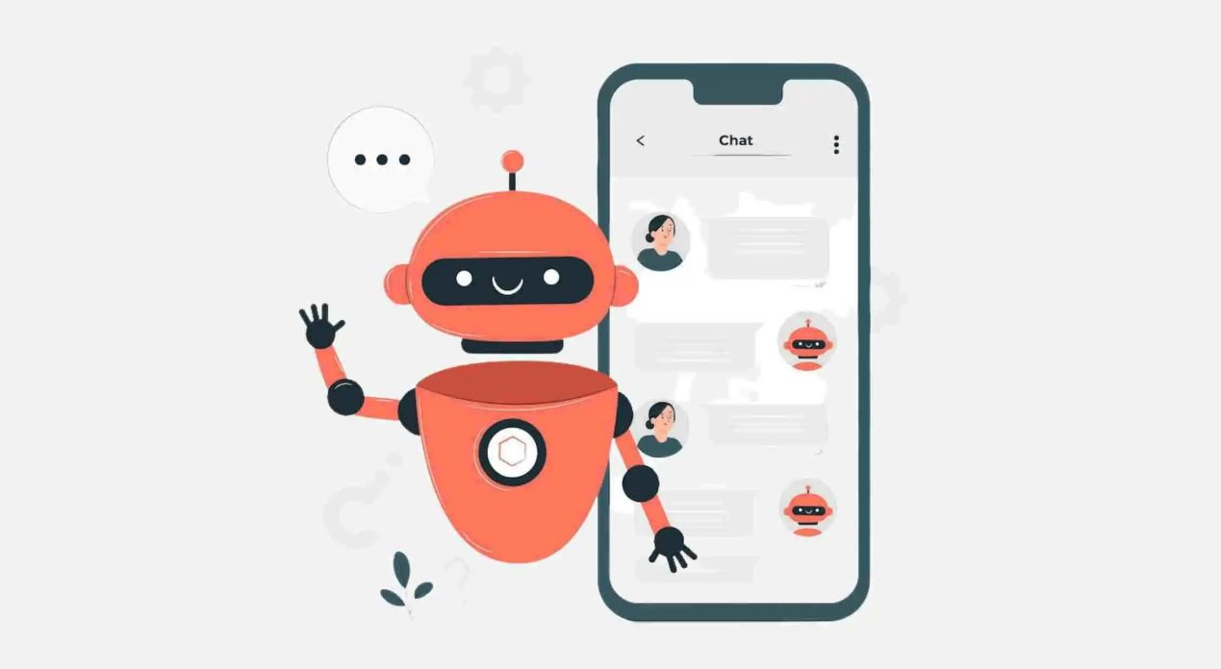

### Data Source:

When using an app or website, customers expect outstanding service. They can become disinterested in the app if they can't locate the solution to a question they have. To avoid losing customers and having an adverse effect on your bottom line, you must provide the highest quality service possible while developing a website or application.The challenge is to create a chatbot in Python that provides exceptional customer service, answering user queries on a website or application. The objective is to deliver high-quality support to users, ensuring a positive user experience and customer satisfaction.

**Dataset Link:[https://www.kaggle.com/datasets/grafstor/simple-dialogs-for-chatbot](https://www.kaggle.com/datasets/grafstor/simple-dialogs-for-chatbot" \t "https://courses.myclass.skillup.online/courses/course-v1:IBM+AI101+2023_B5/courseware/d8660830b7ec4f2e8158584fd8319a7d/6edc648a54684cf2a2882b39112be886/[object Object])**

Functionality:

Certainly, defining the scope of a chatbot's abilities is a crucial step in chatbot development. The scope determines what the chatbot can and cannot do. Below, I'll outline a comprehensive scope for a chatbot that can answer common questions, provide guidance, and direct users to appropriate resources:

**1. Information Retrieval:**

Answer Frequently Asked Questions (FAQs): The chatbot should be able to respond to common queries and provide concise, accurate answers.

Provide General Knowledge: The chatbot should be equipped with access to a knowledge base to offer information on various topics.

**2. Task Assistance:**

Offer How-to Guides: Provide step-by-step instructions or guides for performing specific tasks or actions.

Troubleshoot Issues: Assist users in diagnosing and resolving common problems or issues they might encounter.

**3. Recommendations:**

Recommend Products or Services: If applicable, the chatbot can suggest products or services based on user preferences or needs.

Suggest Related Content: Recommend articles, videos, or other resources based on user interests or questions.

**4. Navigation and Direction:**

Provide Directions: Help users find locations or navigate to places, potentially integrating with mapping services.

Guide Through Processes: Assist users in completing forms, applications, or other processes step by step.

**5. Personalization:**

Remember User Preferences: Allow users to save preferences or settings for a personalized experience.

Provide Tailored Content: Offer content and recommendations based on a user's history and interactions.

**6. Language Support:**

Multilingual Support: If applicable, provide responses and support in multiple languages to cater to a diverse user base.

**7. Integration with Resources:**

Integrate with APIs and Databases: Connect to relevant databases, external systems, or APIs to fetch real-time data or information.

Link to External Resources: Direct users to websites, documents, or external resources when necessary.

**8. User Engagement:**

Small Talk and Engagement: Engage users in casual conversation, respond to greetings, and maintain a friendly tone.

Emojis and GIFs: Incorporate emojis or GIFs for a more expressive and engaging interaction.

**9. Error Handling:**

Graceful Error Handling: Provide informative error messages and suggestions when the chatbot cannot fulfill a request.

### User Interface:

**1. Information Retrieval:**

Answer Frequently Asked Questions (FAQs): The chatbot should be able to respond to common queries and provide concise, accurate answers.

Provide General Knowledge: The chatbot should be equipped with access to a knowledge base to offer information on various topics.

**2. Task Assistance:**

Offer How-to Guides: Provide step-by-step instructions or guides for performing specific tasks or actions.

Troubleshoot Issues: Assist users in diagnosing and resolving common problems or issues they might encounter.

**3. Recommendations:**

Recommend Products or Services: If applicable, the chatbot can suggest products or services based on user preferences or needs.

Suggest Related Content: Recommend articles, videos, or other resources based on user interests or questions.

**4. Navigation and Direction:**

Provide Directions: Help users find locations or navigate to places, potentially integrating with mapping services.

Guide Through Processes: Assist users in completing forms, applications, or other processes step by step.

**5. Personalization:**

Remember User Preferences: Allow users to save preferences or settings for a personalized experience.

Provide Tailored Content: Offer content and recommendations based on a user's history and interactions.

**6. Language Support:**

Multilingual Support: If applicable, provide responses and support in multiple languages to cater to a diverse user base.

### Natural Language Processing (NLP):

Implementing Natural Language Processing (NLP) techniques to understand and process user input in a conversational manner involves several steps. Below, I'll outline a basic example in Python using the spaCy library for NLP. This example demonstrates how to extract intent and entities from user input:

import spacy

# Load the spaCy model

nlp = spacy.load("en_core_web_sm")

# Define a function to process user input

def process_user_input(user_input):

# Process the user input using spaCy

doc = nlp(user_input)

# Extract the intent (verb) and entities (nouns)

intent = None

entities = []

for token in doc:

if "VERB" in token.pos_:

intent = token.text

elif "NOUN" in token.pos_:

entities.append(token.text)

return intent, entities

# Main conversation loop

while True:

user_input = input("User: ")

# Process user input

intent, entities = process_user_input(user_input)

# Print the extracted intent and entities

print("Intent:", intent)

print("Entities:", entities)

# You can now use the intent and entities to determine how to respond to the user

# Add your logic to handle different intents and entities here

# For simplicity, we'll just echo the input

print("Bot: You said:", user_input)

### Responses:

Planning responses for your chatbot is a crucial step in creating an engaging and helpful user experience. Below, I'll outline a variety of response types that your chatbot can offer, including accurate answers, suggestions, and assistance, along with examples for each:

**1. Accurate Answers:**

Factual Information: Provide straightforward answers to factual questions.

User: "What's the capital of France?"

Bot: "The capital of France is Paris."

Product Information: Offer details about products or services.

User: "Tell me more about your premium subscription."

Bot: "Our premium subscription offers ad-free content, offline downloads, and exclusive access to new releases."

**2. Suggestions:**

Content Recommendations: Suggest articles, videos, or products based on user interests.

User: "I'm interested in gardening. Any book recommendations?"

Bot: "Sure! I recommend 'The Well-Tempered Garden' by Christopher Lloyd."

Restaurant or Event Recommendations: Provide suggestions for dining or entertainment.

User: "Can you recommend a good Italian restaurant in the area?"

Bot: "Certainly! I recommend 'Mamma Mia Trattoria' on 123 Main Street."

1. **Assistance:**

How-To Guides: Offer step-by-step instructions for various tasks.

User: "How do I reset my password?"

Bot: "To reset your password, go to our website, click 'Forgot Password,' and follow the on-screen instructions."

Troubleshooting: Help users diagnose and solve common problems.

User: "My Wi-Fi is not working."

Bot: "Let's try restarting your router. Unplug it, wait for 30 seconds, and then plug it back in."

**4. Clarification and Confirmation:**

Confirming User Intent: Seek clarification when user queries are ambiguous.

User: "Can I book a flight?"

Bot: "Sure, could you please provide your departure and destination airports and travel dates?"

Confirmation: Confirm user choices before taking action.

User: "Book a table for two at 7:00 PM."

Bot: "Great! Just to confirm, you'd like to book a table for two at 7:00 PM. Is that correct?"

**5. Personalization:**

Remembering Preferences: Acknowledge and remember user preferences.

User: "I prefer vegetarian options."

Bot: "Noted! I'll keep that in mind when making recommendations."

User History: Refer to previous interactions to provide a personalized experience.

User: "Can you remind me of the last book I purchased?"

Bot: "Of course! You recently purchased 'The Hobbit' by J.R.R. Tolkien."

**6. Error Handling:**

Handling Invalid Input: Provide guidance and suggestions when the user inputs something unclear or invalid.

User: "asdfghj"

Bot: "I'm sorry, I didn't understand your input. Could you please rephrase your question?"

Apologizing for Errors: Apologize and rectify mistakes gracefully.

User: "You got my order wrong."

Bot: "I apologize for the error. Let me check and correct that for you."

### Integration:

Integrating a chatbot with a website or app involves making technical decisions about how the chatbot will be implemented and how it will interact with users. Here are key considerations and decisions to make regarding the integration of your chatbot:

**1. Deployment Platform:**

Web: Determine if you want to integrate the chatbot into a website. If so, decide where on the website it will appear (e.g., as a widget, in the header, or as a pop-up).

Mobile App: Decide if the chatbot will be part of a mobile app. If yes, determine where it will be accessible within the app, such as a dedicated screen or as a floating widget.

**2. Integration Method:**

Embedding: Embed the chatbot directly into the website or app using HTML, JavaScript, or a mobile SDK, depending on the platform.

Third-Party Platforms: Consider using third-party chatbot development platforms like Dialogflow, Microsoft Bot Framework, or IBM Watson Assistant, which provide tools and integrations for multiple platforms.

**3. User Interface (UI):**

Chat Interface: Design the chatbot's user interface, including its appearance, layout, and style. Consider whether it will have a text-based interface, buttons for options, or a combination of both.

Branding: Ensure that the chatbot's UI aligns with your website or app's branding, including color schemes and logos.

**4. Authentication and Authorization:**

Determine if the chatbot needs access to user accounts and data. If so, implement secure authentication and authorization mechanisms to protect user information.

**5. Data Integration:**

Determine if the chatbot needs access to external data sources or APIs to provide information or perform tasks. Implement data integration as needed.

**6. Backend Server:**

Decide whether the chatbot will have a backend server to process and manage user interactions. This server can handle NLP, conversation management, and integration with external services.

**7. NLP Integration:**

Choose an NLP framework or library for understanding and processing user input. Integrate it with your chatbot's backend for natural language understanding.

**8. Conversation Flow:**

Design the conversation flow and logic. Determine how the chatbot will respond to different user inputs and intents.

**9. Multimodal Interaction:**

If applicable, consider supporting multimodal interactions, such as voice input, images, or video.

### Testing and Improvement:

Continuously testing and refining a chatbot's performance based on user interactions is essential for ensuring it remains effective, user-friendly, and valuable. Here's a step-by-step guide on how to go about this process:

**1. Collect User Feedback:**

Encourage users to provide feedback on their interactions with the chatbot. You can do this by adding a feedback option within the chat interface or through email surveys.

**2. Monitor User Interactions:**

Implement analytics and monitoring tools to track user interactions. Pay attention to user behavior, common queries, and areas where the chatbot may struggle.

**3. Conduct Regular Usability Testing:**

Organize usability testing sessions with real users to observe how they interact with the chatbot. Collect feedback on usability, clarity of responses, and any pain points they encounter.

**4. Analyze User Data:**

Analyze user feedback, interaction logs, and analytics data to identify patterns and areas for improvement. Look for common user queries, misinterpretations, or recurring issues.

**5. Identify Pain Points:**

Identify pain points in the user experience. This may include areas where users frequently drop off, express frustration, or where the chatbot fails to provide satisfactory answers.

1. **Refine NLP Models:**

If you're using NLP techniques, continuously refine your NLP models. Train them on new data and update them to handle a wider range of user inputs accurately.

**7. Expand Knowledge Base:**

Regularly update the chatbot's knowledge base with new information, FAQs, or relevant content. Ensure that the chatbot is up to date with the latest data.

### Conclusion:

In conclusion, building a chatbot in Python is a dynamic and evolving process that requires careful planning, development, and ongoing refinement. Chatbots have become valuable tools for businesses and organizations to enhance customer engagement, automate tasks, and provide assistance.