DEPARTMENT OF COMPUTER SCIENCE & ENGINEERING
<NAME OF INSTITUTE / UNIVERSITY, CITY>
SOFTWARE REQUIREMENTS
SPECIFICATION (SRS)
Project Title: BankEase: NextGen Net Banking
Standards: IEEE Std 830-1998 (superseded by ISO/IEC/IEEE 29148:2018; format retained for academic compliance)
Document ID: BE-SRS-001 | Version 1.1 | Classification: Internal

SUBMITTED BY:  1. Shorya Jain (Roll No: 2400320101062)  Degree: Bachelor of Technology (B.Tech)  Academic Year: 2026 - 2027 | UNDER THE GUIDANCE OF:  Dr. Laxmi Saraswat, <actual designation>  Department of Computer Science & Engg.  Status: 3rd Year Project Specification  Date of Submission: <DD-MM-YYYY>

Document Revision & Approval History
Version | Date | Description / Major Changes | Prepared By | Reviewed By
0.1 | 15-Sep-2026 | Initial Draft & Scope Definition | Shorya Jain | Laxmi Saraswat
1.0 | 30-Sep-2026 | Final 3rd Year Mid-Term SRS Baseline | Shorya Jain | HOD / Committee
1.1 | 01-Oct-2026 | Aligned SRS with implemented baseline; added release scope, use cases, concurrency and risk sections | Shorya Jain | Laxmi Saraswat

Guidance Note:
This Software Requirements Specification conforms to the IEEE 830-1998 recommended practice and follows enterprise documentation conventions: controlled document ID and versioning, uniquely numbered and testable requirements, MoSCoW-style priorities, and a requirements traceability matrix (Section 6.4).

1. Introduction

1.1 Purpose
The purpose of this Software Requirements Specification (SRS) is to provide a complete, clear, and unambiguous definition of the functionality, external interfaces, performance targets, security controls, and constraints of the proposed system: 'BankEase: NextGen Net Banking'. This specification is the binding reference between the student developer, project evaluators, the academic supervisor, and prospective end users during the 3rd-year engineering curriculum.

1.2 Scope of the System
Retail banking customers depend heavily on branch visits and fragmented channels for routine tasks such as balance checks, transfers, bill payments, and loan or deposit requests, which slows service and weakens audit visibility. BankEase solves this by delivering a secure, end-to-end net banking platform for account management, fund transfer, bill payment, and loan and investment services, with security and regulatory compliance controls built into every workflow. Key boundaries:
- In-Scope Capabilities: Customer onboarding with KYC, two-factor authentication, role-based workflows, account and statement services, beneficiary and fund transfer (intra-bank, NEFT, IMPS, RTGS), bill payment, loan and FD/RD services, AML/fraud alerts, audit logging, and an admin analytics dashboard. Capabilities are delivered in two releases (see Section 2.6).
- Out-of-Scope Boundaries: Live connectivity to RBI/NPCI payment rails and real credit bureaus (simulated by mock services), replacement of a core banking system, native mobile apps, card and UPI issuance, and live movement of real money (sandbox mode with synthetic data only).
- Expected Benefits (targets, validated during testing): At least 60% reduction in turnaround time for routine services versus branch processing, 100% of financial events captured in an audit trail, elimination of manual logging, and 24x7 access from any device.

1.3 Definitions, Acronyms, and Abbreviations
Category | Term / Acronym | Definition / Standard Context
Standard | SRS | Software Requirements Specification (IEEE Std 830-1998 format).
Architecture | API / REST | Application Programming Interface; Representational State Transfer, a stateless style exchanging JSON over HTTPS.
Security | JWT / RBAC | JSON Web Token for stateless authorization; Role-Based Access Control.
Security | OTP / 2FA | One-Time Password; Two-Factor Authentication (password plus OTP) as mandated for digital payments.
Compliance | KYC / AML | Know Your Customer identity verification; Anti-Money Laundering monitoring of suspicious activity.
Banking | NEFT / IMPS / RTGS | Indian interbank transfer modes: batch, instant 24x7, and real-time gross settlement for high-value payments.
Banking | IFSC / FD / RD / EMI | Branch identifier code; Fixed Deposit; Recurring Deposit; Equated Monthly Installment.
Database | CRUD / ACID | Create, Read, Update, Delete; Atomicity, Consistency, Isolation, Durability of transactions.
Project Specific | JPA / SPA | Java Persistence API (Hibernate ORM); Single Page Application (Angular).
Banking | SIP / Maker-Checker | Systematic Investment Plan; dual-control approval where one person initiates and another authorizes.
Standard | RTM | Requirements Traceability Matrix linking requirements to use cases and tests.

1.4 References
- IEEE Std 830-1998: IEEE Recommended Practice for Software Requirements Specifications.
- ISO/IEC/IEEE 29148:2018: Systems and software engineering, Requirements engineering.
- Software Engineering (10th Edition): Ian Sommerville, Pearson Education.
- Regulatory: RBI Master Direction on Digital Payment Security Controls (2021); RBI Master Direction on KYC (2016, as amended); Information Technology Act, 2000; Prevention of Money Laundering Act, 2002; Digital Personal Data Protection Act, 2023.
- Technical: OWASP Top 10 and ASVS; Spring Boot, Spring Security, and Angular official documentation; MySQL 8.0 Reference Manual; project repository github.com/shhorya/BankEase.

1.5 Document Overview
Section 2 describes the product perspective, user classes, operating environment, and constraints. Section 3 itemizes functional requirements by module using identifiers FR-m.n with priorities High (Must), Medium (Should), and Low (Could). Section 4 specifies external interfaces. Section 5 defines non-functional requirements (NFR) with measurable targets. Section 6 provides analysis models and the traceability matrix. Section 7 records academic sign-off, and Section 8 lists risks and mitigations.

2. Overall Description

2.1 Product Perspective
BankEase is a self-contained three-tier system: an Angular single page application (presentation), a Spring Boot REST API with layered controller, service, and repository components (application logic), and a MySQL database (persistence). It reaches external services such as the OTP gateway, payment network simulator, biller aggregator, and credit bureau only through secure, authenticated HTTPS endpoints.
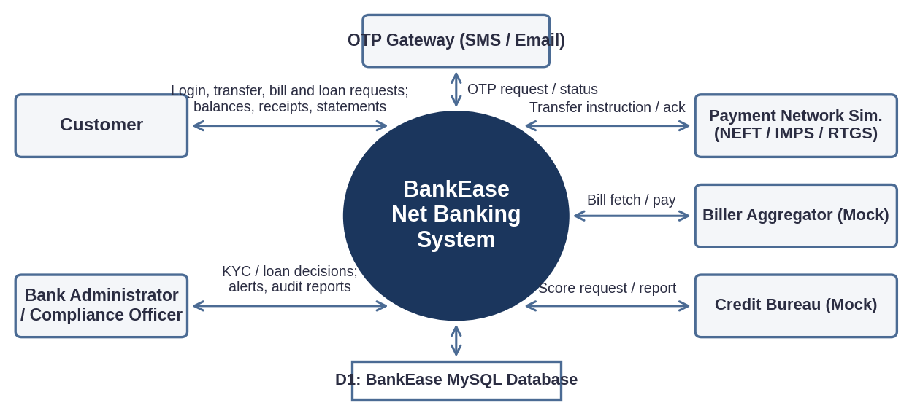
Figure 1: System context diagram (DFD Level 0) of BankEase

2.2 User Classes and Characteristics
User Role / Persona | Technical Proficiency | Core Responsibilities & Rights
Retail Customer | Basic to Intermediate (general web user) | Authenticated access to own accounts: view balances and statements, manage beneficiaries, transfer funds, pay bills, apply for loans, open deposits, update profile.
Bank Administrator | High (operations / DB management) | User and KYC moderation, loan approval (checker role), product and limit configuration, system parameters, backup and restore.
Compliance / Risk Officer | Intermediate (banking domain expert) | Review AML and fraud alerts, inspect audit logs, freeze accounts, generate regulatory reports. No access to customer credentials.
Guest / Public Visitor | Basic | Read-only access to landing page, product information, EMI calculator, and self-registration portal.

2.3 Operating Environment
- Client Requirements: Modern browser (Chrome >= v110, Firefox >= v108, Edge, Safari); minimum 1366x768 on desktop, responsive down to 360x640.
- Server Runtime Environment: Linux (Ubuntu 22.04 LTS), Java 21 LTS, Spring Boot 4.x with embedded Tomcat; Angular 21 built with Node.js 22 LTS; containerized with Docker.
- Database Storage Tier: MySQL 8.0 (InnoDB engine for ACID transactions and foreign-key integrity).

2.4 Design and Implementation Constraints
- Regulatory Compliance: Two-factor authentication, transaction limits, KYC/AML checks, and audit retention in line with RBI directions; personal data handled per the DPDP Act, 2023.
- Security Compliance: Passwords stored only as salted BCrypt hashes; sensitive fields encrypted at rest (AES-256, Release 2); TLS 1.2 or higher in transit; tokens discarded on logout (server-side revocation in Release 2).
- Modularity and Integrity: Layered MVC REST architecture with lazy-loaded Angular modules; monetary values stored as DECIMAL(15,2) and handled with BigDecimal; all fund movements inside ACID transactions.
- Academic Budget Constraint: Free-tier or local containerized hosting; external banking services replaced by mocks; synthetic test data only.

2.5 Assumptions and Dependencies
- Assumptions: Users have continuous Internet access (minimum 2 Mbps), a registered mobile number for OTP, and synchronized device clocks (NTP).
- Dependencies: Availability of the mock OTP/SMS gateway, payment network simulator, biller aggregator, credit score service, and an SMTP service for email notifications.

2.6 Release Scope
Release | Contents
R1 (implemented, mid-term demo) | Registration and login (BCrypt, JWT), login lockout, role-based access (CUSTOMER, ADMIN), per-user account ownership checks, multi-account dashboard, deposit, withdraw and transfer with ACID and row locking, bill payment, loan application with approval, FD/SIP/mutual-fund investments, audit log, OpenAPI docs.
R2 (planned, final year) | OTP 2FA, KYC with PAN/DOB, beneficiaries and NEFT/IMPS/RTGS, statements export, scheduled transfers and autopay, COMPLIANCE role with AML alerts, rate limiting, token revocation and idle timeout, Docker deployment.

3. System Features and Functional Requirements
Requirements are grouped by subsystem module with unique identifiers (FR-m.n). Each is verifiable by test; 'Input / Validation Rule' doubles as the acceptance criterion. Release: R1 = implemented, R1* = partially implemented, R2 = planned (Section 2.6).

3.1 Module 1: Authentication, Onboarding and Access Governance
Req ID | Feature Description | Input / Validation Rule | Priority | Release
FR-1.1 | Registration and KYC Submission | Name, email, 10-digit mobile, PAN (AAAAA9999A), DOB (age >= 18), password (>= 8 chars, alphanumeric + symbol); KYC status starts PENDING. | High | R1* (PAN, DOB and KYC in R2)
FR-1.2 | Two-Factor Login | Username + password verified against BCrypt hash, then 6-digit OTP valid 5 minutes, maximum 3 attempts. | High | R2
FR-1.3 | Session Token Management | Signed JWT valid 15 minutes with 10-minute idle timeout; invalidated on logout. | High | R1* (idle timeout and revocation in R2)
FR-1.4 | Lockout and Password Reset | Lock for 30 minutes after 5 consecutive failures; reset via OTP-verified link expiring in 15 minutes. | Medium | R1* (reset link in R2)
FR-1.5 | Role-Based Authorization | Roles CUSTOMER, ADMIN, COMPLIANCE enforced on every endpoint; violations return HTTP 403 and are logged. Customers may access only their own accounts (object-level authorization); violations return 403. | High | R1* (COMPLIANCE role in R2)

3.2 Module 2: Account Management
Req ID | Feature Description | Input / Validation Rule | Priority | Release
FR-2.1 | Account Dashboard | Shows all linked accounts with masked numbers (XXXX4821), available balance, and last 5 transactions. | High | R1
FR-2.2 | Statements | Date range up to 12 months, filter by type; export PDF or CSV within 5 seconds for 1,000 rows. | Medium | R2
FR-2.3 | Profile and Service Requests | Change address, email, or mobile only after OTP; request cheque book; change password. | Medium | R2
FR-2.4 | Account Freeze Control | Customer, admin, or compliance can freeze or unfreeze; frozen accounts reject all debits. | Medium | R1*

3.3 Module 3: Fund Transfer
Req ID | Feature Description | Input / Validation Rule | Priority | Release
FR-3.1 | Beneficiary Management | Name, account number, IFSC (4 letters + 0 + 6 alphanumeric), OTP verified; activation after 24-hour cooling period (configurable). | High | R2
FR-3.2 | Fund Transfer | Modes: intra-bank, NEFT, IMPS, RTGS (simulated). Amount > 0, <= available balance and daily limit, 2-decimal precision. | High | R1* (intra-bank only)
FR-3.3 | Transaction Authorization | Transfers above INR 10,000 (configurable) require a fresh OTP; 3 wrong OTPs cancel the transfer. | High | R2
FR-3.4 | Atomic Posting and Receipt | Debit and credit in one ACID transaction with rollback on failure; unique reference number; downloadable receipt. Concurrent operations on one account are serialized with pessimistic row locks acquired in a fixed order, preventing overdraft and deadlock. | High | R1 (receipt in R2)
FR-3.5 | Scheduled Transfers | Start date, frequency, end date; executed by scheduler; failures notified by email. | Low | R2

3.4 Module 4: Bill Payment
Req ID | Feature Description | Input / Validation Rule | Priority | Release
FR-4.1 | Biller Catalog and Registration | Categories: electricity, water, telecom, DTH, credit card; consumer number validated against biller format. | Medium | R1*
FR-4.2 | Bill Payment | Fetch due amount from mock aggregator, debit account, status SUCCESS / FAILED / PENDING with auto-reversal on failure. | High | R1* (aggregator and auto-reversal in R2)
FR-4.3 | Autopay and Payment History | Autopay mandate with maximum amount cap; searchable history for 12 months. | Low | R2

3.5 Module 5: Loans and Investments
Req ID | Feature Description | Input / Validation Rule | Priority | Release
FR-5.1 | EMI Calculator and Eligibility | EMI = P x r x (1+r)^n / ((1+r)^n - 1); eligibility from declared income and mock credit score. | Medium | R1* (eligibility in R2)
FR-5.2 | Loan Application and Tracking | Personal, home, vehicle loans; document upload (PDF/JPG, <= 2 MB); status Submitted, Under Review, Approved, Rejected, Disbursed. Loans up to INR 5,00,000 are auto-approved by rule; higher amounts require admin approval (FR-6.2). | High | R1* (document upload in R2)
FR-5.3 | Fixed and Recurring Deposits | Open FD, RD, SIP or mutual-fund investments (simulated); view and close; premature closure applies penalty; maturity value by compound interest. | Medium | R1* (closure and maturity in R2)
FR-5.4 | Portfolio View | Consolidated view of loans, FDs, and RDs with current values. | Low | R1*

3.6 Module 6: Administration, Compliance and Reporting
Req ID | Feature Description | Input / Validation Rule | Priority | Release
FR-6.1 | User and KYC Moderation | Admin approves or rejects KYC and activates or disables users; reason is mandatory. | High | R2
FR-6.2 | Loan Approval Workflow | Maker-checker: officer recommends, admin approves; self-approval blocked. | High | R1*
FR-6.3 | Immutable Audit Trail | Every login, transaction, and admin action logged with user, IP, and timestamp; append-only; retained at least 5 years. | High | R1* (immutability and retention in R2)
FR-6.4 | Fraud and AML Alerts | Rule-based flags (single transfer >= INR 5,00,000 or more than 5 transfers in 10 minutes, both configurable); alert queue for compliance review. | High | R2
FR-6.5 | Analytics and Reports | Counts, volumes, and status trends; export PDF or XLSX. | Medium | R2

4. External Interface Requirements

4.1 User Interfaces (UI)
The Angular interface follows standard UX practice: clean navigation bar, breadcrumbs, and modal confirmation dialogs for financial actions. Forms give immediate feedback (success banners, inline errors under invalid fields). Account numbers are always masked and a session countdown warns before timeout.
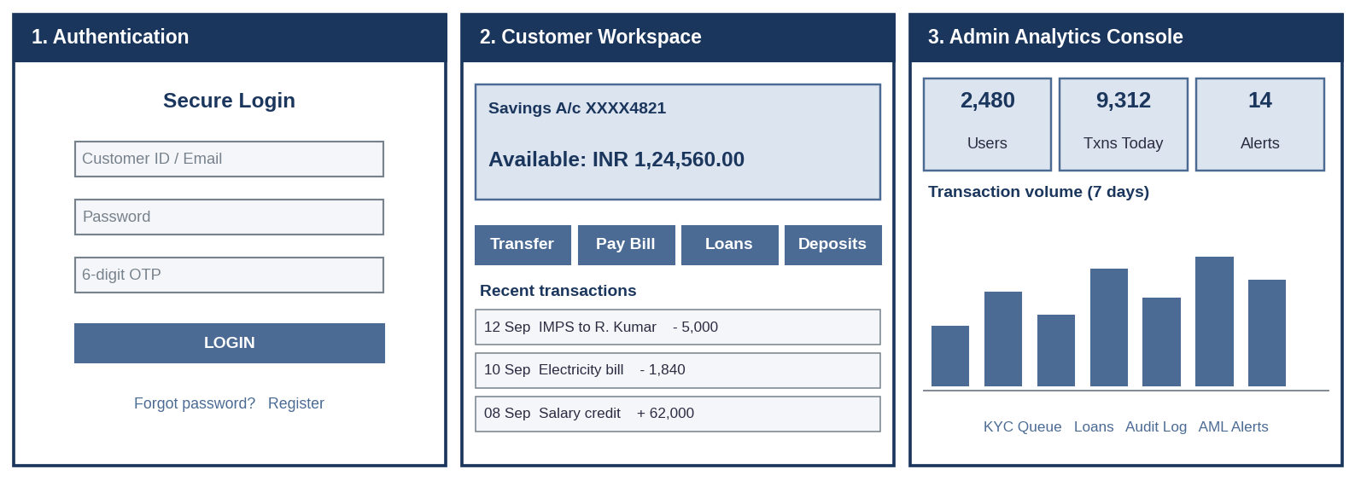
Figure 2: UI wireframes - (1) Authentication, (2) Customer Workspace, (3) Admin Analytics Console

4.2 Hardware Interfaces
- Standard Deployment: Keyboard, mouse or touch, display >= 720p; no specialized hardware. Server needs at least 4 vCPU, 8 GB RAM, 50 GB storage.
- Embedded / IoT Variants: Not applicable to this project.

4.3 Software Interfaces
- Relational Database Connector: Spring Data JPA with Hibernate over MySQL Connector/J on TCP port 3306.
- Frontend to Backend: Angular HttpClient with a JWT interceptor calling REST endpoints under /api (versioning to /api/v1 in Release 2); OpenAPI documentation at /swagger-ui.html.
- External Services: OTP/SMS gateway, payment network simulator, biller aggregator, and credit score service (all mock REST services); SMTP for email; a PDF library for statements and receipts.

4.4 Communication Interfaces
- Web Traffic Protocol: HTTPS on port 443, TLS 1.2 or higher (1.3 preferred); HSTS enabled; CORS restricted to the application origin.
- Data Serialization: UTF-8 application/json with standard HTTP status codes and a uniform error body (code, message, timestamp).

5. Non-Functional Requirements (NFRs)
Attribute | Target Metric / Standard | Verification & Testing Method
5.1 Performance | Page load < 2.0 s; API response < 350 ms (95th percentile) at 50 concurrent users; fund transfer end-to-end < 3 s. | JMeter / Apache Benchmark load testing.
5.2 Security | Zero plain-text passwords; parameterized queries; OWASP Top 10 mitigations; rate limit 100 requests/min per user (Release 2; Release 1 enforces login lockout); CSRF and XSS protection; secrets kept outside source code. | OWASP ZAP scan; manual penetration test; static analysis.
5.3 Reliability | Uptime >= 98% during review; no partial transfers after failure (atomic rollback); daily database backup. Concurrent transfers never overdraw an account (verified by a parallel-request test). | Fault-injection tests; systemd / Docker auto-restart monitoring.
5.4 Portability | Cross-browser support (Chrome, Edge, Firefox, Safari); responsive mobile to desktop; environment-neutral Docker deployment. | DevTools viewport checks; BrowserStack.
5.5 Compliance and Auditability | All financial events traceable to a user and time; audit logs tamper-evident and retained >= 5 years; sensitive data masked in logs. | Audit log review; compliance checklist walkthrough.
5.6 Usability | A new customer completes a transfer in <= 5 steps; WCAG 2.1 AA contrast and keyboard navigation for core screens. | Usability walkthrough; Lighthouse accessibility audit.
5.7 Maintainability | Layered, modular code; >= 70% unit test coverage on service layer; API documented with OpenAPI. Current baseline is a context-load test; the 70% target is to be reached before final submission. | JUnit / Mockito and Jasmine / Karma reports; Swagger UI.

6. System Design and Analysis Models
The following models illustrate the static and dynamic behavior of BankEase. The DFD Level 0 is presented in Figure 1.

6.1 Use Case Diagram
Actors: Customer and Bank Admin / Compliance Officer. The OTP and payment gateways participate as supporting external systems in UC2, UC5, and UC6.
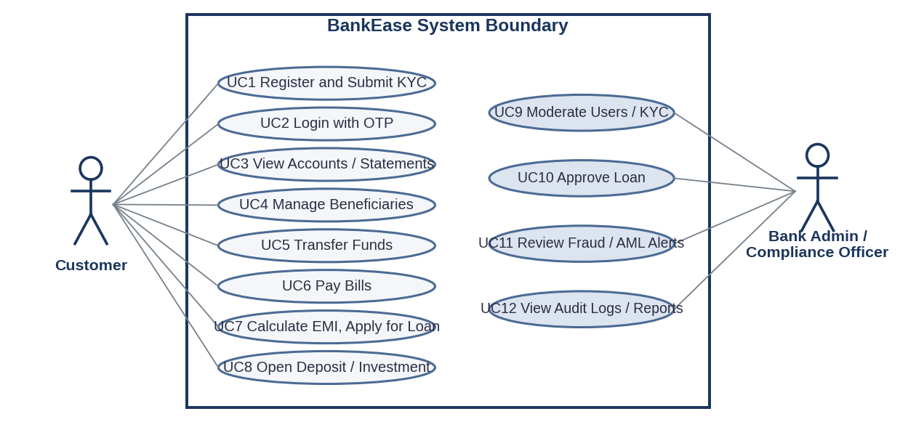
Figure 3: Use case diagram of BankEase
ID | Use case | ID | Use case
UC1 | Register and submit KYC | UC7 | Calculate EMI, apply for loan
UC2 | Log in with OTP | UC8 | Open deposit or investment
UC3 | View accounts and statements | UC9 | Moderate users and KYC
UC4 | Manage beneficiaries | UC10 | Approve loan
UC5 | Transfer funds | UC11 | Review fraud/AML alerts
UC6 | Pay bill | UC12 | View audit logs and reports

6.2 Entity-Relationship Diagram
Crow's Foot style cardinalities (1 to N). The schema is in Third Normal Form: each non-key attribute depends only on its table key, and repeated data such as beneficiaries and transactions sits in separate tables linked by foreign keys.
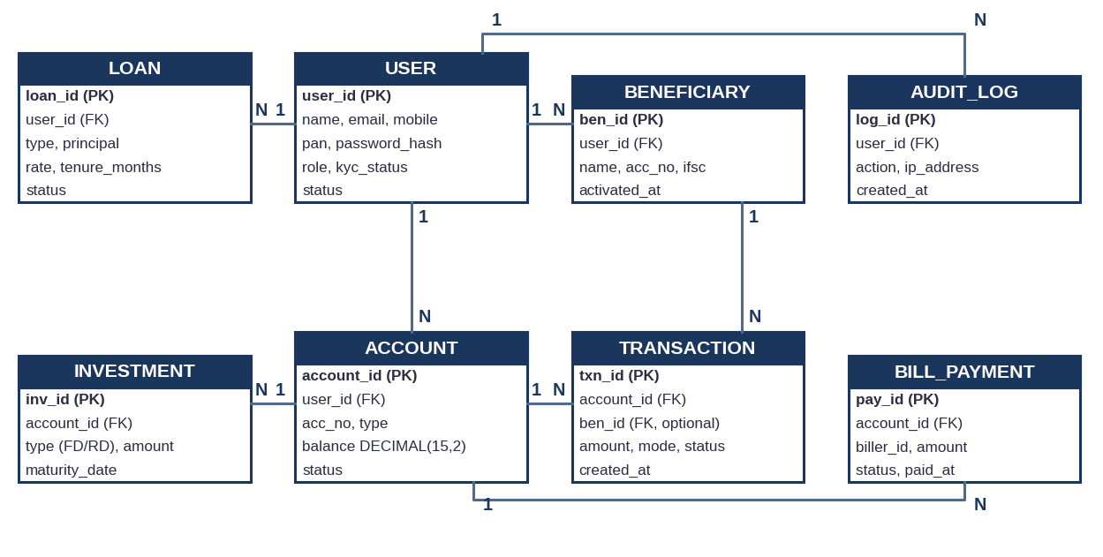
Figure 4: Entity-relationship diagram of BankEase

6.3 Sequence Diagram: Fund Transfer
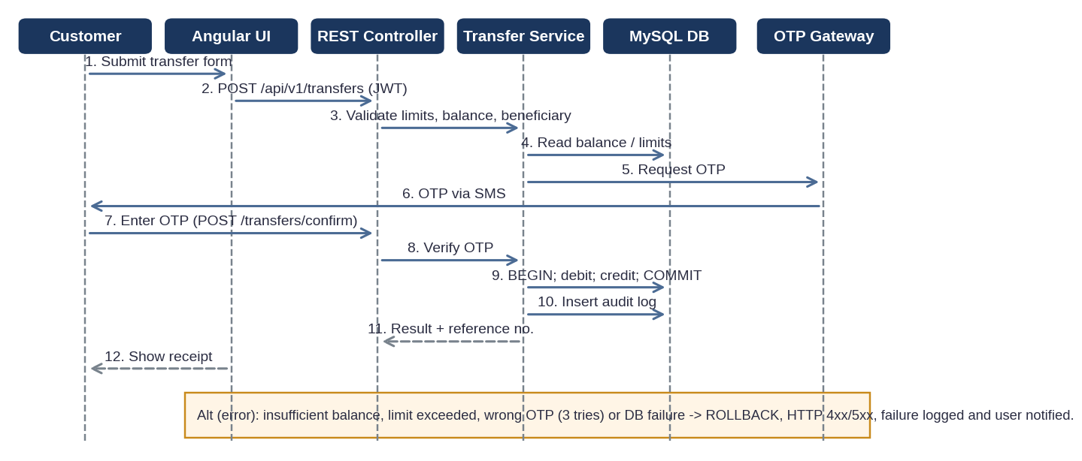
Figure 5: Sequence diagram for an OTP-authorized fund transfer (OTP step planned for Release 2)

6.4 Requirements Traceability Matrix
Module | Requirements | Use Cases | Verification
M1 Authentication | FR-1.1 to FR-1.5 | UC1, UC2 | Unit and API tests; OWASP ZAP; 5.2
M2 Accounts | FR-2.1 to FR-2.4 | UC3 | Integration tests; usability walkthrough; 5.6
M3 Fund Transfer | FR-3.1 to FR-3.5 | UC4, UC5 | Transaction rollback tests; JMeter; 5.1, 5.3
M4 Bill Payment | FR-4.1 to FR-4.3 | UC6 | Mock aggregator integration tests
M5 Loans and Deposits | FR-5.1 to FR-5.4 | UC7, UC8 | Calculation unit tests; workflow tests
M6 Admin and Compliance | FR-6.1 to FR-6.5 | UC9 to UC12 | Audit log review; alert rule tests; 5.5

7. Academic Review & Sign-Off
This Software Requirements Specification has been submitted and reviewed by the academic supervisory panel:
Project Coordinator / Guide | Internal Examiner | Head of Department (HOD)
Signature: __________________  Date: __________________ | Signature: __________________  Date: __________________ | Signature: __________________  Date: __________________

8. Risks and Mitigations
Risk | Mitigation
Concurrent transfers corrupt balances | Pessimistic locking and ACID transactions.
Credential theft or brute force | BCrypt, lockout, JWT expiry, OTP (Release 2).
Unauthorized data access | Ownership checks and RBAC on every endpoint.
Scope too large for the timeline | Two-release plan (Section 2.6).

